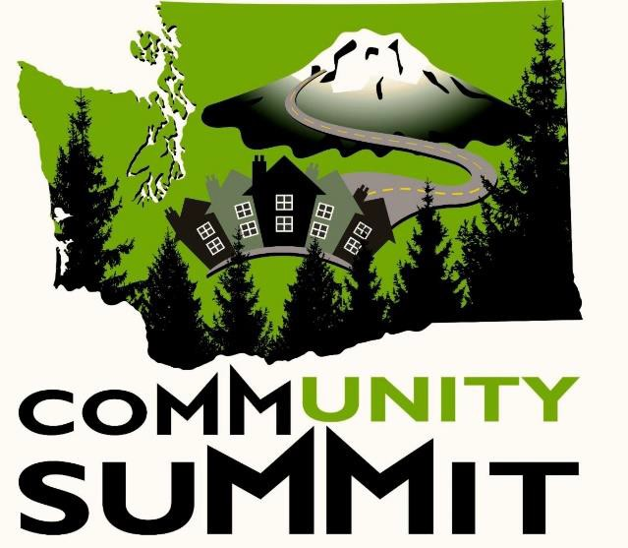
The DDA Community Summit Goes On-Line
The Developmental Disabilities Administration’s annual Community Summit launched its first online session Wednesday, May 6, 2020. The Community Summit, which was scheduled to happen June 9 through 11, 2020 in Wenatchee, Washington, was cancelled due to the ongoing COVID-19 public health crisis. An alternative was sought, and it was decided that an online format could be utilized to bring some of the Community Summit’s popular programming to the public. The inaugural session
of the Community Summit Webinar Series opened with a welcome message from DSHS Developmental Disabilities Administration Assistant Secretary Evelyn Perez. Perez greeted the audience with an acknowledgement that the quarantine has affected every citizen, “But we are still a community, we still need connection to each other, we still need the Community Summit.”
The first webinar session also featured a special appearance from Gaelynn Lea, who was the opening keynote speaker at the 2019 Community Summit. Lea, an advocate for disability rights from Duluth, Minnesota, uses her music as a platform to promote positive social change. She reflected on her quarantine experience, and shared her song “Watch the World Unfold.”
Webinar hosts Ron Bryan, from DDA’s Roads to Community Living Program, and Monica Zumach, from WISE, introduced the Community Summit Webinar Series schedule and interviewed presenters from upcoming sessions. Sheldon Schwitek, executive director of the ARC Community Advocates of Kalamazoo, Michigan, talked about how individuals are being affected by social distancing amidst the quarantine and the impact on people who are caring for others. Schwitek will continue his message, entitled Calm at the Center, on May 14,, 2020. Jeremy Norden-Paul from the Washington State Developmental Disabilities Council, Stacy Dym from the ARC of Washington, and DSHS Assistant Secretary Evelyn Perez talked about the services their organizations provide to support the community. Norden-Paul, Dym, and Perez will cohost a Town Hall meeting to address community support issues on May 20, 2020.
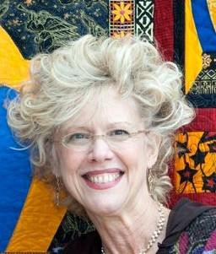
The Community Summit Webinar series then welcomed Dr. Beth Mount, whose keynote address, ‘Finding Hope in Uncertainty,” asked viewers to reflect on what is going on around them, and challenged them to think of positive changes that they can carry forward into a different world. Dr. Mount, who for more than 45 years has worked towards the ideal that every person with a disability can be a valued member of the community, will be speaking again on Wednesday, May 13, 2020.

The Community Summit was conceived of in 2013 as a conference to bring together self- advocates, families, friends, and allies to talk about building inclusive communities. The Community Summit Webinar Series seeks to continue this same message via online video streaming. Partnership with Washington state counties has provided the financial support to ensure that everyone can participate in the webinar series free of charge.
The Community Summit Webinar series will continue with sessions scheduled through June 24, 2020. Continuing education certificates are available. Attendees need to register for each session they wish to attend. Sessions are announced each Thursday for the following week.
For more information, or to register please visit www.gowise.org/training and click on Wise Webinar Series. Then look for the Community Summit Webinar Series.

