The Tailored Supports for Older Adults (TSOA) application can be submitted in the following ways:
- Apply on-line at www.washingtonconnection.org.
  - From the Washington Connections home page click “Apply Now”
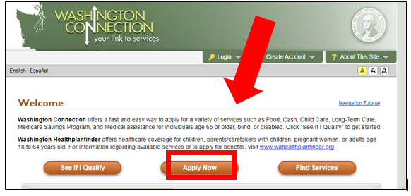

  - Then click “Next”
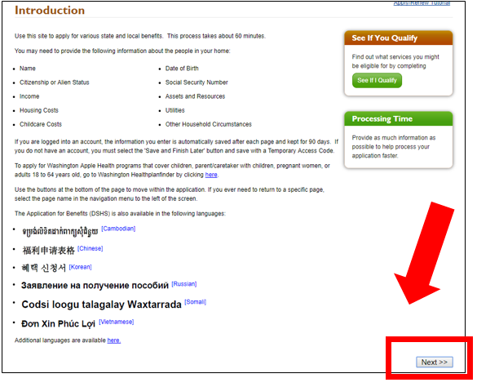
  - After reading the information on the next page, click “Next” again at the bottom right hand corner of the page.

  - This will take you to the beginning of the application. Enter your zip code and click “Next”.
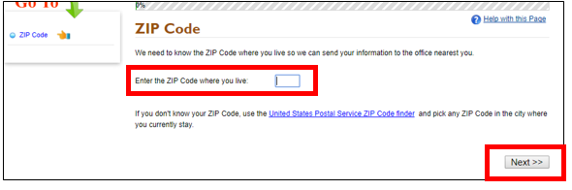

  - Under Long Term Services and Supports, click on “Tailored Supports for Older Adults (TSOA)” and select “Next” to complete the application.
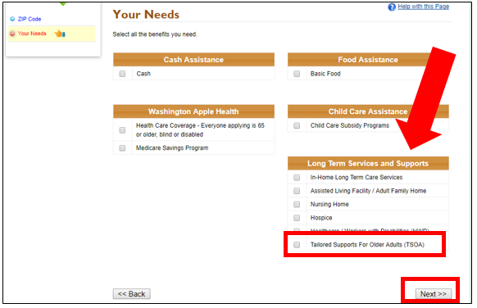

OR

- Download and complete an HCA 18-008 TSOA application form and:
  - Mail to: PO Box 45826, Olympia, WA 98504; or
  - Fax to: 1-855-635-8305; or
  - Take it to your Community Living Connections/Area Agency on Aging or Home and Community Services Offices.

