Communicating with Individuals with limited English proficiency (LEP) or Sensory Disability (SD) in Medicaid programs

Guidance for AAA staff

The purpose of this chapter is to:
- Explain requirements to communicate effectively with persons who do not or have limited ability to speak, read, write, or understand English ensuring equal access to Aging and Long-Term Support Administration (ALTSA) administered Medicaid services and programs;
- Describe language assistance services and explain how to use them.

Ask the Expert
If you have questions or need clarification about the content in this chapter, please contact:
Linda Garcia, LEP, ADA & Voter Registration Assistance Program Manager
at (360) 968-9745 or linda.garcia1@dshs.wa.gov

Table of Contents
Communicating with Individuals with limited English proficiency (LEP) or Sensory Disability (SD) in Medicaid programs 1
Guidance for AAA staff 1
Table of Contents 1
Definitions 2
Authorizing sources 3
Identifying applicants or clients with LEP or SD 3
Types of Language Access Services AAA staff must provide 4
Types of LA services for effective oral communication with clients: 4
Types of LA services for effective written communication with clients: 4
Bilingual or Multilingual Employees 4
Contracted interpreter services 4
Spoken Language or Sign Language Interpreter Services in-person, over the phone (OPI) or video remote interpreting (VRI) technologies 5
Contracted translation services (written materials) 6
Translating client specific letters 6
Translating documents generated in the CARE and GetCare systems into foreign languages and getting those documents in large print (LP) 6
Sending translated CARE documents to Hub Imaging Unit (HIU) 10
Storing MAC and TSOA translated documents in GetCare File Cabinet 11
Translating DSHS official forms, publications, and other general communication materials or getting those documents in large print 11
Materials in Large Print (LP) 11
Braille Transcription 12
Documents in other alternate formats 12
Additional resources 12

Definitions
Area Agency on Aging (AAA) – a unit of local or tribal government designated by the state to address the needs and concerns of all older persons at the regional and local levels.
Auxiliary Aids – includes qualified interpreters, assistive listening systems (loop FM, and infrared), television captioning and decoders, video tapes, both open and closed captioned, TTYs, transcriptions, readers, taped texts, Braille, and large print materials. Any similar device or service needed to make spoken or aural (heard) language accessible is also considered an auxiliary aid.
Certified or Authorized Interpreter (for Spoken Languages) – a person who has passed the required DSHS interpreter examination, offered by DSHS Language Testing and Certification (LTC) program, or has passed a DSHS recognized interpreter examination offered by another organization.
Certified or Authorized Translator (for written documents) – a person who has passed the required DSHS written translation examination, offered by DSHS LTC, or has passed a DSHS recognized written translation examination offered by another organization.
Certified or Qualified Sign Language Interpreter – a person who obtained national interpreter certification (certified) by taking national performance and knowledge tests and/or has demonstrated ability (qualified) to interpret or transliterate effectively, accurately, and impartially, both receptively and expressively.
Client – a person who applies for, or receives, Medicaid LTSS services from DSHS.
Emergency – When no professional interpreter, or translator is available in or out of the state of Washington for a particular language, either in person, by video remote or telephonically and would cause an extensive delay in services for the applicant/client. Staff must document in CARE or GetCare the emergency use of an uncertified or unauthorized interpreter at every in-person interaction with applicant/client.
Interpretation – as used in this document, the transfer of an oral communication from one language to another.
Language Access (LA) Services – describes services that agencies use to bridge the communication barrier with individuals who cannot effectively communicate in English. It’s a full spectrum of oral, written, and assistive technology services available to ensure access to programs and services for population with limited English proficiency (LEP) or Sensory Disability (SD).
Limited English Proficiency (LEP) - a limited ability or inability to speak read and/or write English well enough to communicate effectively. Clients determine if they are limited in their ability to speak, read, write, or understand English. This definition includes persons with sensory disabilities.
Sensory Disability (SD) – a disability of the senses (e.g. sight, hearing, smell, touch, taste, spatial awareness), generally refers to disabilities related to hearing, vision, speech, or a combination (e.g. hard of hearing, deaf, partially sighted, or low vision and/or blind, deaf/blind, or physically unable to speak.)
Sign Language and Sign Systems - Visual or tactile ways of communicating thoughts, ideas, and feelings through American Sign Language or manual signs and gestures with specifically defined vocabulary.
Translation – the transfer of written communication from one language to another.
Primary/Preferred Language – the language that a client identifies as the language in which the person prefers to communicate verbally and/or in writing.
Written Communication – DSHS publications, Department forms and documents that:
- Describe services, client’s rights and responsibilities, or changes in benefits, eligibility or service;
- Request information from a client, a response on the part of a client, or notify a client of an adverse action; or
- Require a client’s signature or informed consent.

Authorizing sources
Title VI of the Civil Rights Act
of 1964 42 U.S.C. § 2000d https://www.justice.gov/crt/fcs/TitleVI-Overview

Americans with Disabilities Act (ADA)
of 1990 42 U.S.C. chapter 126 https://www.ada.gov/pubs/adastatute08.htm

Title 34 CFR (Education) 104
and 45 (Public Welfare) CFR 84
Nondiscrimination on Basis of
Handicap in Programs or Activities
Receiving Federal Financial Assistance https://www.federalregister.gov/documents/2017/01/03/2016-31236/nondiscrimination-on-the-basis-of-disability-in-programs-or-activities-receiving-federal-financial

RCW 49.60.030
Freedom from Discrimination https://app.leg.wa.gov/RCW/default.aspx?cite=49.60.030

RCW 74 Public Assistance https://app.leg.wa.gov/RCW/default.aspx?Cite=74

National CLAS Standards https://thinkculturalhealth.hhs.gov/clas/standards

WAC 10-08-150 https://apps.leg.wa.gov/wac/default.aspx?cite=10-08-150

WAC 388-03 https://apps.leg.wa.gov/WAC/default.aspx?cite=388-03

WAC 388-271 https://apps.leg.wa.gov/wac/default.aspx?cite=388-271

Identifying applicants or clients with LEP or SD
AAA staff must identify clients’ communication needs at the initial contact, during assessment and re-assessment interviews and:
- Inform or remind clients of their right to requests Language Access services,
- Document specific communication need of the client on the client demographics section of the appropriate application (CARE or GetCare) if applicable,
- If the client has a legal decision maker, AAA staff must document this in the client’s electronic record. Include in documentation if the decision maker needs documents translated and into which language.

Types of Language Access Services AAA staff must provide
AAAs are expected to provide effective, equitable, understandable, and respectful quality care and services in a manner that is culturally and linguistically appropriate, recognizing different communication needs when communicating orally or in writing and using appropriate Language Access (LA) services or assistive technology.

Types of LA services for effective oral communication with clients:
- Bilingual or Multilingual Employees providing direct services in needed language(s).
- Contracted Interpreter Services:
    - Spoken Language Interpreter Services in-person, over the phone (OPI) or video remote interpreting (VRI) technologies.
    - Sign Language Interpreter Services in-person, video remote, or by using assistive technology devices.

Types of LA services for effective written communication with clients:

- Contracted Translation Services into non-English languages.
- Materials in Large Print.
- Braille Transcription Services.
- Audio Recordings of Written Materials.
- Other – Closed or Open Captioning of videos; Communication Access Real-Time Transcription, Accessible websites, etc.

LA Services should be provided:
- at no cost to clients,
- in a timely manner,
- by qualified providers and be of high quality,
- in coordination with knowledgeable professionals – SMEs,
- in consideration of individual situation, and
- with cultural awareness and respect.

Bilingual or Multilingual Employees
AAA staff who provide direct services to clients in a language(s) other than English, including Sign Languages, must, at the minimum, demonstrate a proficiency through a process established by the AAA.

Contracted interpreter services
AAA staff must use interpreters when AAA bilingual staff cannot meet the language needs of the applicant/client.

Spoken Language or Sign Language Interpreter Services in-person, over the phone (OPI) or video remote interpreting (VRI) technologies

AAA can choose to use DES Master Contracts for:
- Interpreter Services, Over the Phone and Video Remote (currently #02819),
- Sign Language Interpreter ASL (currently # 02120 and # 03930) administered by the Office of the Deaf and Hard of Hearing (ODHH) of DSHS, or
- Develop their own contracts.

AAA must pay for all professional in-person and remote interpreter services – over-the-phone interpreting (OPI) or video-remote-interpreting (VRI) provided to the applicants or clients they serve.
Find DES Interpreter Services contracts here: https://apps.des.wa.gov/DESContracts/

Communicating with clients using spoken or sign language interpreter services
- Document the use of contracted interpreter services at every scheduled in-person encounter with the client.
- Spoken language interpreters providing LA services to the clients must be certified, authorized, or recognized by DSHS Language Testing and Certification (LTC) program (WAC 388-03-30) and comply with the DSHS code of professional conduct (WAC 388-03-50.) Some languages of limited diffusion may not have DSHS certified/authorized professional interpreters. In these cases, the contracted interpreter agency must qualify these interpreters.
- Sign Language interpreters providing LA services to the clients must maintain their certification through the Registry of Interpreters for the Deaf (RID) www.rid.org and comply with the Code of Professional Conduct.
- Interpreter service is a purchased service and may not be authorized as a client service.
- Applicants or clients with LEP or SD (Title XIX, MAC and TSOA) may secure, at their expense, the services of their own interpreter. This does not waive the AAA’s responsibility to arrange and pay for a professional certified or authorized interpreter. AAA staff must not allow the following to serve as interpreters:
  - Paid Individual Provider (IP) - to avoid possible conflict of interest;
  - Children under the age of 18 years even if they are not a family member or relative.
- Staff may use a family member or a friend of the client over the age of 18 in case of emergency. Family members and friends cannot receive payment for interpreter services.
For the purposes of this chapter, emergency means “When no professional interpreter, or translator is available in or out of the state of Washington for a particular language, either in person, by video remote or telephonically and would cause an extensive delay in services for the applicant/client. Staff must document in CARE or GetCare the emergency use of an uncertified or unauthorized interpreter at every in-person interaction with applicant/client.
- If staff use a family member/friend over the age of 18 to assist in communicating with the applicant or client, they must document in the client’s electronic record:
  - attempts to secure a professional interpreter;
  - use of family member or friend to assist in communication; and
  - for SD, use of other options for communication, such as Telecommunication Relay Services (TRS) 711 or 1-800-974-1548, Video-Remote Interpreting (VRI), or other assistive technology.
Note: AAA staff will not need special equipment when calling or receiving calls from individuals with SD. To learn more about TRS, please visit ODHH website page on Telecommunication.

Contracted translation services (written materials)

AAA staff must provide written documents to clients with LEP or SD in the languages or formats clients can read and understand at no charge to the clients and without significant delay.
- AAA staff must not rely on family and friends for providing translation services.
- If the client with LEP or SD is illiterate or has cognitive limitations and has a formal or informal decision maker, AAA staff must provide documents in a language or a format that the decision maker can read and document it in the client’s electronic record.
- If the client is illiterate and cannot read English or their primary language, AAA staff must document it in the client’s electronic record and describe how staff obtained consent or required signature.

Translating client specific letters
AAAs can choose to use DES Master Contract– Translation Services-Written Word (currently # 04218), Category 5 Client Specific or develop their own contract. AAAs must pay for all professional translation services provided to the applicants or clients they serve.

Find DES Translation Services contract here: https://apps.des.wa.gov/DESContracts/.

Translating documents generated in the CARE and GetCare systems into foreign languages and getting those documents in large print (LP)
AAA staff must use the current ALTSA vendor for translations of CARE and GetCare system generated documents and follow the established process for requesting document translation into foreign languages or converting into Large Print (LP) format.
Use Translation-Billing EXE application generating secure email when requesting translated document(s) or needing document(s) in LP.

Step by step instructions for requesting CARE or GetCare documents in client’s language or in LP:

Inside the Firewall

Step 1 - Create a separate PDF for each document needing translation, naming it according to the selection (“Planned Action Notice - PAN” or “Service Summary - SS” or “Assessment Details – AD”, etc.) you make in the “Translation-Billing EXE” application; do not merge documents together and do not scan or ZIP (compress) them.
Step 2 – Find “Translation-Billing EXE” application.
This will be an icon on your desktop that can be loaded by your local IT staff.
Step 3 – Run “Translation-Billing EXE” application for CARE or GetCare documents. Once launched, it will prompt you to identify information about your administration/program.

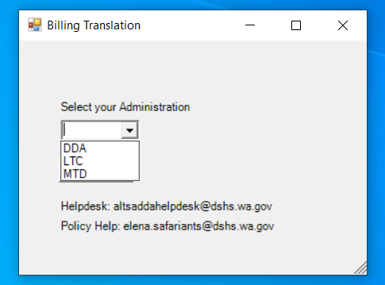
Step 4 - After making initial selection (LTC or MTD), the user will need to enter and select from the drop down list the following required data fields:
- Language Code
- Region/PSA
- Reporting Unit (RU)
- Client’s ALTSA/CARE ID
- Document Type(s): Check the boxes corresponding to the document type(s) you need translated for each client. You must send a separate email for each client who needs translation of the documents. However, you may send multiple documents to be translated for a specific client in one email.
NOTE: If any of the fields are unfilled or filled with incorrect or extraneous information such as attached files do not match the file names in the “Subject” line, PDFs are not created directly from the CARE or GetCare system, etc., the vendor may decline your request for translation and request you resubmit it.

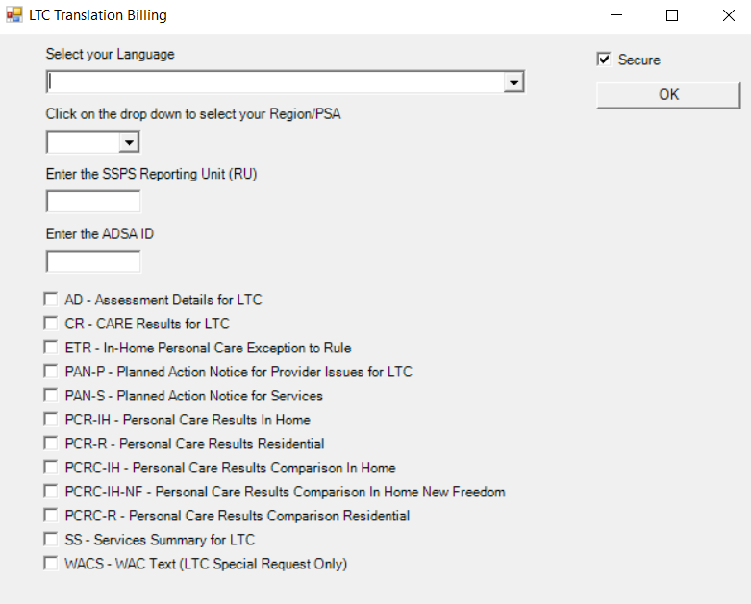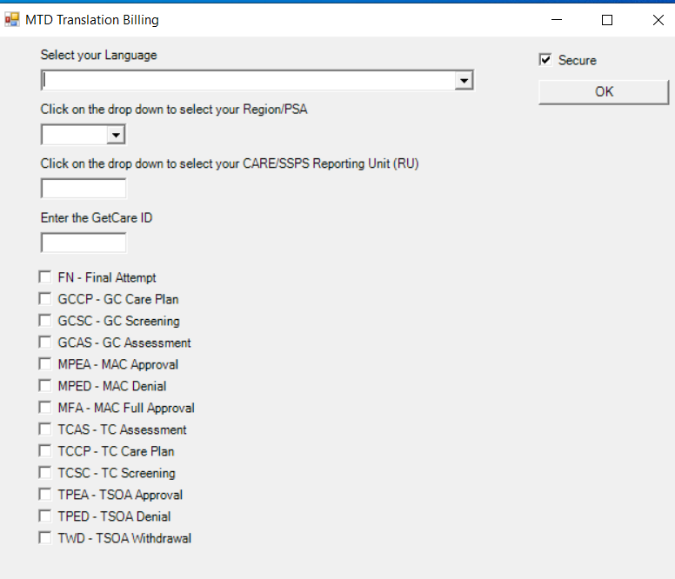

After completing all the data fields click OK; a secure e-mail will automatically be created, and time stamped with the filled “To” and “Subject” fields.
DO NOT CHANGE THESE E-MAIL FIELDS! The codes mean something to the contractor and help make the process more efficient.

Step 5 – In the body of the e-mail you may include special handling instructions or additional information such as the name of the language marked as OT (other) in the EXE application.
Step 6 – Attach the PDF document(s) for translation to the e-mail you created in Step 1 and properly selected in Step 4.
Step 7 – Pause and double check your translation request and then press “Send” from your E-mail system. Once you submit your request, your request cannot be changed.
Step 8 – The Contractor will acknowledge the receipt of your request and return the translated documents through the secure email.

NOTE: Make sure you do not send new translation requests in the same email chain of old requests.

Outside the Firewall
Step 1 - Create a separate PDF for each document needing translation, naming it according to the selection (“Planned Action Notice - PAN” or “Service Summary - SS” or “Assessment Details – AD”, etc.) you make in the “Translation-Billing EXE” application; do not merge documents together and do not scan or ZIP (compress) them.
Step 2 – Find “Translation-Billing EXE” application.
This will be an icon on your desktop that can be loaded by your local IT staff.
Step 3 – Run “Translation-Billing EXE” application for CARE or GetCare documents. Once launched, it will prompt you to identify information about your administration/program.

Step 4 - After making initial selection (LTC or MTD), the user will need to enter and select from the drop down list the following required data fields:
- Language Code
- Region/PSA
- Reporting Unit (RU)
- Client’s ALTSA/CARE ID
- Document Type(s): Check the boxes corresponding to the document type(s) you need translated for each client. You must send a separate email for each client who needs translation of the document(s). However, you may send multiple documents to be translated for a specific client in one email.

NOTE: If any of the fields are unfilled or filled with incorrect or extraneous information such as attached files do not match the file names in the “Subject” line, PDFs are not created directly from the CARE or GetCare system, etc., the vendor may decline your request for translation and request you resubmit it.

Step 5 - After completing all the data fields, the following message will be displayed containing the data you just entered:

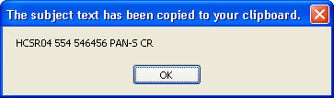

DO NOT CHANGE THESE E-MAIL FIELDS! The codes mean something to the contractor and help make the process more efficient.
If you have Outlook, it will also generate a new email message with the “To:” and “Subject:” lines completed. Click “OK”.

If you do not have Outlook, take the following steps:

Step 6 - Access your e-mail system and
- create an e-mail addressed to wa.translations.2123@prisma.com;
- navigate to the subject line of this e-mail;
- press and hold the CTRL key and type the letter V. This will place the information that you completed in Step 4 into the subject line of your e-mail.
Step 7 - Attach the document(s) for translation to e-mail and press “Send” from your agency’s secure e-mail system.

Receiving your Translated CARE and GetCare Documents
When the Contractor has completed translation of your document, they will send a secure e-mail back. Open and save and/or print each documents individually.

Turnaround time frames for CARE and GetCare document translation
- 4 business days for correspondence which requires keying-in or formatting of previously translated text in all languages.
- 8 business days for correspondence which requires keying-in, formatting, and new translation.
- 10 business days for 10 or more pages requiring keying-in, formatting, and new translation.

NOTE: Staff should only communicate with the Contractor using the Translation-Billing EXE application. Contractor will email case management staff through this system. Case management staff should follow up on job orders through the same email chain. This makes it easier for the Contractor to follow up and bill local offices correctly. Make sure you do not send new translation requests in the same email chain for old requests.

Paying for translation of CARE/GetCare/TCARE documents
Contractor will determine what requires translation and keying-in and will bill in accordance with the contractual agreement:
- DSHS/ALTSA will pay for the translation of the system’s templates.
- AAA are responsible for the cost of translating the text inserted into the templates.

Sending translated CARE documents to Hub Imaging Unit (HIU)
When sending CARE documents to the Hub Imaging Unit (HIU) for the Document Management System (DMS), send English and translated versions of all documents together with the exception of documents listed below. These documents in English are stored in CARE; send only translated versions of:
- Assessment Details (only send for translation if the client has requested a copy);
- CARE Results (CARE Results are only sent when the PCR/PCRC does not print as part of the PAN. This should only occur for the New Freedom Program);
- Planned Action Notices for Providers and Services;
- Personal Care Results Comparison (PCR/PCRC) – In-home and Residential; and
- Service Summary not generated and stored in CARE*. (If the Service Summary record is not stored in CARE, send the English version along with the translated version to HIU).

NOTE: The English documents are the official versions, so to reduce risk of legal complaint, the client and/or representative with LEP must sign both the English and translated versions. The English and translated versions should always be sent to the client and/or representative with LEP at the same time and should be signed on the same date.

Storing MAC and TSOA translated documents in GetCare File Cabinet
For MAC and TSOA programs, the translated version of documents must be stored in the client’s GetCare electronic file cabinet. GetCare stores the English versions of system-generated documents.

Translating DSHS official forms, publications, and other general communication materials or getting those documents in large print
Always check the DSHS Forms intranet and internet site to find translated forms by entering the DSHS form number, title, language needed, or program.
For DSHS publications, check Publications Library to find already existent translations by entering DSHS publication number, program/topic, or language.
Please check these sites periodically for the most current version of the documents for downloading, as documents undergo revisions.
Please check ALTSA Translated Documents to find program documents not listed on the DSHS Forms website or in Publications Library.
If you do not find the document in the needed language, you will need to initiate a new translation request.
AAA designated staff will contact Linda Garcia at (360) 968-9745 or linda.garcia1@dshs.wa.gov indicating the document number or name and the language(s) needed.
DSHS/ALTSA will be responsible for payments on translations.

Best practice: Field staff should send translated documents at the same time as the English version to applicants/clients.

Materials in Large Print (LP)
Generally, LP documents have font size of 18 or 20 point. If the client needs documents in LP, please ask what size font is most convenient. You can request DSHS forms in LP by contacting Linda Garcia at linda.garcia1@dshs.wa.gov

If other documents such as Care Plans need LP conversion, AAA staff may request LP the same way they request translations into foreign languages using Translation-Billing EXE application and choosing LP – Large Print from the dropdown list in “Select your Language” section.

Braille Transcription
For clients who are blind and read documents transcribed in Braille, submit the request by sending needed documents as attachments and indicating Braille Grade (1 or 2) via secure email to Linda Garcia at linda.garcia1@dshs.wa.gov. DSHS/ALTSA will be responsible for payments.

The Contractor – WSSB Ogden Resource Center will send completed Braille transcription directly to the client along with the copy of the original document.

AAA staff will obtain the client’s consent or required signature on the original document, as documents in Braille cannot be photocopied or signed. If the client has a guardian or DPOA, document that the guardian or person with DPOA discussed decisions related to client’s care prior to obtaining a signature or receiving consent.

ALTSA ADA/LEP program manager will send an email to the requestor that will include:
- A statement that the text was transcribed into Braille and sent to the client;
- The date when the packet was mailed and UPS tracking number;
- A notification if the packet was returned as undeliverable and the date of the notification.

AAA staff will document this information in client’s electronic record.

Documents in other alternate formats
If you need documents in other alternate formats (recordings, real-time transcriptions, etc.), please contact ALTSA ADA/LEP Program Manager, Linda Garcia at (360) 968-9745 or linda.garcia1@dshs.wa.gov.

Additional resources
https://www.lep.gov/

https://www.ada.gov/effective-comm.htm

https://www.hhs.gov/civil-rights/for-individuals/section-1557/index.html

If using Voice Signature, see Voice Signature Script attachment in Chapter 3 Appendix.

