Communicating with Individuals with limited English proficiency (LEP) or
Sensory Disability (SD)
Guidance for ALTSA and DDA staff

The purpose of this chapter is to:
- Explain requirements to communicate effectively with persons who do not or have limited ability to speak, read, write or understand English ensuring equal access to services and programs administered by Aging and Long-Term Support Administration (ALTSA) and Developmental Disabilities Administration (DDA);
- Describe language assistance services and explain how to use them.

Ask the Expert
If you have questions or need clarification about the content in this chapter, please contact:
- ALTSA – Linda Garcia, LEP, ADA & Voter Registration Assistance Program Manager
(360) 968-9745, linda.garcia1@dshs.wa.gov
- DDA – Jeff Flesner, DDA Language Access and Logistics Administrator
(360) 407-1581, jeff.flesner@dshs.wa.gov

Table of Contents
Definitions 2
Authorizing Sources 3
Identifying Applicants or Clients with LEP or SD 5
Types of Language Access Services ALTSA and DDA staff must provide 5
Types of LA and AT services for effective oral communication with clients: 5
Types of LA and assistive technology services for effective written communication with clients: 5
Bilingual or Multilingual Employees 6
Contracted Interpreter Services 6
In-Person Spoken Language Interpreter Services 6
Requesting Spoken Language In-Person Interpreter Services 7
Sign Language Interpreter Services 8
Over the Phone Interpreter Services for spoken languages (OPI) 9
Contracted Translation Services (written materials) 10
Translating DSHS official forms, publications, and other general communication materials (Categories 1-4) or getting those documents in large print (LP) 10
Client Specific Translations 11
Translating documents generated in the CARE system into foreign languages and getting those documents in large print (LP) 12
Sending translated documents to Hub Imaging Unit (HIU) 15
Materials in Large Print (LP) 15
Braille Transcription 15
Documents in other alternate formats 16
Tips for Working with Spoken and Sign Language Interpreters 16

Definitions

- Area Agency on Aging (AAA) – a public or private non-profit agency designated by the state to address the needs and concerns of all older persons at the regional and local levels.
- Auxiliary Aids – includes qualified interpreters, assistive listening systems (loop FM, and infrared), television captioning and decoders, video tapes, both open and closed captioned, TTYs, transcriptions, readers, taped texts, Braille and large print materials. Any similar device or service needed to make spoken or aural (heard) language accessible is also considered an auxiliary aid.
- Certified or Authorized Interpreter (for Spoken Languages) – a person who has passed the required DSHS interpreter examination, offered by DSHS Language Testing and Certification (LTC) program or has passed a DSHS recognized interpreter examination offered by another organization.
- Certified or Authorized Translator (for written documents) – a person who has passed the required DSHS written translation examination, offered by DSHS LTC, or has passed a DSHS recognized written translation examination offered by another organization.
- Certified or Qualified Sign Language Interpreter – a person who obtained national interpreter certification (certified) by taking national performance and knowledge tests and/or has demonstrated ability (qualified) to interpret or transliterate effectively, accurately, and impartially, both receptively and expressively.
- Client – a person who applies for, or receives, services from DSHS or AAA.
- DSHS Certified Bilingual Employee – a DSHS staff member who has passed the required DSHS Bilingual Skills Test(s) or sign language evaluation and is authorized to provide direct services to LEP, deaf, and/or deaf-blind clients and employees.
- Emergency – When no professional interpreter, or translator is available in or out of the state of Washington for a particular language, either in person, by video remote or telephonically and would cause an extensive delay in services for the applicant/client. Staff must document in CARE the emergency at every in-person interaction with applicant/client.
- Interpretation – as used in this document, the transfer of an oral communication from one language to another.
- Language Access (LA) Services – describes services that agencies use to bridge the communication barrier with individuals who cannot effectively communicate in English. It’s a full spectrum of oral, written, and assistive technology services available to ensure access to programs and services for population who are limited English proficient (LEP) or have Sensory Disability (SD).
- Limited English Proficiency (LEP) - a limited ability or inability to speak read and/or write English well enough to communicate effectively. Clients determine if they are limited in their ability to speak, read, write or understand English. This definition includes persons with sensory disabilities.
- Sensory Disability (SD) – a disability of the senses (e.g. sight, hearing, smell, touch, taste, spatial awareness), generally refers to disabilities related to hearing, vision, speech, or a combination (e.g. hard of hearing, deaf, partially sighted or low vision and/or blind, deaf/blind, or physically unable to speak.)
- Sign Language and Sign Systems - Visual or tactile ways of communicating thoughts, ideas, and feelings through American Sign Language or manual signs and gestures with specifically defined vocabulary.
- Translation – the transfer of written communication from one language to another.
- Primary/Preferred Language – the language that a client identifies as the language in which the person prefers to communicate verbally and/or in writing.
- Written Communication – DSHS publications, forms and documents that:
  - Describe services, client’s rights and responsibilities, or changes in benefits, eligibility or service;
  - Request information from a client, a response on the part of a client, or notify a client of an adverse action; or
  - Require a client’s signature or informed consent.

Authorizing Sources

Title VI of the Civil Rights Act  of 1964 42 U.S.C. § 2000d | https://www.justice.gov/crt/fcs/TitleVI-Overview
Americans with Disabilities Act (ADA)  of 1990 42 U.S.C. chapter 126 | https://www.ada.gov/pubs/adastatute08.htm
Title 34 CFR (Education) 104  and 45 (Public Welfare) CFR 84  Nondiscrimination on Basis of  Handicap in Programs or Activities  Receiving Federal Financial Assistance | https://www.federalregister.gov/documents/2017/01/03/2016-31236/nondiscrimination-on-the-basis-of-disability-in-programs-or-activities-receiving-federal-financial
RCW 49.60.030  Freedom from Discrimination | https://app.leg.wa.gov/RCW/default.aspx?cite=49.60.030
RCW 74 Public Assistance | https://app.leg.wa.gov/RCW/default.aspx?Cite=74
National CLAS Standards | https://thinkculturalhealth.hhs.gov/clas/standards
WAC 10-08-150 | https://app.leg.wa.gov/WAC/default.aspx?cite=10-08-150
WAC 388-03 | https://apps.leg.wa.gov/WAC/default.aspx?cite=388-03
WAC 388-271 | https://app.leg.wa.gov/WAC/default.aspx?cite=388-271
DSHS AP 7.20 | OJCR - DSHS-AP-07-20.pdf - All Documents (sharepoint.com)
DSHS AP 7.21 | OJCR - DSHS-AP-07-21.pdf - All Documents (sharepoint.com)
DSHS AP 18.82 | OJCR - DSHS-AP-18-82.pdf - All Documents (sharepoint.com)

Identifying Applicants or Clients with LEP or SD

ALTSA and DDA staff must identify and document clients’ communication needs at the initial contact, during assessment and re-assessment interviews and
- Inform or remind applicants/clients of their right to requests Language Access services at no cost to them and document it in electronic service record (e.g. Service Episode Record – SER);
- Document specific communication need of the client on the Client Demographics screen in CARE;
- If the client has a legal decision maker, ALTSA and DDA staff must document this in electronic service record. Include in documentation if the decision maker needs an interpreter and/or documents translated and into which language.

Types of Language Access Services ALTSA and DDA staff must provide

All agencies receiving federal financial assistance are required to provide effective, equitable, understandable, and respectful quality care and services in the manner that is culturally and linguistically appropriate, recognizing different communication needs when communicating orally or in writing and using appropriate Language Access (LA) or Assistive Technology (AT) services.
Staff will use LA or AT services when establishing, implementing or monitoring a client’s plan of care and communicating with a client and/or client’s formal or informal support or decision makers with LEP or SD.

Types of LA and AT services for effective oral communication with clients:
- Bilingual or Multilingual Employees providing direct services in needed language(s).
- Contracted Interpreter Services:
  - Spoken Language Interpreter Services in-person, over the phone (OPI) or video remote interpreting (VRI) technologies.
  - Sign Language Interpreter Services in-person or by using video remote and other assistive technology devices.

Types of LA and assistive technology services for effective written communication with clients:
- Contracted Translation Services into non-English languages
- Materials in Large Print
- Braille Transcription Services
- Audio Recordings of Written Materials
- Other – Closed or Open Captioning of videos; Communication Access Real-Time Transcription, Accessible websites, etc.

LA Services must be at no cost to clients and provided:
- In a timely manner;
- By qualified providers and be of high quality;
- In coordination with knowledgeable professionals – Subject Matter Experts (SME);
- In consideration of individual situation; and
- With cultural awareness and respect.

Bilingual or Multilingual Employees

ALTSA and DDA staff who provide direct services to clients in a language(s) other than English, including Sign Languages, must, at the minimum, demonstrate through the process established by DSHS:
- Their proficiency in English and ‘target’ language – a foreign or sign language employee intends to use when communicating with clients;
- Knowledge of frequently used terminology; and
- Cultural awareness and sensitivity.

The role of Bilingual/Multilingual employees is to work directly with and assist clients as required in their job description. Normally, bilingual/multilingual employees should not interpret or translate in a third-party capacity on a regular basis. They may periodically interpret or translate in non-client related situations, or in brief, emergent client-related situations.

For more details, see DSHS Administrative Policy 18.82.

Currently, DSHS Language Testing and Certification (LTC) program is offering tests to all employees regardless of whether they are in a designated dual language position. Employees who wish to take tests simply need to contact LTC at dshsct@dshs.wa.gov to begin the process. If they would like to test using their work time, they will need their supervisor’s permission; they can also test using their leave time if they wish – in this case, they do not need to get supervisor’s approval. For additional information, visit Language Testing & Certification - Home (sharepoint.com).

Contracted Interpreter Services

ALTSA and DDA staff must use interpreters when:
- Applicant or client requested the LA service
- Establishing eligibility for services for client with LEP or SD
- Client with LEP or SD accesses services provided by ALTSA and/or DDA
- Necessary for Quality Assurance purposes

Staff must consider the availability of interpreter resources. Staff should consult with their administration’s Language Access Advisor for assistance in determining the most appropriate method of verbal communication – in-person, over-the-phone (OPI), or video remote interpreting (VRI).

In-Person Spoken Language Interpreter Services
Staff must use interpreters for spoken languages who are certified, authorized, or recognized by DSHS Language Testing and Certification (LTC) program (WAC 388-03-30) and comply with the DSHS code of professional conduct (WAC 388-03-50.) Some languages of limited diffusion may not have DSHS certified/authorized professional interpreters. In these cases, the interpreter services contractor must qualify these interpreters.

Applicants or clients with LEP or SD may secure, at their expense, the services of their own interpreter. This does not waive the ALTSA (HCS/APS/RCS) and DDA staff responsibility to arrange and pay for a professional (certified, authorized or recognized) interpreter.

Rules for communicating with clients using spoken language interpreter services
- Document the use of contracted spoken language interpreter services at every encounter with the client.
- Staff shall not authorize spoken language interpreter service as a client service. Interpreter service is a purchased service.
- ALTSA and DDA staff shall not allow to serve as interpreters:
  - Paid Individual Providers (IP) - to avoid possible conflict of interest;
  - Children under the age of 18 years even if they are not a family member or relative.
- Staff may use a family member or a friend of the client over the age of 18 in case of emergency.
For the purposes of this chapter, emergency means “When no professional interpreter, or translator is available in or out of the state of Washington for a particular language, either in person, by video remote or telephonically and would cause the applicant/client an extensive delay regarding application or reauthorization of services”. Family members and friends cannot receive payment for interpreter services.
- If staff used a family member/friend over the age of 18 or other Language Access services or auxiliary aids to assist in communicating with the applicant or client, they must document the following in the client’s electronic record:
  - Attempts to secure a professional interpreter;
  - Use of family member or friend to assist in communication; and
  - Use of other options for communication, such as OPI or VRI modalities.

Requesting Spoken Language In-Person Interpreter Services
- Use current language access service contracts to request In-person interpreter services:

a. HCA Interpreter Service contract K2474, currently Universal Language Service (ULS)
DSHS must use the ULS on-line scheduling system to request interpreters and manage job requests - HCA Universal | Universal Language Services

To request access to the ULS on-line scheduling system for new Requesters, contact your regional language access coordinator. Instructions on how to request a new requester account with ULS can be found in the document below.

Available resources for Requesters provided by the Contractor:
  - Requester Guides: https://hcauniversal.com/requester-guides/
  - Requester FAQ: https://hcauniversal.com/requester-faq/
  - Requester Training videos: Requester Webinars – HCAUniversal

To register you organization with Universal Language for interpreter services through the Washington State Health Care Authority (HCA) Interpreter Services (IS) Program, follow instructions at the following link - Provider Registration – HCAUniversal

b. DES Interpreter Service contract 06821 – Contractor, currently Four Corners Translation, LLC. Use on-line scheduling system to schedule In-Person interpreter services - https://stateofwa.interpretmanager.com/app/account/sign-in

To request access to the Four Corners on-line scheduling system, contact your regional language access coordinator. The regional language access coordinator will send an email request to the ALTSA Language Access program manager, Linda Garcia (linda.garcia1@dshs.wa.gov).

The email should include the staff member’s name, email address and the role (User or Requester Administrator) the staff member is to be assigned within the Four Corners system.

Once the email is received, the new User will receive an email Invite to the Four Corners platform and must complete the Onboarding process as outlined in the Four Corners Platform Guide. Staff should review the Onboarding process in the Four Corners User Guide BEFORE acting on the email Invite. The Invite is time sensitive and will expire after 24 hours.
Additional resources for the Four Corners contract can be found on the Language Access Sharepoint site.

NOTE: DSHS staff can choose to use either contract, as both the HCA contract K2474 (ULS) and the DES contract 06821 (Four Corners) provide services following the guidelines of the Collective Bargaining Agreement (CBA). The Language Access Provider (LAP) CBA can be found at the following link: https://ofm.wa.gov/sites/default/files/public/labor/agreements/23-25/nse_lap.pdf

- If no DES vendor has language resources for in-person appointment, DSHS staff can seek off-contract interpreter services providers. Use DSHS form 17-123 for placing a request and complete “Documentation for Using Non-Contracted Vendors” to justify going off he contract. See documents below.

These forms serve as a backup documentation to invoices from vendors. Make sure to complete them and obtain needed signatures. Give a copy to the Business Manager and save a copy in the client file.

NOTE: Do not use these forms when using a family member or a friend of the client.

Sign Language Interpreter Services
Use Sign Language contracts administered by the DSHS/ALTSA Office of the Deaf and Hard of Hearing (ODHH) https://fortress.wa.gov/dshs/odhhapps/Interpreters/Contractors.aspx

Communicating with clients using ODHH Sign Language Interpreter Services contracts
- Fill the Master Contract Sign Language Request Form (attached below) or New Online Request Interpreter Form when requesting a Sign Language interpreter. Follow the instructions on the form and send to the contractor.

This form serves as a backup documentation for payment purposes, make sure to provide all required information and obtain needed signatures.

- Sign Language interpreters providing LA services to the clients maintain their certification through the Registry of Interpreters for the Deaf (RID) www.rid.org and comply with the Code of Professional Conduct.
- Document the use of the contracted Sign Language interpreter services at every encounter with the client in the client’s electronic record.

If you have questions about Sign Language Interpreter Services contracts, contact:
- Berle Ross, Sign Language Interpreter Services Program Manager
(360) 339-4559, Email: berle.ross@dshs.wa.gov

For more information about services available for individuals who are deaf or hard of hearing, Deaf-Blind, or Speech Disabled, please contact ODHH - Office of the Deaf and Hard of Hearing (wa.gov)

Calling or receiving calls from someone with SD
You do not need any special equipment when calling or receiving calls from individuals who are deaf or hard of hearing. Telecommunication Relay Service (TRS) uses operators, called communications assistants (CAs), to facilitate telephone calls between people with hearing and speech disabilities and other individuals.

Please visit website of the ODHH to learn about how people who are deaf, hard of hearing, or have speech impairment use different ways to call you:
Telecommunications - https://www.dshs.wa.gov/altsa/odhh/telecommunication

Over the Phone and Virtual Remote Interpreter Services for spoken languages (OPI/VRI)

Pre-Scheduled language access needs:
Use when…
DSHS staff are unable to procure an In-Person interpreter for a pre-scheduled appointment. Staff may use DES contract 06821 to request Over-the-Phone interpreter (OPI) or Video Remote Interpreter (VRI) services using the Four Corners platform (see Four Corners Platform Guide). These services are to be used for pre-scheduled appointments only as outlined within the Collective Bargaining Agreement. For On-Demand service needs, please see below.

On-Demand language access needs:
Use when…
  - The individual with LEP needs urgent/emergent assistance;
  - A qualified in-person or OPI/VRI interpreter is not available for a pre-scheduled appointment;
  - There are no qualified in-person or OPI/VRI* interpreters serving language(s) or dialect(s) needed.

Staff are also allowed to utilize On-Demand OPI services when they become aware within 24 hours before the start of a pre-scheduled appointment that a qualified in-person interpreter will not be available.

ALTSA and DDA employees have access to the On-Demand OPI resource through DSHS contracts with two Contractors:
  - Language Link
  - 911 Interpreters

Account codes/numbers have been set up for ALTSA APS, HCS, MSD/OAS, and RCS and for DDA with both vendors.

ALTSA and DDA staff must not share Account codes/numbers assigned for their individual region, division, section, or program with others. For information on rates, specific accounts and instructions on how to place a call, please contact:
- ALTSA – Linda Garcia, LEP, ADA & Voter Registration Assistance Program Manager
(360) 968-9745, linda.garcia1@dshs.wa.gov
- DDA – Jeff Flesner, DDA Language Access and Logistics Administrator
(360) 407-1581, jeff.flesner@dshs.wa.gov

Contracted Translation Services (written materials)

ALTSA and DDA staff must provide written documents to the clients with LEP or SD in the languages or formats clients can read and understand at no charge to the clients and without significant delay.
  - ALTSA and DDA staff must not rely on family and friends for providing translation services.
  - If the client with LEP or SD is illiterate and cannot read English or their primary language, ALTSA and DDA staff must provide documents in a language or a format that the client prefers and document it in the client’s electronic record. Staff must also document it in the client’s electronic record how they obtained consent or required signature.
  - If the client with LEP or SD has cognitive limitations and has a formal or informal decision maker, staff must provide documents in a language or a format that the decision maker can read and document it in the client’s electronic record.

Translating DSHS official forms, publications, and other general communication materials (Categories 1-4) or getting those documents in large print (LP)
Always check the following:
  - DSHS Forms intranet and internet site to find translated forms by entering the DSHS form number, title, language needed, or program.
  - Publications Library to find already existent translations by entering DSHS publication number, program/topic, or language.
  - ALTSA Translated Documents to find program documents not listed on the DSHS Forms website or in Publications Library.
  - Voter Registration – https://www.sos.wa.gov/elections/abvr/Forms.aspx for availability of translated materials.

Please check these sites periodically for the most current version of the documents for downloading, as documents undergo revisions. If you do not find the document in the needed language, you will need to initiate a new translation request.

- ALTSA staff will contact Linda Garcia at (360) 968-9745 or linda.garcia1@dshs.wa.gov
- DDA staff will contact Dallas Hightower at 360-407-1538 or dallas.hightower@dshs.wa.gov for DSHS official forms, DSHS Publications and other general communication materials.

Please indicate the document number or name and the language(s) needed. You may need to email some general communication documents (other than DSHS forms or publications) requiring translation to ALTSA or DDA Translation Coordinator – Linda Garcia or Michelle Hinkle.

Getting DSHS Forms in Large Print (LP)
If the client needs documents in LP, please ask what size of font is most convenient. In general, LP documents have font size of 18 or 20 point.
- You can request DSHS forms in LP by contacting Millie Brombacher at (360) 664-6048 or millie.brombacher@dshs.wa.gov

Best practice: All English and translated forms and publications (new or revised) must be posted on the Forms or Visual Communications websites at the same time. Field staff should send translated documents at the same time as the English version to applicants/clients.

Client Specific Translations
For requesting translation of letters, notices, DSHS forms filled by client or staff, reminders, etc. please use DSHS form 17-120.
Staff can send Translation Request and client specific documents needing translation to any of the four vendors listed in the “To:” section of the form. Remember to add word [secure] to the subject line of your email to protect client’s information. Contact your Translation Coordinator if you have any questions regarding this category of translation work.

State Online Language Translation Request Application (SOLTRA) for ALTSA and DDA Financial Staff Only

SOLTRA Translation Application
This application, developed and maintained by DSHS/ESA IT staff, generates order forms, logs and tracks client specific translation requests completed by contracted vendors.

Only public benefit specialists (PBS) of ALTSA and DDA have access to this system.
- Contact Linda Garcia at (360) 968-9745 or linda.garcia1@dshs.wa.gov if you need assistance.

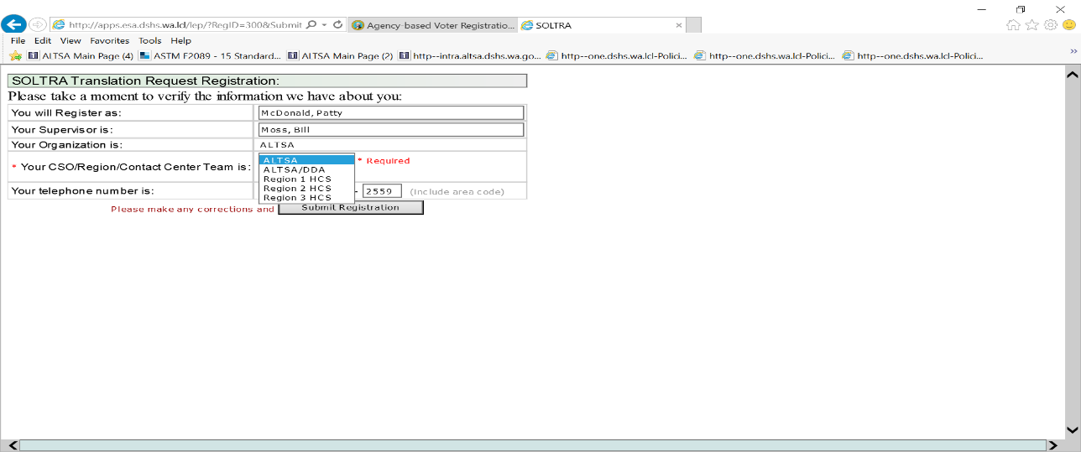

Translating documents generated in the CARE system into foreign languages and getting those documents in large print (LP)
ALTSA and DDA staff must use the current vendor for translations of CARE system generated documents and follow the established process for requesting documents translation into foreign languages or converting into Large Print (LP) format.
Use Translation-Billing EXE application generating secure email when requesting translated document(s) or needing document(s) in LP.

Step by step instructions for requesting CARE documents in client’s language or in LP:

Step 1 – Create document PDF separately for each document needing translation, naming it according to the selection (“Planned Action Notice - PAN” or “Service Summary - SS” or “Assessment Details – AD”, etc.) you make in the “Translation-Billing EXE”;” application; do not merge documents together and do not scan or ZIP (compress) them.

Step 2 – Find “Translation-Billing EXE” application.
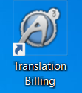
This will be an icon on your desktop that can be installed by local IT staff or manually by:
- Accessing the Software Center. Click the search field on your lower left task bar “Type here to search” and then type "Software Center."
- After entering the center, search for “Translation Billing.”
- Click and install the application.

Step 3 – Run “Translation-Billing EXE” application for CARE documents. Once launched, it will prompt you to identify information about your administration/program.

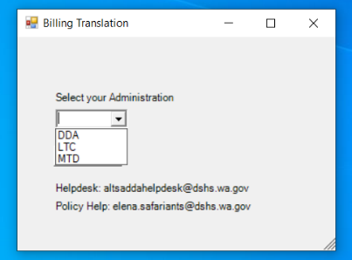

Step 4 – After making initial selection (DDA or LTC), you will need to enter and/or select from the drop down list the following required data fields:
  - Language Code
  - Region
  - Reporting Unit (RU): You must know or find out about your Reporting Unit and enter or select it.
  - Client’s ALTSA/CARE ID
  - Document Type(s): Check the boxes corresponding to the document type(s) you need translated for the client. You must send separate email for each client who needs translation of the documents.

NOTE: If any of the fields are unfilled or filled with incorrect or extraneous information, attached files do not match the file names in the “Subject” line, PDFs are not created directly from the CARE system, etc. the vendor may decline your request for translation and request you resubmit it.

DDA | LTC
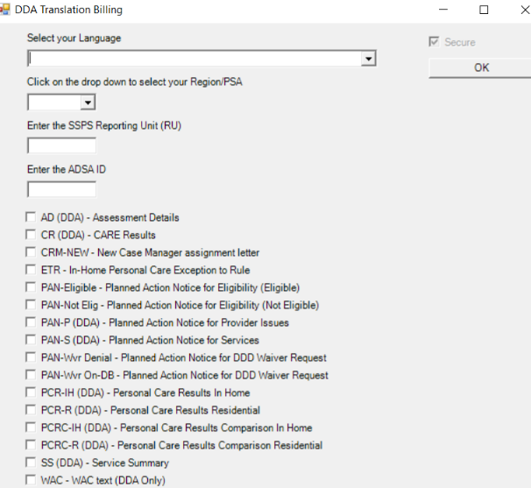 | 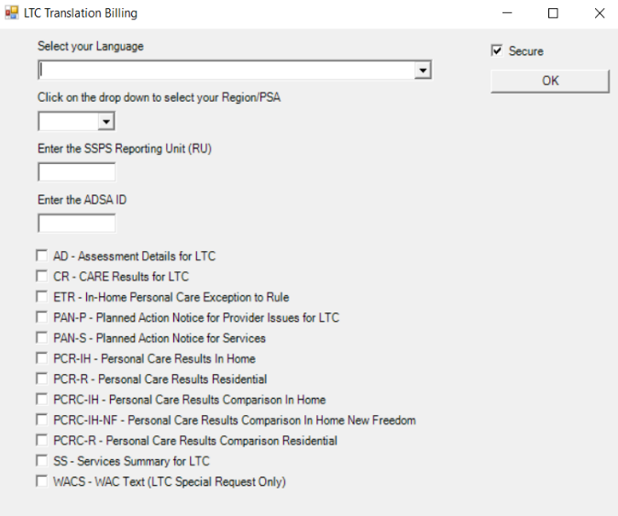

After completing all the data fields click OK; a secure e-mail will automatically be created with the filled “To” and “Subject” fields.

NOTE: DO NOT CHANGE THESE E-MAIL FIELDS! The codes mean something to the contractor and help make the process more efficient.

Step 5 – In the body of the e-mail you may include special handling instructions or additional information such as the name of the language marked as OT (other) in the “Translation-Billing EXE” application a duplicate file or modifications to a prior submitted request.

Step 6 – Attach the document(s) for translation to e-mail you created in Step 1 and properly marked in Step 4.

Step 7 – Pause and double check your translation request and then press “Send” from your E-mail system. Once you submit your request, your request cannot be changed.

NOTE: You must communicate to Prisma of any submission mistakes or if you believe you might have submitted a duplicate request.

Step 8 – The Contractor will acknowledge the receipt of your request and send the translated documents by return email through the secure email of the “Translation-Billing EXE” application.

NOTE: Make sure you do not send new translation requests in the same email chain of old requests.

Receiving your Translated CARE Documents
When Contractor has completed translation of your document, they will send a secure e-mail back. Open and save and/or print each documents individually.

Turnaround time frames for CARE documents translation
- 4 business days for correspondence which requires keying-in or formatting of previously translated text in all languages.
- 8 business days for correspondence which requires keying-in, formatting, and new translation.
- 10 business days for 10 or more pages requiring keying-in, formatting, and new translation.

NOTE: Staff should only communicate with the Contractor using the translation billing-”Translation-Billing EXE” application. Contractor will email ALTSA/DDA staff through this system. ALTSA/DDA staff should follow up on job orders through the same email chain. This makes it easier for the Contractor to follow up and bill local offices correctly. Make sure you do not send new translation requests in the same email chain for old requests.

Sending translated documents to Hub Imaging Unit (HIU)
When sending documents to the Hub Imaging Unit (HIU), ALTSA staff must send English and translated versions together of all documents with the exception of documents listed below. These documents in English are stored in CARE; send only translated versions of:
- Assessment Details (only send for translation if the client has requested a copy.)
- CARE Results (CARE Results are only sent when the PCR/PCRC does not print as part of the PAN. This should only occur for the New Freedom Program.)
- Planned Action Notices for Providers and Services.
- Personal Care Results Comparison (PCR/PCRC) – In-home and Residential; and
- Service Summary not generated and stored in CARE: If the Service Summary record is not stored in CARE, send the English version along with the translated version to HIU.

NOTE: While the English documents are the official versions, the client and/or representative with LEP must sign both the English and translated versions. The English and translated versions must always be sent to the client and/or representative with LEP at the same time and should be signed on the same date.

Materials in Large Print (LP)
If the client needs any other than DSHS forms and CARE documents in LP, please ask what size of font is most convenient for the client to read. In general, LP documents have font size of 18 or 20 point.
You can request DSHS ALTSA and DDA documents in LP by contacting:
- ALTSA – Linda Garcia, linda.garcia1@dshs.wa.gov
- DDA – Dallas Hightower, dallas.hightower@dshs.wa.gov

Braille Transcription
For clients who are blind and read documents transcribed in Braille:
- ALTSA staff must place the request by sending needed documents as attachments and indicating Braille Grade (1 or 2) via secure email to Linda Garcia at linda.garcia1@dshs.wa.gov.
- DDA staff must place the request by sending needed documents as attachments and indicating Braille Grade (1 or 2) via secure email to Dallas Hightower at dallas.hightower@dshs.wa.gov .

The Contractor – WSSB Ogden Resource Center will send completed Braille transcription directly to the client along with the copy of the original document.

ALTSA and DDA staff will obtain the client’s consent or required signature on the original document, as documents in Braille cannot be photocopied or signed. If the client has a guardian or DPOA, you must document that the guardian or DPOA discussed decisions related to their care prior to obtaining a signature or receiving consent.

ALTSA ADA/LEP program manager or DDA Translations Coordinator will send an email to the requestor that will include:
- A statement that the text was transcribed into Braille and sent to the client;
- The date when the packet was mailed and UPS tracking number;
- A notification if the packet returned as undeliverable and the date of the notification.

NOTE: Staff will document this information in client’s electronic record.

Documents in other alternate formats
If you need documents in other alternate formats (recordings, real-time transcriptions, etc.), contact:
- ALTSA – Linda Garcia, LEP, ADA & Voter Registration Assistance Program Manager
(360) 968-9745, linda.garcia1@dshs.wa.gov
- DDA – Jeff Flesner, DDA Language Access and Logistics Administrator
(360) 407-1581, jeff.flesner@dshs.wa.gov

Tips for Working with Spoken and Sign Language Interpreters

Spoken and sign language interpreters are trained professionals bound by a code of ethics, which includes adherence to strict confidentiality. The interpreter is there to facilitate communication only and can neither add nor omit any information exchanged by communicating parties at any time.

Check DSHS Forms site to ensure use of most current form.
DES contract 06821- OPI/VRI modalities
Check DSHS Forms site to ensure use of most current form.
If using Voice Signature, see Voice Signature Script attachment in Chapter 3 Appendix.

