Section 30b Initiative 2: Long Term Services & Supports – MAC & TSOA

Purpose
This section will provide a description of the two LTSS programs offered through Initiative 2 of the Demonstration and the related rules and policy.
Summary of Sections

Section 30b Initiative 2: Long Term Services & Supports – MAC & TSOA 1
Purpose 1
MAC & TSOA Resources 3
Ask an Expert 3
Intent 4
Intake and Service Delivery Flow 4
Role of AAA and HCS staff 4
GetCare 6
CARE 6
Presenting Program Options 6
Warm Hand-Off Standards & Protocol 7
Program Description & Eligibility Criteria 8
Medicaid Alternative Care (MAC) 9
Tailored Supports for Older Adults (TSOA) 9
Presumptive Eligibility (PE) 10
What is PE? 10
PE Time Period 11
Completing the PE Screening 12
Financial PE questions in CARE: 12
Functional eligibility questions in CARE: 13
Financial eligibility questions in GetCare: 14
Functional eligibility questions in GetCare: 14
NFLOC Confirmation 15
PE Notices 17
Benefit Categories/Services and Levels 18
Benefit Categories 18
Caregiver Assistance Services 19
Training & Education 19
Specialized Medical Equipment & Supplies 20
Health Maintenance & Therapy Supports 20
Personal Assistance Services 20
Benefit Levels 20
Screenings and Assessments 21
GetCare 21
TCARE® 22
Care Plans and Service Notices 22
Step 1, 2, and 3 care plans 22
Service Notices 23
Providers 23
Contracts 23
ProviderOne 24
Authorizations 24
RACs 25
Typical RAC Timeframes 26
Common Errors 26
MTD Related Error Codes in GetCare 26
Tracking Benefit Expenditures 27
Decrementation (coming soon) 28
Exceptions to Rule/Policy 28
ETR Process 29
Complaint Procedure for denial of initial ETRs 29
DSHS Forms and Notices 30
Administrative Hearings (aka Fair Hearings) 32
Requesting an Administrative Hearing 32
Wait List 33
Conflict Free Case Management 33
Background 33
Area Agency on Aging Requirements 34
Aging and Long Term Support Administration Requirements 35

MAC & TSOA Resources
For additional resources about the MAC and TSOA programs, please visit the following websites:

MTD Initiative 2 Emergency WAC

MTD Community WorkSpace

Health Care Authority MTD site

ALTSA MTD internet site

HCS MTD intranet site for staff

Ask an Expert
For questions about MAC and TSOA contact:
Kim Boon, HCS Program Manager, State Unit on Aging unit
Kim.Boon@dshs.wa.gov
360-725-3293

Debbie Johnson, HCS Program Manager, Home & Community Programs unit
Debbie.Johnson2@dshs.wa.gov
360-725-2531

Intent
The intent of Initiative 2, Long Term Services and Supports (LTSS), is to expand options for people so they can stay at home and delay or avoid the need for more intensive services, and to support families in caring for loved ones while increasing the well-being of caregivers. This initiative creates a system of care that will:
- Provide the right service(s) at the right time in the right setting
- Expand person-centered choices
- Support unpaid family caregivers and individuals at risk of institutionalization
- Delay or avoid the need for more intensive Medicaid-funded long-term services and supports (LTSS) when possible.
The two new programs in this initiative are mirrored after the state funded Family Caregiver Support Program (FCSP). FCSP was established in 2000 and is available in every county in WA.
The FCSP program was developed with the concept that supporting unpaid family caregivers keeps Washington families together and means less people need expensive long-term care placement or services. If family caregivers become unavailable, it’s likely that adults would need to access more costly in-home and residential services. These caregivers need support to help prolong their ongoing caregiving activities as well as ensure their own mental and physical health stays intact while coping with related challenges. Cutting edge research demonstrates that it is critical to understand how a caregiver is feeling about their role in order to better tailor support to their individual needs. The FCSP has shown that the majority of caregivers (84%) show significant improvements on key outcomes when their stresses and burdens are addressed.
For more information about the FCSP see Chapter 17 of the LTC manual.

Intake and Service Delivery Flow
Intake and service delivery flow consists of taking a person through the process of accessing services. The Area Agencies on Aging (AAAs) use both the TCARE® and GetCare systems. GetCare must interface with the CARE system, Barcode and ProviderOne (P1).
MAC and TSOA services can be received by clients living in a private residence such as their own home or a relative’s home.

Role of AAA and HCS staff
Medicaid Alternative Care (MAC) and Tailored Support for Older Adults (TSOA) programs may be accessed through either the AAA or HCS front door.
AAA staff work in the GetCare and/or TCARE® system after having person-centered conversations with clients about available services and supports. If MAC or TSOA is the client’s choice, AAA staff complete the following:
- Intake
- Presumptive eligibility (PE) screenings
MAC and TSOA service provision is unique: The AAA GetCare systems interface with the CARE system to ensure seamless service delivery flow.
- Annual Nursing Facility level of care screenings
- GetCare or TCARE® screenings
- GetCare or TCARE® assessments
- Care plans
- Service enrollments and authorizations
- Eligibility notifications and other required notices to care receivers
- Obtain signatures on required DSHS forms (see Forms and Notices section)
- On-going Voter Assistance (NOTE: functionality to complete this work will be developed into GetCare soon)
- On-going case management
- Administrative hearings, as necessary
Designated HCS MTD intake workers, using CARE, will also work with clients to conduct person-centered conversations about available services and supports. If the MAC or TSOA program is selected by the client, these designated workers will complete the following:
- Intake
- Presumptive eligibility screenings and functional eligibility determinations
- Initial Voter Assistance
- Confirmation of functional eligibility via review of the PE screenings completed by AAA workers
HCS financial workers, using ACES, will process TSOA applications, confirm financial eligibility and complete annual financial reviews for MAC and TSOA care receivers.
In order for certain tasks, such as full eligibility confirmation to be completed by HCS, information must be confidentially shared between AAA and HCS offices. Warm hand-off protocols, developed between each AAA and their respective HCS partners, focus on confidential and quick communication so that clients receive seamless service provision. See the Warm Hand-Off Section below for additional information.
Whether services are accessed through the HCS or the AAA front door, HCS obtains a P1 ID number for each care receiver from P1. It is sent electronically from the care receiver’s record in CARE to their record in GetCare. With a P1 ID number, AAA case managers may create enrollments and authorizations and send them to P1. P1 will then auto-generate authorization notices to the provider, the care receiver, and the caregiver. Once an authorization is accepted by P1, providers may submit a claim(s) to P1 for payment against that specific authorization

The chart below depicts the process.
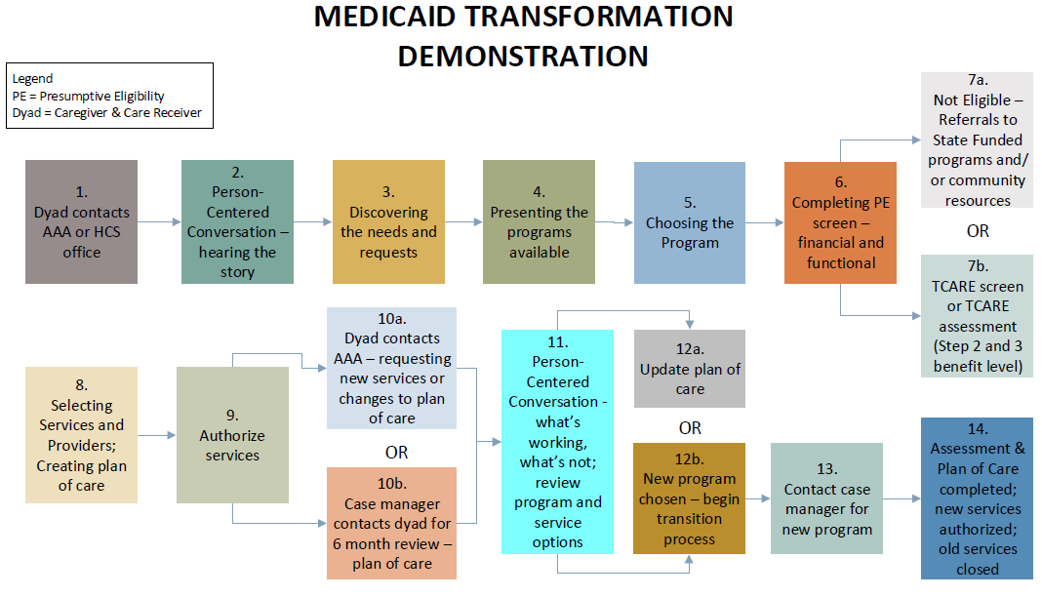

GetCare
GetCare is the client management information system used by AAAs to complete intakes, presumptive eligibility screenings, screenings, assessments, care plans, enrollments and authorizations, and notices. GetCare is the system of record for MAC and TSOA programs. The exception to this is social security numbers (SSNs) – P1 is the system of record for this data element as this system confirms the SSN with federal databases.
For MAC and TSOA, System of Record means information provided through GetCare takes precedence over information from any other system involved in the service delivery flow.

CARE
CARE is the case management information system used by HCS to complete intakes, presumptive eligibility screenings, and functional eligibility confirmations, obtain P1 Id numbers for care receivers and share information with P1.

Presenting Program Options
When people contact the AAA or HCS office for the first time or when people who are currently receiving services want to understand more about available programs, services and supports, it is important for AAA and HCS staff to facilitate a person centered discussion with them. The full range of available programs, services and supports should be presented, providing information that allows people to understand options that best suit their needs.
The focus of this discussion should be an “important to, important for” approach, which is similar to motivational interviewing and other related approaches to person centered discussions.
For more information about person centered conversations see the MTD Community WorkSpace on the ALTSA SharePoint site.

The following tools were developed to help with understanding the program options available:
Decision Tool for Program Options - version 1
Decision Tool for Program Options - version 2
AAA workers and HCS staff must document in a Progress Note (GetCare) or SER (CARE) that they have discussed all program options (FCSP, CFC, MAC, TSOA, COPES, New Freedom, nursing facility care, etc.) with the care receiver prior to enrolling into a program.

Warm Hand-Off Standards & Protocol
The Warm Hand-Off (WHO) Protocol is the plan for how and when information and/or documents will be shared between AAA staff and HCS staff to ensure seamless and confidential service provision for clients of both the Medicaid Alternate Care (MAC) and the Tailored Supports for Older Adults (TSOA) programs.
In each program there is essential information, such as intakes, presumptive eligibility, and P1 ID number, which must be sent back and forth electronically between GetCare and CARE. The Warm Hand-Off Protocol details how this sharing of documents and information is going to occur and within what timelines. The WHO also requires names and contact information of lead staff at local HCS and AAA offices to be known to each counterpart, providing a point person to ensure seamless service delivery for clients.
Contingency Plan: The protocol also provides instruction for how information will be confidentially exchanged if usual ways of handing off are not operational. For example, when computers are down for a day and documents still need to be warmly handed off between AAA and HCS partners, or there is a delay in determining final eligibility for a dyad. This section details how data will be exchanged so that seamless service delivery is provided to clients.
Evaluation: In this section of the protocol, each AAA and HCS partner provides a plan for how each area’s respective WHO Protocol will be evaluated. For example, it should include details about how the plan will be reviewed to determine if it is working or needs modifications or updates. Also included is information about what systems will be put in place to ensure seamless and timely handoffs and how often the lead contact staff between offices will touch base to review whether the process is working as designed.
WHO Protocol Due Dates:
MAC/TSOA Hand-Offs | Work flow | Maximum # of days
NFLOC Prescreen Information for confirmation of NFLOC eligibility | From AAA CM to HCS CM | 2 business days from intake contact
TSOA Financial Application | From client (with assistance from AAA) to HCS financial | 30 calendar days from authorization
Prescreen Information for service authorization | From HCS CM to AAA CM | 2 business days from intake contact
ProviderOne ID for new clients | From HCS CM to AAA CM | 2 business days from receipt of information from AAA
NFLOC Functional Eligibility confirmation | From HCS CM to AAA CM | 10 business days from referral date
TSOA only: Confirmation whether a TSOA application was received | From HCS Financial to AAA CM | 30 calendar days from authorization
TSOA only: Care Receiver Financial Eligibility Determination | From HCS Financial to AAA | 45 calendar days from receipt of financial application

Each AAA is required to develop and maintain a MAC/TSOA WHO Protocol as part of their contract with ALTSA for this demonstration project.
AAA & HCS Warm Hand-off Protocols

Program Description & Eligibility Criteria
Initiative 2 includes two new programs, Medicaid Alternative Care (MAC) and Tailored Supports for Older Adults (TSOA). MAC serves Medicaid eligible individuals, and their unpaid family caregivers, who have chosen not to access classic Medicaid LTSS programs such as Community First Choice (CFC), COPES, Roads to Community Living (RCL), Medicaid Personal Care (MPC), or New Freedom. TSOA serves individuals who are functionally eligible but not yet financially eligible for Medicaid or are receiving limited Medicaid coverage based upon a specific set of criteria (such as Medically Needy or Medicare Savings Program). Both MAC and TSOA programs are designed to offer the right amount of services, at the right time in order to divert or delay the need for more comprehensive Medicaid long term services and supports. Both programs are funded 100% by federal Medicaid dollars and offer the same services, with some exceptions. MAC and TSOA services can be received by clients living in a private residence such as their own home or a relative’s home. There is no client participation or estate recovery with either program. The primary goal of these two new programs are to:
- Preserve and promote choice in how individuals and families receive long term services and supports,
- Support families in caring for loved ones while increasing the well-being of caregivers, and
- Delay or avoid the need for more intensive Medicaid-funded long-term services and supports (LTSS) when possible.

MAC and TSOA programs mirror the state Family Caregiver Support Program (FCSP). This program is not funded with Medicaid dollars and has been successfully administered by the AAAs since the year 2000. In the MAC and TSOA programs, the unpaid family caregiver and the care receiver are collectively referred to as the dyad. Some service recipients in the TSOA program may not have an unpaid family caregiver. With both options, the care receiver, being the traditional Medicaid client, must first be determined eligible and if applying as half of a dyad, must provide consent for their unpaid family caregiver to receive services. The unpaid family caregiver, who must be at least 18 years old, is the individual who provides care to their care receiver and does not receive direct, public, or private payment such as a wage for the caregiving services they provide. An unpaid family caregiver may be a spouse, adult child, other family member, a friend, a neighbor, or a partner and does not need to be a Washington State resident.

Medicaid Alternative Care (MAC)
MAC serves dyads and they may access services through either the AAA or HCS front door. An example of a dyad who may want to access MAC services is one who:
- Does not want or need a more comprehensive Medicaid LTSS program,
- Doesn’t want to risk estate recovery, and/or
- Feels that paying participation would cause an unsustainable financial hardship.
To be eligible for the MAC program, and before services can be authorized, the care receiver must meet ALL of the following eligibility criteria:
AAAs: HCS Financial will confirm CN or ABP coverage groups. Attestation is enough for Presumptive Eligibility assessment.
- Be age 55 or older
- Live in their own home (not a residential facility)
- Currently on and accessing Categorically Needy (CN) or Alternative Benefit Plan (ABP) Medicaid coverage group (Apple Health)
- Meet nursing facility level of care (NFLOC) but has chosen not to receive Medicaid long term supports and services through the state’s other programs.

Tailored Supports for Older Adults (TSOA)
TSOA serves dyads and also individuals who do not have an unpaid family caregiver. Dyads and individuals without an unpaid family caregiver (referred to as a care receiver) may access services through either the AAA or the HCS front door. An example of an individual who may want to access TSOA services is one who lives alone and needs support to continue living alone.
To be eligible for the TSOA program, and before services can be authorized, whether for the dyad or an individual, the care receiver must meet ALL of the following eligibility criteria:
- Be age 55 or older
- Live in their own home (not a residential facility)
- Be a US citizen or have eligible immigrant status
- Not currently eligible for Categorically Needy (CN) or Alternative Benefit Plan (ABP) Medicaid coverage (Apple Health)
  - Note: TSOA applicants may be currently on a Medically Needy (MN) or Medicare Savings Program (MSP) ACES coverage group and still be financially eligible for TSOA. This coverage group only provides limited scope of Medicaid benefits from Health Care Authority.
- Meet nursing facility level of care (NFLOC)
- Meet financial requirements:
  - Income up to 300% of the Supplemental Security Income (SSI) Federal Benefit Rate (as of 7/2017, $2200/month)
  - Has countable resources below $53,100 for a single or $108,647 for a married couple.
For MAC and TSOA clients, the nursing facility level of care (NFLOC) assessment and the financial review must be completed annually. Each NFLOC assessment completed post-presumptive eligibility, should be completed by AAA MTD staff and will not require confirmation by HCS staff. HCS Financial staff will conduct the annual financial review.
A care receiver may have more than one caregiver. However, the care receiver only has one benefit amount (service dollars) so the funds must be shared between the identified caregivers.
A caregiver may be supporting more than one care receiver. For example, an adult daughter may be providing care to both her mother and her father. In this situation, if both parents are enrolled in MAC or TSOA then each parent would have a benefit amount that could be used to support their caregiver.

Presumptive Eligibility (PE)

What is PE?
PE is a process that allows us to gather preliminary information, based upon attestation, to decide that the care receiver appears to meet eligibility criteria. The two components we review for determining PE are financial and functional. The ability to authorize services under PE allows us to get services to dyads or individuals more quickly while the full eligibility determinations are being completed.
 | MAC | TSOA
Financial | - Care Receiver’s Medicaid Coverage Group =  - Categorically Needy (CN) or  - Alternative Benefit Plan (ABP)  WAC 182-513-1605 | - Care Receiver’s income less than the Special Income Level (SIL) ($2,205 for 2017); and  - Single Care Receiver’s resources less than $53,100; or  - Married Care Receiver’s joint resources less than $108,647  WAC 182-513-1615
Functional | Nursing Facility Level of Care  (NFLOC)  WAC 388-106-0355 | Nursing Facility Level of Care  (NFLOC)  WAC 388-106-0355

PE Time Period
Services are available under PE for a limited time. The PE time period begins on the date the PE determination is made and ends with the earlier date of:
- The day the decision was made by the HCS financial worker on the TSOA financial application;
- The date it was confirmed that care receiver did not meet functional eligibility criteria; OR
- The last day of the month following the month that the PE services were authorized (when no TSOA application was submitted).
Example 1: Susy Que was determined to meet TSOA PE criteria on August 19, 2017 and the NFLOC confirmation was made that day. She submitted her TSOA application on September 12th and continued to receive services under PE until October 5, 2017 when the HCS financial worker was able to determine full financial eligibility.
PE RAC start date = the date PE was completed and locked (8/19/17)
PE RAC end date = 10/4/17
Full Eligibility RAC start date = 10/5/17
Full Eligibility RAC end date = 10/31/18
TSOA program start date for 14-443 = the date PE was completed and locked (8/19/17)

Example 2: Susy Que was determined to meet TSOA PE criteria on August 19, 2017. Her NFLOC confirmation decision was completed on August 21, 2017 and indicated that she did not meet NFLOC criteria. Susy Que’s PE period ends August 21, 2017 and she is no longer eligible to receive services under PE. Had Susy received any paid services between August 19th and 21st, the AAA case manager would also need to create the NOPE RAC (start date 8/19/17 and end date 8/21/17) after closing the PE RAC. This will move the service expenditures out of the TSOA funding bucket into the NOPE funding bucket. The PE RAC start and end dates should match the NOPE RAC start and end dates.
PE RAC start date = the date PE was determined (8/19/17)
PE RAC end date = 8/21/17
TSOA program start date for 14-443 = the date PE was determined (8/19/17)
TSOA program end date for 14-443 = the date NFLOC confirmation results (8/21/17)
NOPE RAC start date = 8/19/17 (only use this RAC if client received TSOA services)
NOPE RAC end date = 8/21/17 (only use this RAC if client received TSOA services)

Example 3: Susy Que was determined to meet TSOA PE criteria on August 19th and the NFLOC confirmation was made that day. She did not submit her TSOA application before September 30, 2017, the last day of the month following the month her initial services under PE were authorized. Her PE period ends September 30th and she cannot receive TSOA services until she submits a TSOA application and a financial eligibility decision is made by the HCS financial worker. In this case, Susy may decide to receive FCSP services until her financial eligibility for TSOA is completed. However, FCSP services are limited and expenditure levels vary, therefore FCSP may have waitlists depending upon the budget at the local AAA.
PE RAC start date = the date PE was determined (8/19/17)
PE RAC end date = 9/30/17
TSOA program start date for 14-443 = the date PE was determined (8/19/17)
TSOA program end date for 14-443 = 9/30/17
Dyads and TSOA individuals may only receive services under PE once every twenty-four months. For instance, in example 2 above, Susy would not be eligible to apply for PE and receive MAC or TSOA services under PE for two years (October 2019). She would be able to request and receive MAC or TSOA services prior to October 2019 once her full eligibility (both financial and functional) had been confirmed.

Completing the PE Screening
The Presumptive Eligibility Screening tool has been built into both the CARE and GetCare systems to allow both HCS and AAA workers to complete the screening. This allows a MAC or TSOA applicant to enter either “door” to begin the intake process and access services in the most efficient manner.
CARE, the tool used by HCS, has a MTPD node that includes the PE screening functionality. Below are screen shots of the financial and functional sections in CARE.

Financial PE questions in CARE:
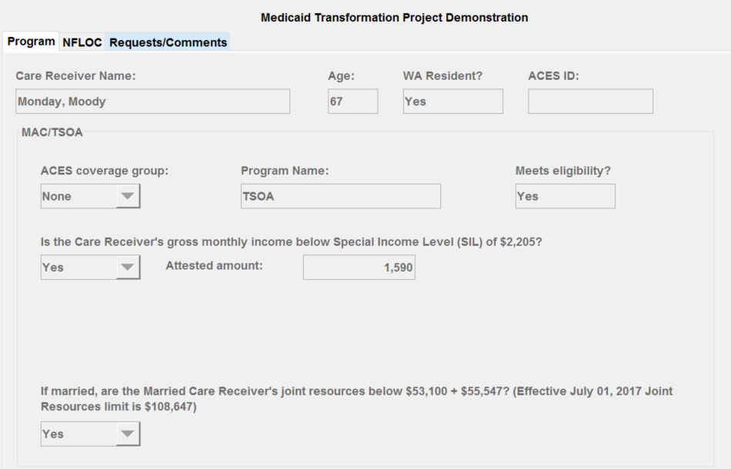

Functional eligibility questions in CARE:
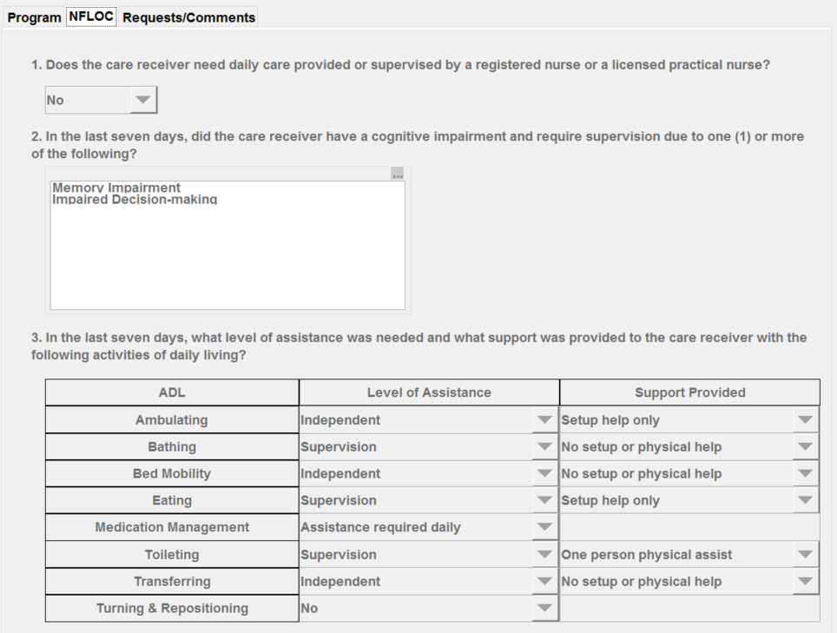
Training materials related to completing PE screening in CARE can be found here on the MTD Community WorkSpace.
GetCare, the tool used by AAAs, has a MTPD section that includes the PE Screening Assessment. The screen shots of the financial and functional sections in GetCare are as follows:

Financial eligibility questions in GetCare:
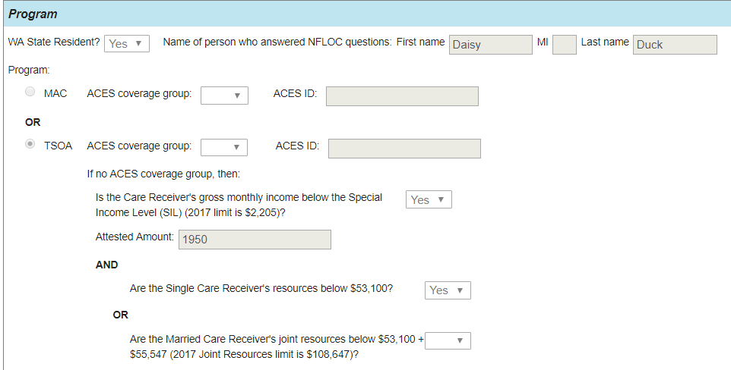

Functional eligibility questions in GetCare:
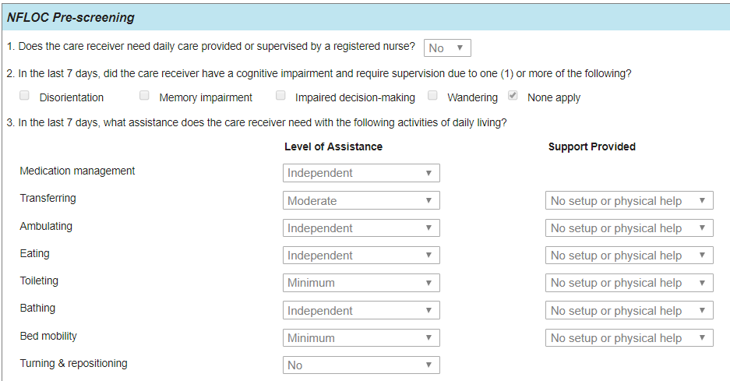
Training materials related to completing PE screening in GetCare can be found here on the MTD SharePoint site called MTD Community WorkSpace.
ACES coverage groups and the related financial (ACES) RACs can be found here on the MTD Community WorkSpace. Training materials to help you understand RACs can be found on the MTD Community WorkSpace by clicking on the MAC-TSOA tile on the home page.

The Functional RACs, also known as ALTSA RACs, indicate what program the dyad or individual is eligible to receive. They are as follows:
RAC Title | RAC | RAC Description
Medicaid Alternative Care (MAC) | 3170 | MAC Care receivers are Medicaid eligible
Medicaid Alternative Care : Presumptive Eligibility (Pre-MAC) | 3171 | MAC Care receivers have time limited presumptive eligibility both financially and functionally
Tailored Supports for Older Adults (TSOA) | 3175 | TSOA Care receivers meet TSOA financial eligibility which allows for a higher income and resources than Medicaid
Tailored Supports for Older Adults: Presumptive Eligibility (Pre-TSOA) | 3176 | TSOA Care receivers have time limited presumptive eligibility both financially and functionally.
Tailored Supports for Older Adults No Unpaid Caregiver (TSOA-No-CGR) | 3177 | TSOA Care receiver does not have an unpaid caregiver, meets TSOA financial eligibility which allows for a higher income and resources than Medicaid.
Tailored Supports for Older Adults No Unpaid Caregiver: Presumptive Eligibility (Pre-TSOA-NO-CGR) | 3178 | TSOA Care receivers without an unpaid caregiver have time limited presumptive eligibility both financially and functionally.
Not Presumptively Eligible for MAC and TSOA (NOPE) | 3190 | NOT Presumptively Eligible for MAC and TSOA (NOPE) is used when clients were initially enrolled as presumptively eligible for either MAC or TSOA and received paid services but were later found to be ineligible. Once found ineligible for MAC or TSOA this RAC must be used to reprocess claims to comply with federal reporting.
State Only Adjustment of Payment (SOAP) | 3490 | Used when a payment must be made using state-only funds. The claim must be reprocessed.

NFLOC Confirmation
HCS MTD workers must confirm all initial NFLOC eligibility decisions. AAA workers complete all annual NFLOC reassessments.
In order to maintain the intent of mirroring MAC and TSAO service delivery as closely as possible to Family Caregiver Support Program (FCSP), to ensure caregivers and care receivers are not required to respond to the same questions multiple times, and to streamline processes in order to delivery services as promptly as possible, confirmation of NFLOC will be completed using the following processes:
AAA Intake:
When completing the PE screening in GetCare, in order to facilitate WHO protocols, the AAA worker will:
- Describe in the comment box the type of daily care provided or supervised by a RN or LPN if the answer to NFLOC question #1 is yes. (Note: send via email until comment functionality has been completed in GetCare and CARE)
- Describe in the comment box the cognitive impairment that caused the need for supervision if the answer to NFLOC question #2 is something other than “None Apply”. (Note: send via email until comment functionality has been completed in GetCare and CARE)
- Add any additional information in the comment box that may be useful for the HCS worker confirming NFLOC eligibility. (Note: send via email until comment functionality has been completed in GetCare and CARE)
To complete the NFLOC confirmation, the HCS worker will review:
- any comments submitted with the PE screening completed by the AAA worker (Note: sent via email until comment functionality has been completed in GetCare and CARE)
- the level of assistance and support provided coding to ensure the coding looks accurate based upon the definitions of the coding
- contact the AAA worker who completed the PE screening when clarification is needed on the comments submitted or the coding selected by the AAA worker
HCS will avoid contacting the care receiver or NFLOC respondent to ask the NFLOC questions again if at all possible.
HCS Intake:
When completing the PE screening in CARE, the HCS worker will:
- Describe in the comment box the type of daily care provided or supervised by a RN or LPN if the answer to NFLOC question #1 is yes.
- Describe in the comment box the cognitive impairment that caused the need for supervision if the answer to NFLOC question #2 is something other than “None Apply”.
- Add any additional information in the comment box that may be useful for the AAA worker to know.
When the PE screening is sent to GetCare, NFLOC decision is considered confirmed and will be reflected as such in both CARE and GetCare.
When the PE screening is completed in CARE, the AAA worker will:
- Review the comments submitted by the HCS worker who confirmed NFLOC eligibility and seek clarification as needed.
- If care receiver does not meet NFLOC eligibility, proceed with the program denial process.
- If care receiver does meet NFLOC eligibility, proceed with the program approval, care planning and service authorization process.
Additional information:
The AAA and HCS worker may decide to complete the PE screening via a 3 way conference call or have additional ways to communicate information related to the PE screening. Please add this to your area’s Warm Hand-Off Protocol if using this approach.
Note: Comment boxes have not been transferring properly from GetCare to CARE and vice versa. This issue is on the list of enhancements to be completed in GetCare/CARE and the estimated time of completion is not yet determined, although should be forthcoming sooner rather than later. In the meantime, users can communicate this information via their Warm Hand-Off Protocol (WHO) to their HCS or AAA partner.

PE Notices
The following templates for the required PE notices are in GetCare and are accessible by clicking the “Write Client” button which is visible after opening the identification bar of the Client File section. The care receiver’s specific details can be added into the templates, printed and mailed to the care receiver and caregiver. GetCare will also send the completed notice to Barcode to be entered into the care receiver’s electronic Barcode record. All PE notices will be generated by AAAs in GetCare even for those that begin as HCS intakes.
TYPE | PURPOSE | # of TRANSLATED LANGUAGES
MAC PE Approval Notice | To provide notification to care receiver that PE has been approved | 8
TSOA PE Approval Notice | To provide notification to care receiver that PE has been approved | 8
MAC PE Denial Notice | To provide notification to care receiver that PE has been denied | 8
TSOA PE Denial Notice | To provide notification to care receiver that PE has been denied | 8

The top eight languages besides English are:

- Spanish
- Russian
- Chinese
- Korean
- Laotian
- Vietnamese
- Somali
- Cambodian

Benefit Categories/Services and Levels
For MAC and TSOA programs there are five benefit categories and within each category are a selection of available services.

Benefit Categories
The diagram below shows the benefit categories:
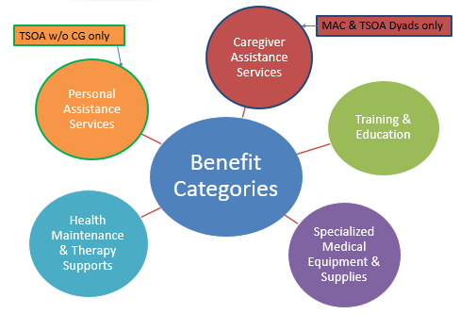
- Personal Assistance Services (the orange circle) are available only for individuals served in the TSOA program who do not have an unpaid family caregiver.
- Caregiver Assistance Services (the red circle) are available for only dyads.
- Services within Training & Education, Specialized Medical Equipment & Supplies, and Health Maintenance & Therapy Supports are available for both dyads and individual TSOA enrollees.
Network adequacy, mandatory for MAC and TSOA, requires that specific services be available in at least one location within each AAA planning and service area (PSA). In the Services Summary listed below, services in red font must be available at roll out, those listed in green are those that must continue to be developed post rollout, and services listed in black font are not required but may be available. Additional services may be added to this list into the future.
Below is a list of the services within each benefit category for MAC and TSOA. Bolded items represent the categories used in the Centers for Medicare and Medicaid Services (CMS) Special Terms and Conditions for MTD. Underlined subcategories and bulleted service details represent the language used in Family Caregiver Support, CLC-GetCare, and TCARE. Red font denotes services that must be available for MAC/TSOA individuals by September 11, 2017. Green font denotes services that must continue to be developed throughout the course of the demonstration. Purple * denotes services that may be received by CG and CR.

Caregiver Assistance Services
Respite
  - Adult Day Care
  - Adult Day Health (where available)
  - Memory Care and Wellness Services
  - Overnight Facility-Based Respite
  - Overnight In-home Respite
CG Assistance Services is not available to TSOA individuals without an unpaid caregiver – see Personal Assistance Services
  - In-Home

Supplemental Services
  - Transportation
  - Home Safety Evaluation
  - Housework and Errands
  - Yardwork – Volunteer Services referral
  - Home Delivered Meals*
  - Bath Aide
  - Home Modification and Repairs

Training & Education
Support Groups
  - Online Support Group*
  - Support Group*

Training/Consultation (Group Training; Health and Wellness Consultation; Consultation on Supported Decision Making; Financial or Legal Consultation)
  - Occupational Therapist Consultation*
Must have at least one service that provides:
1. Coping/skill building and
2. Training to meet the needs of the care receiver)
  - Physical Therapy Consultation*
  - Dementia Consultation/Training*
  - Long Term Care Planning*
  - Legal Services*
  - Caregiver Conference
  - Caregiver Consultation
  - Family Caregiver Training/Education
  - Powerful Tools for Caregivers
  - Dietician Consultation*
  - Chronic Disease Self-Management Program*
  - Fall Prevention Workshop*
  - Medication Management*
  - STAR-C
  - RDAD (Reducing Disease in Alzheimer’s Disease)

Specialized Medical Equipment & Supplies
Supplemental Services
  - PERS
  - Assistive/Adaptive Equipment
  - DME
  - Care Supplies

Health Maintenance & Therapy Supports
Counseling*

Supplemental Services (Adult Day Health where currently available and a health promotion wellness service. This health promotion wellness service may be offered under Training/Consultation for example, Powerful Tools for Caregivers or CDSME)
  - Massage*
  - Wellness Programs and Activities*
  - Wellness Newsletter (will be available through ALTSA by Fall 2017) *
  - Acupuncture*
  - RDAD (Reducing Disability in Alzheimer’s Disease)
    - Evidence-Based Exercise Programs*

Personal Assistance Services
Personal Care
All MAC and TSOA service claims will be paid through the Health Care Authority’s ProviderOne application, the Medicaid payment system.
Nurse Delegation
Adult Day Care
Transportation
Home Delivered Meals
Home Safety Evaluation
Home Modifications and Repairs

Some of the services available through the MAC and TSOA programs are defined in WAC:

Adult Day Care: WAC 388-106-0800 through WAC 388-106-0805
Adult Day Health: WAC 388-106-1810 through WAC 388-106-1815
Nurse Delegation: WAC 246-840-910 to 960
Personal Care Services: WAC 388-106-0010

Benefit Levels
Once a client has been determined presumptively or fully-confirmed eligible, services are provided at one of three different steps. The chart below lays out benefit levels and criteria for accessing services at each step. AAAs are responsible for tracking client expenditures to prevent over-expenditures at any step.
Program | Step 1  Based on demographics & program eligibility; may receive under PE | Step 2  Based on demographics, program eligibility, & results of a TCARE® or GetCare Screening; may receive under PE | Step 3  Based on demographics, program eligibility, & results of a TCARE® or GetCare Assessment; may receive under PE
MAC/TSOA Dyads | $250 one time only | $500 annually minus any expenditures at Step 1 | Avg. $550 monthly not to exceed $3,300 in a six month period
TSOA Individual w/o CG | $250 one time only | $500 annually minus any expenditures at Step 1 | $550/month

A caregiver may provide services to multiple care receivers (such as an adult daughter caring for both her mother and her father). Each care receiver has a benefit level that can be used to support their caregiver. However, the case worker needs to ensure that the funds for each care receiver is not duplicating services for their shared caregiver.
A care receiver may have more than one caregiver (such as a father that has two adult children sharing the caregiving tasks). However, the care receiver has only one benefit level that must be shared in order to provide the supports to their caregivers.

Screenings and Assessments
Screenings and assessments for MAC and TSOA are completed in the GetCare (aka CLC) system or the TCARE® application. Screenings must be reviewed at least every six months or more frequently if there is a change in the caregiver’s or care receiver’s condition. Assessments must be completed at least annually or more frequently if there is a change in the caregiver’s or care receiver’s condition.

GetCare
GetCare is the primary case management system for MAC and TSOA. This system contains many elements necessary for implementing the MAC and TSOA programs including but not limited to:
- Demographic information for caregivers and care receivers
- Screening tool and assessment for TSOA individual without a caregiver
- Presumptive Eligibility screening
The GetCare Screening (TSOA without a CG Screening) is a process that gathers information about the individual without a caregiver in order to determine risk scores. The information gathered includes functional needs, fall risk, availability of informal support, memory and decision making issues, and emotional well-being. The risk scores from the screening are used to determine if the individual will be referred for a GetCare assessment (TSOA without a CG Assessment).
The TSOA without a CG Assessment is a process that gathers information about an individual without a caregiver in the following areas: functional needs, diagnoses and conditions, behavioral health supports, oral health, and nutritional health needs. The assessment will assist the individual with choosing the step three services that will address their assessed needs.

TCARE®
The TCARE® process is based on the premise that providing the right service at the right time supports those unpaid family caregivers who are burdened by their caregiving responsibilities. TCARE® includes screening, assessment, consultation and service planning elements that are designed to be utilized with the Family Caregiver Support Program (FSCP), Medicaid Alternative Care (MAC), and Tailored Supports for Older Adults (TSOA) programs which are administered through the Area Agencies on Aging (AAA).
The TCARE® process:
- Validates the family caregivers’ feelings and experiences along their caregiving journey
- Stimulates caregivers to reflect on their caregiving responsibilities through relevant and insightful questions
- Provides structure to the interview between the assessor and the caregiver
- Identifies a broad range of support services available through public and private funding that address the specific stressors and burdens of the caregiver
There are several parts to the TCARE® process, two of which are the TCARE® Screening and the TCARE® Assessment. The TCARE® Screening can be conducted in a variety of settings: in person, by telephone, or through a self-screen form called the Personal Caregiver Survey. The scores from the screening determine whether the caregiver should be referred for the third part of the TCARE® protocol which is the TCARE® Assessment. The assessment includes all of the screening questions, as well as additional questions focused on both the caregiver’s experience and the care receiver’s situation. Some of the major areas covered in the assessment are: care receiver behaviors, memory issues, ADLs, IADLs, Cognitive Performance questions and diagnoses/conditions. When the need for an assessment is indicated by the screening, the assessment and care plan must be completed within 30 calendar days of the screening.
For complete details on the TCARE® process, see Ch. 17 (Family Caregiver Support Program) of the LTC manual.

Care Plans and Service Notices
The Centers for Medicare and Medicaid Services (CMS) require that a care plan must be completed prior to authorizing services for Medicaid funded services. Additionally, MAC and TSOA enrollees must receive a formal written notice of the services being authorized on their behalf.

Step 1, 2, and 3 care plans
Care plans are created in GetCare for MAC & TSOA dyads and TSOA individuals who are receiving Step 1 or Step 2 services. TSOA individuals receiving Step 3 services will also have a GetCare care plan. MAC & TSOA dyads receiving Step 3 services will have a care plan developed in TCARE®.
PROGRAM | STEP 1: | STEP 2: | STEP 3:
MAC or TSOA dyad | Care plan in GetCare | Care plan in GetCare | Care plan in TCARE®
TSOA w/o a caregiver | Care plan in GetCare | Care plan in GetCare | Care plan in GetCare

The care plan includes paid and unpaid services addressing the identified needs of the caregiver and the care receiver. The care receiver must provide consent of the plan before services can be received and it is best practice to obtain consent from the caregiver as well. Verbal consent can be provided initially (and documented in the care plan) with written consent provided within 60 days of completing the plan. Written consent may be provided by secure email or other electronic means for step 1 and step 2 services per WAC 388-106-1980(3).

Service Notices
The purpose of the service notice (DSHS 15-492) is to provide the care receiver with information about the specific type, amount and duration of each service being authorized as well as administrative hearing rights if they disagree with any of that information. Service notices are not required under presumptive eligibility but must be completed and sent to care receivers once they move out of PE into full eligibility. The service notice should be sent to the care receiver with the care plan.
Service notices must be sent to the care receiver at least 10 calendar days before the effective date of the action such as denial, reduction, or termination. The service notice needs to describe what action is being taken and under what authority that action is being taken (the specific WAC reference).

Providers
In order to claim and be paid for services provided under MAC and TSOA programs, all providers, with the exception of Durable Medical Equipment (DME) providers, must have a DSHS signed contract, be registered or contracted in ACD (Agency Contracts Database), and be enrolled in ProviderOne. DME providers must have a core provider agreement with Health Care Authority (HCA) and be enrolled as a DME provider in ProviderOne.
Providers must also be added into GetCare with the appropriate ProviderOne number, Location Code and Service Sets. GetCare System Administrators should use Issue Manager in GetCare to request that new providers be entered once they have a signed contract in the ACD and a ProviderOne number.

Contracts
The Area Agencies on Aging will maintain a provider network to support the services available to MAC and TSOA enrollees. The AAAs also maintain the provider network for Family Caregiver Support Program (FCSP), traditional Medicaid programs such as CFC, MPC and COPES, and other supportive programs for older adults. Most of these Medicaid and MAC/TSOA providers will have DSHS contracts executed and monitored by the AAAs. (Please see the Benefit Categories and Services section, above, for additional information about network adequacy.) When unpaid services are included in the care plan, no contract is required.

Contracts in support of MAC and TSOA programs may be available via one the following methods:
- Statewide contract through ALTSA or Core Provider Agreement with HCA
- AAA or DSHS existing contracts
- FCSP services contracts that have the necessary Medicaid language included and the contract has been registered in the Agency Contracts Database maintained by ALTSA.

The contracts that are executed and maintained by the contracts unit in ALTSA Headquarters are:
- Specialized Equipment and Supplies (SES)
- Nurse Delegation (ND)
- Assistive Technology (AT)
- AFH (respite)
- Assisted Living Facilities (respite)
- Nursing Facilities (respite)
For more information about contracting and network adequacy requirements see MB H17-043.
Refer providers who want more information about contracting to be a service provider to ALTSA's internet site.

ProviderOne
ProviderOne is Washington State’s MMIS (Medicaid Management Information System) and is the system used by all Medicaid providers to submit claims to be paid for services provided.
ProviderOne “talks” to many different systems such as ACES/Barcode, ACD, CARE, and GetCare. If any of these systems are down (experiencing technical difficulties) updates from those systems to ProviderOne may be delayed. Some changes made in GetCare and CARE will be processed overnight and updated to the client’s authorization in ProviderOne. For example, when the primary case manager, functional RAC, or RU change, the PCM and RU fields will be updated overnight for any authorization with current or future end dates.
Refer providers who want more information about ProviderOne to HCA’s website for social service providers

Authorizations
Authorizations for MAC and TSOA services will be completed by AAA staff through the GetCare system which interfaces with P1. Authorizations may be completed after a P1 identification number has been obtained for the MAC or TSOA care receiver.
Prior to authorizing MAC or TSOA services, AAA staff must check for service coverage under Medicaid Apple Health, long-term care insurance, or other third parties such as private insurance. If a third party covers provision of a service, it must be the payment source for claims for this service instead of MAC or TSOA.
Services may not be authorized for someone who is determined not presumptively or not confirmed eligible for the MAC or TSOA programs.

RACs
Recipient Aid Categories (RACs) identify to the ProviderOne system under which program (MAC, TSOA, or neither) the dyad or individual without an unpaid family caregiver is going to receive services either through presumptive eligibility or fully confirmed eligibility. Additionally, ProviderOne has been programmed to know which services can be provided under which RAC. Selecting the correct functional RAC is important so that data extracted from ProviderOne accurately reflects service provision and providers are correctly paid. The functional RAC must match the financial RAC that is sent from ACES to ProviderOne. Please see list of MAC and TSOA functional RACs in the following table:
RAC Title | RAC | RAC Description
Medicaid Alternative Care (MAC) | 3170 | MAC Care receivers are Medicaid eligible
Medicaid Alternative Care : Presumptive Eligibility (Pre-MAC) | 3171 | MAC Care receivers have time limited presumptive eligibility both financially and functionally
Tailored Supports for Older Adults (TSOA) | 3175 | TSOA Care receivers meet TSOA financial eligibility which allows for a higher income and resources than Medicaid
Tailored Supports for Older Adults: Presumptive Eligibility (Pre-TSOA) | 3176 | TSOA Care receivers have time limited presumptive eligibility both financially and functionally.
Tailored Supports for Older Adults No Unpaid Caregiver (TSOA-No-CGR) | 3177 | TSOA Care receiver does not have an unpaid caregiver, meets TSOA financial eligibility which allows for a higher income and resources than Medicaid.
Tailored Supports for Older Adults No Unpaid Caregiver: Presumptive Eligibility (Pre-TSOA-NO-CGR) | 3178 | TSOA Care receivers without an unpaid caregiver have time limited presumptive eligibility both financially and functionally.
Not Presumptively Eligible for MAC and TSOA (NOPE) | 3190 | NOT Presumptively Eligible for MAC and TSOA (NOPE) is used when clients were initially enrolled as presumptively eligible for either MAC or TSOA and received paid services but were later found to be ineligible. Once found ineligible for MAC or TSOA this RAC must be used to reprocess claims to comply with federal reporting.
State Only Adjustment of Payment (SOAP) | 3490 | Used when a payment must be made using state-only funds. The claim must be reprocessed.

AAA case managers must reopen MAC/TSOA Service Enrollments in GetCare and change RACs for clients when they change from presumptive eligibility to fully confirmed eligibility or from one of the six primary RACs to either the NOPE or SOAP RAC.

Typical RAC Timeframes
For MAC enrollees, Presumptive Eligibility RAC timeframes begin on the date of the locked Presumptive Eligibility Screening and typically end the last day of the following month.
TSOA enrollees may or may not have financial eligibility at the time of their Presumptive Eligibility screening. Presumptive Eligibility TSOA RACs will begin on the date of the locked functional PE screening and end of the last day of the month with one exception – if the care receiver submits a TSOA financial application within the PE period, the care receiver remains presumptively eligible until HCS financial worker determines full financial eligibility.
If the TSOA care receiver did not previously have financial eligibility, full TSOA eligibility will begin on the first of the month that HCS financial worker confirms the financial eligibility and end one year later. If the TSOA care receiver has financial eligibility through another source at the time of the PE screening, full TSOA eligibility will begin on the date functional eligibility is confirmed by HCS and end one year later. Financial eligibility will be determined on a different cycle and therefore may impact the eligibility of the client within the TSOA eligibility RAC timeframe.
MAC enrollees must have financial eligibility at the time of their Presumptive Eligibility screening. This means that functional eligibility confirmation is the last step in determining full eligibility for MAC clients. Full MAC eligibility will begin on the date functional eligibility is confirmed by HCS and end one year later. Financial eligibility will be determined on a different cycle and therefore may impact the eligibility of the client within the MAC eligibility RAC timeframe.

Common Errors
Common errors refers to the stoppages in processing a specific action that occurs when ProviderOne does not recognize submitted information. For MAC and TSOA, these stoppages will most commonly happen when an authorization header or a service line is submitted with information that conflicts with data that ProviderOne has already accepted. When such a stoppage occurs, ProviderOne will automatically generate an error message letting the user know there is a problem. Each message is assigned a code by ProviderOne based upon the type of error that occurred. Below is a table of the most common error messages that will be seen in GetCare.

MTD Related Error Codes in GetCare
GetCare users may see ProviderOne errors while working with authorizations for MAC & TSOA services. Here’s a list of what the errors mean and what should be done, by whom, to resolve it.
Error | Error Description | Action Needed | By Whom
Address Errors Invalid | The client or Care Receivers address is invalid | Review, correct, and complete steps to update ProviderOne | Case Manager
AREP (authorized representative) Warnings | The Collateral Contact or Caregiver with the contract role of “P1 Client Letters” has an invalid address | Review, correct, and complete steps to update ProviderOne | Case Manager
02255 | Client not eligible for date of service | No action needed; Will resolve when full RAC and dates are added | Case Manager
30988 | Financial Eligibility Requirement | Determine if error should be “forced” and if so, refer to HQ for action* | Case Manager and HQ
40061 | Unexpected error occurred, please contact system administrator (fatal error) | Review service lines to see if unresolved errors exist. If unable to determine source of the error, post error into Issue Manager entitled as “MTD authorization error” for review by AAA supervisor and escalation by local System Admin* | Case Manager and System Admins / CARE Help Desk
40065 | Proc/Svc Code service duration exceeds the maximum allowed duration limit (fatal error) | Review service limits and modify, if necessary | Case Manager
*The local system administrators will review the error with respective AAA staff and, if they determine there is a valid issue, they will post to issue manager in GetCare. Escalated errors will be pulled by State System Administrator for review by the State MTD/P1 team. Issues will be updated as to resolution or the next steps HQ (or the AAA User) needs to take for resolution.
More information related to ProviderOne common errors is available on the DSHS/ProviderOne website.

Tracking Benefit Expenditures
AAAs are responsible for tracking client expenditures to prevent over-expenditures at any step based upon the steps identified in the table below:

Program | Step 1  Based on demographics & program eligibility; may receive under PE | Step 2  Based on demographics, program eligibility, & results of a TCARE® or GetCare Screening; may receive under PE | Step 3  Based on demographics, program eligibility, & results of a TCARE® or GetCare Assessment; may receive under PE
MAC/TSOA Dyads | $250 one time only | $500 annually minus any expenditures at Step 1 | Avg. $550 monthly not to exceed $3300 in a six month period
TSOA Individual w/o CG | $250 one time only | $500 annually minus any expenditures at Step 1 | $550/month

Decrementation (coming soon)

Exceptions to Rule/Policy
Before authorizing any exceptions to rule (ETR) or exceptions to policy (ETP), you must receive local or headquarters (HQ) approval, depending on the type of request.
NOTE: ETRs may not be used to exceed the Step 1 benefit level of $250.
ETRs that require local approval include:
- Exceeding Step 2 benefit level of $500/annually up to $1,000
- A caregiver or TSOA individual who is in crisis and needs to be served with step 2 or 3 services without first completing a screening or assessment. A care plan must be completed prior to receiving services. The screening and/or assessment must be completed within 30 days if ongoing services are needed.
ETRs that require HCS HQ approval are:
- Exceeding Step 2 benefit level greater than $1,000
- Exceeding Step 3 benefit level greater than $550/month (for TSOA individual)
- Exceeding Step 3 benefit level greater than $3,300 in a six month period (MAC and TSOA dyads)
- DME/Bathroom equipment for care receivers who have Medicaid Apple Health or Medicare benefits that may also cover the requested piece of bathroom equipment. See MB H15-035, MB H16-019, and MB H16-052 for more details, tools and instructions.

ETR Process
Until the functionality to complete ETRs is fully developed in the GetCare system, we will utilize email and the Progress Note section of GetCare to document this work.
In the rare instance when a dyad requests respite benefits and the TCARE® assessment does not result in this recommendation, an exception to rule (ETR) may be requested and resolved at the AAA level by the person assigned this authority.
Both local and HCS HQ ETR requests must include the following details:
- Name and P1 ID # of care receiver
- Program and step (i.e., MAC, step 3)
- Request description
  - What item/service is being requested
  - Justification for request
  - Alternatives explored before considering ETR request
  - Cost of the request (e.g., hours, dollars, quantity, etc.)
- Start and end date of request
- Related WAC #
For local ETR requests:
- Send an email to your supervisor or designated ETR reviewer using your local process. The email must include the details noted above.
- The supervisor or designee will review the request and email the decision (approval or denial) back to the worker who submitted the request.
- The worker will print the email containing the ETR request decision, scan it as a PDF, and save it as an attachment in the Progress Notes section of GetCare [Detailed instructions will be available in Community WorkSpace, GetCare section by 9/15/17 and will be added to this chapter after final field review.]
- Mail ETR Notice DSHS form #05-255 to care receiver informing them of the decision.
For HCS HQ ETR Requests:
- Send an email to your supervisor or designated ETR reviewer using your local process. The email must include the details noted above.
- The supervisor or designee will review the request and, if they agree with the request, will submit via secure email to the MAC/TSOA program manager.
- The MAC/TSOA program manager will review the request and email the decision (approval or denial) back to the worker who submitted the request with a cc to the supervisor/designee.
- The worker will print the email containing the ETR request decision, scan it as a PDF, and save it as an attachment in the Progress Notes section of GetCare [Detailed instructions will be available in Community WorkSpace, GetCare section by 9/15/17]
- Mail ETR Notice DSHS form #05-255 to care receiver informing them of the decision.

Complaint Procedure for denial of initial ETRs
Initial ETRs do not have administrative hearing rights. However, care receivers do have the right to make a complaint to the Department.

For complaints related to initial ETR decisions made by AAA at the field level, follow your AAA Grievance Policy.
Complaints related to initial ETR decisions made by HCS Headquarters will be reviewed as follows:
      - The client may make a complaint in writing to the HCS or State Unit on Aging (SUA) Office Chief. The Office Chief will make a decision about the written complaint within ten days of the date it was received and send a letter informing the client of the decision and that the decision may be reviewed by the HCS Director at the client’s request.
      - If the client makes a written request asking the HCS Director to review the Office Chief’s decision, the Director will make a decision about the complaint within ten days of the date it was received and send a letter informing the client of the final decision.
When responding to a complaint it is important to address, at a minimum, the specific concern perceived by the client and explain how all of the pieces of information were reviewed (e.g. screening, assessment, any additional information provided in the complaint, or information from other relevant sources) in order to make a decision. The CM may want to discuss the care plan with the client in order to identify service gaps that may be addressed using other available resources.

ETP Section currently under construction – stay tuned
- ETPs that require local approval are:

- ETPs that require ALTSA HQ approval are:

ETP Process: coming soon!

DSHS Forms and Notices
The forms and notices below will be used for dyads and individuals enrolled in the Medicaid Alternative Care (MAC) and Tailored Supports for Older Adults (TSOA) programs.
All of these forms will be utilized by the AAA MTD workers.
These forms can be accessed on the DSHS Internet forms site. Forms must be sent to care receivers in their primary language.
A post implementation enhancement will add these forms as templates in the GetCare system where care receiver demographic information will be auto-populated. AAA case workers will be able to complete the rest of the details in the form and save it in the care receiver’s electronic File Cabinet in GetCare. The case worker will then print the form/notice and provide it to the care receiver and obtain their signature (note that not all of the forms/notices require a signature).
TYPE | DSHS form # | PROGRAM | PURPOSE | # of TRANSLATED LANGUAGES
Acknowledgement of Services♦ | 14-225 | MAC | To document care receiver’s choice to receive MAC services in the community rather than a nursing facility | 8*
Exception to Rule (ETR) Notice♠ | 05-255 | MAC & TSOA | To provide notification to the care receiver of an ETR approval/denial or notice that request for ETR was not initiated | 8
Release of Information/Consent♦ | 14-012 | MAC & TSOA | To obtain consent from care receiver and caregiver to gather & share information for care planning purposes | 8*
Rights & Responsibilities♦ | 16-172 | MAC & TSOA | To inform care receiver of their rights and responsibilities when receiving services from ALTSA/AAA | 8*
Service Notice♠ | 15-492 | MAC & TSOA | To inform care receiver of:  - actions (approval, denial, reduction, and termination) taken regarding their services; and  - Administrative Hearing rights | 8
The top 8 DSHS languages besides English are:

- Spanish
- Russian
- Chinese
- Korean
- Laotian
- Vietnamese
- Somali
- Cambodian

*These forms have been translated into many more languages. Only the top 8 languages will be loaded into GetCare. Additional translated languages are available on the DSHS forms site and will be added into GetCare when requested.
♠These forms are formal notices and must be sent to DMS to be scanned into the care receiver’s electronic record in Barcode.
♦These three forms must be signed by the care receiver and then be sent to DMS to be scanned into the care receiver’s electronic record in Barcode. The caregiver must sign a 14-012 and the signed copy needs to be scanned and entered in the caregiver’s electronic file cabinet in GetCare.

Administrative Hearings (aka Fair Hearings)
Care receivers have the right to an administrative hearing when the department (HCS/AAA):
- Sends a notice that approves, denies, reduces, or terminates a service or eligibility (at least 10 calendar days before the effective date of the action);
- Determines a client received more benefit than they were eligible for and an overpayment was issued;
- Reduces or terminates an ongoing service such as respite or in-home personal care that was initially approved through an ETR: and
- Denies or terminates financial eligibility (Note: these hearings are facilitated by HCS financial staff).

Requesting an Administrative Hearing
Hearing requests must be made within a specific timeframe. The care receiver has to request a hearing (aka as an appeal) to Office of Administrative Hearings (OAH) within 90 days of the date he or she received the service notice.
A client (care receiver) or their representative may request a hearing in any of the following ways:
- Verbal request. Department staff or their designee must notify OAH of any verbal request from the client, preferably in writing.
- Written request (of any kind). Department staff or their designee must notify OAH of any written request that doesn’t go directly to OAH.
- The Request for Hearing form that accompanies every Service Notice (15-492). This form can be completed by the care receiver and mailed or faxed to OAH. The care receiver may also ask department staff or their designee to help them complete and submit the hearing request to OAH.
Administrative hearings related to financial eligibility decisions (full eligibility not PE) are handled by the financial staff.
Hearings related to decisions for services and functional eligibility (full eligibility not PE) are handled by AAA staff. Each AAA will designate who completes this work.
For more details about administrative hearings (AH), the AH process, and roles of the case manager and AH coordinator see Ch. 26 of the LTC Manual.

Wait List
The state has client numbers and expenditure limits for each year of the Demonstration. It is possible that a wait list will be required if it appears that the limit will be reached. The waiver years for the Demonstration are as follows:
Waiver Year | Time Period
One | January 9, 2017 – December 31, 2017
Two | January 1, 2018 – December 31, 2018
Three | January 1, 2019 – December 31, 2019
Four | January 1, 2020 – December 31, 2020
Five | January 1, 2021 – December 31, 2021

In the event that a wait list is implemented, we will stop conducting presumptive eligibility (PE) determinations. Dyads or individuals receiving services under presumptive eligibility established prior to implementation of the wait list will be able to continue receiving services until their PE period ends or their final eligibility determination is completed whichever comes first.
If additional funds become available, dyads or individuals may be removed from the wait list on a first come first served basis.
During the time a wait list is in place, dyads or individuals should be referred to other options such as FCSP, local community resources, or other Medicaid long term care services (CFC, MPC, New Freedom, Residential Support Waiver, COPES, etc.).

Conflict Free Case Management

Background
Federal requirements for the Community First Choice Program, the COPES, New Freedom, and Residential Supports waivers, and the Medicaid Transformation Project Demonstration require Aging and Long Term Support Administration (ALTSA) to ensure that conflict of interest safeguards are in place for all Medicaid participants. These safeguards outline provider qualifications, require a strategy for solving conflict and outline clear conflict-of-interest guidelines per Washington State MTD, Special Terms and Condition (STC) #52. Conflict of Interest, § 42 CFR 441.301(c)(1)(v)(vi), § 42 CFR 441.730, and § 441.555 (c).
In some areas of the state it is challenging for ALTSA and Area Agencies on Aging (AAA) to recruit and enroll providers of evidence based services or other services with a low demand such as support groups. This can be especially true when looking for culturally or linguistically appropriate providers or when serving a minute population spread across a vast frontier area or tribal reservation. Yet often these are the exact services that a participant needs and desires at the time they are assessed.
ALTSA and the AAAs are committed to providing needed services at the time and location that is right for the participant. Both entities acknowledge there may be occasions when safeguards are needed to protect participants from conflict of interest. This policy details the safeguards that must be in place when an AAA provides assessment and/or service planning and is the only qualified and willing entity available to be authorized to provide a home and community based service.

Area Agency on Aging Requirements
AAA’s must attest (see attached sample attestation form below) that they will adhere to the following conflict of interest policies:
- The AAA will ensure that participants:
  - As part of the assessment and authorization process, receive information about the full range of services available to the participant and not just the service furnished by the AAA; and
  - Are supported in exercising their right to free choice of providers; and
  - Are informed of their opportunity to identify other qualified and willing providers available in the participant’s geographic area to provide the service.
- The AAA’s grievance resolution process must refer the participant to DSHS if they wish to dispute the assertion that there is not another qualified and willing entity available in the participant’s geographic area to provide the service.
- Where the AAA attests it is the only willing and qualified provider, the AAA must request ALTSA approval prior to authorizing service provision by an AAA employee. The approval shall be in effect as long as these policies are followed and until an alternative provider is identified. ALTSA will verify AAA is the only willing and qualified provider by:
  - Reviewing the AAA provider recruitment efforts and results annually; and
- Confirming there is no available contracted provider in the State’s contract database, ACD.

- That the development of the service plan is administratively separated, from the provision of authorized services. With the functions ideally accomplished by separate units.

- Where service provision and/or assessment and service planning functions are provided by the same AAA employee because the only available qualified provider of the service is also the case manager who assists the client with service planning, supervision must be provided separately from the assessment and/or service planning functions. For this purpose, supervision means verifying that the requirements of this Conflict of Interest policy are being met as services are being delivered and that authorization levels are consistent with what is typical for the service.

- The case manager will remain unbiased and impartial during the development of the person-centered service plan.

- That the AAA will include the service in its process for continuous recruitment and open enrollment of qualified providers required by Chapter six of the AAA policy and procedures manual.

- That case manager training includes these policies prior to providing services along with training on confidentiality, ethics and grievance procedures.

Aging and Long Term Support Administration Requirements
ALTSA will provide oversight and monitoring of the conflict of interest safeguards for Medicaid participants when service provision and service planning are provided by the same AAA employee. The results of the activities will be reported to the State Medicaid Agency at the quarterly waiver management committee meeting. Monitoring and oversight activities will include an annual review of:

- AAA compliance with these policies and adherence to the AAA attestation.

- AAA efforts to enroll service providers.

- A comparison of service utilization patterns where the AAA is the direct provider with utilization that is typical for comparable services provided by contracted providers.

- A comparison of rates paid to the AAA with rates paid to contracted vendors for comparable services.

