Chapter 30c Initiative 3: Foundational Community Supports–
Supported Employment
Chapter 30c describes the Supported Employment program offered through Initiative 3, Foundational Community Supports (FCS) of the Medicaid Transformation and the related rules, policy and procedures.

Ask the Expert
If you have questions or need clarification about the content in this chapter, please contact:

Supported Employment Team mailbox:
SupportedEmployment@dshs.wa.gov

Michael Corcoran Employment Program Manager
Michael.Corcoran@dshs.wa.gov

Jim Bischoff HCS Region 1 Employment Specialist
360-870-4511 James.Bischoff@dshs.wa.gov

Ruby Pham HCS Region 2 Employment Specialist
564-200-2264 Ruby.Pham@dshs.wa.gov

Laura DeVol HCS Region 3 Employment Specialist
360-870-4918 Laura.DeVol1@dshs.wa.gov

Table of Contents
Initiative 3: Foundational Community Supports- Supported Employment 1
Background 2
Resources 2
Administration of Foundational Community Supports 3
Program Description 3
Eligibility, Intake, Referral and Service Delivery Flow 5
Revision History 10

Background
The Medicaid Transformation is an agreement between the state and the Centers for Medicare and Medicaid Services (CMS) that contains multiple initiatives. The intent of Initiative 3, Foundational Community Supports (FCS) – Supported Employment (SE), is to support individuals in obtaining and retaining employment in support of their broader health goals. Evidence strongly suggests that individuals with disabilities who are employed experience increased health status which includes:
- Psychological benefits which lead to decreases in mental health symptoms, smoking and other health factors
- Increased success in recovery and rehabilitation processes including mental health, substance use disorders and even smoking cessation
- Reduced health care costs
Supported Employment services are designed to be person-centered and individualized one-to-one supports to individuals interested in employment in the community. FCS creates a system of services which will provide pre-employment and post-employment services to an individual at any point in their pathway to employment. The services are not time-limited, but are intended to support the individual for as long as there is an identified need.

resOURCES
For additional resources about the Foundational Community Supports (FCS) and Supported Employment program, please visit the following websites:

FCS WACs

MTD Community WorkSpace

Health Care Authority MTD site

HCS MTD intranet site for staff

Amerigroup TPA Provider Website with Resources

Amerigroup TPA Website for Clients

Forms
FCS Referral form for direct referral to TPA

Supported Employment Assessment form

FCS Quick Reference Guide

TPA marketing flyer for clients

Administration of Foundational Community Supports

The FCS services are part of the Medicaid Transformation (MT). For more information on MT see Chapter 30a of the LTC Manual. The larger Demonstration, and FCS in particular, involves multiple state agencies of which ALTSA is one. Due to the multiple agencies involved, the state has set up a single, statewide Third Party Administrator (TPA) for the FCS services, which includes Supported Employment services.

The TPA is a contracted, non-state entity that provides administrative oversight of the benefit programs and services. The TPA is responsible for:
- Provider network development and maintenance
- Client eligibility determination
- Service Authorizations for services to providers
- Distribution of reimbursement payments
- Encounter data tracking
Amerigroup has been contracted with the state through the Health Care Authority and will be functioning as the TPA for the duration of MT.

Program Description
Supported Employment services assist those individuals who want to work and meet FCS criteria to become employed in integrated community employment. Activities are intended to ensure successful employment outcomes through the utilization of collateral contacts, skills training, cueing, modeling and supervision as identified by the person-centered employment plan.

Individualized Supported Employment services include: identifying career and occupational targets, developing ongoing relationships with prospective employers, assisting with the interviewing and hiring process, and, once employed, support with maintaining employment. Coaching and skill-building of interpersonal relationships in the work setting as well as education for self-advocacy and support with the American with Disabilities Act are also included.

The focus is on obtaining competitive employment that reflects the interests and desires of the individual through:
- Pre-employment services — activities that assist an individual with obtaining employment.
- Employment-sustaining services — activities that support the individual in retaining and maintaining employment.
Pre-employment services support an individual’s ability to prepare for and transition to competitive employment, including direct face-to-face contact with the client as well as collateral service.
- Pre-employment services include the following:
  - Prevocational/job-related discovery or assessment
  - Person-centered employment planning
  - Individualized job development and placement
  - Job carving — defined as working with the client and employer to modify an existing job description so it contains one or more, but not all, of the tasks from the original job description when a potential applicant for a job is unable to perform all the duties identified in the job description
  - Benefits education and planning — defined as counseling to assist the client in fully understanding the range of state and federal benefits he or she might be eligible for, the implications that work and earnings would have for continued receipt of these benefits, and the client’s options for returning to work
  - Transportation (only in conjunction with the delivery of an authorized service)

- Employment-sustaining services include the following:
  - Career advancement services — defined as services that expand opportunities for professional growth, assist with enrollment in higher education or credentialing and certificate programs to expand job skills or enhance career development, and assist the individual in monitoring his/her satisfaction with employment and determining the level of interest and opportunities for advancement with the current employer, and/or changing employers for career advancement
  - Negotiation with employers — defined as services where a provider identifies and addresses job accommodations or assistive technology needs with the employer on behalf of the individual
    - Job accommodations can include the following:
      - Adjusting work schedule to reduce exposure to triggering events (i.e., heavy traffic triggering symptoms of agoraphobia)
      - Providing a private area for individuals to take breaks if they experience an increase in symptoms
      - Access to a telephone to contact a support person if needed while at work
      - Adjusting job schedule to accommodate scheduled appointments
      - Small, frequent breaks as opposed to one long one
    - Assistive technology can include the following:
      - Bedside alarms
      - Electronic medication reminders while at work or at home
      - Use of headset/iPod to block out internal or external distractions
  - Job analysis — defined as gathering, evaluating and recording accurate, objective data about the characteristics of a particular job to ensure the specific matching of skills and amelioration of maladaptive behaviors.
  - Job coaching
  - Benefits education and planning — defined as counseling to assist the client in fully understanding the range of state and federal benefits he or she might be eligible for, the implications that work and earnings would have for continued receipt of these benefits, and the client’s options for returning to work
  - Transportation (only in conjunction with the delivery of an authorized service)
  - Asset development — defined as services supporting clients’ accrual of assets that have the potential to help clients improve their economic status, expand opportunities for community participation and positively impact their quality of life experience
    - Assets are defined as something with value owned by an individual, such as money in the bank, property and retirement accounts
  - Follow along supports — defined as the ongoing supports necessary to assist an eligible client to sustain competitive work in an integrated setting of his or her choice.
    - This service is provided for, or on behalf of, a client and can include communicating with the client’s supervisor or manager, whether in the presence of the client or not (if authorized and appropriate). There is regular contact and follow-up with the client and employer to reinforce and stabilize job placement. Follow-along support and/or accommodations are negotiated with an employer prior to the client starting work or as circumstances arise.

Service providers will be engaged in individualized job development services that support individuals in searching for and securing a job in the community such as:
- Identifying and negotiating jobs.
- Building relationships with employers.
- Customized employment development, job analysis and job carving.
- Linking with community resources to support job search.

Eligibility, Intake, Referral and Service Delivery Flow
Eligibility determination is completed by the TPA, Amerigroup, based on criteria established by the state in agreement with the Centers for Medicare & Medicaid Services (CMS), the federal funding agency for MT. There are multiple sets of criteria for eligible clients, including an ALTSA specific set.

To be determined eligible for FCS Supported Employment services by the TPA, a client must meet the following criteria:
- Be aged 16 or older;
- Eligible for Apple Health (Medicaid);
- Desire to obtain employment;
- Meet the needs-based health and risk factors indicated below:

  - Health Factor: An ALTSA client meets the necessary health needs criteria by being financially and functionally eligible with a current CARE assessment identifying the need for assistance with 3 Activities of Daily Living (ADLs) and/or hands-on assistance with at least one ADL, which may include body care

And:

  - Risk Factor: Meets the necessary risk factor criteria by having an inability to obtain or maintain employment resulting from age, physical disability, or traumatic brain injury (TBI).

A more detailed description of needs based criteria for FCS may be found in the FCS Quick Reference Guide. Intake and service delivery flow consists of identifying an individual interested in employment, assessing them for eligibility, referring them to the TPA for eligibility determination and assignment to a local employment provider to begin services. The intake and referral process for an individual can take a number of paths including self-directed referral or assistance from HCS/AAA field staff and/or the HCS Employment team (see image below).

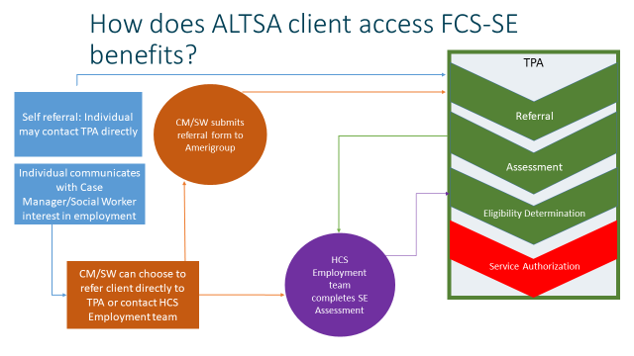
Action Key:
Blue: Client
Orange: Social Worker/Case Manager
Purple: HCS Employment Team
Green: Amerigroup
The most effective and quickest referral process for the client is to communicate the client’s interest to the HCS Employment team. This process assures that the client will have a complete eligibility determination packet assembled and submitted to the TPA and facilitate a more rapid eligibility determination and assignment to a provider. The ways to communicate a referral to the HCS Employment team:
- Contact the HCS Employment team through the SupportedEmployment@dshs.wa.gov email or 1-844-427-8256
- Contact one of the HCS Employment team directly through the contact information in the “Ask an Expert” section of this Chapter.

There is a way to indicate a client’s interest in Supported Employment in CARE which is located on the Profile Screen. The following image will demonstrate where and how to indicate interest in the Supported Employment program. If a client is interested in working or requests a referral to Employment services, select the “Yes” option to the Supported Employment question. When this is selected, instructions to contact the ALTSA Employment team at SupportedEmployment@dshs.wa.gov will be provided. When emailing the Supported Employment email, please include the client’s name and a piece of identifying information, such as, ProviderOne number, ACES ID, or date of birth.

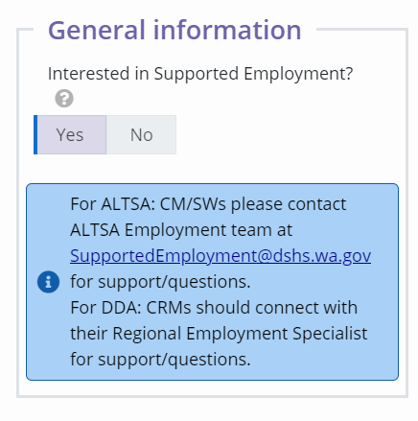

Clients may also be referred directly to TPA. Clients, their family or any support person, including HCS/AAA field staff, may contact the TPA directly through either phone or email to inquire about services and begin the assessment and eligibility determination process. Points of contact to begin the process are: phone – 1-800-451-2828; email – fcstpa@amerigroup.com .

More information for clients about the FCS services and how to apply can be found on Amerigroup’s FCS website.

If a client is referred directly to TPA, the TPA will evaluate the individual for the eligibility criteria indicated above. For the needs based health and risk factor criteria, the TPA will refer the client to an employment provider directly for supporting documentation and resubmission for a final eligibility determination.

Once a client is determined eligible for FCS services by the TPA, the TPA will assign the client to a local employment service provider and set up a Service Authorization in Provider One directly. Billing for services by providers will be through the TPA. The TPA will process billing and reimburse providers directly, then enter encounter data and billing information into Provider One directly.
HCS/AAA field staff and/or HCS Employment team will document each stage of the process from initial communication regarding FCS Supported Employment services with the client through the establishment of a Service Authorization with a provider in Provider One for FCS supported Employment services through Service Episode Records (SERs).

Revision History
Date | Made By | Change(s) | MB #
6/6/2023 | Michael Corcoran | Initial publishing.

