Chapter 7h – Appendices
Chapter 7h describes the various appendices that pertain to Home and Community Based Service (HCBS) programs, services, and case management activities.

Ask the Expert
If you have questions or need clarification about the content in these Appendices, please contact the expert(s) listed in each Appendix section.

Table of Contents
Chapter 7h – Appendices 1
Table of Contents 1
Appendix I: Coordination with Developmental Disabilities Administration (DDA) 3
Process for a DDA client requesting services from HCS/AAA 5
Process for non-DDA enrolled children turning 18 and transferring to HCS/AAA 5
Appendix II: Estate Recovery 7
Services Exempt from Recovery 8
Assets Not Subject to Recovery 8
Recovery Process 8
Resident Personal Funds Held By a Facility 9
Prepaid Burial Plan or Contract 9
Discovery of Decedent's Estate 9
Interest Assessed on Past Due Debt 9
Appendix III: Resources 10
ALTSA and DDA Service Comparison Chart 10
ACES and RAC codes cheat sheet for all core programs (i.e., CFC, MPC, HCBS waivers, etc.) 10
Social Service Authorization Manual (SSAM) 10
Medicaid Programs – LTSS Chart (ACES coverage group cheat sheet) 10
Appendix IV: Non-Grant Medical Assistance (NGMA) 10
Instructions for Completing NGMA Referral in Barcode 11
Requesting Retro Medical from a Previous Application 13
Attaching Documents 14
Appendix V: Ongoing Additional Requirements (OAR) 17
Eligibility and Authorization Process 17
WAC 388-473-0010 – What are ongoing additional requirements and how do I qualify? 20
Benefit Review Cycle 20
WAC 388-473-0020 – When do we authorize meals as an ongoing additional requirement? 20
WAC 388-473-0040 – Assistance for service animals as an ongoing additional requirement. 21
WAC 388-473-0050 – Telephone and internet services as an ongoing additional requirement. 21
WAC 388-473-0060 – Laundry as an ongoing additional requirement. 22
WAC 388-473-0070 – Transportation as an ongoing addition requirement. 22
WAC 388-478-0050 – Payment standards for ongoing additional requirements and WAC 388-473-0080 – Medically related items or services as an ongoing additional requirement. 22
Appendix VI: Requesting Funding from the Managed Care Organization (MCO) for Behavioral Health Personal Care (BHPC) 25
Resources for Chapter 7h 25
Related WACs and RCWs 25
Forms 26
Resources 26
Acronyms 26
REVISION HISTORY 27

Appendix I: Coordination with Developmental Disabilities Administration (DDA)

Ask the Expert
If you have questions or need clarification about the content of Appendix I, please contact:

Melissa Randles | State Plan Services Unit Manager | DDA
 | 360-407-1515 office | Melissa.Randles@dshs.wa.gov
The Developmental Disabilities Administration (DDA) strives to transform lives by providing support and fostering partnerships that empower people to live the lives they want. Individuals with developmental disabilities may be served by DDA, Home & Community Services (HCS), the Area Agency on Aging (AAA) or a combination of these entities.

DDA implements Community First Choice (CFC), Roads to Community Living (RCL) and Medicaid Personal Care (MPC) programs just like HCS and the AAAs. All administrations operate these programs using the same program rules (WAC). What is important to remember is that no individual can be on the same program with two different administrations/agencies.

The CFC and MPC programs are managed by DDA for:
- individuals of all ages who have a developmental disability, and
- children who do not have developmental disabilities but who meet the functional eligibility criteria. This includes youth who are in foster care placements with Children’s Administration up to their 21st birthday.

Determination of developmental disability under Chapter 388-823 WAC does not guarantee eligibility for, or access to, paid services. Clients must still meet the eligibility requirements for the service. Access is governed by capacity and/or funding, unless it is a State Plan service.

When DDA determines that a person does not have the condition of a developmental disability, DDA must coordinate access to other services including long-term care or other DSHS services for which the person may be eligible.

CFC and MPC services for adults are authorized by both ALTSA and DDA under the same federal and state rules. Clients cannot be authorized for CFC or MPC from both ALTSA and DDA at the same time. If HCS/AAA receives a request for services from an adult with a developmental disability, it is important to inform that individual of the availability of DDA case resource management to assess, authorize and provide services. The individual may receive CFC or MPC services from HCS/AAA while completing the enrollment process for DDA. Once DDA eligibility has been determined, the HCS/AAA worker should coordinate with the DDA case resource manager to transfer the case to DDA. This coordination must be completed without a disruption of services to the client.

Coordination/transfer of client services between DDA and HCS/AAA may occur for the following reasons:
- Adult DDA clients and applicants may request HCS/AAA services;
- Adults with disabilities who are determined to be DDA clients may also gain access to services from HCS/AAA that are not available from DDA (like Adult Day Health). While adults may receive COPES waiver services from ALTSA and state-only funded services (like employment services, State Supplementary Payment (SSP) program or Individual & Family Services) from DDA at the same time, they can only be enrolled in one waiver at any given time.
- Adults with developmental disabilities receiving HCS/AAA services may apply to DDA for services if they are not already DDA enrolled.

Communicate with a DDA case resource manager when there is a need to transfer or coordinate services:
- DDA will authorize client services available through DDA once a determination of developmental disability has been made.
- HCS/AAA will be the primary case manager in CARE when authorizing nursing facility or ALTSA waiver services (such as COPES) to DDA clients.
- Clients do not have to disenroll with DDA to receive ALTSA services.
- HCS/AAA may refer clients to DDA for a determination of developmental disability, but long-term care services will be initiated or continued by HCS/AAA pending the DDA determination. Services must not be interrupted during the transition from HCS/AAA to DDA for on-going service delivery.
- Developmental disability determination decisions by DDA may be appealed by the client, but not by department staff.

During the DDA eligibility determination process, the CARE record for an active HCS/AAA client must be transferred to DDA.
- DDA will add the HCS/AAA case manager to the DDA team in CARE so both DDA and HCS/AAA will have access to the client’s CARE record and assessment.
- HCS/AAA will be able to authorize social service payments as needed.

Process for a DDA client requesting services from HCS/AAA
- Referral received from DDA case resource manager or DDA client;
- Functional Eligibility – Complete LTC assessment in CARE to establish functional eligibility;
- Financial Eligibility – Notify financial on a 14-443 in Barcode of the DDA transfer so the client’s financial record can be obtained from the DDA LTC Specialty Unit. If the client is a MAGI client on N05 coverage group, there is no need to send a 14-443 to financial since they do not manage MAGI clients;
- Authorize services once all program requirements are met;
- Remember that a client can only receive MPC or CFC services from one agency at any given time. DDA cannot authorize MPC or CFC for the same time period that HCS has an open ProviderOne (P1) social service authorization and vice versa.

Process for non-DDA enrolled children turning 18 and transferring to HCS/AAA
Children who do not meet DDA eligibility criteria, but have personal care needs are case managed through DDA until they are 18 years old unless they remain in an extended foster care placement. As long as the youth (age 18, 19 or 20) is in foster placement, DDA retains the case and continues to provide case management related to MPC and CFC services. At age 18 or upon leaving foster care, between the ages of 18 and 21, if the client requests to continue receiving personal care services, a referral must be made to HCS for LTC eligibility and ongoing case management. Once eligibility has been established, the MPC or CFC services will be transferred from DDA to HCS without disruption.

Functional Eligibility –
- 2 months prior to the client’s 18th birthday, the DDA case resource manager will:
  - make a referral to HCS, and
  - notify other agencies [e.g., Children’s and Health Care Authority (HCA)] as appropriate of the transfer.
- 30 days prior to the client’s 18th birthday, HCS will:
  - complete the functional assessment in CARE,
  - confirm the qualified provider,
  - accept the transfer from DDA, and
  - authorize services on or after the 18th birthday. The case will be transferred per the usual process to the AAA for ongoing case management, if appropriate.
- For non-DDA enrolled clients who remained in foster care after the 18th birthday and are now leaving foster care between the ages of 18 and 21 and continue to need personal care services,
  - the DDA case resource manager will:
    - make a referral to HCS, and
    - coordinate with Children’s Administration throughout the transition.
  - The HCS worker will:
    - determine LTC eligibility,
    - confirm client’s choice of qualified provider,
    - authorize services after the 18th birthday, and
    - transfer the case per the usual process to the AAA for ongoing case management, if appropriate.
  - DDA and HCS will coordinate to ensure the transition of services for the client is as seamless as possible and to ensure there is no disruption of services to the client and no duplication of service payments to the provider(s).

Financial Eligibility –
Working with financial systems will be different depending on the program under which the individual is receiving services. When the individual needs to apply for Medicaid through HCS, and is not already on SSA/SSI, then a Non-Grant Medical Assistance (NGMA) determination will need to be made. See Appendix IV: Non-Grant Medical Assistance (NGMA) for more information.

When the HCS case manager receives the case, notify the financial unit about the change of case management and ask to be added to the AREP screen in ACES.
- Foster Care – Youth can choose to stay in this program until they are age 21. Financial eligibility does not need to be established until they leave the program or turn 21 years of age, whichever comes first.
        - If notified by the client or Children’s Administration that they are leaving the program prior to the 21st birthday, notify financial on a 14-443 of the referral. If appropriate, fast track to prevent a disruption of services.
        - Notify financial 60 days prior to 21st birthday of the need to send a financial packet and determine financial eligibility.
- Children’s Health Insurance Program (CHIP) – Children remain eligible on this medical program until they are 19 years of age as long as required premiums are paid.
        - Verify financial eligibility at review time;
        - Notify financial 60 days prior to 19th birthday of the need to coordinate transfer of the financial record from the MEDS unit within HCA.
- Medicaid (Title 19) – Children remain eligible on this medical program until they are 19 years of age.
- Verify financial at review time;
- Notify financial 60 days prior to 19th birthday of the need to coordinate transfer of the financial record from the DDA LTC Specialty Unit and/or HCA.
- Undocumented Children (State Funds only) – Children remain eligible on this medical program until they are 19 years of age.
- For youth needing LTC services from HCS upon aging out of this program, DDA must make a referral to HCS at least six (6) months prior to the 19th birthday to allow adequate time for intake and eligibility determination.
- Verify financial eligibility when file is transferred from DDA. Financial eligibility is determined by the DDA LTC Specialty Unit.
- Terminate services on the 19th birthday. There are no other Medicaid services available.
- Refer to community resources.
- Authorize services once all program requirements are met.

Appendix II: Estate Recovery

Ask the Expert
If you have questions or need clarification about the content of Appendix II, please contact:

Amanda Aseph | Office Chief – Financial Eligibility & Policy | ALTSA
 | 360-725-3406 office | Amanda.Aseph@dshs.wa.gov
The state of Washington’s Estate Recovery Program was enacted July 27, 1987. In 1993, federal law mandated that all states enact estate recovery programs.

State law, RCW 43.20B.080, requires staff to fully disclose in advance, both verbally and in writing, the terms and conditions of estate recovery to all persons offered long-term care services subject to recovery of payments. All Aging and Long-Term Support Administration (ALTSA) services except Adult Protective Services (APS) are subject to recovery.

The state does not place a lien on assets or try to recover against an estate until the death of the medical assistance recipient with the exception of a recipient permanently residing in a medical institution who is required to pay participation. The state will defer recovery until the death of a surviving spouse, a registered domestic partner, and/or while there is a surviving child who is under age 21, blind, or disabled.

Estate recovery program recovers the cost of long-term care services and related hospital and prescription drug services from a recipient’s estate. Federal and State laws also allow states to recover all Medicaid costs. The estate recovery laws have changed several times since the program was enacted. The department recovers from estates according to the law in effect at the time the services were received. Effective January 1, 2014, the estate recovery rules have been amended to no longer include all Medicaid services as subject to recovery. The estate recovery handout (DSHS 14-454) has been amended.

To meet disclosure requirements, you must provide the following documents to all prospective and new clients and verbally explain both the estate recovery program and the community service options available:
- WashingtonLawHelp.org info on Estate Recovery for Medical Services Paid for by the State and;
- Home and Community Services (HCS) publication: Medicaid and Options for Long-Term Care Services for Adults (DSHS 22-619x)
- Estate Recovery Information Sheet
- Estate Recovery Repaying the State for Medical and Long Term Care (LTC) DSHS form 14-454

Services Exempt from Recovery
- Services received prior to 7/26/87, when the Estate Recovery Program was enacted;
- Services received prior to 7/25/93, specific criteria in WAC 182-527-2746;
- Adult Protective Services provided to a frail elder or vulnerable adult and paid for only by state funds.

Assets Not Subject to Recovery
- Certain properties belonging to American Indians/Alaska Natives (explained in WAC 182-527-2746);
- Government reparation payments specifically excluded by federal law as long as such funds have been kept segregated and not commingled with other countable resources and remains identifiable.

Recovery Process
- The Office of Financial Recovery (OFR) administers Estate Recovery collections for the Department of Social and Health Services (DSHS).
- DSHS recovers from the estate of a deceased client. "Estate" includes all real property (land or buildings) and all other property (mobile homes, vehicles, savings, other assets) the client owned or had an interest in when the client died. A home transferred to a spouse or to a minor, blind or disabled child prior to the client's death, is not considered part of the client's estate. This is a legal transfer under Medicaid rules and does not affect the client's eligibility.
- DSHS recovers from estates according to the estate recovery law in effect at the time the services were received.
- DSHS will file a lien or make a claim against property that is included in the deceased client's estate. Prior to filing a lien against real or titled property, the department shall give notice and an opportunity for a hearing to the probate estate's personal representative, if any, or any other person known to have title to the affected property.
- DSHS will defer recovery:
- While there is a surviving child, who is less than 21 years of age, blind or disabled, per Chapter 182-527 WAC.
- Until the death of a surviving spouse (if any). When the surviving spouse dies, recovery action will be taken against property in which the deceased client had an interest in at the time of death.
- If the client's heirs would experience undue hardship, and they meet the undue hardship criteria specified in Chapter 182-527 WAC.

Resident Personal Funds Held By a Facility
Within 30 days after the resident's death, the nursing facility or community residential facility (Adult Family Home, Adult Residential Care, or Assisted Living) must convey the resident's personal funds held by the facility to the Office of Financial Recovery (OFR) or to the individual or probate jurisdiction administering the resident's estate. OFR may authorize release of funds to pay for burial costs, either before or after it receives the funds.

Prepaid Burial Plan or Contract
DSHS can recover from the balance of funds in a prepaid funeral service contract or plan that is not used to pay for burial expenses if the plan or contract is sold by a funeral home or cemetery regulated by the state. This includes prepaid funeral service contracts sold by a funeral home and funded through insurance.

Funeral plans or trusts established by a lawyer or sold by an insurance agent are not affected by this law.

Discovery of Decedent's Estate
The primary sources from which OFR finds out about a decedent's estate are:
- ACES Computer reports. ACES produces a report monthly of medical recipients who have died. Form letters generated from these reports are mailed to the recipient's last known address as shown on the report. The letter asks survivors or estate handlers to answer questions related to estate assets and whether probate has been or will be filed.
- The Superior Court Office Management Information System (SCOMIS) report is sent to OFR from the Office of the Administrator for the Courts. The report lists monthly probate and non-probate filings for each county.
- As of 7/1/95 state law requires the personal representative of the probated estate and the notice agent of the non-probated estate to send a copy of the notice to creditors to OFR.
- Current Washington law allows parties to dispose of debts and personal property in estates that are valued under $100,000.00 by affidavit of successor instead of probate/non-probate. As of 7/1/95, the person claiming to be a successor of the decedent is required to send a copy of the affidavit of successor to OFR.

Interest Assessed on Past Due Debt
The recovery debt becomes past due and accrues interest at a rate of one percent per month beginning nine months after the earlier of the filing of the department’s creditor’s claim in the probate, or the recording of the department’s lien.

Appendix III: Resources

ALTSA and DDA Service Comparison Chart

ACES and RAC codes cheat sheet for all core programs (i.e., CFC, MPC, HCBS waivers, etc.)

Social Service Authorization Manual (SSAM)

Medicaid Programs – LTSS Chart (ACES coverage group cheat sheet)
Low-Income Home Energy Assistance Program (LIHEAP) – Cooling Options for Low Income Households

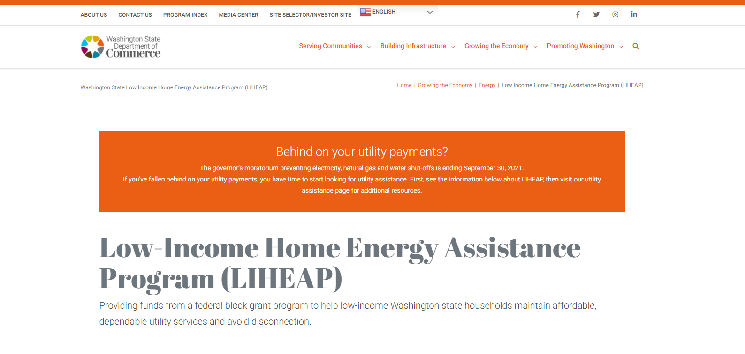
To apply for LIHEAP, contact the LIHEAP provider in your community. Each agency has its own process for scheduling appointments. Consult the Washington State Department of Commerce LIHEAP website frequently asked questions on eligibility, the services that are available, and who to contact in the community.

With LIHEAP, people can acquire heating or cooling units, pay bills, and receive assistance with repairing or replacing unsafe, inoperative or dysfunctional systems. And people in counties impacted by wildfire smoke may qualify for assistance to receive air purifiers if there is an emergency wildfire proclamation in place.

Appendix IV: Non-Grant Medical Assistance (NGMA)

Ask the Expert
If you have questions or need clarification about the content of Appendix IV, please contact:

Annie Moua | Waiver Program Manager | ALTSA/HCS
 | 509-590-3909 office | Anne.Moua@dshs.wa.gov
Effective January 1st, 2014, clients under 65 years of age no longer need to be determined disabled in order to access medical coverage as long as the household’s countable income is below 133% of the FPL. Disability must still be determined if the client is under 65 years of age and needs to access HCBS waiver services, regardless of income.

Blindness or disability is already established for clients who receive SSI or Social Security Disability benefits. Clients who are 18 – 64 who do not receive SSI/SSDI must have their disability determined via the Non-Grant Medical Assistance (NGMA) Program.

Disability through the NGMA process is completed by a Department of Disability Determination Services (DDDS) adjudicator. Eligibility is determined based on the SSI disability criteria (WAC 182-512-0050):
  - Blind (as defined in WAC 182-512-0050); or
  - Disabled – the inability to do any substantial gainful activity by reason of any medically determinable physical or mental impairment which can be expected to result in death or which has lasted or can be expected to last for a continuous period of not less than 12 months.

To determine if a NGMA is needed, look at the SSI criteria (aged, blind or disabled):
- Clients who are on SSI/SSA Disability, blind, or 65 or older, are already categorically related and a NGMA is NOT needed:
  - Determine if a financial application has been submitted (unless already on Medicaid), and
  - Authorize services – use Fast Track if appropriate.
- For clients under age 65 who appear to meet SSI disability criteria, use the NGMA process to determine the disability. Clients who do NOT appear to meet SSI disability criteria still have the right to pursue NGMA if they wish. Explain the program criteria for severity and durational requirements to clients. If the client wishes to continue, complete the packet. If the client withdraws, notify the financial services specialists within 5 days and refer the client to other community resources or access state-funded resources if appropriate.
- A client who receives MAGI-based medical coverage must be determined disabled using the NGMA process if they need to access waiver services. However, a NGMA is not needed in order to authorize MPC or CFC services.

Instructions for Completing NGMA Referral in Barcode
The NGMA transmittal form can be accessed from the “Forms” menu of the Electronic Case Record (ECR).
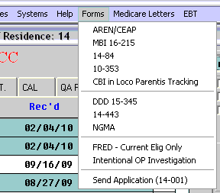

When you select “NGMA” from the menu you should see the following screen:

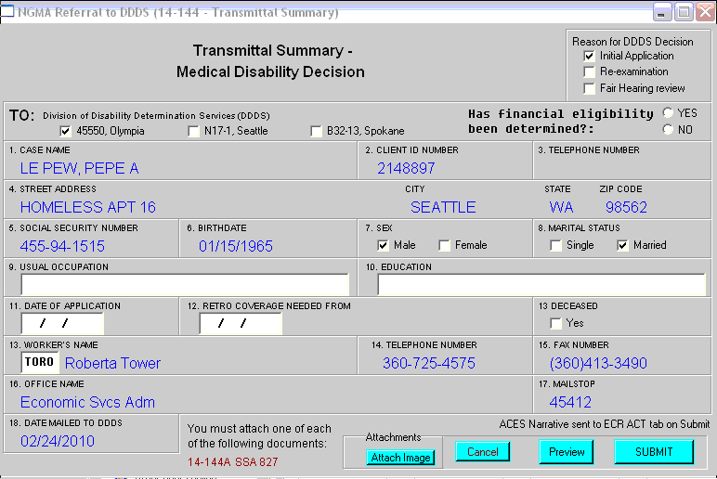
At the top right hand corner of the screen are checkboxes to indicate whether this is an Initial Application, Re-examination, or a Fair Hearing review.

On the first line of the transmittal summary there are checkboxes to indicate where the Transmittal Summary should be sent. This will be pre-selected based on the client's office of record. You may change this location by selecting a different checkbox.

Financial Eligibility for NGMA must be determined before the Transmittal Summary can be sent to DDDS. Indicate Yes or No that eligibility has been established.

Boxes 1-6 contain information from ACES for the client selected. This data may not be changed through this form. If the information about the client is incorrect, ACES must be updated first.

Box 7 and 8 will be pre-selected from information via an ACES interface. This information may be corrected by changing the checkbox selected.

Box 9 and 10 allow input for Usual Occupation and Education respectively. These are not mandatory fields.

Box 11 is for the current date of application.

Box 12 is for the requested retro medical time period. Retro medical may not be requested more than 3 months prior to a medical application.

A date must be entered into number 12, Retro Medical Coverage. If retro medical is not needed or requested, enter today's date in field number 12.

Requesting Retro Medical from a Previous Application
Example: The client applies for medical on 2/12/2010 and wishes to have retro medical considered back to 6/1/2010.

If these dates are entered into fields 11 and 12, an invalid date popup warning will appear.

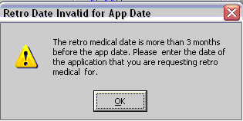

An additional application date box will appear. Enter the date of the application that the retro medical is being requested for. The retro medical coverage date cannot be more than 3 months prior to the original application date.

Box 13 has a checkbox to indicate if the client is deceased.
Boxes 14 through 19 include information about who sent the form and the date it was sent to DDDS. Only box 14 can be changed.

Attaching Documents
Certain documents must be attached to the Transmittal Summary before the document can be submitted to DDDS. This is done by clicking the 'Attach Image' button at the bottom of the screen. The documents that must be attached are listed in red to the left of the button.

When the 'Attach Image' button is clicked, the ECR will open and the My ECR tab will be on top. The NGMA (DDDS) filter will be pre-selected with the NGMA document types.

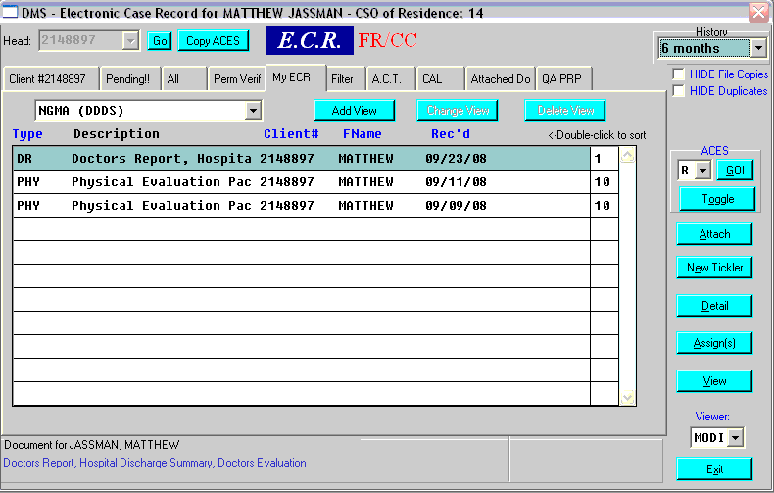

Highlight the documents that you would like to attach to the NGMA Transmittal Summary. On the right hand side of the ECR there will be a new button above the 'New Tickler' button. Once you have all of the documents highlighted, click the 'Attach' button.

You may go to the 'Attached Docs' tab to see which documents have been attached.

Hit the ECR's 'Exit' button to return to the NGMA screen. If the documents have been attached the document types should have changed from red to green.

If there are more than 50 pages in the documents that are attached, a warning message will appear.

When the popup is closed the Attach Image button will be replaced with a 'Select Pages' button.

Clicking the 'Select Pages' button will open a new screen listing all of the documents attached with the number of pages for each document.

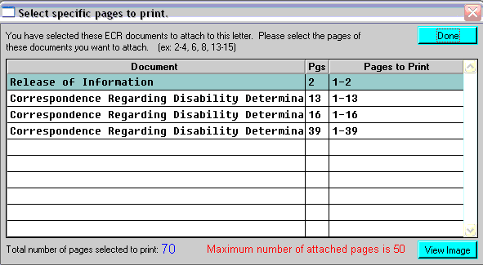

The total number of pages for the documents attached is listed at the bottom of the screen. To only attach a few pages of the document, select the document by highlighting the line the document is on. You may view the document by clicking the 'View Image' button at the bottom of the screen.

Enter the page numbers for the document in the Pages to Print column.

When finished, click the 'Done' button. Then click the 'Submit' button again.

Once everything has been completed on the Transmittal Summary screen, you may preview the document or submit the document.

Submitting the document will create a NGMA document with an assignment to the appropriate DDDS office. You will be asked to click OK to commit the form to the ECR.

Appendix V: Ongoing Additional Requirements (OAR)

Ask the Expert
If you have questions or need clarification about the content of Appendix V, please contact:

Annie Moua | HCBS Waiver Program Manager | ALTSA/HCS
 | 509-590-3909 office | Anne.Moua@dshs.wa.gov
Definition from the Economic Services Administration (ESA) Social Services Manual: An "Ongoing Additional Requirement" is a benefit that is needed by a person that maintains their independent living situation or allows them to live in an environment that is as independent as possible.

Ongoing Additional Requirements (OAR) may provide financial assistance to eligible individuals for costs associated with:
- Restaurant meals
- Home delivered meals
- Laundry
- Service animal food
- Telephone
- Internet
- Transportation
- Dentures
- Optometrists visit for eyeglasses
- Eyeglasses
- Hearing aid(s)
- Veterinary cost for service animals
- Boarding for service animals

Eligibility and Authorization Process
OAR eligibility is determined by the HCS/AAA Social Service Specialist (SSS)/Case Manager (CM) or DDA Case Resource Manager (CRM). A request for OAR from the client can start from the SSS/CM/CRM or the Public Benefit Specialist (PBS).
- PBS staff will notify SSS/CM/CRM using the DSHS 07-104 when a client is requesting OAR through the PBS.
- SSS/CM/CRM will use the OAR Service Request Decision screen in Barcode to document pending, approved, and denied OAR service requests when a client requests or the SSS/CM/CRM determines a need for OAR.
  - SSS/CM/CRM must select one service typer per OAR request in the Barcode OAR Service Requestion Decision screen.

When an OAR service request is approved:
- A begin date is required. This date will be no more than three (3) months from the current month.
- An end date is required. This date will be no more than 24 months from the begin date.
- An amount authorized must be entered. This amount must not be more than the approved service limit.
  - The approved service type cannot exceed the monthly or annual limit.
  - Do not allow monthly approval for service that are a one-time payment.
- Barcode will auto-generate an OAR1 tickler to the assigned HCS PBS or DDA PBS pool when an OAR service request has been approved by the SSS/CM/CRM.
  - Tickle Name: OAR1
  - Tickle Subject: OAR has been approved
  - Tickle Details: include client name, begin and end dates, service type, one-time or ongoing and amount.
- PBS will issue OAR benefits in ACES and ACES will issue a letter and document in the ACES narrative.
- SSS/CM/CRM will get a Barcode OAR2 tickler when an approved OAR service needs to be reviewed.
  - Barcode will auto-generate an OAR2 tickler at approval and is set to ready to work 45 days prior to end date for each approved service.
    - Tickle Name: OAR2
    - Tickle Subject: OAR review is needed
    - Tickle Details: Review OAR service for: include client name, begin and end dates, service type, one-time or ongoing and amount.

When an OAR service request is denied:
- One denial reason must be selected. That denial reason is inserted into an open letter.
  - Reasons to choose from:
    - Max Benefit Received - You already received the maximum benefit in a 12-month period
    - Duplicate Service - The service you requested is covered by another program
    - Unnecessary Service - The service you requested does not affect your health, safety or ability to continue to live independently
    - Missing Information - You didn’t provide sufficient verification to support your need
    - Funds Exhausted - Program funding has been exhausted
    - Need not confirmed - At review, we weren't able to confirm you need additional services to continue to live independently
    - Other - Text box to insert explanation
    - ETR denied by HQ - An Exception to Rule was submitted and denied by Headquarters.
      - For ETR denials, staff need to insert text in the letter based on the ETR decision in Barcode
- When an OAR request is denied, an Open letter must be sent.

When an OAR service request is pending:
- Select “Pend” and “Save”.
- The status will be displayed as “pending” until SSS/CM/CRM completes the final decision and either approves or denies the OAR service request.
  - SSS/CM/CRM name and the date the OAR request is saved will be displayed on the OAR request.
    - There is an optional space for SSS/CM/CRM to indicate date “Information Request letter” was sent and information due date.
- A Barcode OAR3 tickler will need to be manually created with the information below. The ready to work date will be the next day after the information due date entered.
  - Tickle Name: OAR3
  - Tickle Subject: OAR Information Due
  - Tickle Details: Review OAR notes and client ECR for: include client name and due date. Finalize OAR request.

OAR benefits are not approved if:
  - The assistance the individual is requesting is available to them through another program, or
  - The individual lives in a licensed Adult Family Home (AFH), Assisted Living Facility (ALF), or Enhanced Services Facility (ESF).

WAC 388-473-0010 – What are ongoing additional requirements and how do I qualify?
An individual may qualify for OAR if he/she is active in one of the following programs:
- Temporary assistance for needy families (TANF), or tribal TANF;
- State family assistance (SFA);
- Pregnant women assistance (PWA);
- Refugee cash assistance (RCA);
- Aged, blind, or disabled (ABD) cash assistance;
- Housing and essential needs (HEN) referral; or
- Supplemental security income (SSI).

Authorization of OAR benefits occurs only when it is determined the item is essential to the client. The decision is based on proof the client provides documenting of:
            - The circumstances that create the need; and
            - How the need affects the client’s health, safety, and ability to continue to live independently.

Benefit Review Cycle

The following review cycle table shows when the need for OAR is reviewed:
REVIEW CYCLE
Program | Frequency (Months)
TANF/RCA/SFA/PWA | 6 Months
ABD | 12 Months
HEN | 12 Months
SSI | 24 Months
All | Any time need or circumstances are expected to change

WAC 388-473-0020 – When do we authorize meals as an ongoing additional requirement?
Additional requirement benefits for meals will be authorized when all the following conditions are determined to be true:
- You meet the criteria in WAC 388-473-0020;
- You are physically or mentally impaired in your ability to prepare meals; and
- Getting help with meals would meet your nutrition or health needs and is not available to you through another federal or state source, such as the Community Options Program Entry System (COPES), Medicaid Personal Care (MPC), or informal support, such as a relative or volunteer.

The department decides whether to authorize this benefit as restaurant meals or home-delivered meals.
- Restaurant meals are authorized when:
- You are unable to prepare some of your meals;
- You have some physical ability to leave your home; and
- Home-delivered meals are not available or would be more expensive.

- Home-delivered meals are authorized when:
- You are unable to prepare any of your meals;
- You are physically limited in your ability to leave your home; and
- Home-delivered meals are available.

WAC 388-473-0040 – Assistance for service animals as an ongoing additional requirement.
A "service animal" means any dog or miniature horse, as discussed in RCW 49.60.040, that is individually trained to do work or perform tasks for the benefit of an individual with a disability, including a physical, sensory, psychiatric, intellectual, or other mental disability.

Benefits authorized for food for a service animal if it is decided the animal is necessary for the client’s health and safety and supports their ability to continue to live independently.

Benefits authorized for future veterinary care for a service animal if it is decided that a service animal has a medical necessity that would require treatment so that the service animal can continue to do the work or task the animal has been trained to perform. Payment for past veterinary bills is not allowed.

Boarding for a service animal for a maximum amount of $300.00 a year is authorized if it is determined that the client needs medical or mental health care and is in a licensed facility in which the service animal cannot reside and there is no one who can provide care for your service animal.

WAC 388-473-0050 – Telephone and internet services as an ongoing additional requirement.
Benefits for telephone services are authorized when it has been determined that without a telephone,
- The client’s life would be endangered, you could not live independently, or you would require a more expensive type of personal care, and
- The client has applied for telephone assistance through a federal program.

NOTE: telephone services are meant only for landline assistance.

Benefits for internet services are authorized when is it has been determined:
- Without internet services, the client could not live independently, or they would require a more expensive type of personal care; and
- The client has applied for low-cost internet and need assistance paying the monthly bill.

NOTE: The client is not eligible for benefits for telephone or internet services if they are receiving these services free of charge.

WAC 388-473-0060 – Laundry as an ongoing additional requirement.
Benefits for laundry are authorized when it has been determined that you:
- Are not physically able to do your own laundry; or
- Do not have laundry facilities that are accessible to you due to your physical limitations.

WAC 388-473-0070 – Transportation as an ongoing addition requirement.
Assistance for transportation costs as an ongoing additional requirement may be authorized when it has been determined that the client needs assistance:
- Getting to and from appointments; or
- Taking care of activities to continue living independently.

WAC 388-478-0050 – Payment standards for ongoing additional requirements and WAC 388-473-0080 – Medically related items or services as an ongoing additional requirement.
The payment standards for OAR are as follows:
- Restaurant meals: $390.00 per month
- Laundry: $20.84 per month
- Service animal food: $50.00 per month
- Home delivered meals: The amount charged by the agency providing the meals
- Telephone: $4.00 per month
- Internet: Up to $30.00 per month
- Transportation: $40.00 per month
- Dentures: $1,800.00 in a 12-month period
- Optometrists visit for eyeglasses: $200.00 in a 12-month period
- Eyeglasses: $240.00 in a 12-month period
- Hearing aid(s): $1,000.00 in a 12-month period
- Veterinary cost for service animals: $200.00 annual limit
- Boarding for service animals: $300.00 annual limit

Clarifying Information for WAC 388-473-0040 regarding Service Animals
What is a service animal?
The Americans with Disabilities Act (ADA) defines a service animal as any guide dog, signal dog, or other animal individually trained to provide assistance to an individual with a disability. If they meet this definition, animals are considered service animals under the ADA regardless of whether they have been licensed or certified by a state or local government.
Reminder: A service animal is not a pet.

Service animals perform some of the functions and tasks that the individual with a disability cannot perform for him or herself. Guide dogs are one type of service animal, used by some individuals who are blind. This is the type of service animal with which most people are familiar. But there are service animals that assist persons with other kinds of disabilities in their day-to-day activities.

Some examples include:
- Alerting individuals with hearing impairments to sounds.
- Pulling wheelchairs or carrying and picking up things for individuals with mobility impairments.
- Assisting individuals with mobility impairments with balance.

Case Worker Responsibilities regarding Service Animals:
- Use the following criteria to determine if the individual’s need for a service animal qualifies as an Ongoing Additional Requirement.
The animal:
  - Must help the individual with a sensory, mental, or physical disability.
  - The training does not need to be formal, but the animal should be trained to help the person with tasks related to the disability. Do not ask for proof of training.

EXAMPLE 1: The client indicates the dog is to help with the blindness to get around. If the use of the animal in assisting the client seems questionable, you can request verification from the client's medical professional that the animal provides assistance with the disability.

EXAMPLE 2: The dog is used to calm down the client. It seems questionable. You can ask the client to provide a statement from the treating doctor, psychiatrist, or other medical professional on how the animal helps the client with their disability.

- When it has been determined that the above conditions are met, you may approve Ongoing Additional Requirements by using the Barcode OAR Service Request screen.

Appendix VI: Requesting Funding from the Managed Care Organization (MCO) for Behavioral Health Personal Care (BHPC)

Information and Instructions for MCO-funded BHPC Wraparound Support Services is located in Chapter 22a of the LTC Manual

Resources for Chapter 7h

Related WACs and RCWs

Appendix I: Coordination with Developmental Disabilities Administration (DDA)
Chapter 388-823 WAC Developmental Disabilities Administration Intake and Eligibility Determination

Appendix II: Estate Recovery
Chapter 182-527 WAC Estate Recovery and Pre Death Liens
WAC 182-527-2746 Estate recovery—Asset-related limitations
WAC 388-96-384 Liquidation or transfer of resident personal funds
Chapter 43.20B RCW Revenue Recovery for Department of Social and Health Services
RCW 43.20B.080 Recovery for paid medical assistance—Rules—Disclosure of estate recovery costs, terms, and conditions
Chapter 74.39A RCW Long-Term Care Services Options—Expansion
RCW 18.39.250 Prearrangement contracts—Trusts—Refunds
RCW 18.39.255 Prearrangement contracts—Insurance funded—Requirements
RCW 68.46.050 Withdrawals from trust funds—Notice of department of social and health services' claim
RCW 70.129.040 Protection of resident's funds—Financial affairs rights

Appendix IV: Non-Grant Medical Assistance (NGMA)
WAC 182-512-0050 SSI-related medical—General information

Appendix V: Ongoing Additional Requirements (OAR)
WAC 388-473-0010 What are ongoing additional requirements and how do I qualify?
WAC 388-473-0020 When do we authorize meals as an ongoing additional requirement?
WAC 388-473-0040 Food for service animals as an ongoing additional requirement
WAC 388-473-0050 Telephone and internet services as an ongoing additional requirement
WAC 388-473-0060 Laundry as an ongoing additional requirement
WAC 388-473-0070 Transportation as an ongoing addition requirement
WAC 388-473-0080 Medically related items or services as an ongoing additional requirement
WAC 388-478-0050 Payment standards for ongoing additional requirements

Forms
DSHS form 14-443 Financial/Social Services Communication (use form in Barcode)
DSHS form 14-454 Estate Recovery Repaying the State for Medical and Long Term Services and Supports
DSHS publication 22-619x Medicaid and Options for Long-Term Care Services for Adults

Resources
Ongoing Additional Requirements PowerPoint

Acronyms
AAA | Area Agency on Aging
ADA | Americans with Disabilities Act
ALTSA | Aging and Long-Term Support Administration
APS | Adult Protective Services
BHO | Behavioral Health Organization
BHPC | Behavioral Health Personal Care
CARE | Comprehensive Assessment and Reporting Evaluation
CFC | Community First Choice
CHIP | Children’s Health Insurance Program
COPES  CTS | Community Options Program Entry System  Community Transition Services
DDA | Developmental Disabilities Administration
DDDS | Department of Disability Determination Services
DSHS | Department of Social and Health Services
ECR | Electronic Case Record
HCA | Health Care Authority
HCBS | Home and Community Based Services
HCS | Home and Community Services
LTC | Long-Term Care
LTSS | Long Term Services and Supports
MCO | Managed Care Organization
MPC | Medicaid Personal Care
NGMA | Non-Grant Medical Assistance
OAR | Ongoing Additional Requirements
OFR | Office of Financial Recovery
P1 | ProviderOne
RCL | Roads to Community Living
RCW | Revised Code of Washington
RSW | Residential Support Waiver
SER | Service Episode Record
SCOMIS | Superior Court Office Management Information System
SSA | Social Security Administration
SSAM | Social Service Authorization Manual
SSI | Supplemental Security Income
SSP | State Supplementary Payment
WAC | Washington Administrative Code
WTAP | Washington Telephone Assistance Program

REVISION HISTORY
DATE | MADE BY | CHANGE(S) | MB #
04/2024 | Annie Moua | Update to Appendix V: OAR – addition of several OAR benefits, eligibility expansion, and new authorization process through Barcode OAR Service Request Decision screen.
05/2023 | Victoria Nuesca | • No content change  • Advising that information and instructions for appendix VI on MCO-funded BHPC Wraparound Support Services is now in Chapter 22a of the LTC Manual  • Update to the contacts for the different appendices and links
01/2021 | Jamie Tong, Kelli Emans | MCO funded BHPC support clarification and instructions regarding wraparound support and ESF services.
10/2020 | Victoria Nuesca and Jamie Tong | New template revision and updated policy related to MCO funding of wraparound support. | H20-094
09/2019 | Jamie Tong | Update to Appendix VI – criteria, policy and instructions for requesting and authorizing funding from BHO/MCO | H19-050

