Analysis of the Washington Adult Family Home Services Medicaid Payment Methodology

  - Final Report

  - Prepared for:
  - Washington State Department of Social and Health Services (DSHS)

Submitted by:
Navigant Consulting, Inc.
1201 Third Avenue
Suite 3320
Seattle, Washington 98101

navigant.com
Table of Contents
Section I: Overview of Adult Family Homes and Services Provided 3
Section II: Overview of the Current Medicaid Payment Methodology and Rates 4
Section III: Access to Care 7
Section IV: Quality 12
Section V: Comparison of the Costs of Adult Family Home Services to Current Rates 14
Section VI: Conclusion 18

APPENDICES:

APPENDIX A: Current Daily Rates

APPENDIX B: Adult Family Homes Enforcement Action Options

Introduction

Navigant Consulting, Inc. was engaged by the Washington State Department of Social and Health Services (DSHS), also referred to as “the Department”, to conduct an analysis of the current Medicaid payment methodology and rates paid for Adult Family Home services relative to the efficiency, accessibility and the quality of care standards established under Federal requirements. The Federal requirements that apply to the methods states employ to pay for Medicaid services, which are described in U.S.C. § 1396a (a)(30)(A), specify that a state plan for Medical Assistance (referred to herein as Medicaid) provide such methods and procedures relating to the utilization of, and the payment for, care and services available under the plan as may be necessary to safeguard against unnecessary utilization of such care and services. In addition these requirements specify the state plan for Medical Assistance should assure that payments are consistent with efficiency, economy, and quality of care and are sufficient to enlist enough providers so that care and services are available under the plan at least to the extent that such care and services are available to the general population in the geographic area.

As such, our analysis focused on an evaluation of the current Washington Medicaid payment methodology and related rates relative to consistency with efficiency and economy, and access to care and quality of care in Washington State.

Section I: Overview of Adult Family Homes and Services Provided

Adult Family Homes are residential homes licensed to care for up to six non-related residents and provide housing, meals, laundry, any necessary supervision and help with activities of daily living. Adult Family Homes can also provide personal care and social services to their residents and allow residents to live an independent lifestyle in a community setting while receiving necessary services from Adult Family Home staff. Some Adult Family Homes provide intermittent nursing services and others may specialize in serving people with mental health needs, developmental disabilities, or dementia.

Based on data provided to us by the Department as of July of state fiscal year 2016, approximately 42 percent of all Adult Family Home residents pay for their care privately, where the remaining 58 percent of Adult Family Home residents are eligible for Medicaid services. The Department contracts with Adult Family Homes to provide services for Medicaid residents in Adult Family Homes.

Under federal regulations, federally-matched state Medicaid dollars may not be used to pay for the room and board costs associated with long-term care services, including the room and board components of costs in Adult Family Homes. As such, Medicaid residents in Adult Family Homes are responsible for paying for their own room and board, and the Department pays only for the allowable Medicaid services that residents receive. The Department will in some cases pay for room and board expenses with state only dollars when, for instance, the resident has no or little participation to cover the room and board expense.

Based on data provided to us by the Department, there were approximately 2,768 Adult Family Homes in Washington State in 2015, with approximately 15,316 licensed beds. Of those, approximately 2,421 were Medicaid contracted (87 percent of the total number of Adult Family Homes), and those Medicaid contracted Adult Family Homes had approximately 13,434 licensed beds (88 percent of the total number of licensed beds). In the State of Washington, Adult Family Homes can enter into a contract with the Department to provide care to Medicaid residents, but that contract does not require that they accept all Medicaid-eligible residents, even if they have available beds. Adult Family Homes in Washington can refuse to accept Medicaid residents at their discretion, even if they are a Medicaid-contracted provider.

Section II: Overview of the Current Medicaid Payment Methodology and Rates

This section describes the current Medicaid payment methodology and rates for Adult Family Homes in Washington. This description is intended to provide a high level overview of how payment rates are set for Medicaid residents in Adult Family Homes.

Methodology Used to Establish Current Rates

In Washington State, the Medicaid rates reimbursed to providers are determined by the Legislature. These reimbursement rates are based on negotiations between the Governor’s office and the union representing Adult Family Home providers.

The Department developed a methodology in the early 2000’s to establish daily reimbursement rates for adult family home services on a client by client basis based on each client’s assignment to one of 12 unique CARE Classifications. These CARE Classifications are reflective of different levels of resources that are required to care for residents with individual needs. In July of 2008, the methodology was expanded to include 17 unique classification groups. Under the current rate setting methodology, each Medicaid-eligible Adult Family Home resident is assigned to one of the 17 CARE Classifications based on an assessment of the resident using the CARE assessment tool. The daily reimbursement rate for services varies based on this classification as well as the geographic area the services are provided.

Federal law requires that Medicaid providers are reimbursed at levels consistent with efficiency, economy, and quality of care, and that the level of reimbursement is sufficient to attract enough providers to provide services to the population. 42 U.S.C. § 1396a (a) (30) (A).

Note that Washington’s Medicaid State Plan, which describes the Department’s methods for determining payments for Adult Family Home Services, has been approved by the federal government.

Current Rates for State Fiscal Year 2017

Appendix A of this report shows the rates currently in effect for services provided in Adult Family Homes. Based on data provided to us by the Department, the weighted average Adult Family Home rate given the anticipated number of Medicaid beneficiaries for SFY 2017 is expected to be $100.67 per day.

The three geographic area groups used for rate-setting purposes are King County, all other Metropolitan Counties, and all Nonmetropolitan Counties. The counties included in each geographic area group are shown on the map in Exhibit 2.1. This Exhibit also shows the number of Adult Family Home providers in each county and geographic region.

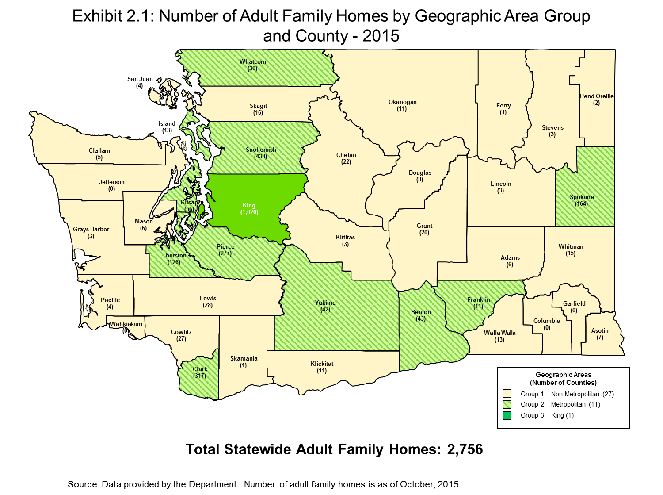

Section III: Access to Care

In this section, we analyze the availability of Adult Family Home beds in Washington as a way to determine if barriers to access exist for Medicaid beneficiaries requiring Adult Family Home services. We analyze access to care primarily using Adult Family Home licensed beds and occupancy rates over time, as well as information provided to us by the Department regarding Medicaid placements.

Washington Adult Family Home Capacity and Occupancy from 2008 to 2014

We first look at total Adult Family Home capacity in Washington. Adult Family Home capacity can be measured by the number of bed days available – that is the number of licensed beds multiplied by the number of days in the year. Table 3.1 shows the number of Adult Family Homes, number of licensed beds and total available bed days in the state between 2008 and 2016. This table shows that in recent years, the number of Adult Family Homes and the number of licensed beds and available bed days has been relatively constant in the last three years shown.

Table 3.1: Adult Family Home Capacity in Washington 2008 – 2016

State Fiscal Year | Number of Facilities | Number of Licensed Beds | Total Number of Bed Days Available
2008 | 2,602 | 14,271 | 5,223,186
2009 | 2,732 | 15,081 | 5,504,565
2010 | 2,829 | 15,635 | 5,706,775
2011 | 2,888 | 15,918 | 5,810,070
2012 | 2,870 | 15,830 | 5,793,780
2013 | 2,842 | 15,596 | 5,692,540
2014 | 2,772 | 15,214 | 5,553,110
2015 | 2,750 | 15,190 | 5,544,350
2016 | 2,768 | 15,316 | 5,605,656

Source:
Number of facilities and licensed beds were provided by the Department and are as of the end of July of each state fiscal year. Numbers of beds days available were calculated using the number of days in each year.

Adult Family Homes are not required to report occupancy rates to the Department. As such, as of the date of this report, data regarding statewide occupancy levels in Adult Family Homes were not available. However, in 2000 and 2007, the Department conducted a survey of Adult Family Homes regarding their occupancy levels and the average statewide occupancy rate based on these two surveys was determined to be 83 percent.

Table 3.2 shows Adult Family Homes estimated total occupied beds based on the assumption that Adult Family Homes realized an 83 percent occupancy rate in each year. It also shows total beds occupied by Medicaid residents and the estimated average Medicaid utilization rate, that is, Medicaid’s share of estimated total occupied beds for 2008 through 2014.

Table 3.2: Adult Family Homes Medicaid Utilization in Washington 2008 – 2016

State Fiscal Year | Total Licensed Adult Family Home Beds | Estimated Number of Occupied Beds at Assumed 83% Occupancy Rate | Number of Beds Occupied by Medicaid Residents | Estimated Average Medicaid Utilization Rate
2008 | 14,271 | 11,845 | 5,633 | 48%
2009 | 15,081 | 12,517 | 5,937 | 47%
2010 | 15,635 | 12,977 | 6,287 | 48%
2011 | 15,918 | 13,212 | 6,645 | 50%
2012 | 15,830 | 13,139 | 6,878 | 52%
2013 | 15,596 | 12,945 | 7,075 | 55%
2014 | 15,214 | 12,628 | 7,101 | 56%
2015 | 15,190 | 12,608 | 7,121 | 56%
2016 | 15,316 | 12,712 | 7,296 | 57%

Source:
Data provided by the Department and is as of the end of July of each state fiscal year.

This table shows that the total number of licensed Adult Family Homes beds in the state increased by 1,045, a 7.3 percent increase, from 2008 to 2016. It also shows that the utilization of beds by Medicaid residents has steadily increased over this same period, and in 2016 Medicaid occupied beds were 1,663 greater than in 2008, or 29.5 percent greater.

Table 3.3 shows the estimated average number of unfilled beds each day in Washington Adult Family Homes in 2008 through 2016, based on the assumed 83 percent average statewide occupancy rate from the Department surveys.

Table 3.3: Estimated Number of Unfilled Adult Family Home Beds in Washington 2008 – 2016

State Fiscal Year | Estimated Average Number of Unfilled Beds per Day at 83% Occupancy Rate
2008 | 2,426
2009 | 2,564
2010 | 2,658
2011 | 2,706
2012 | 2,691
2013 | 2,651
2014 | 2,586
2015 | 2,582
2016 | 2,604

Source:
Estimated Number of Unfilled Bed Days and Estimated Average Number of Unfilled Beds per Day were calculated using data provided by the Department.

This table shows that, based on the assumed occupancy rate of 83 percent, that there is available Adult Family Home capacity in Washington State.

Washington Adult Family Home Capacity by County, For 2016

To assess whether Washington residents in all areas of the state have access to Adult Family Home services, we analyzed the distribution of Adult Family Home beds at the county level.

As of October 2015, the number of Adult Family Homes per county ranged from zero in four counties to 1,021 in King County. Exhibit 3.1 shows that the number of licensed beds per county, for counties with at least one Adult Family Home, ranged from 4 to 5,699. As expected, the most urban and populous counties of King, Pierce, Snohomish and Spokane have the most Adult Family Home beds. Currently, Columbia, Garfield, Jefferson and Wahkiakum Counties do not have Adult Family Homes.

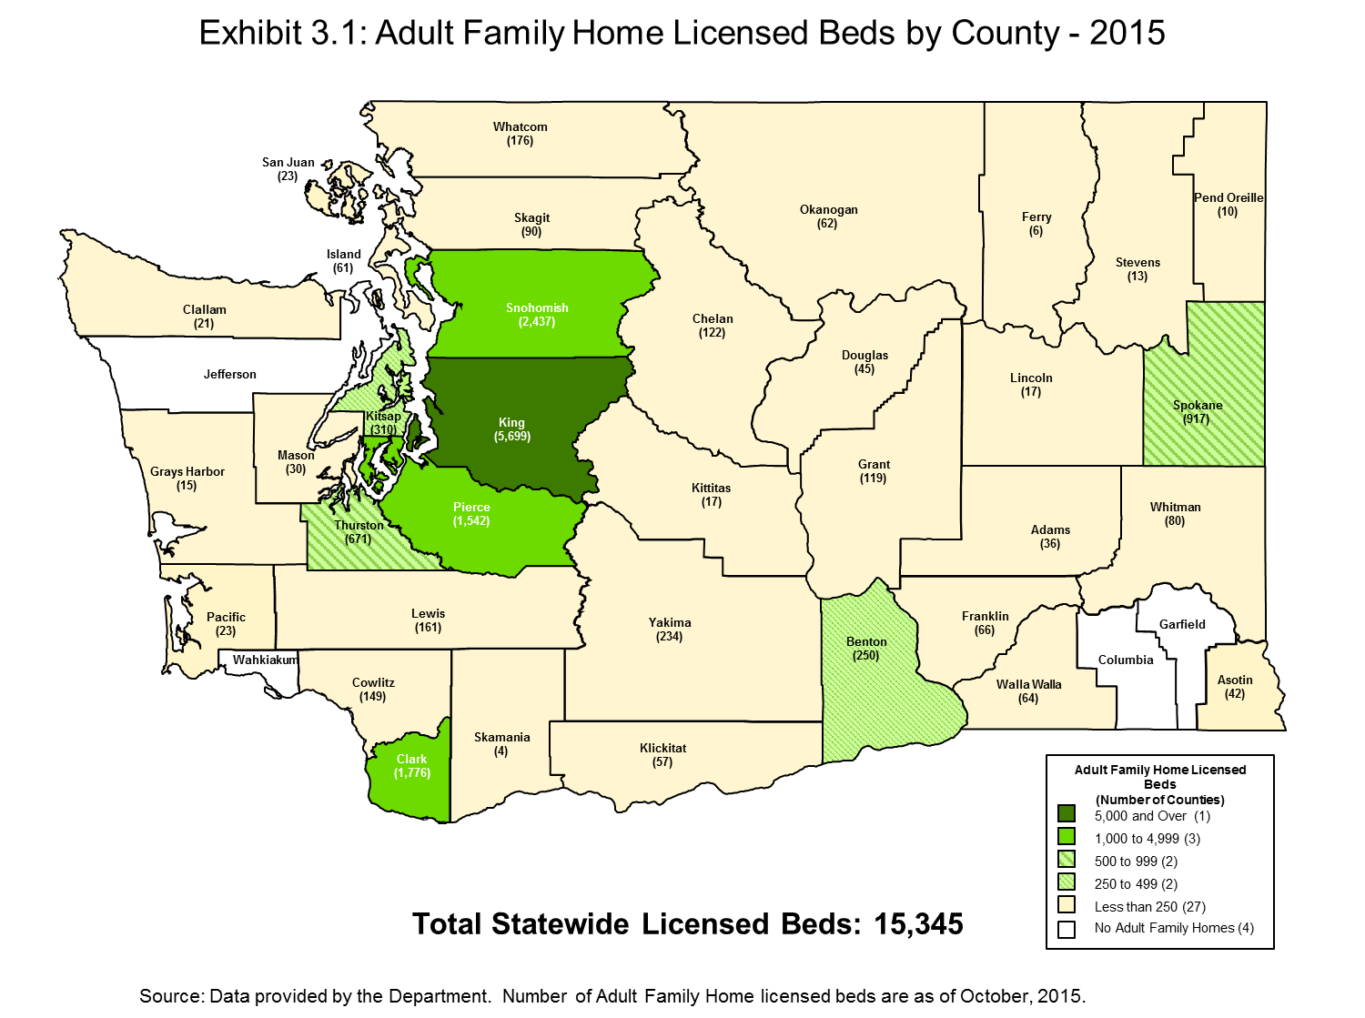
Capacity of Medicaid-contracted Adult Family Homes

As discussed previously, not all Adult Family Homes are contracted with the Department to provide Medicaid services. Table 3.4 shows the change in the number of Medicaid-contracted Adult Family Homes in Washington between 2008 and 2015 based on data provided to us by the Department, and the number of licensed beds in those Medicaid-contracted Adult Family Homes.

Table 3.4: Medicaid-contracted Adult Family Home Capacity in Washington 2008 – 2016

State Fiscal Year | Number of Medicaid-Contracted Facilities | Number of Licensed Beds in Medicaid-contracted Facilities
2008 | 2,297 | 12,637
2009 | 2,352 | 13,031
2010 | 2,382 | 13,242
2011 | 2,449 | 13,626
2012 | 2,471 | 13,776
2013 | 2,496 | 13,778
2014 | 2,431 | 13,417
2015 | 2,438 | 13,484
2016 | 2,421 | 13,434

This table shows that the number of Medicaid-contracted Adult Family Homes has increased by 124 facilities, and that the number of licensed beds in Medicaid-contracted facilities has increased by 797 licensed beds between state fiscal years 2008 and 2016. It also shows that the number of Medicaid-contracted facilities has remained relatively constant over the most recent years shown.

Medicaid-contracted Adult Family Homes have been determined to be qualified to accept Medicaid residents, and will accept Medicaid rates for payment of the services they provide for Medicaid residents, but they may, at their discretion, decline to accept Medicaid-eligible residents.

Given this circumstance, for purposes of understanding whether there is sufficient access to Adult Family Home services for Medicaid-eligible residents, it is important to know whether Medicaid-eligible residents have historically had difficulty being placed into licensed Adult Family Homes. To understand this, we discussed Medicaid placements with the Department representatives. Based on these discussions, we found that the Department generally has not experienced difficulty in placing Medicaid-eligible residents into Adult Family Homes. The Department estimates that two percent or less of placements result in any difficulty for placement, and those that do generally involve residents with special circumstances, including:

- Bariatric (seriously obese) clients
- Clients with criminal histories, such as sexual offenses
- Clients with disabilities resulting from traumatic brain injuries or mental illness
- Clients with known histories of behavioral problems, such as physical or verbal aggression against facility staff or with other residents
- Clients with dementia and wandering

Section IV: Quality
In the previous section we analyzed whether Washington’s Medicaid payment methodology for Adult Family Home services supports sufficient access to care for Washington’s Medicaid beneficiaries. In this section, we analyze whether Washington’s Medicaid payment methodology supports provision of care at an acceptable level of quality.

Inspections are one of the numerous quality assurance activities that occur in Adult Family Homes. The Department has a comprehensive inspection protocol in place, which includes the identification and assessment of citations. Remedies for citations are dependent upon the severity of the circumstances, and can range from providing consultation with no plan of correction for initial citations where there is no potential harm to residents in the Adult Family Home, to civil penalties for repeat citations, to the most severe remedy, which can result in license revocation or stop placement. For a complete description of potential enforcement action options for Adult Family Homes, see Appendix B.

Based on the General Guidelines for Adult Family Home inspections, the purpose of an inspection is to determine if the home is in compliance with applicable licensing laws and regulations, all of which are documented in the State WACs and RCWs. Licensing laws and regulations also include those that are specific to Medicaid-contracted services to assure that the facilities meet the additional Medicaid contracting requirements.

It should be noted that inspections are not limited to Adult Family Homes providing services to Medicaid-eligible residents. All Adult Family Homes licensed in the State of Washington are subject to licensing inspection requirement.

The following lists the operational principles for conducting an inspection of a Family Home in Washington:

- Adult Family Homes must meet, and always be in compliance with, the applicable minimum licensing requirements.
- Adult Family Homes are required to deliver quality care to residents in order to meet the requirements.
- Adult Family Homes must correct all deficiencies in a timely manner. Time frames must be acceptable to the department.
- Timeliness of data collection is critical for enforcement.
- Adult Family Homes must begin correction of any citation as soon as they are notified of a deficiency.
- The field staff will contact the Field Manager when deficiencies involving resident care issues and the likelihood of compromised resident safety should result in shortened POC timeframes.
- The Field Manager will immediately refer any situation involving the likelihood of life threatening risk to a resident (imminent risk, imminent harm) to the Compliance Specialist/Assistant Director for possible immediate enforcement.
- The field staff will follow the written inspection and follow up visit principles and procedures to ensure that inspections and follow up visits are done in a consistent manner.
- Homes that do not meet all of the licensing requirements during the full inspection may have up to two follow-up inspections prior to contacting the Compliance Specialist/Assistant Director.

The Department is required to conduct inspections of every Adult Family Home at least every 18 months, however, based on our discussions with Department staff, inspections are being conducted more frequently than the requirement, and occur on average once every 15 months.

Table 4.1 shows the number of citations for the past ten years in Adult Family Homes which, based on the enforcement protocols shown in Appendix B, did require a Plan of Correction.

Table 4.1: Adult Family Home Inspection Citations Requiring Plan of Correction, 2007 – 2015

Calendar Year | Number of Citations
2007 | 7,415
2008 | 10,079
2009 | 13,140
2010 | 13,080
2011 | 15,412
2012 | 15,094
2013 | 12,433
2014 | 13,484
2015 | 12,829

Source: Citation data provided by the Department

Table 4.1 shows that the number of citations requiring a plan of correction was at its highest point in Calendar Year 2011 and that by Calendar Year 2015, decreased by approximately 17 percent.

In addition to the inspection process, there are other safeguards in place for Adult Family Home residents. All Adult Family Home staff are required by law to report suspected abuse or neglect of a resident, which trigger the inspection process. There is also an established complaint investigation system that has the ability to quickly respond to public allegations of resident abuse and neglect. Under this system, all reports received from the public are assigned an on-site investigative priority.

According to the Department, the increase in the number of citations in CY 2011 and CY 2012 may be attributed to an increased focus on enforcement, regulation, and quality control in Adult Family Homes. This focus on enforcement and quality control was reflected in the manner inspections were conducted and resulted in more citations during this period.

The significant decrease in the number of citations since CY 2012 may be attributed to several factors. According to the Department, the implementation of the Tracking Incidents among Vulnerable Adults (TIVA) system has allowed for better information collection on reported incidents. As a result, incidents which require field investigations are more accurately identified and issues can be addressed with the Adult Family Home provider therefore preventing some citations.

Another factor which may have contributed to the decrease in citations is providers becoming increasingly familiar with new regulations and therefore better able to prevent citations. The decrease in the number of citations may also be attributed to the increase in licensing fees for Adult Family Homes. The increase in licensing fees may have discouraged providers who were not serious about providing care from providing services and further reduced the number of citations since CY 2012, according to the Department.

Section V: Comparison of the Costs of Adult Family Home Services to Current Rates

In the previous sections of this report, we analyzed whether Washington’s Medicaid payment methodology for Adult Family Home services supports sufficient access to care for Washington’s Medicaid beneficiaries and whether Washington’s Medicaid payment methodology supports provision of care at an acceptable level of quality. In this section of the report, we analyze the level of the current reimbursement rates compared to the costs of providing services.

Adult Family Home providers are not required to submit cost data to the Department, and as such, it is not possible to make comparisons of current rates to current cost data from the providers of Adult Family Home services. However, it is possible to look back to historical data, using trending assumptions to take into consideration inflation over time, and make comparisons of rates to costs. The most recent and comprehensive study of the relationship between the costs of providing Adult Family Home services and rates was completed by DSHS in 2003.

To determine the costs to providers of providing services and what an appropriate level of reimbursement would be, the Department staff and Home and Community residential care industry representatives, providers and interested parties formed workgroups. Over a two year period, the workgroups conducted research and held monthly meetings to discuss their results, proposals and issues. During this process, all cost components of providing Home and Community residential care and services were systematically identified and proxies or benchmarks were chosen to represent the market price for these components. The workgroups chose to use proxies and benchmarks for identified costs because of the prohibitive cost of collecting and updating actual cost data from the State’s Adult Family Home providers. The workgroups selected various industry benchmarks for wage and salary levels, supplies, insurance, food, utilities and capital costs.

Using the product of these workgroups, the Department designed a pricing method to establish per resident day market rates for providing Adult Family Home services for each CARE Classification and for the three geographic regions described previously in this report.

The Department used benchmarks to represent the market price of:

- Salaries and Wages – based on wage rates extracted from the U.S. Bureau of Labor and Statistics in 2002.
- Payroll Taxes and Fringe Benefits – based on data extracted from nursing facility Medicaid cost reports from 1999, adjusted by a 2003 legislatively mandated inflation rate.
- Operation Costs (Supplies, Utilities, Food, Taxes, Insurance, etc.) – based on data extracted from nursing facility Medicaid cost reports from 1999, adjusted by a 2003 legislatively mandated inflation rate.

The Department also used in the rate methodology:

- Staff Service Hours – based on the results of a 2001/2002 time study conducted to determine the number of hours actually used in the provision of care, the amount of time for each CARE Classification was established. The Department examined the amount of time staff spent caring for residents in 20 Boarding Homes and 83 Adult Family Homes.
- Size Standards – based on the median number of licensed beds by service area.
- Occupancy Rate – based on a blend of data collected from lenders, developers, appraisers and Adult Family Home operators.
- Capital Costs – based on a combination of:
  - Average price per square foot for new Adult Family Home facility construction in Washington State, based on information from the Marshall Valuation Service;
  - Nursing facility Medicaid cost report data from 1999 (adjusted by 2003 legislatively mandated inflation rate) to determine the cost of moveable equipment; and,
  - Adult Family Home facility assessed values to determine land values.
- Cost Lids at the 25th Percentile – threshold assumption that Nursing Homes have higher costs
The Department determined that the rates established through this study for SFY 2004 were a reasonable proxy for the reasonable and necessary costs of providing Adult Family Home services to Medicaid residents.

Analysis of Payment-to-Cost Coverage for SFY 2017

Based on the assumption that the rates determined in SFY 2004, resulting from the Adult Family Home study completed in 2003, represent a proxy for the reasonable and necessary costs of providing Adult Family Home services to Medicaid residents at that time, we can determine an estimate of the cost of providing Adult Family Home services in SFY 2017 by applying adjustments. First, we can apply a trend factor to approximate inflation between SFY 2004 and SFY 2017. Second, we can apply an adjustment to estimate the change in acuity for the same time period to take into account increases in the intensity of services and changing costs of resources for providing care.

To adjust Adult Family Home providers’ costs for inflation, we applied a trend factor to the SFY 2004 weighted average rate for Adult Family Home services to account for inflation between December 2003 to December 2016, the midpoints of SFY 2004 and SFY 2017, respectively. The Department calculated a weighted average rate for Adult Family Home services for SFY 2004 based on the actual number of Medicaid residents in Adult Family Home facilities and their distribution among the various CARE Classifications, settings and geographic area groups.

The weighted average rate for SFY 2004 represents the weighted average cost of Adult Family Home services provided to Medicaid residents in that year, and we inflated this cost to December 2014 using Consumer Price Index (CPI) data for the Western Region of the US and for the Seattle Metropolitan Area as published by the U.S. Bureau of Labor Statistics. Then, because the CPI data are only available through October 2015, we had to extrapolate available CPI data to estimate inflation in subsequent periods. To calculate the inflation factor necessary to inflate the weighted average cost to December of 2016, we determined the annual percentage change in the CPI between the midpoint of SFY 2014 and SFY 2015. We then applied this percentage change to the index at the midpoint of SFY 2015 to estimate the index at the midpoint of SFY 2016.

Using the same approach, we applied the same calculated percentage change to calculate the index at the midpoint of SFY 2017.

The Department also provided us with caseload distribution data across CARE classifications from SFY 2005 through SFY 2016. We examined changes in caseload distribution to determine whether shifts in acuity have occurred during this time period. We first analyzed changes in caseload distribution between SFY 2005 and SFY 2008, which is the period prior to the implementation of the new CARE classification system expanding the classifications from 12 to 17 categories. Based on our review of caseload distribution between SFY 2005 and SFY 2008, it appears there were no significant shifts among the CARE classifications, and therefore we assume there were no significant increases or decreases in acuity during this period. We did not analyze changes in caseload distribution between SFY 2009 and SFY 2011 because the changes across the CARE classifications were likely to have been impacted by the implementation of the new CARE classification system.

The caseload distribution data provided by the Department indicates that between SFY 2011 and SFY 2016, shifts in caseload distribution did occur, and we observed increases in the proportion of clients classified in CARE Levels 11 through 17. We discussed changes in acuity with the Department, and based on those discussions we understand acuity has increased by approximately 18 percent since SFY 2011. For purposes of this analysis, based on what we observed between SFY 2005 to SFY 2008 before the change to the new classification system and information provided by the state after the implementation of the new classification system, we assume that 18 percent is a reasonable proxy for adjusting costs for acuity for the period between SFYs 2004 and 2017.

The weighted average Adult Family Home services rate for SFY 2004 that the Department calculated was $61.81, which again, we assume for purposes of this analysis is a proxy for the actual costs that are necessary for providing Adult Family Home services to Medicaid residents in SFY 2004. Since acuity has increased by approximately 18 percent since SFY 2004, increasing the calculated weighted average rate of $61.81 by 18 percent will result in a rate before inflation of $72.94 per day. Table 5.1 below shows that inflating this $72.94 cost proxy in SFY 2004 to SFY 2017 yields an estimated current cost of providing Adult Family Home services of $95.04 or $96.79, depending on which CPI inflation factor is selected.

Table 5.1: Estimated Cost of Providing Services in SFY 2017

 | SFY 2004 | Inflation Factor between Midpoints of SFY 2004 and SFY 2017 (Dec. 2003 and Dec. 2016) |  | Estimated Weighted Average Adult Family Home Cost for SFY 2017
 |  | CPI West Region | CPI Seattle Area | Using West Region CPI | Using Seattle Area CPI
Average Weighted Cost for Adult Family Home Services | $72.94 | 1.303 | 1.327 | $95.04 | $96.79

We compared the estimated weighted average cost of providing Adult Family Home services in SFY 2017 with the estimated SFY 2017 weighted average Adult Family Home rate for Medicaid residents of $100.67, which was calculated by the Department. As Table 5.2 below shows, we estimate that payment-to-cost coverage for SFY 2017 is approximately 105 percent, assuming the rates shown in Appendix A of this report.

Table 5.2: Medicaid Payment-to-Cost Ratio SFY 2017

Inflating FY 2004 Average Weighted Cost by: | Estimated Weighted Average Cost for Adult Family Home Services in SFY 2017 | Weighted Average Rate for Adult Family Home Services for SFY 2017 | Payment-to-Cost Ratio
CPI West Region | $95.04 | $100.67 | 106.0%
CPI Seattle Area | $96.79 | $100.67 | 104.0%

In SFY 2014, the payment-to-cost ratio for the CPI West Region and the CPI Seattle Area was 103.3 percent and 102.6 percent respectively. As shown in Table 5.2, in SFY 2017, the payment-to-cost is slightly higher than SFY 2014 levels. The payment-to-cost ratio for SFY 2017 is 106.0 percent and 104.0 percent for the CPI West Region and the CPI Seattle area respectively.

The weighted average rate in SFY 2017 is approximately 10.5 percent higher than the SFY 2015 weighted average rate.

Section VI: Conclusion

Based on the analyses described in this report, it appears that there is sufficient access to Adult Family Home beds in Washington State for Medicaid residents at an acceptable level of quality. The number of beds occupied by Medicaid residents has increased over the past five years and there have been no waiting lists for Adult Family Home placement generally. Adult Family Home quality appears to have improved in recent years, as measured by the number of inspection citations requiring correction plans in recent years. Since 2011, the number of citations requiring a corrective action has decreased by 16.8 percent while the number of facilities from December of state fiscal year 2011 through December of state fiscal year 2016 has decreased by 4.2 percent. During this same period the number of licensed beds decreased by 3.8 percent. To reiterate, the decrease in citations, according to the Department, may be attributed to the implementation of the TIVA incident tracking system, Adult Family Home providers becoming better familiar with new regulations, and the increase in licensing fees for Adult Family Home providers. The decrease in the number of Adult Family Home providers may also be attributed to the increased licensing fees.

In addition, the rates that Washington State pays for Medicaid-contracted Adult Family Home services are consistent with federal requirements for efficiency and economy, to the extent that they are based on what the State has determined to be reflective of the market-based prices for the various components used to calculate rates. Washington’s Medicaid State Plan, which describes the methods used to establish rates for Adult Family Home Services, has been approved by the federal government. Moreover, the Adult Family Home rates are prospective and standardized – that is, rates are the same for all providers for each CARE Classification (with some geographic adjustment). As such, providers know the rates in advance of contracting with the Department and accepting Medicaid residents. Because the rates are standardized and prospective without a retrospective cost settlement component, the payment methodology provides additional incentives for providers to prudently manage the costs associated with providing services.

Even with the increase in estimated pay-to-cost ratios from SFY 2014 levels to SFY 2017 levels, we recommend that the Department continue to monitor provider access and the quality of care provided.

Note that the service component of the Adult Family Home service is generally the same as the care provided to clients who receive personal care services, the difference being that Adult Family Home services include a room and board component. The cost associated with the room and board component is largely borne by the client.
The Comprehensive Assessment Reporting Evaluation (CARE) is the standard client assessment tool used by case managers in Washington State to document a client’s functional ability, determine eligibility for long-term care services, evaluate what and how much assistance a client will receive, and develop a plan of care.
Metropolitan Counties are those counties that are in one of the national Metropolitan Statistical Areas, and comprise Benton, Clark, Franklin, Island, Kitsap, Pierce, Snohomish, Spokane, Thurston, Whatcom, and Yakima counties.
Nonmetropolitan Counties are those counties that are outside of one of the national Metropolitan Statistical Areas, and comprise Adams, Asotin, Chelan, Clallam, Columbia, Cowlitz, Douglas, Ferry, Garfield, Grant, Grays Harbor, Jefferson, Kittitas, Klickitat, Lewis, Lincoln, Mason, Okanogan, Pacific, Pend Orielle, San Juan, Skagit, Skamania, Stevens, Wahkiakum, Walla Walla and Whitman counties.
Based on 365 days in the calendar year for 2009, 2010, 2011, 2013, and 2014, and 366 days in the calendar year for 2008, 2012, and 2016.
Consumer Price Index – All Urban Consumers, All items and CPI – All Urban Consumers, Seattle-Tacoma-Bremerton, All items.

