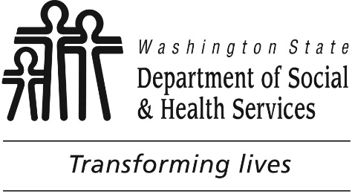

Washington State’s Revised Statewide Transition Plan for New HCBS Rules
Posted for Public Comment on March 15, 2017 Revised February 2017

Washington State

Revised Transition Plan for New HCBS Rules

To be Submitted to CMS in May 2017—Posted for Public Comment on March 15, 2017

Table of Contents

INTRODUCTION-PURPOSE 7

OVERVIEW OF WASHINGTON’S HCBS SYSTEM 8
Aging and Long-Term Support Administration—Overview 8
Developmental Disabilities Administration--Overview 10
Provider Types used by ALTSA and DDA 10
Stakeholder and Tribal Meetings/Presentations 12
Posting of State Transition Plan for Public Comment 12
Stakeholder and Tribal Comments 13
Process for Ensuring Ongoing Transparency and Input from Stakeholders and Tribes 14

RESULTS OF THE STATE SYSTEMIC EVALUATION OF HCBS SETTINGS 14
State HCBS settings 14
Systemic Evaluation of Setting Types 16
Setting Types that have been approved by CMS 16

Washington State

Revised Transition Plan for New HCBS Rules

To be Submitted to CMS in May 2017—Posted for Public Comment on March 15, 2017

Setting Types the State assessed that fully comply with HCBS Characteristics 16
Setting Types the State assessed that will fully comply with HCBS Characteristics 17
Setting Types that do not/cannot meet HCBS characteristics 17
Ongoing evaluation of all settings for HCBS characteristics 18

APPENDIX A: ANALYSIS BY SETTING 20
Supported Living 20
Adult Day Care Services 35
DDA Group Home 40
Licensed Staffed Residential (LSR), Child Foster Home, and Group Care Facilities 50
DDA Individual Supported Employment 60
DDA Group Supported Employment 72
DDA Community Inclusion 84
Community Healthcare Providers 87
Dental Providers 89
DDA Behavioral Health Crisis Bed Diversion Services 91
DDA Specialized Psychiatric Services 102
DDA Positive Behavior Support and Consultation 105

Washington State

Revised Transition Plan for New HCBS Rules

To be Submitted to CMS in May 2017—Posted for Public Comment on March 15, 2017

DDA Community Crisis Stabilization Services 108
Vehicle Modification Providers 120
Veterinarians for Service Animals 122
Transportation Providers 124
DDA Group Training Homes 126
DDA Companion Homes 139
DDA Pre-Vocational Services 149

APPENDIX B: SITE SPECIFIC ASSESSMENT 159
Ongoing evaluation of all settings for HCBS characteristics 168
Ongoing Identification and Review of Settings for Heightened Scrutiny 176

APPENDIX C: STATE’S REMEDIAL WORK PLAN AND TIMELINES 177

APPENDIX D: COMMENTS RECEIVED BY ALTSA AND DDA 192

APPENDIX E: ATTACHMENTS 193
Letter Sent to Participants Regarding their Rights 193
LONG-TERM CARE WORKER ORIENTATION TRAINING (UPDATED 1/15/16) 196

Washington State

Revised Transition Plan for New HCBS Rules

To be Submitted to CMS in May 2017—Posted for Public Comment on March 15, 2017

ATTACHMENTS TO THE MILESTONES COMPLETED IN APPENDIX C 197
DDA Policy 4.02 197
Client Service Summary Excerpt 206
Excerpt from Client Service Contract for Companion Home 7-1-2015 207
Excerpt from Engrossed Substitute Senate Bill 6052 215
Excerpt from Group Training Home Contract 7-1-2015 216
Excerpt from Washington Initiative for Supported Employment (WISE) Contract 217
R15-047 – INFORMATION 218
R15-056 - INFORMATION 220
Resident Interview Questions 222
WA.0409 232
WA.0410 235
WA.0411 237
DDA Residential Provider Training 239
ALTSA and DDA HCBS Settings 246
DDA Policy 4.07 249
Client Rights WAC Revision Proposal updated 10-18-16 260
Public Notification of Revised STP 262

Washington State

Revised Transition Plan for New HCBS Rules

To be Submitted to CMS in May 2017—Posted for Public Comment on March 15, 2017

Public Notification of Revised STP 263
STP Tribal Notification Letter 266
Notification to post HCBS Transition Plan Flyer 269
HCBS Transition Plan Flyer 272

Washington State

Revised Transition Plan for New HCBS Rules

To be Submitted to CMS in May 2017—Posted for Public Comment on March 15, 2017

Introduction-Purpose
The Washington State Health Care Authority (HCA, the state’s Medicaid Agency), the Department of Social and Health Services (DSHS) Aging and Long-Term Support Administration (ALTSA), and Developmental Disabilities Administration (DDA) submit this revised statewide transition plan in accordance with the requirements set forth in the Centers for Medicare and Medicaid Services new requirements for Home and Community- based Services regulations found at 42 CFR § 441.301(c)(4)(5) and § 441.710(a)(1)(2). Washington State has updated the statewide transition plan based on feedback received from CMS on the previously submitted statewide transition plan. On November 4, 2016, Washington State received initial approval of its Statewide Transition Plan (STP) and is currently working to achieve final approval.

There have been three significant changes to Washington’s LTSS system since the previous Statewide Transition plan was submitted to CMS on March 11, 2015. First, the Community First Choice (CFC) program was approved by CMS on June 30, 2015. This approval included Adult family Home and Assisted Living settings. Second, the Individual and Family Support (IFS) waiver was approved by CMS on May 27, 2015 with a June 1, 2015 effective date. Third, CMS approval was granted for two Residential Support Waiver (RSW) amendments. These amendments approved the Adult Day Health and the Enhanced Service Facility settings on August 19, 2015 and May 23, 2016, respectively.

Washington State fully supports the intent of the HCBS setting rules. Washington State has long been an advocate for providing services to clients in the most integrated home and community-based settings, and is a leader in providing clients with choices regarding the settings in which long-term services and supports are provided and will continue its partnership with participants, advocacy groups, stakeholders, and Tribes.

Washington State

Revised Transition Plan for New HCBS Rules

To be Submitted to CMS in May 2017—Posted for Public Comment on March 15, 2017

Overview of Washington’s HCBS System
Aging and Long-Term Support Administration and Developmental Disabilities Administration

ALTSA and DDA jointly administer the Community First Choice program which was implemented July 1, 2015 and currently serves over 64,000 individuals.

Aging and Long-Term Support Administration—Overview

The DSHS Aging and Long-Term Support Administration (ALTSA) mission is to transform lives by promoting choice, independence and safety through innovative services. ALTSA’s Medicaid HCBS waiver programs are:
- Community Options Program Entry System (COPES), a 1915(c) waiver serving over 35,600 individuals.
- New Freedom HCBS, a 1915(c) waiver serving over 500 individuals.
- Residential Support Waiver, a 1915(c) waiver serving over 700 individuals.

In addition to the Medicaid HCBS waiver programs, ALTSA also offers these state plan programs:
- Medicaid Personal Care, serving over 600 individuals.
- Managed Care PACE, serving over 500 individuals.
- Private Duty Nursing, serving over 100 individuals.

ALTSA also administers the Roads to Community Living (Money Follows the Person) federally-funded program—serving (895) individuals.

ALTSA offers services that empower individuals to remain independent and supported in the setting of their choice. This is accomplished through the development of person-centered care plans that reflect individual choices and preferences.

Across all programs, ALTSA offers a variety of services that support people in the community, including:
- Personal care and supportive services for approximately 53,000 individuals living in their own homes, adult family homes, and assisted living settings.
- Assistance with skilled nursing needs available in all settings.
- Support to transition from nursing homes to independent living and community residential settings.
- Information and assistance regarding services available in private homes, in adult family homes, assisted living facilities, and nursing homes, including options counseling for individuals regardless of income.
- Locally-designed programs focused on the needs of adults who are older.
- The Stanford University Chronic Disease Self-Management Education Programs and other evidence-based health promotion programs.

Washington State

Revised Transition Plan for New HCBS Rules

To be Submitted to CMS in May 2017—Posted for Public Comment on March 15, 2017

- Care coordination for foster children to support improved health outcomes for children and their families.
- Protection of safety, rights, security and well-being of people in all settings, including licensed or certified care settings.
- Protection of vulnerable adults from abuse, neglect, abandonment, and exploitation.

ALTSA’s strategies are driven by several bedrock principles. Staff members are essential in carrying out these core principles and are one of the primary reasons the state’s long-term care system is ranked as one of the best in the nation.

We believe the individuals we support:
- Should have the central role in making decisions about their daily lives.
- Will choose supports that promote health, independence, community integration, and self-determination.
- Succeed best when support is person-centered and recognizes that their needs are interrelated.

We believe families and friends of the people we support:
- Are an essential reason many people can live successfully in their own homes and communities.
- Can realize a positive difference in their lives, and the lives of their loved one, with even a small investment in support.
- Act as advocates for quality support and services in the best interest of their family member or friend.

We believe the system of services administered by ALTSA must be:
- Accountable for outcomes and costs.
- Informed by evidence of effectiveness.
- Responsive to changing needs.
- Sustainable over time and within realistic resource estimates.
- Collaborative with service recipients, families, communities, providers, partners, and other stakeholders.
- Accessible to individuals who are Limited English Proficient or have a communication barrier due to a disability.
- Able to keep people free from abuse and neglect, and support shared responsibility with individuals, families, providers, advocates and communities to prevent or respond to abuse and abusers.

Operationalizing these strategies has allowed Washington State to be a national leader in rebalancing our service delivery system from institutional to home and community-based settings with 84% of Medicaid clients receiving services in their own homes and community residential settings. In fact, AARP released its 2014 scorecard of states’ long-term care systems in which Washington State was ranked second in the nation in terms of long-term services and supports for older adults, people with physical disabilities, and family caregiver.

Washington State

Revised Transition Plan for New HCBS Rules

To be Submitted to CMS in May 2017—Posted for Public Comment on March 15, 2017

Developmental Disabilities Administration--Overview

The DSHS Developmental Disabilities Administration’s (DDA’s) mission is to transform lives by providing support and fostering partnerships that empower people to live the lives they want. DDA’s Medicaid HCBS waiver programs are:

- CORE (1915(c) waiver)--serving about 4561 individuals.
- Basic Plus (1915(c) waiver)--serving about 8192 individuals.
- Children’s Intensive In-Home Behavioral Supports (CIIBS) (1915(c) waiver)—serving about 100 individuals.
- Community Protection (1915(c) waiver)--serving about 410 individuals.
- Individual and Family Services (IFS) (1915(c) waiver)—serving about 4,621 individuals.

DDA administers programs that are designed to assist individuals with developmental disabilities and their families to obtain services and supports based on individual preferences, capabilities and needs.

DDA also administers the Roads to Community Living (Money Follows the Person) federally -funded program.

DDA strives to develop and implement public policies that promote individual worth, self-respect, dignity, and power of choice; healthy safe and fulfilling lives; and supports that meet the individual’s needs during the person’s life span.

Provider Types used by ALTSA and DDA
Individuals on Medicaid may choose to receive HCBS services in their own home or from a residential provider. In-home service providers include individual providers, home care agency providers, and DDA supported living providers. Residential providers include adult residential services, enhanced adult residential services, assisted living facilities, enhanced service facilities, adult family homes, DDA group homes, group training homes, licensed staffed residential, companion homes, child foster homes, and group care facilities. In addition, participants may access adult day services, employment services, and services from typical community resources.

Washington State

Revised Transition Plan for New HCBS Rules

To be Submitted to CMS in May 2017—Posted for Public Comment on March 15, 2017

Monitoring On-Going Compliance

DSHS licenses Adult Family Homes and Assisted Living Facilities, and certifies supported living and group home providers, according to state laws (Revised Code of Washington, RCW) and Washington Administrative Code (WAC). The Department’s Residential Care Services Division (RCS) conducts unannounced inspections at least every 18 months and at least every two years for supported living and DDA group homes, complaint investigations and monitoring visits to determine if homes are in compliance with laws, regulations, and contract requirements. Washington has provided monitoring services for many years and is a leader in promoting community integration. The provider must promote resident rights and the health, safety, and well-being of each resident living in each licensed or certified setting.

The licensing and certification processes include monitoring of the following:

- Criminal background checks on all providers, staff, volunteer caregivers, and anyone who will have unsupervised access to residents;
- National fingerprint-based background checks on all providers, entity representatives, resident managers, and caregivers hired after January 1, 2012;
- Financial assessments;
- Complaints received by either DSHS or Department of Health;
- The Department’s abuse registry;
- Ensuring completion of the Department-approved orientation for AFH providers and administrator training for AFH administrators;
- Ensuring that providers and caregivers have completed specific training requirements; and
- On-site inspections to ensure homes meet all licensing and certification requirements in WAC and RCW, including those regarding resident rights. DDA Client rights draft revised WAC 388-823-1095 specifically includes references to HCBS settings rights and applies to all DDA participants (in Appendix E Attachments). Revised WAC will be implemented by July 1, 2017, and is listed in Appendix C: State’s Remedial Work Plan and Timelines.

The Washington State Long-Term Care Ombuds Program provides advocacy support for residents in licensed residential settings. They receive complaints and resolve problems involving quality of care, restraint use, transfer and discharge, abuse, and other aspects of resident dignity and rights.

DSHS contracted evaluators conduct annual inspections of adult day service centers and companion homes to ensure that they are complying with state laws and regulations, including those regarding resident rights.

Children’s Administration’s Division of Licensed Resources (DLR) conducts inspections of licensed staffed residential, child foster homes, and group care facilities at least every three years. DLR is also responsible for complaint investigations along with Child Protective Services (CPS).

Washington State

Revised Transition Plan for New HCBS Rules

To be Submitted to CMS in May 2017—Posted for Public Comment on March 15, 2017

Public Input Process
Notices to Providers

The HCBS requirements apply to the HCBS waiver programs described in the Introduction-Purpose. ALTSA and DDA notified providers in writing about the new HCBS requirements. All current and historical notices are posted here unless hyperlinked below.
- Letter to Stakeholders Announcing the Changes (January 13, 2014)
- Letter to Pre-vocational providers (November 6, 2014)
- Letter to Group Training Homes (November 6, 2014)
- Notice to Assisted Living Administrators about resident interviews regarding new HCBS rules (May 22, 2014)
- Notice to Assisted Living Facility Administrators and interested parties regarding New HCBS Rules webpage (September 29, 2014)
- Notice to Adult Family Home providers and interested parties regarding New HCBS Rules webpage (September 29, 2014)
- Notice to Adult Family Home providers and interested parties regarding key requirements in the federal HCBS regulations (June 29, 2015)
- Notice to Assisted Living Administrators and interested parties regarding key requirements in the federal HCBS regulations (June 29, 2015)
- Notice to Adult Family Home providers and interested parties regarding webinar on HCBS requirements (July 27, 2015)
- Notice to Assisted Living Administrators and interested parties regarding webinar on HCBS requirements (July 27, 2015)

Stakeholder and Tribal Meetings/Presentations
- Provided statewide informational webinars on May 30, 2014, November 5, 2014, August 11, 2015, and August 13, 2015.
- Conducted five meetings with ALTSA stakeholders and advocates.
- Conducted six meetings with Developmental Disabilities Administration (DDA) stakeholders and advocates.
- Letter to DDA Stakeholders for public feedback meeting (October 6, 2014)
- Posted presentation on ALTSA internet site Home and Community Based Services Rules - Stakeholder Notices on August 27, 2014.
- Held Tribal roundtable discussions on September 16, 2014, and October 14, 2014.
- Held formal Tribal consultation on October 23, 2014.
- Notice on January 15, 2016 to Tribes regarding posting of revised statewide transition plan.
- Notice on March 1, 2017 to Tribes regarding posting of revised statewide transition plan (Updated 3/15/17).

Posting of State Transition Plan for Public Comment
- Published first public notice in Washington State Register on September 3, 2014.

Washington State

Revised Transition Plan for New HCBS Rules

To be Submitted to CMS in May 2017—Posted for Public Comment on March 15, 2017

- Published second public notice in Washington State Register on September 30, 2014.
- Published third public notice in Washington State Register on October 15, 2014.
- Posted information on the transition plan on the DDA internet site http://www.dshs.wa.gov/ddd/ on October 20, 2014.
- Mailed notice to stakeholders and Tribes on December 2, 2014 regarding the posting of the draft transition plan effective December 17, 2014.
- Posted draft transition plan on ALTSA internet site http://www.dshs.wa.gov/altsa on December 17, 2014 to open the public comment period.
- Provided statewide webinar on December 17, 2014, as an additional opportunity to discuss and solicit comments on the draft transition plan.
- Published additional public notice in Home and Community Services Offices, Area Agency on Aging Offices, and Developmental Disabilities Administration Offices on January 5, 2015 announcing an extended comment period ending February 6, 2015.
- Published fourth public notice in Washington State Register on January 2, 2015 announcing an extended comment period ending February 6, 2015.
- Updated draft transition plan on ALTSA internet site https://www.dshs.wa.gov/altsa/hcbs-statewide-draft-transition-plan on January 6, 2015 to extend the comment period through February 6, 2015.
- Updated transition plan on ALTSA internet site on March 11, 2015.
- Published public notice in Washington State Register on January 6, 2016 for the posting of the revised statewide transition plan
(Updated 1/15/16).
- Sent notice on January 15, 2016, to Tribes regarding posting of revised statewide transition plan (Updated 1/15/16).
- Revised transition plan posted on the ALTSA internet site and in local HCS, AAA, and DDA offices on January 15, 2016 through February 15, 2016 for public comment (Updated 1/15/16).
- Published public notice in Washington State Register on March 1, 2017 for the posting of the revised statewide transition plan to be posted for 30 day public comment period beginning March 15, 2017 (Updated 3/15/17).
- Sent notice on March 1, 2017 to Tribes regarding posting of revised statewide transition plan (Updated 3/15/17).
- Revised transition plan posted on the ALTSA internet site and in local HCS, AAA, and DDA offices on March 15, 2017 through April 16, 2017 (Updated 3/15/17).

Stakeholder and Tribal Comments
Stakeholder and Tribal comments about the transition plan were solicited through the methods described above. Stakeholder and Tribal comments were provided through a variety of methods including e-mail, telephone, letter, in-person meetings, via conferences and webinars, and the internet site.

Washington State

Revised Transition Plan for New HCBS Rules

To be Submitted to CMS in May 2017—Posted for Public Comment on March 15, 2017

Process for Ensuring Ongoing Transparency and Input from Stakeholders and Tribes
The Centers for Medicare and Medicaid Services (CMS) will continue to work with the state to ensure that all waiver programs are brought into compliance with the new federal requirements. As of November 4, 2016, CMS granted initial approval of Washington’s statewide transition plan. CMS will continue to provide input until the transition plan receives final approval allowing until January 1, 2019 to effectuate full compliance. Updated statewide transition plans will be posted on the ALTSA internet site as milestones are reached, with updates and an opportunity for public comment.

Results of the State Systemic Evaluation of HCBS Settings State HCBS settings:
ALTSA and DDA have a robust LTSS system based on the core value that individuals can be supported to age in place in the setting of their choice. Participants may choose from an array of settings in which LTSS can be provided and all participants may choose to receive supports in their own homes, which is a non-disability specific setting.

Participants who elect to receive services in their own homes may hire qualified family members or friends to as an individual provider of personal care, choose care provided through a home care agency, or hire an individual provider through the Home Care Referral Registry. Participants in Washington State can self-direct their care and are able to receive Nurse Delegation in their own home. In order to ensure that participants who chose a private home have access to in-home care providers capable of meeting their support needs, Washington has extensive and well-developed training and certification for long term care workers. In addition, the State is engaged in workforce development strategies for Individual Providers through advanced training opportunities, wage increases based on cumulative career hours, health care, and retirement benefits. These efforts contribute to a competent and professional workforce.

Case managers assist participants to develop a person centered plan of care that reflects the individual participant’s choices and preferences. As part of the planning process, case managers discuss all available options for service settings and provider types. Participants choose from among these settings and providers when developing their plan. When selecting an in home option participants may access waiver services to make any needed adaptations to the participant’s home.

As of February 2016, WA serves 53,164 participants through the Home and Community Services (HCS) Division. Of those, 40,233 (76%) are served in their own home and 12,362 (23%) are in provider owned residential settings.

The Developmental Disabilities Administration serves 43,726 participants. Of those, 39,290 (90%) live in their own homes.

Washington State

Revised Transition Plan for New HCBS Rules

To be Submitted to CMS in May 2017—Posted for Public Comment on March 15, 2017

Washington increases housing capacity for participants through:
  - Housing and Urban Development (HUD) programs and subsidies
    - Non-Elderly Disabled category 2 (NED 2) vouchers:
      - Washington maintains a 95% occupancy rate for its 215 NED 2 vouchers awarded by HUD in 2011. These vouchers provide rent subsidies for individuals exiting institutional settings through the Housing Authorities of Snohomish County, the City of Longview, the City of Tacoma, the City of Yakima, and Clallam County.
    - HUD 811 Subsidies:
      - ALTSA partners with the Department of Commerce to provide approximately 215 units of project-based housing rental assistance to non-elderly, disabled ADS clients currently residing in institutional, residential or in-home settings.
    - Housing Bridge Program:
      - Provides up to 24 months of state paid rental assistance for disabled, low-income participants in the form of a monthly rent subsidy, which is paid directly to housing providers. This is similar to tenant-based housing choice voucher programs administered through public housing authorities.
      - Housing Bridge rental subsidies support transitions of individuals moving primarily from institutional
settings. The program, funded from Money Follows the Person rebalancing funds, has helped approximately 80 clients statewide achieve permanent affordable independent housing.
  - County city housing levy funds to build programs for individuals with limited household incomes
    - Seattle has produced 12,500 units to date.
    - Bellingham has produced 226 units to date.
    - Vancouver passed a seven year housing levy during the November 2016 elections which will allow the city to raise up to
$6 million per year for affordable housing.
    - HUD program information for Washington State is available here.
  - USDA rental housing projects
    - 294 projects in 34 of 39 counties with 8,891 affordable housing units to date.
  - Down payment and utility bill assistance to home buyers with limited household incomes
    - Low-Income Housing Tax Credit: On May 13, 2016 it was announced that the State’s Housing Finance Commission provided an estimated $55.2 million in equity from Low-Income Housing Tax Credits that provided 540 units of affordable housing statewide. More information is available here.

Washington State

Revised Transition Plan for New HCBS Rules

To be Submitted to CMS in May 2017—Posted for Public Comment on March 15, 2017

Systemic Evaluation of Setting Types:
ALTSA and DDA reviewed the requirements for HCBS settings for all identified setting types to determine whether the setting type fully complies with the requirements, setting types that will comply with the requirements after implementing changes, and settings that do not or cannot meet the HCBS requirements. In addition, some setting types have been approved by CMS since the last posting of this document. The review included an evaluation of state laws, rules, policies, processes, and forms/tools in relation to the new federal HCBS requirements and an identification of changes that are necessary to achieve and maintain compliance with the federal HCBS requirements. The state solicited input from the state Long-Term Care Ombuds, stakeholders, and clients as part of this evaluation. The state conducted on site visits of all adult day service centers, all settings presumed to be institutional, all group training homes, and one residential setting identified by a stakeholder as potentially not meeting the characteristics of an HCBS setting. The Adult Day Health providers have been approved in the residential support 1915(c) waiver and the providers and settings are the same as in the COPES 1915(c) waiver.

Setting Types that have been approved by CMS:
- Individual, privately-owned or rented homes and apartments (In-Home Settings)
- Adult Family Homes
- Assisted Living Facilities
- Enhanced Services Facilities
- Adult Day Health Providers
  - Adult Day Health settings were included in the Residential Support Waiver (RSW) amendment approved in May 2016

Setting Types the State assessed that fully comply with HCBS Characteristics:
- Vehicle Modification Providers
- Veterinarians for Service Animals
- Transportation Providers
- Community Healthcare Providers
- Dental Providers
- DDA Group Training Homes
- DDA Companion Homes
- Supported Living

Washington State

Revised Transition Plan for New HCBS Rules

To be Submitted to CMS in May 2017—Posted for Public Comment on March 15, 2017

- Group Home Licensed Staffed Residential, Child Foster Care and Group Care Facilities
- DDA Individual Employment work sites
- DDA Group Supported Employment work sites
- DDA Community Inclusion
- DDA Behavioral Health Crisis Bed Diversion Services
- DDA Specialized Psychiatric Services
- DDA Positive Behavior Support and Consultation
- DDA Community Crisis Stabilization Services
- Adult Day Care Providers

Setting Types the State assessed that will fully comply with HCBS Characteristics:
•

Setting Types that do not/cannot meet HCBS characteristics:
- DDA Pre-Vocational Services
  - See Appendix C for further information about the plans for DDA Pre-Vocational Services and the individuals affected.

Washington State

Revised Transition Plan for New HCBS Rules

To be Submitted to CMS in May 2017—Posted for Public Comment on March 15, 2017

Settings Identified for Heightened Scrutiny Evaluation
ALTSA and DDA identify facilities for a Heightened Scrutiny evaluation via multiple avenues, including:
- RCS monitoring visits including interviews with staff, management, and residents
- RCS investigations of non-compliance with regulations
- Reports from stakeholders, community advocacy agencies, Ombuds, family, or other community members
- Comments or complaints received by case management staff directly from the participant

Ongoing evaluation of all settings for HCBS characteristics
All settings must meet the HCBS final federal rule. Where noted in the “Analysis by Setting” section, the State is using WAC 388-823-1095 as an overarching rule to ensure DDA settings compliance. The State evaluates settings for HCBS characteristics during the monitoring process completed by the monitoring entity. During this process, sites or homes receive an on-site review, interviews are completed with participants, staff, and administrators as appropriate to the setting, and a visual review of the home or facility, and client record reviews are completed. A more comprehensive outline of the rules and regulations used during monitoring activities of provider owned settings is provided in Appendix B.

To assist in evaluating provider owned settings, an existing RCS report is being revised to track and trend RCS facility citations for non- compliance. When issues are identified through this report, the state will develop and implement an improvement plan to address systemic issues.

Additionally, DDA is developing a database to track all reported instances of sites that are not in full compliance with HCBS settings requirements, remediation measures taken, and follow-up inspections to verify compliance. This database and data from RCS databases will allow for monitoring compliance across all settings.

Remediation
For settings who fail to meet any of the HCBS requirements, outcomes of the licensing/certification processes include citations and/or enforcement actions taken on non-compliant providers (such as plans of correction, shortened timelines for certification, fines, and certification/license revocation).

In addition, system issues are addressed through training of providers, revision of laws and rules, and strengthening of licensing requirements. ALTSA is revising reports to track and trend issues that arise regarding participant rights. This information is used by the RCS Management Team, HCS Management Team, DDA Management team, and an ALTSA-wide executive management committee to address systemic issues through Quality Improvement projects.

Washington State

Revised Transition Plan for New HCBS Rules

To be Submitted to CMS in May 2017—Posted for Public Comment on March 15, 2017

When providers are unable to come into compliance with the HCBS rules (or other rules and regulations that pose a health or safety risk to residents), RCS revokes the license of the facility. When a facility’s license is revoked, ALTSA and DDA have the following procedures for resident relocations:

Resident Relocation Procedure
- After receiving notification from Residential Care Services (RCS), or written notification from a facility, the Agency’s Social Services Program Manager, Field Services Administrator (FSA) or their designee will notify the Social Services Supervisors of the closure.
- Clients are notified of the pending closure.
  - Clients are provided a 30 day advance notification.
  - When client safety is a significant concern or there is imminent risk of harm, shorter timeframes may be given to protect residents.
  - All residents are provided the opportunity to a fair hearing.
- The Program Manager, FSA, or designee and Supervisors, after obtaining the resident list, will determine the level of involvement needed by staff and response time needed to assist with relocating clients based on the facility census and closure date.
  - Determine an Agency Point Person(s) and a Point Person(s) in the facility.
  - Identify HCS, DDA, VA and managed care (e.g. PACE) clients from the census list to enlist additional case management assistance by all appropriate agencies.
  - Assign Agency Case Managers to each client.
  - The Agency Point Person will notify facility staff of client assignments and the Program Manager, FSA, or designee and DDA Policy and Quality Improvement (PQI) Specialist of any issues that will need special consideration.
  - Case management staff will:
    - Complete a face-to-face visit to determine level of care, provide placement setting options, and evaluate the need for assessment.
    - Complete comprehensive assessments as required.
    - Identify placement options and availability.
    - Review all placement options with the client, the client’s representative, and other parties chosen by the client.
    - Once the client chooses a placement option, staff will:
      - Arrange for transportation.
      - Authorize placements.
      - Notify Financial Services of new placement.
      - Follow-up with the client two weeks after placement.
  - Staff will notify their supervisor as relocations are completed.
The Program Manager, FSA, or designee will coordinate with RCS as needed.

Washington State

Revised Transition Plan for New HCBS Rules

To be Submitted to CMS in May 2017—Posted for Public Comment on March 15, 2017

APPENDIX A: Analysis by Setting
Supported Living

Setting Description: Supported Living, also called Certified Community Residential Services and Supports (CCRSS), provides instruction and support services to the participant to the degree the person-centered service plan identifies in the following categories: home living activities, community living activities, life-long learning activities, health and safety activities, social activities, employment, protection and advocacy activities, exceptional medical support needs and exceptional behavioral support needs. Services are provided in an individual’s own private home or apartment, typically shared with housemates. Settings are governed by a lease signed between the participant and the landlord.

Number of Individuals Served: 3,726 Number of sites: 1,600

45 individuals are served in 19 provider owned/controlled homes; these homes are listed at the end of this section

This entire section was updated 7/26/16.

Characteristics/Requirements | Supported Living State Evaluation | Compliance Level | Oversight Process | Remediation
The setting is integrated in, and supports full access of individuals receiving Medicaid HCBS to, the greater community, including opportunities to seek employment and work in competitive integrated settings, engage in community life, control personal resources, and receive services in the community, to the same | The Supported Living/Certified Community Residential Services and Supports (CCRSS) rule are in Chapters 388-101 WAC and 388- 101D WAC.  Participants reside in private homes located in the community and access services in their homes and in typical public community  settings. | Fully Compliant | As part of the certification and complaint investigation process described in the overview, Residential Care Services (RCS) Contracted Evaluators and RCS Investigators conduct client observations, client and collateral interviews, service provider and staff interviews.  RCS contracted evaluators and | Revising WAC 388-823- 1095 to include all rights listed in the HCBS rules and adding language to the contracts requiring adherence to the WAC. See Appendix C.

Washington State

Revised Transition Plan for New HCBS Rules

To be Submitted to CMS in May 2017—Posted for Public Comment on March 15, 2017

Characteristics/Requirements | Supported Living  State Evaluation | Compliance  Level | Oversight Process | Remediation
degree of access as individuals not  receiving Medicaid HCBS. | The State has completed a review of state statutes and regulations regarding supported living (CCRSS) and determined that those laws are in alignment with the HCBS setting requirements. |  | RCS Investigators also review  clients’ finances and conducts client record reviews to ensure service providers’ compliance.  The state certification process includes a determination of whether providers are adhering to the Individual Instruction & Support Plan (IISP).  While completing regular certification evaluations and complaint investigations, the CCRSS provider is evaluated to ensure quality of supports and services and client rights are being protected.  In addition to the monitoring activities overseen by RCS, DDA has taken the following steps:  1. Increasing DDA’s QA system with the addition of a Residential Quality Assurance Unit which includes three Residential Specialists to develop and  share best practices;

Washington State

Revised Transition Plan for New HCBS Rules

To be Submitted to CMS in May 2017—Posted for Public Comment on March 15, 2017

Characteristics/Requirements | Supported Living  State Evaluation | Compliance  Level | Oversight Process | Remediation
- A training Program
Manager has been hired to develop a 70 hour training program to be implemented for all residential staff beginning January 2016;
- DDA has added a quality assurance researcher to review and analyze agency Individual Support Plans (ISPs) to assist agencies to increase quality of goal writing and data tracking;
- DDA has hired an auditor to ensure each client is receiving the ISS hours identified in their ISP and that client funds are expended correctly.

On-site inspections ensure homes meet all licensing and certification requirements in WAC and RCW, including WAC
388-823-1095.
The setting is selected by the individual from among setting options including non-disability specific settings and an option for  a private unit in a residential | Services are provided in person’s own private home or apartment. | Partially Compliant | As part of the certification and RCS complaint investigation process described in the overview, RCS Contracted  Evaluators and RCS | Revising WAC 388-823- 1095 to include all rights listed in the HCBS rules and adding language to

Washington State

Revised Transition Plan for New HCBS Rules

To be Submitted to CMS in May 2017—Posted for Public Comment on March 15, 2017

Characteristics/Requirements | Supported Living  State Evaluation | Compliance  Level | Oversight Process | Remediation
setting. The setting options are  identified and documented in the person-centered service plan and are based on the individual’s needs, preferences, and, for residential settings, the resources available for room and board. | WAC 388-823-1095 my rights as a  DDA client and WAC 388-101D- 0125 Client rights.  During the assessment and planning process, case managers inform participants of all options regarding services and providers, and ensure that this is documented either by client signature or in the client’s service episode record.  Residential Guidelines and CCRSS provider contracts inform and guide the provision of CCRSS services. |  | Investigators conduct client  record reviews ensuring Individual Instruction & Support Plans are being followed.  On-site inspections ensure homes meet all licensing and certification requirements in WAC and RCW, including WAC 388-823-1095. | the contracts requiring  adherence to the WAC. See Appendix C.
An individual’s essential personal rights of privacy, dignity and respect, and freedom from coercion and restraint are protected. | Protection of rights is enforced through WAC 388-101D-0125 through WAC 388-101D-0145.  WAC 388-101D-0140 requires that the service provider must adhere to individual goals identified in the participant’s person-centered service plan. | Fully Compliant | As part of the certification and RCS complaint investigation process described in the overview, RCS Contracted Evaluators and RCS Investigators conduct client observations, client and collateral interviews, service provider and staff interviews, and client record reviews to ensure service providers’ compliance. | Revising WAC 388-823- 1095 to include all rights listed in the HCBS rules and adding language to the contracts requiring adherence to the WAC. See Appendix C.

Washington State

Revised Transition Plan for New HCBS Rules

To be Submitted to CMS in May 2017—Posted for Public Comment on March 15, 2017

Characteristics/Requirements | Supported Living  State Evaluation | Compliance  Level | Oversight Process | Remediation
The DDA Residential Quality
Assurance Unit is monitoring to WAC 388-101D-0140.

On-site inspections to ensure homes meet all licensing and certification requirements in WAC and RCW, including WAC 388-823-1095.
Individual initiative, autonomy, and independence in making life choices, including but not limited to, daily activities, physical environment, and with whom to interact are optimized and not regimented. | Protection of rights is enforced through WAC 388-101D-0125 through WAC 388-101D-0145.  WAC 388-101D-0140 requires that the service provider must adhere to individual goals identified in the participant’s person-centered service plan. | Fully Compliant | As part of the certification and RCS complaint investigation process described in the overview, RCS Contracted Evaluators and RCS Investigators conduct client observations, client and collateral interviews, service provider and staff interviews and client record reviews to ensure service providers’ compliance.  The DDA Residential Quality Assurance Unit is monitoring to WAC 388-101D-0140.  On-site inspections ensure homes meet all licensing and certification requirements in WAC and RCW, including those  regarding resident rights. | Revising WAC 388-823- 1095 to include all rights listed in the HCBS rule and adding language to the contracts requiring adherence to the WAC s. See Appendix C.

Washington State

Revised Transition Plan for New HCBS Rules

To be Submitted to CMS in May 2017—Posted for Public Comment on March 15, 2017

Characteristics/Requirements | Supported Living  State Evaluation | Compliance  Level | Oversight Process | Remediation
Individual choice regarding  services and supports, and who provides them, is facilitated. | Protection of rights is enforced  through WAC 388-101D-0125 through WAC 388-101D-0145.  WAC 388-101D-0140 requires that the service provider must adhere to individual goals identified in the participant’s person-centered service plan. | Fully  Compliant | CMs offer the individual  choices of long-term care settings and provider types.  As part of the certification and RCS complaint investigation process described in the overview, RCS Contracted Evaluators and RCS Investigators conduct client observations, client and collateral interviews, service provider and staff interviews, and client record reviews to ensure service providers’ compliance.  The DDA Residential Quality Assurance Unit is monitoring to WAC 388-101D-0140.  On-site inspections ensure homes meet all licensing and certification requirements in WAC and RCW, including WAC  388-823-1095. | Revising WAC 388-823-  1095 to include all rights listed in the HCBS rules and adding language to the contracts requiring adherence to the WAC. See Appendix C.
Individuals have a choice of roommates in the setting; | All Supported Living residents have private bedrooms.  WAC 388-823-1095 my rights as a DDA client. | Partially Compliant | As part of the certification and RCS complaint investigation process described in the overview, RCS Contracted  Evaluators and RCS | Revising WAC 388-823- 1095 to include all rights listed in the HCBS rules and adding language to

Washington State

Revised Transition Plan for New HCBS Rules

To be Submitted to CMS in May 2017—Posted for Public Comment on March 15, 2017

Characteristics/Requirements | Supported Living  State Evaluation | Compliance  Level | Oversight Process | Remediation
 | Protection of rights is enforced through WAC 388-101D-0125 through WAC 388-101D-0145.  WAC 388-101D-0140 requires that the service provider must adhere to individual goals identified in the participant’s person-centered service plan.  Residential Guidelines and CCRSS provider contracts inform and guide the provision of supported living services. |  | Investigators conduct client  observations, client and collateral interviews, service provider and staff interviews, and client record reviews to ensure service providers’ compliance.  The DDA Residential Quality Assurance Unit is monitoring to WAC 388-101D-0140.  On-site inspections ensure homes meet all licensing and certification requirements in WAC and RCW, including WAC  388-823-1095. | the contracts requiring  adherence to the WAC. See Appendix C.  Supported Living contracts are being also being modified to include language that providers will assist participants to select housing with private bedrooms or the bedroom configuration of the participant’s choice
Individuals have the freedom to furnish and decorate their sleeping or living units | WAC 388-823-1095 my rights as a DDA client.  Protection of rights is enforced through WAC 388-101D-0125 through WAC 388-101D-0145. Chapter WAC 388-101D-0140  requires that the service provider must adhere to individual goals identified in the participant’s person-centered service plan.  Residential Guidelines and CCRSS provider contracts inform and | Partially Compliant | As part of the certification and RCS complaint investigation process described in the overview, RCS Contracted Evaluators and RCS Investigators conduct client observations, client and collateral interviews, service provider and staff interviews, and client record reviews to ensure service providers’ compliance. | Revising WAC 388-823- 1095 to include all rights listed in the HCBS rules and adding language to the contracts requiring adherence to the WAC. See Appendix C.

Washington State

Revised Transition Plan for New HCBS Rules

To be Submitted to CMS in May 2017—Posted for Public Comment on March 15, 2017

Characteristics/Requirements | Supported Living  State Evaluation | Compliance  Level | Oversight Process | Remediation
 | guide the provision of CCRSS  services. |  | The DDA Residential Quality  Assurance Unit is monitoring to WAC 388-101D-0140.  On-site inspections ensure homes meet all licensing and certification requirements in WAC and RCW, including WAC 388-823-1095.
Individuals have the freedom and support to control their own schedules and activities, and have access to food at any time | WAC 388-823-1095 my rights as a DDA client.  Protection of rights is enforced through WAC 388-101D-0125 through WAC 388-101D-0145.  WAC 388-101D-0140 requires that the service provider must adhere to individual goals identified in the participant’s person-centered service plan.  Residential Guidelines and CCRSS provider contracts inform and guide the provision of CCRSS services. | Partially Compliant | As part of the certification and RCS complaint investigation process described in the overview, RCS Contracted Evaluators and RCS Investigators conduct client observations, client and collateral interviews, service provider and staff interviews and client record reviews to ensure service providers’ compliance.  The DDA Residential Quality Assurance Unit is monitoring to WAC 388-101D-0140.  On-site inspections ensure homes meet all licensing and certification requirements in WAC and RCW, including WAC  388-823-1095. | Revising WAC 388-823- 1095 to include all rights listed in the HCBS rules and adding language to the contracts requiring adherence to the WAC. See Appendix C.

Washington State

Revised Transition Plan for New HCBS Rules

To be Submitted to CMS in May 2017—Posted for Public Comment on March 15, 2017

Characteristics/Requirements | Supported Living  State Evaluation | Compliance  Level | Oversight Process | Remediation
Individuals are able to have  visitors of their choosing at any time | WAC 388-823-1095 my rights as a  DDA client.  Protection of rights is enforced through WAC 388-101D-0125 through WAC 388-101D-0145.  WAC 388-101D-0140 requires that the service provider must adhere to individual goals identified in the participant’s person-centered service plan.  Residential Guidelines and CCRSS provider contracts inform and guide the provision of CCRSS services. | Partially  Compliant | As part of the certification and  RCS complaint investigation process described in the overview, RCS Contracted Evaluators and RCS Investigators conduct client observations, client and collateral interviews, service provider and staff interviews, and client record reviews to ensure service providers’ compliance.  The DDA Residential Quality Assurance Unit is monitoring to WAC 388-101D-0140.  On-site inspections ensure homes meet all licensing and certification requirements in WAC and RCW, including WAC 388-823-1095. | Revising WAC 388-823-  1095 to include all rights listed in the HCBS rules and adding language to the contracts requiring adherence to the WAC. See Appendix C.
The setting is physically accessible to the individual | This setting type is primarily not a provider owned or controlled setting.  Protection of rights is enforced through WAC 388-101D-0125 through WAC 388-101D-0145. | Partially Compliant | As part of the certification and RCS complaint investigation process described in the overview, RCS Contracted Evaluators and RCS Investigators conduct client observations, client and collateral interviews, service  provider and staff interviews, | Revising WAC 388-823- 1095 to include all rights listed in the HCBS rules and adding language to the contracts requiring adherence to the WAC. See Appendix C.

Washington State

Revised Transition Plan for New HCBS Rules

To be Submitted to CMS in May 2017—Posted for Public Comment on March 15, 2017

Characteristics/Requirements | Supported Living  State Evaluation | Compliance  Level | Oversight Process | Remediation
 | WAC 388-101D-0140 requires that  the service provider must adhere to individual goals identified in the participant’s person-centered service plan.  Residential Guidelines and CCRSS provider contracts inform and guide the provision of CCRSS services. Expectations in the CCRSS provider contract:  - All services are to be provided in a person- centered approach with an intent to deliver services in an integrated setting and facilitate the Client’s full access to the greater community, including opportunities to seek employment and work in competitive, integrated settings, engage in community life, control personal resources and receive services in the community in the same manner as individuals without disabilities. |  | and client record reviews to  ensure service providers’ compliance.  The DDA Residential Quality Assurance Unit is monitoring to WAC 388-101D-0140.  On-site inspections ensure homes meet all licensing and certification requirements in WAC and RCW, including WAC 388-823-1095.

Washington State

Revised Transition Plan for New HCBS Rules

To be Submitted to CMS in May 2017—Posted for Public Comment on March 15, 2017

Characteristics/Requirements | Supported Living  State Evaluation | Compliance  Level | Oversight Process | Remediation
 | As part of the person centered service planning process, participants are provided with options that meet their physical accessibility requirements. If a participant’s needs change regarding accessibility, the case manager works with the resident and facility to accommodate the resident’s needs. As a part of the inspection process, licensors also look at residents and their assessments to make sure the setting, including physical plant requirements, is meeting their needs.
The setting that is located in a building that is also a publicly or privately operated facility that provides inpatient institutional treatment, or in a building on the grounds of, or immediately adjacent to, a public institution, or any other setting that has the effect of isolating individuals receiving Medicaid HCBS from the broader community of individuals  not receiving HCBS. | Not applicable none of these settings are located in a building that is also a publicly or privately operated facility that provides inpatient institutional treatment. | Fully Compliant
The unit or room is a specific  physical place that can be owned, | Services are provided in person’s  own private home or apartment | Fully  Compliant | As part of the certification and  RCS complaint investigation | Revising WAC 388-823-  1095 to include all rights

Washington State

Revised Transition Plan for New HCBS Rules

To be Submitted to CMS in May 2017—Posted for Public Comment on March 15, 2017

Characteristics/Requirements | Supported Living  State Evaluation | Compliance  Level | Oversight Process | Remediation
rented or occupied under another  legally enforceable agreement by the individual receiving services, and the individual has, at a minimum, the same responsibilities and protections from eviction that tenants have under the landlord tenant law of the State, county, city or other designated entity. | selected by the person and  controlled by a lease between the Client and the landlord under the protection of the Washington State Landlord Tenant Law.  WAC 388-823-1095 my rights as a DDA client.  Protection of rights is enforced through WAC 388-101D-0125 through WAC 388-101D-0145.  WAC 388-101D-0140 requires that the service provider must adhere to individual goals identified in the participant’s person-centered service plan.  Residential Guidelines and CCRSS provider contracts inform and guide the provision of CCRSS services. |  | process described in the  overview, RCS Contracted Evaluators and RCS Investigators conduct client observations, client and collateral interviews, service provider and staff interviews, and client record reviews to ensure service providers’ compliance.  The DDA Residential Quality Assurance Unit is monitoring to WAC 388-101D-0140.  On-site inspections ensure homes meet all licensing and certification requirements in WAC and RCW, including WAC 388-823-1095. | listed in the HCBS rules  and adding language to the contracts requiring adherence to the WAC. See Appendix C.
For the small number of provider- | DDA acknowledges that some | Partially | As part of the certification and | Revising WAC 388-823-
owned or controlled properties in | CCRSS residences are provider- | Compliant | RCS complaint investigation | 1095 to include all rights
this setting, safeguards are in place | owned or controlled but do meet |  | process described in the | listed in the HCBS rules
to protect participants. | all HCBS standards. |  | overview, RCS Contracted | and adding language to
 |  |  | Evaluators and RCS | the contracts requiring
 |  |  | Investigators conduct client | adherence to the WAC.
 |  |  | observations, client and | See Appendix C.
 |  |  | collateral interviews, service
 |  |  | provider and staff interviews,

Washington State

Revised Transition Plan for New HCBS Rules

To be Submitted to CMS in May 2017—Posted for Public Comment on March 15, 2017

Characteristics/Requirements | Supported Living  State Evaluation | Compliance  Level | Oversight Process | Remediation
and client record reviews to
ensure service providers’ compliance.

The DDA Residential Quality Assurance Unit is monitoring to Chapter WAC 388-101D- 0140.

Safeguards for provider owned or controlled housing already in place include:
(1) A Provider-Owned Housing Memorandum of Understanding between the participant and provider which includes the following rights:
- Client has the right to live wherever they choose within the service area
- Client has the right to move from a provider owned home and continue to receive SL services with the provider
- Client is aware that service provision with the SL provider is not contingent upon residing in a provider
owned home

Washington State

Revised Transition Plan for New HCBS Rules

To be Submitted to CMS in May 2017—Posted for Public Comment on March 15, 2017

Characteristics/Requirements | Supported Living  State Evaluation | Compliance  Level | Oversight Process | Remediation
- Client has the right, at any
time, to request to move to another home within the service area.
(2) A written exception to policy (ETP) from the Deputy Assistant Secretary (DDA Policy 4.02 D1) (see Appendix E).

On-site inspections ensure homes meet all licensing and certification requirements in WAC and RCW, including WAC
388-823-1095.

Washington State

Revised Transition Plan for New HCBS Rules

To be Submitted to CMS in May 2017—Posted for Public Comment on March 15, 2017

Provider-Owned or Controlled Supported Living Settings:

Supported Living Agency Name | Location* | Individuals Residing at this location
Ambitions | Xxxx South Waverly Place, Kennewick WA | 3
Ambitions | Xxxx Ray Road, Moses Lake WA | 4
Ambitions | Xxxx Lynn Road, Moses Lake WA | 4
Haven Homes, Inc. | Washington Apartments, Medical Lake WA | 3
Haven Homes, Inc. | Lower Mobile, Medical Lake WA | 3
Mission Vista | Xxxx N. Emerson, Wenatchee WA | 1
Integrated Living Services | Xxxx S. 172nd St., SeaTac WA | 3
Cascade Connections | Xxxx Martin Place, Lynden WA | 2
Holly Community Services | Xxxx W. Racine St., Bellingham WA | 4
Communitas Supported Living | Xxxx West Ave., Port Orchard WA | 2
Communitas Supported Living | Xxxx Arsenal Way, Bremerton | 2
CAPA - Two Sites (Duplex) | Xxxx 120th St. S., Tacoma | 3
CAPA - Two Sites (Duplex) | Xxxx Alaska St. S., Tacoma | 3
CAPA - Two Sites (Duplex) | Xxxx 140th St. E., Tacoma WA | 3
Soundview Associates | Xxxx Digby Rd., Mt Vernon, WA | 4
Mission Vista | Xxxx N. Emerson, Wenatchee, WA | 1
* Note: To protect participant privacy, the specific home address is not included.

Washington State

Revised Transition Plan for New HCBS Rules

To be Submitted to CMS in May 2017—Posted for Public Comment on March 15, 2017

Adult Day Care Services
Setting Description:
Adult day care service programs are community-based programs with the goal of meeting the needs of adults with impairments through individualized plans of care. Adult Day Care (ADC) is a supervised daytime program providing core services for adults with medical or disabling conditions that do not require the intervention or services of a registered nurse or licensed rehabilitative therapist acting under the supervision of the client’s authorizing practitioner. All community members have free access to these services and settings including both Medicaid and non-Medicaid funded participants.

New WAC was promulgated since the initial statewide transition plan was submitted. The WAC references below were revised to show these new rules. (Updated 1/15/16).

Number of Medicaid contracted providers for ADC services only: 6 Number of Medicaid participants: 16

Characteristics/Requirements Met

Characteristics/Requirements | Adult Day Services  State Evaluation | Compliance  Level | Oversight Process | Remediation
The setting is integrated in, and supports full access of individuals receiving Medicaid HCBS to, the greater community, including opportunities to seek employment and work in competitive integrated settings, engage in community life, control personal resources, and receive services in the community, to the same degree of access as individuals not receiving Medicaid HCBS. | Adult day care service programs provide opportunities for community integration for people living alone.  WAC 388-71-0738(2) Center  policies must include  (0) A participant bill of rights describing the client’s rights and responsibilities must be developed, posted, distributed to and explained to participants, families, staff and volunteers. | Fully Compliant | The Area Agency on Aging (AAA) monitors adult day centers at least annually to determine compliance with adult day care and/or adult day health requirements and the requirements for contracting with the Department or the AAA, including compliance with this requirement. | The State will amend chapter 388-71 WAC to assure that Adult Day Services will adhere to all aspects of the federal Home Community Based Settings requirements for non-residential settings. This includes ensuring that  individuals receiving HCBS Adult Day

Washington State

Revised Transition Plan for New HCBS Rules

To be Submitted to CMS in May 2017—Posted for Public Comment on March 15, 2017

Characteristics/Requirements | Adult Day Services  State Evaluation | Compliance  Level | Oversight Process | Remediation
Services have the
opportunity to receive services in the community with the same degree of access as individuals not receiving Medicaid HCBS.
See Appendix C.
The setting is selected by the individual from among setting options including non-disability specific settings and an option for a private unit in a residential setting. The setting options are identified and documented in the person-centered service plan and are based on the individual’s needs, preferences, and, for residential settings, the resources available for room and board. | During the assessment process, it is a CM responsibility to inform individuals of their options regarding settings and providers. The settings discussed include all of our residential care options, institutional care, and non- disability specific home settings that include apartments, houses, temporary housing, and other settings that the client may consider a home or residence.  This is documented in the Service Episode Record of the  CARE assessment tool. | Fully Compliant | The Area Agency on Aging (AAA) monitors adult day centers at least annually to determine compliance with adult day care and/or adult day health requirements and the requirements for contracting with the Department or the AAA, including compliance with this requirement.
An individual’s essential personal rights of privacy, dignity and respect, and freedom from coercion and restraint are protected. | WAC 388-71-0766 (1) and (12):  What are the adult day centers' facility requirements? The facility must have sufficient  space….The program must | Silent  When the new rules are enacted, the  new | The Area Agency on Aging (AAA) monitors adult day centers at least annually to determine compliance with adult day care  and/or adult day health | The State is currently promulgating rules to mandate that restraints must not be

Washington State

Revised Transition Plan for New HCBS Rules

To be Submitted to CMS in May 2017—Posted for Public Comment on March 15, 2017

Characteristics/Requirements | Adult Day Services  State Evaluation | Compliance  Level | Oversight Process | Remediation
 | provide and maintain essential  space necessary to provide services and to protect the privacy of the participants receiving services. In addition to space for program activities, the facility must have a rest area and designated areas to permit privacy.  The rule does not fully address the issue. | requirements  will elevate the compliance level to “Fully Compliant”. | requirements and the  requirements for contracting with the Department or the AAA, including compliance with this requirement. | used and residents are  free from coercion. See Appendix C.
Individual initiative, autonomy, and independence in making life choices, including but not limited to, daily activities, physical environment, and with whom to interact are optimized and not regimented. | In the revised WAC, the Department enhanced the participant’s right to participate per their preferences (new WAC 388-71-0702 (3)(l).  WAC 388-71-0718 (6)(c)  mandates a negotiated service agreement that is client directed, and that clients must be offered alternatives when they do not want to participate. | Fully Compliant | The Area Agency on Aging (AAA) monitors adult day centers at least annually to determine compliance with adult day care and/or adult day health requirements and the requirements for contracting with the Department or the AAA, including compliance with this requirement. | The State will amend chapter 388-71 WAC to assure that Adult Day Services will adhere to all aspects of the federal Home Community Based Settings requirements for non-residential settings. This includes ensuring that individuals receiving HCBS Adult Day Services have the opportunity to receive services in the community with the same degree of access  as individuals not

Washington State

Revised Transition Plan for New HCBS Rules

To be Submitted to CMS in May 2017—Posted for Public Comment on March 15, 2017

Characteristics/Requirements | Adult Day Services  State Evaluation | Compliance  Level | Oversight Process | Remediation
receiving Medicaid
HCBS.
See Appendix C
Individual choice regarding services and supports, and who provides them, is facilitated. | During the assessment process, it is a CM responsibility to inform individuals of their options regarding settings and providers. This is documented in the Service Episode Record of the CARE assessment tool. | Fully Compliant | The Area Agency on Aging monitors adult day centers at least annually to determine compliance with adult day care and/or adult day health requirements and the requirements for contracting with the Department or the AAA, including compliance with this requirement.  Internal Quality Assurance monitors to whether the client was offered choice of setting and provider. | The State will amend chapter 388-71 WAC to assure that Adult Day Services will adhere to all aspects of the federal Home Community Based Settings requirements for non-residential settings. This includes ensuring that individuals receiving HCBS Adult Day Services have the opportunity to receive services in the community with the same degree of access as individuals not receiving Medicaid HCBS.  See Appendix C
The setting is physically accessible to the individual | WAC 388-71-0766: What are  the adult day centers' facility requirements? Lists physical environment requirements, including requiring that the site | Fully Compliant | The Area Agency on Aging (AAA) monitors adult day centers at least annually to determine compliance with adult day care and/or adult day health  requirements and the

Washington State

Revised Transition Plan for New HCBS Rules

To be Submitted to CMS in May 2017—Posted for Public Comment on March 15, 2017

Characteristics/Requirements | Adult Day Services  State Evaluation | Compliance  Level | Oversight Process | Remediation
 | have a ramp if there are stairs at  the site. |  | requirements for contracting with  the Department or the AAA, including compliance with this  requirement.
Note: The state visited all adult day care service centers in 2014. One adult day care center was located in a nursing facility (Josephine Sunset Home). The center terminated its contract June 18, 2014—no Medicaid -funded participants were receiving adult day services prior to termination of the contract.

Washington State

Revised Transition Plan for New HCBS Rules

To be Submitted to CMS in May 2017—Posted for Public Comment on March 15, 2017

DDA Group Home

Setting Description: Provides community residential instruction, supports, and services to two or more individuals who are not related to the provider. Group homes are licensed as an adult family home or assisted living facility.

Number of individuals served: 265 individuals served in 45 DDA Group Homes

Characteristics/Requirements Met
Characteristics/Requirements | DDA Group Home State Evaluation | Compliance Level | Oversight Process | Remediation
The setting is integrated in, and supports full access of individuals receiving Medicaid HCBS to, the greater community, including opportunities to seek employment and work in competitive integrated settings, engage in community life, control personal resources, and receive services in the community, to the same degree of access as individuals not receiving Medicaid HCBS. | RCW 70.129.140 (b) interact with members of the community both inside and outside the facility.  RCW 70.129.040 (1) personal resources  RCW 70.129.020 Exercise of rights.  WAC 388-76-10510 (5) Is  provided the opportunity to engage in religious, political, civic, recreational, and other social activities of their choice WAC 388-76-10620 Resident rights – Quality of life –  WAC 388-76-10640 Resident rights – Quality of life – Reasonable accommodation. WAC 388-76-10555 Resident  rights – Financial affairs. | Fully Compliant | As part of the inspection process described in the overview, Residential Care Services conducts resident interviews (see Appendix E) regarding respect of individuality, independence, personal choice, dignity, and activities. RCS also conducts resident observations and talks with a sample of residents to determine compliance with this requirement.  The Long-Term Care Ombuds Program also monitors implementation of Chapter 70.129 RCW. | Revising WAC 388-823- 1095 to include all rights listed in the HCBS rules and adding language to the contracts requiring adherence to the WAC. See Appendix C.

Washington State
Revised Transition Plan for New HCBS Rules
To be Submitted to CMS in May 2017—Posted for Public Comment on March 15, 2017
 | Characteristics/Requirements | DDA Group Home  State Evaluation | Compliance  Level | Oversight Process | Remediation
 |  | WAC 388-76-10520 refers to  Chapter 70.129 RCW  The State has completed a review of state statutes and regulations regarding DDA group homes and determined that those laws are in alignment with the HCBS setting requirements. |  | The state licensure and survey process includes a determination of whether providers are adhering to the person centered planning process when Negotiated Care Plans or Negotiated Service Agreements and Admissions Agreements are developed. RCS has also added questions related to HCB setting rule compliance to its resident survey tool (see Appendix E).  On-site inspections ensure homes meet all licensing and certification requirements in WAC and RCW, including WAC 388-823-1095.
 | The setting is selected by the Individual from among setting options including non-disability specific settings and an option for a private unit in a residential setting. The setting options are identified and documented in the person- centered service plan and are based on the individual’s needs, preferences, and, for residential | WAC 388-823-1095 my rights as a DDA client  During the assessment process, it is the case manager’s responsibility to inform individuals of their options regarding settings and providers. Participants report via the Assessment Meeting Wrap–  up and the Assessment Meeting | Partially Compliant | CMs offer the individual choices of long-term care settings and provider types.  As part of the inspection and the RCS complaint investigation process described in the overview, Residential Care Services conducts client observations, client and collateral  interviews, and provider and staff | Revising WAC 388-823- 1095 to include all rights listed in the HCBS rules and adding language to the contracts requiring adherence to the WAC. See Appendix C.
41 | P a g e

Washington State
Revised Transition Plan for New HCBS Rules
To be Submitted to CMS in May 2017—Posted for Public Comment on March 15, 2017
 | Characteristics/Requirements | DDA Group Home  State Evaluation | Compliance  Level | Oversight Process | Remediation
 | settings, the resources available for  room and board. | Survey that they are informed of  their options regarding services and providers. |  | interviews. RCS conducts client  record reviews.  On-site inspections ensure homes meet all licensing and certification requirements in WAC and RCW, including WAC  388-823-1095.
 | An individual’s essential personal rights of privacy, dignity and respect, and freedom from coercion and restraint are protected. | Rights are protected in RCW  70.129.005 and WAC 388-76- 10620 (1), including not using restraints on any resident (RCW 70.129.120)  Protection of rights is also enforced through WAC 388- 101D-0125 through WAC 388- 101D-0145 | Fully Compliant | As part of the inspection process described in the overview, RCS conducts an environmental tour as part of the facility inspection process, conducts resident record reviews, and observes use of restraints, and talks with a sample of residents to determine compliance with this requirement. | Revising WAC 388-823- 1095 to include all rights listed in the HCBS rules and adding language to the contracts requiring adherence to the WAC. See Appendix C.
 |  |  |  | The Long-Term Care Ombuds Program also monitors implementation of Chapter 70.129 RCW.
On-site inspections ensure homes meet all licensing and certification requirements in WAC and RCW, including WAC
388-823-1095.
 | Individual initiative, autonomy, and independence in making life  choices, including but not limited to, | Rights are protected in RCW  70.129.140 and RCW  70.129.005. | Fully Compliant | As part of the inspection process described in the overview, RCS  conducts comprehensive resident | Revising WAC 388-823- 1095 to include all  rights listed in the
42 | P a g e

Washington State
Revised Transition Plan for New HCBS Rules
To be Submitted to CMS in May 2017—Posted for Public Comment on March 15, 2017
 | Characteristics/Requirements | DDA Group Home  State Evaluation | Compliance  Level | Oversight Process | Remediation
 | daily activities, physical  environment, and with whom to interact are optimized and not regimented. | Protection of rights is also enforced through WAC 388- 101D-0125 through WAC 388- 101D-0145 |  | interviews (see Appendix E),  reviews resident records, interviews providers/resident managers, and interviews staff regarding this requirement.  The Long-Term Care Ombuds Program also monitors implementation of Chapter 70.129 RCW.  On-site inspections ensure homes meet all licensing and certification requirements in WAC and RCW, including WAC  388-823-1095. | HCBS rules and adding  language to the contracts requiring adherence to the WAC. See Appendix C.
 | Individual choice regarding services and supports, and who provides them, is facilitated. | During the assessment process, it is a CM responsibility to inform individuals of their options regarding settings and providers. | Partially Compliant | This is a component of the CARE assessment process. This is also documented as part of the preliminary/negotiated care plan.  On-site inspections ensure homes meet all licensing and certification requirements in WAC and RCW, including those  regarding resident rights. | Revising WAC 388-823- 1095 to include all rights listed in the HCBS rules and adding language to the contracts requiring adherence to the WAC. See Appendix C.
 | Privacy: Individuals have a choice of roommates in the setting | WAC 388-76-10685 (5)  WAC 388-110-140 (2) The  contractor must ensure each resident has a private  apartment-like unit. | Fully Compliant | As part of the inspection process described in the overview, RCS conducts comprehensive resident interviews (see Appendix E),  reviews resident records, | Revising WAC 388-823- 1095 to include all rights listed in the HCBS rules and adding  language to the
43 | P a g e

Washington State

Revised Transition Plan for New HCBS Rules

To be Submitted to CMS in May 2017—Posted for Public Comment on March 15, 2017

Characteristics/Requirements | DDA Group Home  State Evaluation | Compliance  Level | Oversight Process | Remediation
 | WAC 388-78A-3010 |  | interviews providers/resident  managers, and interviews staff regarding this requirement.  On-site inspections ensure homes meet all licensing and certification requirements in WAC and RCW, including WAC  388-823-1095. | contracts requiring  adherence to the WAC. See Appendix C.
Privacy: Individuals have the freedom to furnish and decorate their sleeping or living units | RCW 70.129.100--(1) The  resident has the right to retain and use personal possessions, including some furnishings, and appropriate clothing as space permits, unless to do so would infringe upon the rights or health and safety of other  residents¹. | Fully Compliant | As part of the inspection process described in the overview, RCS conducts comprehensive resident interviews (see Appendix E), reviews resident records, interviews providers/resident managers, and interviews staff regarding this requirement. | Revising WAC 388-823- 1095 to include all rights listed in the HCBS rules and adding language to the contracts requiring adherence to the WAC. See Appendix C.

1 “Appropriate clothing” means that the clothing is suitable to the particular conditions. For example, the participant has the right to have clothing that is appropriate for the weather and for their needs and preferences. If space does not permit clothing for all seasons to be stored in the room, the family and facility would ensure that clothing was brought out based on the season or changing needs or preferences of the resident. “As space permits” means that there needs to be sufficient space to allow the participant to have a homelike environment with their own furnishings and to be able to move about safely and easily within the space. If, for example, a participant has a large collection of decorative items, the facility would work with the participant to ensure that the participant may enjoy their items while also ensuring that the participant, their roommate, family member, and caregivers are able to safely walk through the room and exit the room in an emergency. “Infringing on the rights or health and safety of other participants” means that the rights of the participant would be negatively impacted. (Updated 1/15/16)

44 | P a g e

Washington State
Revised Transition Plan for New HCBS Rules
To be Submitted to CMS in May 2017—Posted for Public Comment on March 15, 2017
 | Characteristics/Requirements | DDA Group Home  State Evaluation | Compliance  Level | Oversight Process | Remediation
On-site inspections ensure
homes meet all licensing and certification requirements in WAC and RCW, including WAC 388-823-1095.
The Long-Term Care Ombuds Program also monitors implementation of Chapter
70.129 RCW.
 | Individuals have the freedom and support to control their own schedules and activities, and have access to food at any time | RCW 70.129.140  - Within reasonable² facility rules designed to protect the rights and quality of life of residents, the resident has the right to:  - Choose activities, schedules, and health care consistent with his or her interests, assessments, and plans of care;  - Interact with members of the community both inside and outside the facility;  - Make choices about aspects of his or her life in the facility that are significant to the resident; | Fully Compliant | As part of the inspection process described in the overview, RCS conducts comprehensive resident interviews (see Appendix E), reviews resident records, interviews providers/resident managers, and interviews staff regarding this requirement.  On-site inspections ensure homes meet all licensing and certification requirements in WAC and RCW, including WAC 388-823-1095.  The Long-Term Care Ombuds Program also monitors implementation of Chapter 70.129 RCW. | Revising WAC to clarify the process and state that any modification to these resident’s rights must follow and document the process outlined in 42 CFR 771.725(b)(13)  Revising WAC 388-823- 1095 to include all rights listed in the HCBS rules and adding language to the contracts requiring adherence to the WAC. See Appendix C.
45 | P a g e

Washington State
Revised Transition Plan for New HCBS Rules
To be Submitted to CMS in May 2017—Posted for Public Comment on March 15, 2017
 | Characteristics/Requirements | DDA Group Home  State Evaluation | Compliance  Level | Oversight Process | Remediation
 | Individuals are able to have visitors  of their choosing at any time | RCW 70.129.090 (1) The  resident has the right and the facility must not interfere with access to any resident by the following:  (f) Subject to reasonable restrictions to protect the rights of others and to the resident's right to deny or withdraw consent at any time, immediate family or other relatives of the resident and others who are visiting with the consent of the  resident; | Fully  Compliant | As part of the inspection process  described in the overview, RCS conducts comprehensive resident interviews (see Appendix E), reviews resident records, interviews providers/resident managers, and interviews staff regarding this requirement.  On-site inspections ensure homes meet all licensing and certification requirements in WAC and RCW, including WAC  388-823-1095. | Revising WAC 388-823-  1095 to include all rights listed in the HCBS rules and adding language to the contracts requiring adherence to the WAC. See Appendix C.
 | The setting is physically accessible to the individual | WACs:  388-76-10685 Bedrooms  388-76-10695 Building Codes- Structural requirements  388-76-10870 – Resident evacuation capability levels – identification required Building Code 51-51-R325 has more details related to ramps, bathrooms, grade of walkway, etc.  As part of the person centered service planning process, participants are provided with  options that meet their physical accessibility requirements. If a | Fully Compliant | As part of the inspection process described in the overview, RCS conducts an environmental tour regarding this requirement.  RCS regulates physical plant requirements every year (not just at initial licensing). If a facility makes changes to their physical plant, the plans must be approved through the construction review process.  Once the work is complete, RCS licensors review the work to ensure the changes are safe for residents. It is possible that a  code that involves access could
46 | P a g e

Washington State
Revised Transition Plan for New HCBS Rules
To be Submitted to CMS in May 2017—Posted for Public Comment on March 15, 2017
 | Characteristics/Requirements | DDA Group Home  State Evaluation | Compliance  Level | Oversight Process | Remediation
 |  | participant’s needs change  regarding accessibility, the case manager works with the resident and facility to accommodate the resident’s needs. As a part of the inspection process, licensors also look at residents and their assessments to make sure the setting, including physical plant requirements, is meeting their needs. |  | be updated but the facility is not  required to complete construction to meet the new standard unless it poses a risk to the health and safety of residents.  On-site inspections ensure homes meet all licensing and certification requirements in WAC and RCW, including WAC 388-823-1095.
 | The setting that is located in a building that is also a publicly or privately operated facility that provides inpatient institutional treatment, or in a building on the grounds of, or immediately adjacent to, a public institution, or any other setting that has the effect of isolating individuals receiving Medicaid HCBS from the broader community of individuals not  receiving HCBS. | This is not applicable. These are residential homes. None are attached to institutions. | Fully Compliant | Not applicable
 | The unit or room is a specific physical place that can be owned, rented or occupied under another legally enforceable agreement by the individual receiving services, and the individual has, at a  minimum, the same responsibilities | RCW 70.129.110 provides protections beyond that required in landlord-tenant law regarding requirements a provider must meet before discharging or transferring a  resident, including first making | Fully Compliant | This provision is enforced through the RCS licensing requirements.  On-site inspections ensure homes meet all licensing and certification requirements in | Revising WAC 388-823- 1095 to include all rights listed in the HCBS rules and adding language to the contracts requiring  adherence to the WAC.
47 | P a g e

Washington State

Revised Transition Plan for New HCBS Rules

To be Submitted to CMS in May 2017—Posted for Public Comment on March 15, 2017

Characteristics/Requirements | DDA Group Home  State Evaluation | Compliance  Level | Oversight Process | Remediation
and protections from eviction that  tenants have under the landlord tenant law of the State, county, city or other designated entity. | an attempt through reasonable  accommodations to avoid the transfer or discharge and giving at least 30 days’ notice before the transfer or discharge.  Title 59 RCW provides protections, including an unlawful entry and detainer action as outlined in Chapter 59.12 RCW, including a process for contesting the eviction  (Updated 1/15/16). |  | WAC and RCW, including WAC  388-823-1095. | See Appendix C.

48 | P a g e

Washington State
Revised Transition Plan for New HCBS Rules
To be Submitted to CMS in May 2017—Posted for Public Comment on March 15, 2017
 | Characteristics/Requirements | DDA Group Home  State Evaluation | Compliance  Level | Oversight Process | Remediation
 | Privacy: Units have lockable entrance doors, with appropriate staff having keys to doors. (Updated 1/15/16). | AMENDATORY SECTION  (Amending WSR 10-03-064, filed 1/15/10, effective 2/15/10)  WAC 388-76-10685 Bedrooms.  The adult family home must:  (7) Ensure each resident can lock the their door if they chose to unless having a locked door would be unsafe for the resident and this is documented in the resident's negotiated care plan (Updated 1/15/16).  WAC 388-110-220 (effective July 1, 2015) the (enhanced adult residential care) contractor must ensure that at the resident’s choice, each resident has the ability to lock his/her bedroom door, unless otherwise indicated in the resident’s negotiated service agreement. (Updated 1/15/16). | Fully  Compliant | As part of the inspection process  described in the overview and as described in the adult family home oversight process on the first row of this table, RCS conducts comprehensive resident interviews (see Appendix E), reviews resident records, interviews providers/resident managers, and interviews staff regarding this requirement.  On-site inspections ensure homes meet all licensing and certification requirements in WAC and RCW, including WAC 388-823-1095. | Revising WAC 388-823-  1095 to include all rights listed in the HCBS rules and adding language to the contracts requiring adherence to the WAC. See Appendix C.
49 | P a g e

Washington State

Revised Transition Plan for New HCBS Rules

To be Submitted to CMS in May 2017—Posted for Public Comment on March 15, 2017

Licensed Staffed Residential (LSR), Child Foster Home, and Group Care Facilities

Setting Description: Staffed Residential, Child Foster Home and Group Care Facilities are licensed and contracted placement options available to DDA enrolled children who require out of home placement due solely to their disability.

Number of Individuals Served: 124 children

Licensed Staffed Residential: 35 sites with 90 children Child Foster Homes: 11 sites with 12 children

Group Care Facilities: 9 sites with 22 children

Characteristics/Requirements Met
Characteristics/Requirements | Licensed Staffed Residential, Child Foster Home, and Group Care Facilities  State Evaluation | Compliance Level | Oversight Process | Remediation
The setting is integrated in, and supports full access of individuals receiving Medicaid HCBS to, the greater community, including opportunities to seek employment and work in competitive integrated settings, engage in community life, control personal resources, and receive services in the community, to the same degree of access as individuals not receiving Medicaid  HCBS. | DDA Licensed Staffed Residential (LSR) Contract and Chapter 388-145-1300 through 1885 WA  Child Foster Home Chapter 388-148 WAC  The State has completed a review of state laws and regulations regarding Staffed Residential, Child Foster Care and Group Care Facilities and determined  that those laws are in | Partially Compliant | Children’s Administration’s Division of Licensed Resources (DLR) licenses each of these settings. Licenses do not exceed 3 years. DLR and Child Protective Services (CPS) investigate complaints.  Annual evaluations of Licensed Staffed Residential facilities are conducted by DDA Quality Assurance Managers or Performance  Quality Improvement staff | Revising WAC 388-823- 1095 to include all rights listed in the HCBS rules and adding language to the contracts requiring adherence to the WAC. See Appendix C.

Washington State

Revised Transition Plan for New HCBS Rules

To be Submitted to CMS in May 2017—Posted for Public Comment on March 15, 2017

Characteristics/Requirements | Licensed Staffed Residential, Child Foster Home, and Group Care Facilities  State Evaluation | Compliance Level | Oversight Process | Remediation
 | alignment with the HCBS  setting requirements. |  | utilizing Children’s Staffed  Residential Quality Assurance Assessment tool (DSHS 21-  059) and applying the same standards as utilized for supported living to ensure HCBS standards.  On-site inspections ensure homes meet all licensing and certification requirements in WAC and RCW, including WAC 388-823-1095.
The setting is selected by the Individual from among setting options including non-disability specific settings and an option for a private unit in a residential setting. The setting options are identified and documented in the person-centered service plan and are based on the individual’s needs, preferences, and, for residential settings, the resources available for room and board. | DDA policy identifies that the referral process is a joint process and that the service options are discussed in person.  Chapter 388-823-1095 WAC  my rights as a DDA client  During the assessment process, it is the case manager’s responsibility to inform individuals of their options regarding settings  and providers. Participants | Partially Compliant | Children’s Administration’s Division of Licensed Resources (DLR) licenses each of these settings. Licenses do not exceed 3 years. DLR and Child Protective Services (CPS) investigate complaints. Annual evaluations of Licensed Staffed Residential facilities are conducted by DDA Quality Assurance Managers or Performance Quality Improvement staff utilizing Children’s Staffed  Residential Quality Assurance | Revising WAC 388-823- 1095 to include all rights listed in the HCBS rules and adding language to the contracts requiring adherence to the WAC. See Appendix C.

Washington State

Revised Transition Plan for New HCBS Rules

To be Submitted to CMS in May 2017—Posted for Public Comment on March 15, 2017

Characteristics/Requirements | Licensed Staffed Residential, Child Foster Home, and Group Care Facilities  State Evaluation | Compliance Level | Oversight Process | Remediation
 | report via the Assessment  Meeting Wrap–up and the Assessment Meeting Survey that they are informed of their options regarding services and providers. |  | Assessment tool and applying  the same standards as utilized for supported living to ensure HCBS standards.  On-site inspections ensure homes meet all licensing and certification requirements in WAC and RCW, including  WAC 388-823-1095.
An individual’s essential personal rights of privacy, dignity and respect, and freedom from coercion and restraint are protected. | Licensed Staffed Residential (LSR) Contract and DDA policies 5.19, 5.20 and 6.12 contain language that addresses this requirement.  Chapter 388-823-1095 WAC  my rights as a DDA client | Partially Compliant | Children’s Administration’s Division of Licensed Resources (DLR) licenses each of these settings. Licenses do not exceed 3 years. DLR and Child Protective Services (CPS) investigate complaints. Annual evaluations of Licensed Staffed Residential facilities are conducted by DDA Quality Assurance Managers or Performance Quality Improvement staff utilizing Children’s Staffed Residential Quality Assurance  Assessment tool and applying the same standards as | Revising WAC 388-823- 1095 to include all rights listed in the HCBS rules and adding language to the contracts requiring adherence to the WAC. See Appendix C.

Washington State

Revised Transition Plan for New HCBS Rules

To be Submitted to CMS in May 2017—Posted for Public Comment on March 15, 2017

Characteristics/Requirements | Licensed Staffed Residential, Child Foster Home, and Group Care Facilities  State Evaluation | Compliance Level | Oversight Process | Remediation
utilized for supported living
to ensure HCBS standards.

On-site inspections ensure homes meet all licensing and certification requirements in WAC and RCW, including
WAC 388-823-1095.
Individual initiative, autonomy, and independence in making life choices, including but not limited to, daily activities, physical environment, and with whom to interact are optimized and not regimented. | Chapter 388-826-0040 WAC  communicates therapeutic supports. DDA policy 4.10 and contract referral process and setting types to look for settings that support the family cultural needs.  Chapter 388-823-1095 WAC  my rights as a DDA client | Partially Compliant | Children’s Administration’s Division of Licensed Resources (DLR) licenses each of these settings. Licenses do not exceed 3 years. DLR and Child Protective Services (CPS) investigate complaints. Annual evaluations of Licensed Staffed Residential facilities are conducted by DDA Quality Assurance Managers or Performance Quality Improvement staff utilizing Children’s Staffed Residential Quality Assurance  Assessment tool. | Revising WAC 388-823- 1095 to include all rights listed in the HCBS rules and adding language to the contracts requiring adherence to the WAC. See Appendix C.
Individual choice regarding services and supports, and who provides them, is facilitated. | Policy 4.10 and contract regarding referral process and setting types will look | Partially Compliant | Children’s Administration’s Division of Licensed Resources (DLR) licenses each  of these settings. Licenses do | Revising WAC 388-823- 1095 to include all rights listed in the HCBS rules  and adding language to

Washington State

Revised Transition Plan for New HCBS Rules

To be Submitted to CMS in May 2017—Posted for Public Comment on March 15, 2017

Characteristics/Requirements | Licensed Staffed Residential, Child Foster Home, and Group Care Facilities  State Evaluation | Compliance Level | Oversight Process | Remediation
 | for settings that support the  family cultural needs.  Chapter 388-823-1095 WAC  my rights as a DDA client |  | not exceed 3 years. DLR and  Child Protective Services (CPS) investigate complaints. Annual evaluations of Licensed Staffed Residential facilities are conducted by DDA Quality Assurance Managers or Performance Quality Improvement staff utilizing Children’s Staffed Residential Quality Assurance Assessment tool and applying the same standards as utilized for supported living to ensure HCBS standards.  On-site inspections ensure homes meet all licensing and certification requirements in WAC and RCW, including WAC 388-823-1095. | the contracts requiring  adherence to the WAC. See Appendix C.
The unit or room is a specific physical place that can be owned, rented or occupied under another legally enforceable agreement by the individual receiving services, and the individual has, at a  minimum, the same | Not applicable.  Child settings Chapters 388- 145, 388-148 and 388-826  WAC require notification of provider in writing. | Fully Compliant | Children’s Administration’s Division of Licensed Resources (DLR) licenses each of these settings. Licenses do not exceed 3 years. DLR and Child Protective Services  (CPS) investigate complaints.

Washington State

Revised Transition Plan for New HCBS Rules

To be Submitted to CMS in May 2017—Posted for Public Comment on March 15, 2017

Characteristics/Requirements | Licensed Staffed Residential, Child Foster Home, and Group Care Facilities  State Evaluation | Compliance Level | Oversight Process | Remediation
responsibilities and protections  from eviction that tenants have under the landlord tenant law of the State, county, city or other designated entity; | Voluntary Placement  Service (VPS) statement identifies that any party could choose to terminate this placement and child would return to their  family’s home. |  | On-site inspections ensure homes meet all licensing and certification requirements in WAC and RCW, including WAC 388-823-1095.
Privacy: Individuals have the freedom to furnish and decorate their sleeping or living units | This is specified in the Licensed Staffed Residential (LSR) contract | Fully Compliant | Children’s Administration’s Division of Licensed Resources (DLR) licenses each of these settings. Licenses do not exceed 3 years. DLR and Child Protective Services (CPS) investigate complaints. Annual evaluations of Licensed Staffed Residential facilities are conducted by DDA Quality Assurance Managers or Performance Quality Improvement staff utilizing Children’s Staffed Residential Quality Assurance Assessment tool and applying the same standards as utilized for supported living to ensure HCBS standards. | Revising WAC 388-823- 1095 to include all rights listed in the HCBS rules and adding language to the contracts requiring adherence to the WAC. See Appendix C.

Washington State

Revised Transition Plan for New HCBS Rules

To be Submitted to CMS in May 2017—Posted for Public Comment on March 15, 2017

Characteristics/Requirements | Licensed Staffed Residential, Child Foster Home, and Group Care Facilities  State Evaluation | Compliance Level | Oversight Process | Remediation
On-site inspections ensure
homes meet all licensing and certification requirements in WAC and RCW, including WAC 388-823-1095.
Individuals have the freedom and support to control their own schedules and activities, and have access to food at any time | Chapter 388-145-1790 WAC  Rule requires the contractor to post a menu. Clients can choose snack options. The evaluation tool asks the child if they go to the store with staff to pick out their own food.  Chapter 388-148-1515 WAC  What are the requirements regarding food?  Chapter 388-823-1095 WAC  my rights as a DDA client | Partially Compliant | Children’s Administration’s Division of Licensed Resources (DLR) licenses each of these settings. Licenses do not exceed 3 years. DLR and Child Protective Services (CPS) investigate complaints. Annual evaluations of Licensed Staffed Residential facilities are conducted by DDA Quality Assurance Managers or Performance Quality Improvement staff utilizing Children’s Staffed Residential Quality Assurance Assessment tool and applying the same standards as utilized for supported living to ensure HCBS standards.  On-site inspections ensure homes meet all licensing and  certification requirements in | Revising WAC 388-823- 1095 to include all rights listed in the HCBS rules and adding language to the contracts requiring adherence to the WAC. See Appendix C.

Washington State

Revised Transition Plan for New HCBS Rules

To be Submitted to CMS in May 2017—Posted for Public Comment on March 15, 2017

Characteristics/Requirements | Licensed Staffed Residential, Child Foster Home, and Group Care Facilities  State Evaluation | Compliance Level | Oversight Process | Remediation
WAC and RCW, including
WAC 388-823-1095.
Individuals are able to have visitors of their choosing at any time | Supervised access- individuals can come over in reasonable time frames.  The rules state background checks are required if an individual over 18 years of age will be visiting the licensed settings.  Chapter 388-823-1095 WAC  my rights as a DDA client | Partially Compliant | Children’s Administration’s Division of Licensed Resources (DLR) licenses each of these settings. Licenses do not exceed 3 years. DLR and Child Protective Services (CPS) investigate complaints. Annual evaluations of Licensed Staffed Residential facilities are conducted by DDA Quality Assurance Managers or Performance Quality Improvement staff utilizing Children’s Staffed Residential Quality Assurance Assessment tool and applying the same standards as utilized for supported living to ensure HCBS standards.  On-site inspections ensure homes meet all licensing and certification requirements in WAC and RCW, including  WAC 388-823-1095. | Revising WAC 388-823- 1095 to include all rights listed in the HCBS rules and adding language to the contracts requiring adherence to the WAC. See Appendix C.
The setting is physically accessible  to the individual | Chapter 388-145-1555 WAC  Chapter 388-148-1440 WAC | Partially  Compliant | Children’s Administration’s  Division of Licensed | Revising WAC 388-823-  1095 to include all rights

Washington State

Revised Transition Plan for New HCBS Rules

To be Submitted to CMS in May 2017—Posted for Public Comment on March 15, 2017

Characteristics/Requirements | Licensed Staffed Residential, Child Foster Home, and Group Care Facilities  State Evaluation | Compliance Level | Oversight Process | Remediation
 | As part of the person centered service planning process, participants are provided with options that meet their physical accessibility requirements. If a participant’s needs change regarding accessibility, the case manager works with the resident and facility to accommodate the resident’s needs. As a part of the inspection process, licensors also look at residents and their assessments to make sure the setting, including physical plant requirements, is meeting their needs. |  | Resources (DLR) licenses each  of these settings. Licenses do not exceed 3 years. DLR and Child Protective Services (CPS) investigate complaints. Annual evaluations of Licensed Staffed Residential facilities are conducted by DDA Quality Assurance Managers or Performance Quality Improvement staff utilizing Children’s Staffed Residential Quality Assurance Assessment tool and applying the same standards as utilized for supported living to ensure HCBS standards.  On-site inspections ensure homes meet all licensing and certification requirements in WAC and RCW, including  WAC 388-823-1095. | listed in the HCBS rules  and adding language to the contracts requiring adherence to the WAC. See Appendix C.
The setting that is located in a building that is also a publicly or privately -operated facility that provides inpatient institutional  treatment, or in a building on the | N/A – None are attached to institutions. | Fully Compliant

Washington State

Revised Transition Plan for New HCBS Rules

To be Submitted to CMS in May 2017—Posted for Public Comment on March 15, 2017

Characteristics/Requirements | Licensed Staffed Residential, Child Foster Home, and Group Care Facilities  State Evaluation | Compliance Level | Oversight Process | Remediation
grounds of, or immediately
adjacent to, a public institution, or any other setting that has the effect of isolating individuals receiving Medicaid HCBS from the broader community of individuals
not receiving HCBS.

Washington State

Revised Transition Plan for New HCBS Rules

To be Submitted to CMS in May 2017—Posted for Public Comment on March 15, 2017

DDA Individual Supported Employment

Setting Description: DDA’s Individual Supported Employment services includes activities needed to gain and sustain minimum wage or higher paid employment and include intake, discovery, job preparation, marketing, job coaching, and job retention. Provider settings are located in integrated employment settings within the community, in business and in industry.

Number of Individuals Served: 5,853 at approximately 5,853 sites

Characteristics/Requirements
Characteristics/Requirements | DDA Individual Supported Employment  State Evaluation | Compliance Level | Oversight Process | Remediation
The setting is integrated in, and facilitates the individual’s full access to, the greater community, including opportunities to seek employment and work in competitive integrated settings, engage in community life, control personal resources, and receive services in the community, in the same manner as individuals without disabilities | RCW 71A.10.015  WAC 388-845-2100(1)(a-f)  Individual supported employment services include activities needed to sustain minimum wage pay or higher. These services are conducted in integrated business environments and include intake, discovery, job preparation, job marketing, and job coaching and job retention.  DDA Policy 4.11 County Services for Working Age Adults | Fully Compliant | By contract and by DDA Policy 4.11 embedded in the contract, each county reviews their employment service providers at minimum once per biennium to ensure that: all contract obligations are adhered to including HCBS settings compliance, that services to working age adults are consistent with DDA policy; each participant is gainfully employed at client’s identified job goal or has an individual employment plan. Additionally, service providers submit monthly  outcome information to | Revising WAC 388-823- 1095 to include all rights listed in the HCBS rules and adding language to the contracts requiring adherence to the WAC. See Appendix C.

Washington State

Revised Transition Plan for New HCBS Rules

To be Submitted to CMS in May 2017—Posted for Public Comment on March 15, 2017

Characteristics/Requirements | DDA Individual Supported Employment  State Evaluation | Compliance Level | Oversight Process | Remediation
 | County Guidelines inform  and direct county services, including employment, to include the following benefits of quality living: power and choice, relationships, status/contribution, integration, competence and health and safety.  The State has completed a review of state statutes and regulations regarding individual supported employment and determined that those laws are in alignment with the HCBS setting requirements. |  | counties and progress  reports to each client’s case resource manager on a semi- annual basis.  Each county completes a 16- page self-assessment tool every other year which assists DDA to prioritize site visits. DDA uses the county self-assessment tool as one of several methods of identifying priorities for site visits. Other considerations include:  - If county is provider;  - If DDA regional or HQ staff identifies county as needing additional site monitoring;  - Every three years, all counties are reviewed.  DDA staff conduct on-site quality assessments to every county once every two years. DDA has 3 Regional Employment Specialists who assist with the quality assessments. Additionally,  DDA reviews outcome

Washington State

Revised Transition Plan for New HCBS Rules

To be Submitted to CMS in May 2017—Posted for Public Comment on March 15, 2017

Characteristics/Requirements | DDA Individual Supported Employment  State Evaluation | Compliance Level | Oversight Process | Remediation
information for trends and
patterns on a county-by - county basis each month.

On-site inspections ensure homes meet all licensing and certification requirements in WAC and RCW, including WAC 388-823-1095.
The setting is selected by the Individual from among setting options including non-disability specific settings and an option for a private unit in a residential setting. The setting options are identified and documented in the person-centered service plan and are based on the individual’s needs, preferences, and, for residential settings, resources available for room and board. | WAC 388-823-1095 My rights as a DDA client.  During the assessment process, it is the case manager’s responsibility to inform individuals of their options regarding settings and providers. Participants report via the Assessment Meeting Wrap–up and the Assessment Meeting Survey that they are informed of their options regarding services and providers.  County Guidelines inform and direct county services, including employment, to include the following  benefits of quality living: | Partially Compliant | By contract and by DDA Policy 4.11 embedded in the contract, each county reviews their employment service providers at minimum once per biennium to ensure that: all contract obligations are adhered to including HCBS settings compliance, that services to working age adults are consistent with DDA policy; each participant is gainfully employed at client’s identified job goal or has an individual employment plan. Additionally, service providers submit monthly outcome information to counties and progress  reports to each client’s case | Revising WAC 388-823- 1095 to include all rights listed in the HCBS rules and adding language to the contracts requiring adherence to the WAC. See Appendix C.

Washington State

Revised Transition Plan for New HCBS Rules

To be Submitted to CMS in May 2017—Posted for Public Comment on March 15, 2017

Characteristics/Requirements | DDA Individual Supported Employment  State Evaluation | Compliance Level | Oversight Process | Remediation
 | power and choice,  relationships, status/contribution, integration, competence and health and safety. |  | resource manager on a semi-  annual basis.  Each county completes a 16- page self-assessment tool every other year which assists DDA to prioritize site visits. DDA staff conduct on- site quality assessments to every county once every two years. DDA has 3 Regional Employment Specialists who assist with the quality assessments. Additionally, DDA review outcome information for trends and patterns on a county-by - county basis monthly.  On-site inspections ensure homes meet all licensing and certification requirements in WAC and RCW, including  WAC 388-823-1095.
An individual’s essential personal rights of privacy, dignity and respect, and freedom from coercion and restraint are protected. | WAC 388-823-1095 My rights as a DDA client.  County Guidelines inform and direct county services, including employment, to | Partially Compliant | By contract and by DDA Policy 4.11 embedded in the contract, each county reviews their employment service providers at  minimum once per biennium | Revising WAC 388-823- 1095 to include all rights listed in the HCBS rules and adding language to the contracts requiring  adherence to the WAC.

Washington State

Revised Transition Plan for New HCBS Rules

To be Submitted to CMS in May 2017—Posted for Public Comment on March 15, 2017

Characteristics/Requirements | DDA Individual Supported Employment  State Evaluation | Compliance Level | Oversight Process | Remediation
 | include the following |  | to ensure that: all contract | See Appendix C.
 | benefits of quality living: |  | obligations are adhered to
 | power and choice, |  | including HCBS settings
 | relationships, |  | compliance, that services to
 | status/contribution, |  | working age adults are
 | integration, competence, |  | consistent with DDA policy;
 | and health and safety. |  | each participant is gainfully
 |  |  | employed at client’s
 |  |  | identified job goal or has an
 |  |  | individual employment plan.
 |  |  | Additionally, service
 |  |  | providers submit monthly
 |  |  | outcome information to
 |  |  | counties and progress
 |  |  | reports to each client’s case
 |  |  | resource manager on a semi-
 |  |  | annual basis.
 |  |  | Each county completes a 16-
 |  |  | page self-assessment tool
 |  |  | every other year which
 |  |  | assists DDA to prioritize site
 |  |  | visits. DDA staff conduct on-
 |  |  | site quality assessments to
 |  |  | every county once every two
 |  |  | years. DDA has 3 Regional
 |  |  | Employment Specialists who
 |  |  | assist with the quality
 |  |  | assessments. Additionally,
 |  |  | DDA review outcome
 |  |  | information for trends and

Washington State

Revised Transition Plan for New HCBS Rules

To be Submitted to CMS in May 2017—Posted for Public Comment on March 15, 2017

Characteristics/Requirements | DDA Individual Supported Employment  State Evaluation | Compliance Level | Oversight Process | Remediation
patterns on a County-by -
County basis monthly.

On-site inspections ensure homes meet all licensing and certification requirements in WAC and RCW, including WAC 388-823-1095.
Individual initiative, autonomy, and independence in making life choices, including but not limited to, daily activities, physical environment, and with whom to interact are optimized and not regimented. | WAC 388-823-1095 My rights as a DDA client.  County Guidelines inform and direct county services, including employment, to include the following benefits of quality living: power and choice, relationships, status/contribution, integration, competence and health and safety. | Partially Compliant | By contract and by DDA Policy 4.11 embedded in the contract, each county reviews their employment service providers at minimum once per biennium to ensure that: all contract obligations are adhered to including HCBS settings compliance, that services to working age adults are consistent with DDA policy; each participant is gainfully employed at client’s identified job goal or has an individual employment plan. Additionally, service providers submit monthly outcome information to counties and progress  reports to each client’s case | Revising WAC 388-823- 1095 to include all rights listed in the HCBS rules and adding language to the contracts requiring adherence to the WAC. See Appendix C.

Washington State

Revised Transition Plan for New HCBS Rules

To be Submitted to CMS in May 2017—Posted for Public Comment on March 15, 2017

Characteristics/Requirements | DDA Individual Supported Employment  State Evaluation | Compliance Level | Oversight Process | Remediation
resource manager on a semi-
annual basis.

Each county completes a 16- page self-assessment tool every other year which assists DDA to prioritize site visits. DDA staff conduct on- site quality assessments to every county once every two years. DDA has 3 Regional Employment Specialists who assist with the quality assessments. Additionally, DDA review outcome information for trends and patterns on a county-by - county basis monthly.

On-site inspections ensure homes meet all licensing and certification requirements in WAC and RCW, including
WAC 388-823-1095.
Individual choice regarding services and supports, and who provides them, is facilitated. | WAC 388-823-1095 My rights as a DDA client.  County Guidelines inform and direct county services, including employment, to | Partially Compliant | By contract and by DDA Policy 4.11 embedded in the contract, each county reviews their employment service providers at  minimum once per biennium | Revising WAC 388-823- 1095 to include all rights listed in the HCBS rules and adding language to the contracts requiring  adherence to the WAC.

Washington State

Revised Transition Plan for New HCBS Rules

To be Submitted to CMS in May 2017—Posted for Public Comment on March 15, 2017

Characteristics/Requirements | DDA Individual Supported Employment  State Evaluation | Compliance Level | Oversight Process | Remediation
 | include the following  benefits of quality living: power and choice, relationships, status/contribution, integration, competence, and health and safety. |  | to ensure that: all contract  obligations are adhered to including HCBS settings compliance, that services to working age adults are consistent with DDA policy; each participant is gainfully employed at client’s identified job goal or has an individual employment plan. Additionally, service providers submit monthly outcome information to counties and progress reports to each client’s case resource manager on a semi- annual basis.  Each county completes a 16- page self-assessment tool every other year which assists DDA to prioritize site visits. DDA staff conduct on- site quality assessments to every county once every two years. DDA has 3 Regional Employment Specialists who assist with the quality  assessments. Additionally, DDA review outcome | See Appendix C.

Washington State

Revised Transition Plan for New HCBS Rules

To be Submitted to CMS in May 2017—Posted for Public Comment on March 15, 2017

Characteristics/Requirements | DDA Individual Supported Employment  State Evaluation | Compliance Level | Oversight Process | Remediation
information for trends and
patterns on a county-by - county basis monthly.

On-site inspections ensure homes meet all licensing and certification requirements in WAC and RCW, including WAC 388-823-1095.
The setting is physically accessible to the individual. | County Guidelines inform and direct county services, including employment, to include the following benefits of quality living: power and choice, relationships, status/contribution, integration, competence, and health and safety. | Partially Compliant | By contract and by DDA Policy 4.11 embedded in the contract, each county reviews their employment service providers at minimum once per biennium to ensure that: all contract obligations are adhered to including HCBS settings compliance, that services to working age adults are consistent with DDA policy; each participant is gainfully employed at client’s identified job goal or has an individual employment plan. Additionally, service providers submit monthly outcome information to counties and progress  reports to each client’s case | Revising WAC 388-823- 1095 to include all rights listed in the HCBS rules and adding language to the contracts requiring adherence to the WAC. See Appendix C.

Washington State

Revised Transition Plan for New HCBS Rules

To be Submitted to CMS in May 2017—Posted for Public Comment on March 15, 2017

Characteristics/Requirements | DDA Individual Supported Employment  State Evaluation | Compliance Level | Oversight Process | Remediation
resource manager on a semi-
annual basis.

Each county completes a 16- page self-assessment tool every other year which assists DDA to prioritize site visits. DDA staff conduct on- site quality assessments to every county once every two years. DDA has 3 Regional Employment Specialists who assist with the quality assessments. Additionally, DDA review outcome information for trends and patterns on a county-by - county basis monthly.

On-site inspections ensure homes meet all licensing and certification requirements in WAC and RCW, including
WAC 388-823-1095.
The setting that is located in a building that is also a publicly or privately operated facility that provides inpatient institutional treatment, or in a building on the  grounds of, or immediately | County Guidelines inform and direct county services, including employment, to include the following benefits of quality living:  power and choice, | Fully Compliant | By contract and by DDA Policy 4.11 embedded in the contract, each county reviews their employment service providers at  minimum once per biennium | Revising WAC 388-823- 1095 to include all rights listed in the HCBS rules and adding language to the contracts requiring  adherence to the WAC.

Washington State

Revised Transition Plan for New HCBS Rules

To be Submitted to CMS in May 2017—Posted for Public Comment on March 15, 2017

Characteristics/Requirements | DDA Individual Supported Employment  State Evaluation | Compliance Level | Oversight Process | Remediation
adjacent to, a public institution, or  any other setting that has the effect of isolating individuals receiving Medicaid HCBS from the broader community of individuals not receiving HCBS. | relationships,  status/contribution, integration, competence and health and safety.  Individual supported employment services are conducted in integrated business environments and include intake, discovery, job preparation, job marketing, and job coaching and job retention. |  | to ensure that: all contract  obligations are adhered to including that services to working age adults are consistent with DDA policy; each participant is gainfully employed at client’s identified job goal or has an individual employment plan. Additionally, service providers submit monthly outcome information to counties and progress reports to each client’s case resource manager on a semi- annual basis.  Each county completes a 16- page self-assessment tool every other year which assists DDA to prioritize site visits. DDA staff conduct on- site quality assessments to every county once every two years. DDA has 3 Regional Employment Specialists who assist with the quality assessments. Additionally,  DDA review outcome information for trends and | See Appendix C.

Washington State

Revised Transition Plan for New HCBS Rules

To be Submitted to CMS in May 2017—Posted for Public Comment on March 15, 2017

Characteristics/Requirements | DDA Individual Supported Employment  State Evaluation | Compliance Level | Oversight Process | Remediation
patterns on a county-by -
county basis monthly.

On-site inspections ensure homes meet all licensing and certification requirements in WAC and RCW, including WAC 388-823-1095.

Washington State

Revised Transition Plan for New HCBS Rules

To be Submitted to CMS in May 2017—Posted for Public Comment on March 15, 2017

DDA Group Supported Employment

Setting Description: DDA’s Group Supported Employment services are a step on the pathway toward gainful employment in an integrated setting and includes supports and paid training in an integrated business setting, supervised by a qualified employment provider during working hours, grouping of no more than eight workers with disabilities and individualized support to obtain gainful employment. Provider settings are located in integrated business and industry settings for groups of not more than eight workers with disabilities.

Number of Individuals Served: 1,034 at approximately 258 sites

Characteristics/Requirements
Characteristics/Requirements | DDA Group Supported Employment  State Evaluation | Compliance Level | Oversight Process | Remediation
The setting is integrated in, and facilitates the individual’s full access to, the greater community, including opportunities to seek employment and work in competitive integrated settings, engage in community life, control personal resources, and receive services in the community, in the same manner as individuals without disabilities. | RCW 71A.10.015  WAC 388-845-2100(2)(a-d)  Group supported employment services are a step on your pathway toward gainful employment in an integrated setting and include supports and paid training in an integrated business setting, supervision by a qualified employment provider during working hours, groupings of no more than eight workers with disabilities and individualized supports to  obtain gainful employment. | Fully Compliant | By contract and by DDA Policy 4.11 embedded in the contract, each county reviews their employment service providers at minimum once per biennium to ensure that: all contract obligations are adhered to including HCBS settings compliance, that services to working age adults are consistent with DDA policy; each participant is gainfully employed at client’s identified job goal or has an individual employment plan. Additionally, service  providers submit monthly | Revising WAC 388-823- 1095 to include all rights listed in the HCBS rules and adding language to the contracts requiring adherence to the WAC. See Appendix C.

Washington State

Revised Transition Plan for New HCBS Rules

To be Submitted to CMS in May 2017—Posted for Public Comment on March 15, 2017

Characteristics/Requirements | DDA Group Supported Employment  State Evaluation | Compliance Level | Oversight Process | Remediation
 | DDA Policy 4.11 County Services for Working Age Adults  County Guidelines inform and direct county services, including employment, to include the following benefits of quality living: power and choice, relationships, status/contribution, integration, competence and health and safety.  The State has completed a review of state laws and regulations regarding group supported employment settings. All rules and regulations regarding this setting are in alignment with federal HCBS setting regulations. |  | outcome information to  Counties and progress reports to each client’s case resource manager on a semi- annual basis.  Each county completes a 16- page self-assessment tool every other year which assists DDA to prioritize site visits. DDA uses the county self-assessment tool as one of several methods of identifying priorities for site visits. Other considerations include:  - If county is provider;  - If DDA regional or HQ staff identifies county as needing additional site monitoring;  - Every three years, all counties are reviewed.  DDA staff conduct on-site quality assessments to every county once every two years. DDA has 3 Regional Employment Specialists who assist with the quality  assessments. Additionally,

Washington State

Revised Transition Plan for New HCBS Rules

To be Submitted to CMS in May 2017—Posted for Public Comment on March 15, 2017

Characteristics/Requirements | DDA Group Supported Employment  State Evaluation | Compliance Level | Oversight Process | Remediation
DDA review outcome
information for trends and patterns on a county-by - county basis monthly.

On-site inspections ensure homes meet all licensing and certification requirements in WAC and RCW, including WAC 388-823-1095.
The setting is selected by the individual from among setting options including non-disability specific settings and an option for a private unit in a residential setting. The setting options are identified and documented in the person-centered service plan and are based on the individual’s needs, preferences, and, for residential settings, resources available for room and board. | WAC 388-823-1095 My  rights as a DDA client.  During the assessment process, it is the case manager’s responsibility to inform individuals of their options regarding settings and providers. Participants report via the Assessment Meeting Wrap–up and the Assessment Meeting Survey that they are informed of their options regarding services and providers.  County Guidelines inform and direct county services, including employment, to include the following | Partially Compliant | By contract and by DDA Policy 4.11 embedded in the contract, each county reviews their employment service providers at minimum once per biennium to ensure that: all contract obligations are adhered to including HCBS settings compliance, that services to working age adults are consistent with DDA policy; each participant is gainfully employed at client’s identified job goal or has an individual employment plan. Additionally, service providers submit monthly outcome information to  counties and progress | Revising WAC 388-823- 1095 to include all rights listed in the HCBS rules and adding language to the contracts requiring adherence to the WAC. See Appendix C.

Washington State

Revised Transition Plan for New HCBS Rules

To be Submitted to CMS in May 2017—Posted for Public Comment on March 15, 2017

Characteristics/Requirements | DDA Group Supported Employment  State Evaluation | Compliance Level | Oversight Process | Remediation
 | benefits of quality living:  power and choice, relationships, status/contribution, integration, competence, and health and safety. |  | reports to each client’s case  resource manager on a semi- annual basis.  Each county completes a 16- page self-assessment tool every other year which assists DDA to prioritize site visits. DDA staff conducts on- site quality assessments to every county once every two years. DDA has 3 Regional Employment Specialists who assist with the quality assessments. Additionally, DDA review outcome information for trends and patterns on a county-by - county basis monthly.  On-site inspections ensure homes meet all licensing and certification requirements in WAC and RCW, including  WAC 388-823-1095.
An individual’s essential personal rights of privacy, dignity and respect, and freedom from coercion and restraint are  protected. | WAC 388-823-1095 My  rights as a DDA client.  County Guidelines inform and direct county services, | Partially Compliant | By contract and by DDA Policy 4.11 embedded in the contract, each county reviews their employment  service providers at | Revising WAC 388-823- 1095 to include all rights listed in the HCBS rules and adding language to

Washington State

Revised Transition Plan for New HCBS Rules

To be Submitted to CMS in May 2017—Posted for Public Comment on March 15, 2017

Characteristics/Requirements | DDA Group Supported Employment  State Evaluation | Compliance Level | Oversight Process | Remediation
 | including employment, to  include the following benefits of quality living: power and choice, relationships, status/contribution, integration, competence, and health and safety. |  | minimum once per biennium  to ensure that: all contract obligations are adhered to including HCBS settings compliance, that services to working age adults are consistent with DDA policy; each participant is gainfully employed at client’s identified job goal or has an individual employment plan. Additionally, service providers submit monthly outcome information to counties and progress reports to each client’s case resource manager on a semi- annual basis.  Each county completes a 16- page self-assessment tool every other year which assists DDA to prioritize site visits. DDA staff conducts on- site quality assessments to every county once every two years. DDA has 3 Regional Employment Specialists who assist with the quality  assessments. Additionally, | the contracts requiring  adherence to the WAC. See Appendix C.

Washington State

Revised Transition Plan for New HCBS Rules

To be Submitted to CMS in May 2017—Posted for Public Comment on March 15, 2017

Characteristics/Requirements | DDA Group Supported Employment  State Evaluation | Compliance Level | Oversight Process | Remediation
DDA review outcome
information for trends and patterns on a county -by- county basis monthly.

On-site inspections ensure homes meet all licensing and certification requirements in WAC and RCW, including WAC 388-823-1095.
Individual initiative, autonomy, and independence in making life choices, including but not limited to, daily activities, physical environment, and with whom to interact are optimized and not regimented. | WAC 388-823-1095 My  rights as a DDA client.  County Guidelines inform and direct county services, including employment, to include the following benefits of quality living: power and choice, relationships, status/contribution, integration, competence, and health and safety. | Partially Compliant | By contract and by DDA Policy 4.11 embedded in the contract, each county reviews their employment service providers at minimum once per biennium to ensure that: all contract obligations are adhere to including HCBS settings compliance, that services to working age adults are consistent with DDA policy; each participant is gainfully employed at client’s identified job goal or has an individual employment plan. Additionally, service providers submit monthly outcome information to  counties and progress | Revising WAC 388-823- 1095 to include all rights listed in the HCBS rules and adding language to the contracts requiring adherence to the WAC. See Appendix C.

Washington State

Revised Transition Plan for New HCBS Rules

To be Submitted to CMS in May 2017—Posted for Public Comment on March 15, 2017

Characteristics/Requirements | DDA Group Supported Employment  State Evaluation | Compliance Level | Oversight Process | Remediation
reports to each client’s case
resource manager on a semi- annual basis.

Each county completes a 16- page self-assessment tool every other year which assists DDA to prioritize site visits. DDA staff conducts on- site quality assessments to every county once every two years. DDA has 3 Regional Employment Specialists who assist with the quality assessments. Additionally, DDA review outcome information for trends and patterns on a county -by- county basis monthly.

On-site inspections ensure homes meet all licensing and certification requirements in WAC and RCW, including
WAC 388-823-1095.
Individual choice regarding services and supports, and who provides them, is facilitated. | WAC 388-823-1095 My  rights as a DDA client.  County Guidelines inform and direct county services, | Partially Compliant | By contract and by DDA Policy 4.11 embedded in the contract, each county reviews their employment  service providers at | Revising WAC 388-823- 1095 to include all rights listed in the HCBS rules and adding language to

Washington State

Revised Transition Plan for New HCBS Rules

To be Submitted to CMS in May 2017—Posted for Public Comment on March 15, 2017

Characteristics/Requirements | DDA Group Supported Employment  State Evaluation | Compliance Level | Oversight Process | Remediation
 | including employment, to  include the following benefits of quality living: power and choice, relationships, status/contribution, integration, competence, and health and safety. |  | minimum once per biennium  to ensure that: all contract obligations are adhered to including HCBS settings compliance, that services to working age adults are consistent with DDA policy; each participant is gainfully employed at client’s identified job goal or has an individual employment plan. Additionally, service providers submit monthly outcome information to counties and progress reports to each client’s case resource manager on a semi- annual basis.  Each county completes a 16- page self-assessment tool every other year which assists DDA to prioritize site visits. DDA staff conducts on- site quality assessments to every county once every two years. DDA has 3 Regional Employment Specialists who assist with the quality  assessments. Additionally, | the contracts requiring  adherence to the WAC. See Appendix C.

Washington State

Revised Transition Plan for New HCBS Rules

To be Submitted to CMS in May 2017—Posted for Public Comment on March 15, 2017

Characteristics/Requirements | DDA Group Supported Employment  State Evaluation | Compliance Level | Oversight Process | Remediation
DDA review outcome
information for trends and patterns on a county -by- county basis monthly.

On-site inspections ensure homes meet all licensing and certification requirements in WAC and RCW, including WAC 388-823-1095.
The setting is physically accessible to the individual. | County Guidelines inform and direct county services, including employment, to include the following benefits of quality living: power and choice, relationships, status/contribution, integration, competence, and health and safety. | Partially Compliant | By contract and by DDA Policy 4.11 embedded in the contract, each county reviews their employment service providers at minimum once per biennium to ensure that: all contract obligations are adhered to including HCBS settings compliance, that services to working age adults are consistent with DDA policy; each participant is gainfully employed at client’s identified job goal or has an individual employment plan. Additionally, service providers submit monthly outcome information to  counties and progress | Revising WAC 388-823- 1095 to include all rights listed in the HCBS rules and adding language to the contracts requiring adherence to the WAC. See Appendix C.

Washington State

Revised Transition Plan for New HCBS Rules

To be Submitted to CMS in May 2017—Posted for Public Comment on March 15, 2017

Characteristics/Requirements | DDA Group Supported Employment  State Evaluation | Compliance Level | Oversight Process | Remediation
reports to each client’s case
resource manager on a semi- annual basis.

Each county completes a 16- page self-assessment tool every other year which assists DDA to prioritize site visits. DDA staff conducts on- site quality assessments to every county once every two years. DDA has 3 Regional Employment Specialists who assist with the quality assessments. Additionally, DDA review outcome information for trends and patterns on a county -by- county basis monthly.

On-site inspections ensure homes meet all licensing and certification requirements in WAC and RCW, including
WAC 388-823-1095.
The setting that is located in a building that is also a publicly or privately operated facility that provides inpatient institutional  treatment, or in a building on the | County Guidelines inform and direct county services, including employment, to include the following  benefits of quality living: | Fully Compliant | By contract and by DDA Policy 4.11 embedded in the contract, each county reviews their employment  service providers at | Revising WAC 388-823- 1095 to include all rights listed in the HCBS rules and adding language to

Washington State

Revised Transition Plan for New HCBS Rules

To be Submitted to CMS in May 2017—Posted for Public Comment on March 15, 2017

Characteristics/Requirements | DDA Group Supported Employment  State Evaluation | Compliance Level | Oversight Process | Remediation
grounds of, or immediately  adjacent to, a public institution, or any other setting that has the effect of isolating individuals receiving Medicaid HCBS from the broader community of individuals not receiving HCBS. | power and choice,  relationships, status/contribution, integration, competence, and health and safety.  WAC 388-845-2100(2)(a-d)  Group supported employment services are a step on your pathway toward gainful employment in an integrated setting and include supports and paid training in an integrated business setting, supervision by a qualified employment provider during working hours, groupings of no more than eight workers with disabilities and individualized supports to obtain gainful employment. |  | minimum once per biennium  to ensure that: all contract obligations are adhered to including HCBS settings compliance, that services to working age adults are consistent with DDA policy; each participant is gainfully employed at client’s identified job goal or has an individual employment plan. Additionally, service providers submit monthly outcome information to counties and progress reports to each client’s case resource manager on a semi- annual basis.  Each county completes a 16- page self-assessment tool every other year which assists DDA to prioritize site visits. DDA staff conducts on- site quality assessments to every county once every two years. DDA has 3 Regional Employment Specialists who assist with the quality  assessments. Additionally, | the contracts requiring  adherence to the WAC. See Appendix C.

Washington State

Revised Transition Plan for New HCBS Rules

To be Submitted to CMS in May 2017—Posted for Public Comment on March 15, 2017

Characteristics/Requirements | DDA Group Supported Employment  State Evaluation | Compliance Level | Oversight Process | Remediation
DDA review outcome
information for trends and patterns on a county -by- county basis monthly.

On-site inspections ensure homes meet all licensing and certification requirements in WAC and RCW, including WAC 388-823-1095.

Washington State

Revised Transition Plan for New HCBS Rules

To be Submitted to CMS in May 2017—Posted for Public Comment on March 15, 2017

DDA Community Inclusion

Setting Description: DDA Community Inclusion is an individualized service that provides clients with opportunities to engage in community- based activities that support socialization, education, recreation, and personal development. The purpose of this service is to assist the client to build and strengthen relationships with others in the community who are not paid to be with the person and for the client to learn, practice, and apply skills that promote greater independence and inclusion in their community. Services are provided in the community in integrated settings.

Number of individuals served: 982 and 982+ sites.

Characteristics/Requirements | DDA Community Inclusion  State Evaluation | Compliance  Level | Oversight Process
Individual choice regarding services and supports, and who provides them, is facilitated. | RCW 71A.10.015  During the assessment process, it is the case manager’s responsibility to inform individuals of their options regarding settings and providers.  Participants report via the Assessment Meeting Wrap–up and the Assessment Meeting Survey that they are informed of their options regarding services and providers.  DDA Policy 4.11 County Services for Working Age Adults  County Guidelines inform and direct county services, including employment, to include the following benefits of quality living: power and choice, relationships, | Fully Compliant | By contract and by DDA Policy 4.11 embedded in the contract, each county reviews their employment service providers at minimum once per biennium to ensure that: all contract obligations are adhered to including HCBS settings compliance, that services to working age adults are consistent with DDA policy; each participant is gainfully employed at client’s identified job goal or has an individual employment plan. Additionally, service providers submit monthly outcome information to counties and progress reports to each client’s case resource manager on a semi-annual basis.  Each county completes a 16-page self- assessment tool every other year which assists DDA to prioritize site visits. DDA uses the county self-assessment tool as one of several methods of identifying priorities for  site visits. Other considerations include:

Washington State

Revised Transition Plan for New HCBS Rules

To be Submitted to CMS in May 2017—Posted for Public Comment on March 15, 2017

 | status/contribution, integration, competence and health and safety.  The State has completed a review of state statutes and regulations regarding community access and determined that those laws are in alignment with the HCBS setting requirements. |  | - If county is provider;  - If DDA regional or HQ staff identifies county as needing additional site monitoring;  - Every three years, all counties are reviewed.  DDA staff conducts on-site quality assessments to every county once every two years. DDA has 3 Regional Employment Specialists who assist with the quality assessments. Additionally, DDA review outcome information for trends and patterns on a county-by-county basis  monthly.
The setting is integrated in, and supports full access of individuals receiving Medicaid HCBS to, the greater community, including opportunities to seek employment and work in competitive integrated settings, engage in community life, control personal resources, and receive services in the community, to the same degree of access as individuals not receiving Medicaid HCBS. | The settings are integrated into the greater community and do not preclude access to the community.  Washington's legislature has codified its intent that choice, participation, privacy, and the opportunity to engage in religious, political, recreational, and other social activities foster a sense of self- worth and enhance the quality of life for long-term care participants.  Washington State Law provides clear protections of rights. Chapter 49.60 of the Revised Code of Washington (RCW) is the state's law against discrimination and which created  the Washington State Human Rights | Fully Compliant | By contract and by DDA Policy 4.11 embedded in the contract, each county reviews their employment service providers at minimum once per biennium to ensure that: all contract obligations are adhered to including HCBS settings compliance, that services to working age adults are consistent with DDA policy; each participant is gainfully employed at client’s identified job goal or has an individual employment plan. Additionally, service providers submit monthly outcome information to counties and progress reports to each client’s case resource manager on a semi-annual basis.  Each county completes a 16-page self- assessment tool every other year which assists DDA to prioritize site visits. DDA staff  conducts on-site quality assessments to

Washington State

Revised Transition Plan for New HCBS Rules

To be Submitted to CMS in May 2017—Posted for Public Comment on March 15, 2017

 | Commission to develop policies and rules to eliminate and prevent discrimination. Chapter 162-26 WAC identifies unfair practices to include reasonable accommodations,  accessibility and service animals. |  | every county once every two years. DDA has 3 Regional Employment Specialists who assist with the quality assessments.  Additionally, DDA review outcome information for trends and patterns on a  county-by-county basis monthly.

Washington State

Revised Transition Plan for New HCBS Rules

To be Submitted to CMS in May 2017—Posted for Public Comment on March 15, 2017

Community Healthcare Providers

Setting Description: Community Healthcare Providers are located in typical community locations (such as physician offices, optometrist offices, OT/PT/Speech therapists’ offices, and audiology offices). All community members have free access to these services and settings including both Medicaid and non-Medicaid-funded participants.

Characteristics/Requirements | Community Healthcare Providers State Evaluation | Compliance Level | Oversight Process
Individual choice regarding services and supports, and who provides them, is facilitated. | During the assessment and planning process, case managers inform participants of all options regarding services and providers, and ensure that this is documented either by client signature or in the client’s  service episode record. | Fully Compliant | Monitoring is conducted during the annual Quality Assurance monitoring cycle.  Department of Health provides oversight of healthcare provider credentials.
The setting is integrated in, and supports full access of individuals receiving Medicaid HCBS to, the greater community, including opportunities to seek employment and work in competitive integrated settings, engage in community life, control personal resources, and receive services in the community, to the same degree of access as individuals not receiving Medicaid HCBS. | The settings are integrated into the greater community and do not preclude access to the community. Washington's legislature has codified its intent that choice, participation, privacy, and the opportunity to engage in religious, political, recreational, and other social activities foster a sense of self-worth and enhance the quality of life for long-term care participants.  Washington State Law provides clear protections of rights. Chapter 49.60 RCW is the state's law against discrimination and which created the  Washington State Human Rights Commission to develop policies and | Fully Compliant | At the time of initial contracting and at contract renewal, the FMS ensures that the provider meets all provider qualifications including business licenses and any other credentials related to the provision of contracted services.  Healthcare professions are regulated by the Department of Health (DOH). Complaints are investigated by DOH. All Healthcare providers are subject to the Uniform Disciplinary Act (RCW 18.130.160)

Washington State

Revised Transition Plan for New HCBS Rules

To be Submitted to CMS in May 2017—Posted for Public Comment on March 15, 2017

Characteristics/Requirements | Community Healthcare Providers State Evaluation | Compliance Level | Oversight Process
rules to eliminate and prevent
discrimination. Chapter 162-26 in Washington Administrative Code (WAC) identifies unfair practices to include reasonable accommodations,
accessibility and service animals.

Washington State

Revised Transition Plan for New HCBS Rules

To be Submitted to CMS in May 2017—Posted for Public Comment on March 15, 2017

Dental Providers

Setting Description: Dental providers are located in typical community locations (such as dental offices, dental clinics). All community members have free access to these services and settings including both Medicaid and non-Medicaid-funded participants.

Characteristics/Requirements | Dental Providers  State Evaluation | Compliance  Level | Oversight Process
Individual choice regarding services and supports, and who provides them, is facilitated. | During the assessment and planning process, case managers inform participants of all options regarding services and providers, and ensure that this is documented either by client signature or in the client’s  service episode record. | Fully Compliant | Monitoring is conducted during the annual Quality Assurance monitoring cycle.  The Department of Health provides oversight of dental providers’ credentials.
The setting is integrated in, and supports full access of individuals receiving Medicaid HCBS to, the greater community, including opportunities to seek employment and work in competitive integrated settings, engage in community life, control personal resources, and receive services in the community, to the same degree of access as individuals not receiving Medicaid HCBS. | The settings are integrated into the greater community and do not preclude access to the community.  Washington's legislature has codified its intent that choice, participation, privacy, and the opportunity to engage in religious, political, recreational, and other social activities foster a sense of self-worth and enhance the quality of life for long-term care participants.  Washington State Law provides clear protections of rights. Chapter 49.60 RCW is the state's law against discrimination and which created the  Washington State Human Rights Commission to develop policies and | Fully Compliant | Health care professions are regulated by the Department of Health (DOH). Complaints are investigated by DOH. All Healthcare providers are subject to the Uniform Disciplinary Act (RCW 18.130.160)

Washington State

Revised Transition Plan for New HCBS Rules

To be Submitted to CMS in May 2017—Posted for Public Comment on March 15, 2017

Characteristics/Requirements | Dental Providers  State Evaluation | Compliance  Level | Oversight Process
rules to eliminate and prevent
discrimination. Chapter 162-26 WAC identifies unfair practices to include reasonable accommodations,
accessibility and service animals.

Washington State

Revised Transition Plan for New HCBS Rules

To be Submitted to CMS in May 2017—Posted for Public Comment on March 15, 2017

DDA Behavioral Health Crisis Bed Diversion Services

Setting Description: Behavioral Health Crisis Bed Diversion Services are one component of Behavioral Health Stabilization Services which include Positive Behavior Support and Consultation, Specialized Psychiatric Services and Behavioral Health Crisis Bed Diversion Services. Behavioral health crisis bed diversion services include support staff, twenty-four hours a day, seven days a week, to meet the client’s needs as identified in the client’s assessment, three meals per day plus snacks, therapeutic interventions, medication monitoring, referral to health care services as needed, supports for performing personal hygiene routine and activities of daily living, if needed by the client, transportation to and from other necessary appointments or services and access to the instruction and support services identified in the client’s person-centered service plan.
Services are located in typical residential communities in single family homes or in apartments. Setting has 8 sites with capacity for 12 participants.
This entire section was updated 1/15/16.

Characteristics/Requirements | DDA Behavioral Health Crisis Bed Diversion Services  State Evaluation | Compliance Level | Oversight Process | Remediation
The setting is integrated in, and supports full access of individuals receiving Medicaid HCBS to, the greater community, including opportunities to seek employment and work in competitive integrated settings, engage in community life, control personal resources, and receive services in the community, to the same degree of access as individuals not receiving Medicaid  HCBS. | Behavioral health crisis bed diversion services WAC 388- 101D-0515 through WAC 388-101D-0550  Participants receive behavioral health crisis bed diversion services located in the community and access services in typical public community settings.  The State has completed a review of state statutes and | Fully Compliant | As part of the certification and complaint investigation process described in the overview, Residential Care Services (RCS) Contracted Evaluators and RCS Investigators conduct client observations, client and collateral interviews, service provider and staff interviews. RCS contracted evaluators and RCS Investigators also reviews  clients’ finances and | Revising WAC 388-823- 1095 to include all rights listed in the HCBS rules and adding language to the contracts requiring adherence to the WAC. See Appendix C.

Washington State

Revised Transition Plan for New HCBS Rules

To be Submitted to CMS in May 2017—Posted for Public Comment on March 15, 2017

 | regulations regarding the behavioral health crisis bed diversion settings and determined that those laws are in alignment with the HCBS setting requirements. |  | conducts client record reviews to ensure service providers’ compliance.  The state certification process includes a determination of whether providers are adhering to the Individual Instruction & Support Plan (IISP).  While completing regular certification evaluations and complaint investigations, the CCRSS provider is evaluated to ensure quality of supports and services and client rights are being protected.  In addition to the RCS monitoring activities, DDA has taken the following steps: 1) Increasing DDA’s QA system with the addition of a Residential Quality Assurance Unit which includes three Residential Specialists to develop and share best practices; 2) A training Program Manager has been hired to develop a 70 hour training program to be implemented for all residential staff beginning January 2016; 3) DDA has  added a quality assurance

Washington State

Revised Transition Plan for New HCBS Rules

To be Submitted to CMS in May 2017—Posted for Public Comment on March 15, 2017

researcher to review and analyze agency ISPs to assist agencies to increase quality of goal writing and data tracking; 4) DDA has also hired an auditor to ensure each client is receiving the ISS hours identified in their ISP and that client funds are expended correctly.

On-site inspections ensure homes meet all licensing and certification requirements in WAC and RCW, including WAC 388-823-1095.
The setting is selected by the individual from among setting options including non-disability specific settings and an option for a private unit in a residential setting. The setting options are identified and documented in the person-centered service plan and are based on the individual’s needs, preferences, and, for residential settings, the resources available for room and board. | During the assessment process, it is the case manager’s responsibility to inform individuals of their options regarding settings and providers. Participants report via the Assessment Meeting Wrap–up and the Assessment Meeting Survey that they are informed of their options regarding services and providers.  WAC 388-823-1095 my  rights as a DDA client  Residential Guidelines and behavioral health crisis bed | Partially Compliant | As part of the certification and complaint investigation process described in the overview, Residential Care Services (RCS) Contracted Evaluators and RCS Investigators conduct client observations, client and collateral interviews, service provider and staff interviews. RCS contracted evaluators and RCS Investigators also reviews clients’ finances and conducts client record reviews to ensure service providers’ compliance. | Revising WAC 388-823- 1095 to include all rights listed in the HCBS rules and adding language to the contracts requiring adherence to the WAC. See Appendix C.

Washington State

Revised Transition Plan for New HCBS Rules

To be Submitted to CMS in May 2017—Posted for Public Comment on March 15, 2017

 | diversion services provider contracts inform and guide the provision of services. |  | On-site inspections ensure homes meet all licensing and certification requirements in WAC and RCW, including  WAC 388-823-1095.
An individual’s essential personal rights of privacy, dignity and respect, and freedom from coercion and restraint are protected. | Protection of rights is enforced through WAC 388- 101D-0125 through WAC 388-101D-0145. | Fully Compliant | As part of the certification and complaint investigation process described in the overview, Residential Care Services (RCS) Contracted Evaluators and RCS Investigators conduct client observations, client and collateral interviews, service provider and staff interviews. RCS contracted evaluators and RCS Investigators also reviews clients’ finances and conducts client record reviews to ensure service providers’ compliance. | Revising WAC 388-823- 1095 to include all rights listed in the HCBS rules and adding language to the contracts requiring adherence to the WAC. See Appendix C.
On-site inspections ensure homes meet all licensing and certification requirements in WAC and RCW, including
WAC 388-823-1095.
Individual initiative, autonomy, | Protection of rights is | Fully | As part of the certification and complaint investigation process described in the overview, Residential Care Services (RCS) Contracted  Evaluators and RCS | Revising WAC 388-823-
and independence in making life | enforced through WAC 388- | Compliant |  | 1095 to include all rights
choices, including but not limited | 101D-0125 through WAC |  |  | listed in the HCBS rules
to, daily activities, physical | 388-101D-0145. |  |  | and adding language to
environment, and with whom to |  |  |  | the contracts requiring
 |  |  |  | adherence to the WAC.

Washington State

Revised Transition Plan for New HCBS Rules

To be Submitted to CMS in May 2017—Posted for Public Comment on March 15, 2017

interact are optimized and not regimented. |  |  | Investigators conduct client observations, client and collateral interviews, service provider and staff interviews. RCS contracted evaluators and RCS Investigators also reviews clients’ finances and conducts client record reviews to ensure service providers’ compliance. | See Appendix C.
On-site inspections ensure homes meet all licensing and certification requirements in WAC and RCW, including
WAC 388-823-1095.
Individual choice regarding services and supports, and who provides them, is facilitated. | Protection of rights is enforced through WAC 388- 101D-0125 through WAC 388-101D-0145. | Fully Compliant | CMs offer the individual choices of behavioral health crisis bed diversion service settings and provider types. Providers must develop a crisis services treatment plan within 48 hours of the client’s start of services. | Revising WAC 388-823- 1095 to include all rights listed in the HCBS rules and adding language to the contracts requiring adherence to the WAC. See Appendix C.
As part of the certification and complaint investigation process described in the overview, Residential Care Services (RCS) Contracted Evaluators and RCS Investigators conduct client
observations, client and

Washington State

Revised Transition Plan for New HCBS Rules

To be Submitted to CMS in May 2017—Posted for Public Comment on March 15, 2017

collateral interviews, service provider and staff interviews. RCS contracted evaluators and RCS Investigators also reviews clients’ finances and conducts client record reviews to ensure service providers’ compliance.

On-site inspections ensure homes meet all licensing and certification requirements in WAC and RCW, including WAC 388-823-1095.
Individuals have a choice of roommates in the setting; | Not applicable as each participant is provided a private, furnished bedroom and only one participant is served in each residence (Chapter 388-101-4080 388- 101D-0520 WAC). | Fully Compliant | As part of the certification and complaint investigation process described in the overview, Residential Care Services (RCS) Contracted Evaluators and RCS Investigators conduct client observations, client and collateral interviews, service provider and staff interviews. RCS contracted evaluators and RCS Investigators also reviews clients’ finances and conducts client record reviews to ensure service providers’ compliance. | Revising WAC 388-823- 1095 to include all rights listed in the HCBS rules and adding language to the contracts requiring adherence to the WAC. See Appendix C.

Washington State

Revised Transition Plan for New HCBS Rules

To be Submitted to CMS in May 2017—Posted for Public Comment on March 15, 2017

On-site inspections ensure homes meet all licensing and certification requirements in WAC and RCW, including
WAC 388-823-1095.
Individuals have the freedom to furnish and decorate their sleeping or living units | WAC 388-823-1095 my  rights as a DDA client Protection of rights is enforced through WAC 388- 101D-0125 through WAC 388-101D-0145.  Residential Guidelines and behavioral health crisis bed diversion services provider contracts inform and guide the provision of services. | Partially Compliant | As part of the certification and complaint investigation process described in the overview, Residential Care Services (RCS) Contracted Evaluators and RCS Investigators conduct client observations, client and collateral interviews, service provider and staff interviews. RCS contracted evaluators and RCS Investigators also reviews clients’ finances and conducts client record reviews to ensure service providers’ compliance. | Revising WAC 388-823- 1095 to include all rights listed in the HCBS rules and adding language to the contracts requiring adherence to the WAC. See Appendix C.
On-site inspections ensure homes meet all licensing and certification requirements in WAC and RCW, including
WAC 388-823-1095.
Individuals have the freedom and | WAC 388-823-1095 my | Partially | As part of the certification | Revising WAC 388-823-
support to control their own | rights as a DDA client | Compliant | and complaint investigation | 1095 to include all rights
schedules and activities, and have | Protection of rights is |  | process described in the | listed in the HCBS rules
access to food at any time | enforced through WAC 388- |  | overview, Residential Care | and adding language to
 | 101D-0125 through WAC |  | Services (RCS) Contracted | the contracts requiring
 | 388-101D-0145. |  | Evaluators and RCS | adherence to the WAC.

Washington State

Revised Transition Plan for New HCBS Rules

To be Submitted to CMS in May 2017—Posted for Public Comment on March 15, 2017

 | Residential Guidelines and behavioral health crisis bed diversion services provider contracts inform and guide the provision of services. |  | Investigators conduct client observations, client and collateral interviews, service provider and staff interviews. RCS contracted evaluators and RCS Investigators also reviews clients’ finances and conducts client record reviews to ensure service providers’ compliance. | See Appendix C.
On-site inspections ensure homes meet all licensing and certification requirements in WAC and RCW, including
WAC 388-823-1095. .
Individuals are able to have | WAC 388-823-1095 my | Partially | As part of the certification | Revising WAC 388-823-
visitors of their choosing at any | rights as a DDA client | Compliant | and complaint investigation | 1095 to include all rights
time | Protection of rights is |  | process described in the | listed in the HCBS rules
 | enforced through WAC 388- |  | overview, Residential Care | and adding language to
 | 101D-0125 through WAC |  | Services (RCS) Contracted | the contracts requiring
 | 388-101D-0145. |  | Evaluators and RCS | adherence to the WAC.
 | Residential Guidelines and |  | Investigators conduct client | See Appendix C.
 | behavioral health crisis bed |  | observations, client and
 | diversion services provider |  | collateral interviews, service
 | contracts inform and guide |  | provider and staff
 | the provision of services. |  | interviews. RCS contracted
 |  |  | evaluators and RCS
 |  |  | Investigators also reviews
 |  |  | clients’ finances and
 |  |  | conducts client record
 |  |  | reviews to ensure service
 |  |  | providers’ compliance.

Washington State

Revised Transition Plan for New HCBS Rules

To be Submitted to CMS in May 2017—Posted for Public Comment on March 15, 2017

 |  |  | On-site inspections ensure homes meet all licensing and certification requirements in WAC and RCW, including WAC 388-823-1095.
The setting is physically accessible to the individual | WAC 388-101-4090 (10)  specifies that providers of DDA Behavioral Health Crisis Diversion Bed Services must provide “An accessible site for clients with physical disabilities.” | Partially Compliant | As part of the certification and complaint investigation process described in the overview, Residential Care Services (RCS) Contracted Evaluators and RCS Investigators conduct client observations, client and collateral interviews, service provider and staff interviews. RCS contracted evaluators and RCS Investigators also reviews clients’ finances and conducts client record reviews to ensure service providers’ compliance.  On-site inspections ensure homes meet all licensing and certification requirements in WAC and RCW, including  WAC 388-823-1095. | Revising WAC 388-823- 1095 to include all rights listed in the HCBS rules and adding language to the contracts requiring adherence to the WAC. See Appendix C.
WAC 388-823-1095 my
rights as a DDA client
Protection of rights is enforced through WAC 388- 101D-0125 through WAC 388-101D-0145.
Residential Guidelines and behavioral health crisis bed diversion services provider contracts inform and guide the provision of services.
The setting that is located in a building that is also a publicly or privately operated facility that provides inpatient institutional  treatment, or in a building on the | Not applicable as all service providers are located in single family homes and apartments. | Fully Compliant | Not applicable.

Washington State

Revised Transition Plan for New HCBS Rules

To be Submitted to CMS in May 2017—Posted for Public Comment on March 15, 2017

grounds of, or immediately adjacent to, a public institution, or any other setting that has the effect of isolating individuals receiving Medicaid HCBS from the broader community of individuals
not receiving HCBS.
The unit or room is a specific physical place that can be owned, rented or occupied under another legally enforceable agreement by the individual receiving services, and the individual has, at a minimum, the same responsibilities and protections from eviction that tenants have under the landlord tenant law of the State, county, city or other designated entity. | Not applicable as participants do not pay rent or room and board for this service. | Fully Compliant | As part of the certification and complaint investigation process described in the overview, Residential Care Services (RCS) Contracted Evaluators and RCS Investigators conduct client observations, client and collateral interviews, service provider and staff interviews. RCS contracted evaluators and RCS Investigators also reviews clients’ finances and conducts client record reviews to ensure service providers’ compliance. | Revising WAC 388-823- 1095 to include all rights listed in the HCBS rules and adding language to the contracts requiring adherence to the WAC. See Appendix C.
On-site inspections ensure homes meet all licensing and certification requirements in WAC and RCW, including
WAC 388-823-1095.

Washington State

Revised Transition Plan for New HCBS Rules

To be Submitted to CMS in May 2017—Posted for Public Comment on March 15, 2017

Washington State

Revised Transition Plan for New HCBS Rules

To be Submitted to CMS in May 2017—Posted for Public Comment on March 15, 2017

DDA Specialized Psychiatric Services

Setting Description: DDA Specialized Psychiatric Services are one component of Behavioral Health Stabilization Services which include Positive Behavior Support and Consultation, Specialized Psychiatric Services and Behavioral Health Crisis Bed Diversion Services. Specialized psychiatric services are specific to the individual needs of persons with developmental disabilities who are experiencing behavioral health symptoms. Services may include psychiatric evaluation, medication evaluation and monitoring and psychiatric consultation. Providers are located in typical community locations such as medical offices and community mental health clinics. All community members have free access to these or similar services and settings include both Medicaid and non-Medicaid funded participants.

Characteristics/Requirements | DDA Specialized Psychiatric Services Providers  State Evaluation | Compliance Level | Oversight Process | Remediation
Individual choice regarding services and supports, and who provides them, is facilitated. | WAC 388-823-1095 my  rights as a DDA client.  During the assessment process, it is the case manager’s responsibility to inform individuals of their options regarding settings and providers. Participants report via the Assessment Meeting Wrap–up and the Assessment Meeting Survey that they are informed of their options regarding services and providers. | Partially Compliant | Monitoring is conducted during the annual Quality Assurance monitoring cycle. Department of Health provides oversight of specialized psychiatric services provider credentials. | Revising WAC 388-823- 1095 to include all rights listed in the HCBS rules and adding language to the contracts requiring adherence to the WAC. See Appendix C.

Washington State

Revised Transition Plan for New HCBS Rules

To be Submitted to CMS in May 2017—Posted for Public Comment on March 15, 2017

The State has completed a review of state statutes and regulations regarding specialized psychiatric services and determined that those laws are in alignment with the HCBS setting
requirements.
The setting is integrated in, and supports full access of individuals receiving Medicaid HCBS to, the greater community, including opportunities to seek employment and work in competitive integrated settings, engage in community life, control personal resources, and receive services in the community, to the same degree of access as individuals not receiving Medicaid HCBS. | The settings are integrated into the greater community and do not preclude access to the community.  Washington's legislature has codified its intent that choice, participation, privacy, and the opportunity to engage in religious, political, recreational, and other social activities foster a sense of self-worth and enhance the quality of life for long-term care participants.  Washington State Law provides clear protections of rights. Chapter 49.60 RCW is the state's law against discrimination and which created the Washington State Human Rights Commission to develop  policies and rules to | Fully Compliant | At the time of initial contracting and at contract renewal, the contracts specialist ensures that the provider meets all provider qualifications including business licenses and any other credentials related to the provision of contracted services.  Healthcare professions are regulated by the Department of Health (DOH). Complaints are investigated by DOH. All Healthcare providers are subject to the Uniform Disciplinary Act (RCW 18.130.160) | Revising WAC 388-823- 1095 to include all rights listed in the HCBS rules and adding language to the contracts requiring adherence to the WAC. See Appendix C.

Washington State

Revised Transition Plan for New HCBS Rules

To be Submitted to CMS in May 2017—Posted for Public Comment on March 15, 2017

eliminate and prevent discrimination. Chapter 162- 26 WAC identifies unfair practices to include reasonable accommodations, accessibility and service
animals.

Washington State

Revised Transition Plan for New HCBS Rules

To be Submitted to CMS in May 2017—Posted for Public Comment on March 15, 2017

DDA Positive Behavior Support and Consultation

Setting Description: DDA Positive Behavior Support and Consultation is one component of Behavioral Health Stabilization Services which include Positive Behavior Support and Consultation, Specialized Psychiatric Services and Behavioral Health Crisis Bed Diversion Services. Positive Behavior Support and Consultation includes individualized strategies for effectively relating to caregivers and other people in the waiver participants life and direct interventions with the person to decrease aggressive, destructive and sexually inappropriate or other behaviors that compromise their ability to remain in the community. Direct interventions may include training, specialized cognitive counseling, conducting a functional assessment, development and implementation of a positive behavior support plan. Providers are located in typical community locations (such as medical and professional offices and community mental health clinics) and may also provide services in participants’ homes. All community members have free access to these or similar services and settings include both Medicaid and non-Medicaid-funded participants.

Characteristics/Requirements | DDA Positive Behavior Support and Consultation Providers  State Evaluation | Compliance Level | Oversight Process | Remediation
Individual choice regarding services and supports, and who provides them, is facilitated. | During the assessment process, it is the case manager’s responsibility to inform individuals of their options regarding settings and providers. Participants report via the Assessment Meeting Wrap–up and the Assessment Meeting Survey that they are informed of their options regarding services and providers.  The State has completed a review of state statutes and | Partially Compliant | Monitoring is conducted during the annual Quality Assurance monitoring cycle. Department of Health provides oversight of behavior health and consultation provider credentials. | Revising WAC 388-823- 1095 to include all rights listed in the HCBS rules and adding language to the contracts requiring adherence to the WAC. See Appendix C.

Washington State

Revised Transition Plan for New HCBS Rules

To be Submitted to CMS in May 2017—Posted for Public Comment on March 15, 2017

regulations regarding behavior support and consultation and determined that those laws are in alignment with the HCBS
setting requirements.
The setting is integrated in, and supports full access of individuals receiving Medicaid HCBS to, the greater community, including opportunities to seek employment and work in competitive integrated settings, engage in community life, control personal resources, and receive services in the community, to the same degree of access as individuals not receiving Medicaid HCBS. | The settings are integrated into the greater community and do not preclude access to the community.  Washington's legislature has codified its intent that choice, participation, privacy, and the opportunity to engage in religious, political, recreational, and other social activities foster a sense of self-worth and enhance the quality of life for long-term care participants.  Washington State Law provides clear protections of rights. Chapter 49.60 RCW is the state's law against discrimination and which created the Washington State Human Rights Commission to develop policies and rules to eliminate and prevent discrimination. Chapter 162-  26 in Washington | Fully Compliant | At the time of initial contracting and at contract renewal, the contracts specialist ensures that the provider meets all provider qualifications including business licenses and any other credentials related to the provision of contracted services.  Behavior support professionals are regulated by the Department of Health (DOH). Complaints are investigated by DOH. All Healthcare providers are subject to the Uniform Disciplinary Act (RCW 18.130.160) | Revising WAC 388-823- 1095 to include all rights listed in the HCBS rules and adding language to the contracts requiring adherence to the WAC. See Appendix C.

Washington State

Revised Transition Plan for New HCBS Rules

To be Submitted to CMS in May 2017—Posted for Public Comment on March 15, 2017

Administrative Code (WAC) identifies unfair practices to include reasonable accommodations, accessibility and service
animals.

Washington State

Revised Transition Plan for New HCBS Rules

To be Submitted to CMS in May 2017—Posted for Public Comment on March 15, 2017

DDA Community Crisis Stabilization Services

Setting Description: Community Crisis Stabilization Services are state operated community behavioral health services to assist participants age 8- 21 who are experiencing a behavioral health crisis that puts a participant at risk of hospitalization, institutionalization or loss of residence or exceeds a participant’s individual ability to cope/remain stable. Services are provided in a typical residential community setting in a single family home.

Characteristics/Requirements | Community Crisis Stabilization Services  State Evaluation | Compliance Level | Oversight Process | Remediation
The setting is integrated in, and supports full access of individuals receiving Medicaid HCBS to, the greater community, including opportunities to seek employment and work in competitive integrated settings, engage in community life, control personal resources, and receive services in the community, to the same degree of access as individuals not receiving Medicaid HCBS. | Chapter 71A.16 RCW  Proposed Chapter 388-833 WAC  DDA Policy 4.07, Community Crisis Stabilization Services DDA Policy 5.14, Positive Behavior Support  DDA Policy 5.18, Cross System Crisis Plan  DDA Policy 5.19, Positive Behavior Support for Children and Youth  DDA Policy 5.20, Restrictive Procedures for Children and Youth  The participant receives community crisis stabilization services in a typical residential | Fully Compliant | Child Protective Services (CPS) investigates complaints of abuse and neglect.  DDA’s Crisis Services Program Manager oversees program operations and monitors for compliance with all statutes, rules and DDA policies.  Community Crisis Stabilization Services (CCSS) has a quality assurance system to:  - Assess the effectiveness of the participant’s individualized treatment plan;  - Identify barriers to implementation in the CCSS and in the participant’s home; | Revising WAC 388-823- 1095 to include all rights listed in the HCBS rules and adding language to the contracts requiring adherence to the WAC. See Appendix C.

Washington State

Revised Transition Plan for New HCBS Rules

To be Submitted to CMS in May 2017—Posted for Public Comment on March 15, 2017

Characteristics/Requirements | Community Crisis Stabilization Services  State Evaluation | Compliance Level | Oversight Process | Remediation
 | community setting in a single family home.  The State has completed a review of state statutes and regulations regarding community crisis stabilization services and determined that those laws are in alignment with the HCBS setting requirements. |  | - Track trends and patterns; and  - Make recommendations to the Deputy Assistant Secretary regarding system and program enhancement.  On-site inspections ensure homes meet all licensing and certification requirements in WAC and RCW, including WAC 388-823-1095.
The setting is selected by the individual from among setting options including non-disability specific settings and an option for a private unit in a residential setting. The setting options are identified and documented in the person-centered service plan and are based on the individual’s needs,  preferences, and, for residential settings, the resources available for room and board. | WAC 388-823-1095 my  rights as a DDA client  A statewide team of professional staff appointed by the Deputy Assistant Secretary and known as the CCSS Review Team reviews all requests for admission and approves or denies referrals.  The individual or legal representative has provided voluntary consent to participate in | Partially Compliant | Child Protective Services (CPS) investigates complaints of abuse and neglect.  DDA’s Crisis Services Program Manager oversees program operations and monitors for compliance with all statutes, rules and DDA policies.  Community Crisis Stabilization Services (CCSS) has a quality assurance system to:  - Assess the effectiveness of the participant’s individualized treatment plan;  - Identify barriers to implementation in the CCSS | Revising WAC 388-823- 1095 to include all rights listed in the HCBS rules and adding language to the contracts requiring adherence to the WAC. See Appendix C.

Washington State

Revised Transition Plan for New HCBS Rules

To be Submitted to CMS in May 2017—Posted for Public Comment on March 15, 2017

Characteristics/Requirements | Community Crisis Stabilization Services  State Evaluation | Compliance Level | Oversight Process | Remediation
 | CCSS per WAC 388-833- 0015.  During the assessment process, it is the case manager’s responsibility to inform individuals of their options regarding settings and providers. Participants report via the Assessment Meeting Wrap–up and the Assessment Meeting Survey that they are informed of their options regarding services and  providers. |  | and in the participant’s home;  - Track trends and patterns; and  Make recommendations to the Deputy Assistant Secretary regarding system and program enhancement.  On-site inspections ensure homes meet all licensing and certification requirements in WAC and RCW, including WAC 388-823-1095.
An individual’s essential personal rights of privacy, dignity and respect, and freedom from coercion and restraint are protected. | WAC 388-823-1095 my  rights as a DDA client | Partially Compliant | Child Protective Services (CPS) investigates complaints of abuse and neglect.  DDA’s Crisis Services Program Manager oversees program operations and monitors for compliance with all statutes, rules and DDA policies.  Community Crisis Stabilization Services (CCSS) has a quality assurance system to:  - Assess the effectiveness of the participant’s | Revising WAC 388-823- 1095 to include all rights listed in the HCBS rules and adding language to the contracts requiring adherence to the WAC. See Appendix C.

Washington State

Revised Transition Plan for New HCBS Rules

To be Submitted to CMS in May 2017—Posted for Public Comment on March 15, 2017

Characteristics/Requirements | Community Crisis Stabilization Services  State Evaluation | Compliance Level | Oversight Process | Remediation
individualized treatment plan;
- Identify barriers to implementation in the CCSS and in the participant’s home;
- Track trends and patterns; and
Make recommendations to the Deputy Assistant Secretary regarding system and program enhancement.
On-site inspections ensure homes meet all licensing and certification requirements in WAC and RCW, including WAC 388-823-1095.
Individual initiative, autonomy, and independence in making life choices, including but not limited to, daily activities, physical environment, and with whom to interact are optimized and not regimented. | WAC 388-823-1095 my  rights as a DDA client | Partially Compliant | Child Protective Services (CPS) investigates complaints of abuse and neglect.  DDA’s Crisis Services Program Manager oversees program operations and monitors for compliance with all statutes, rules and DDA policies.  Community Crisis Stabilization Services (CCSS) has a quality assurance system to: | Revising WAC 388-823- 1095 to include all rights listed in the HCBS rules and adding language to the contracts requiring adherence to the WAC. See Appendix C.

Washington State

Revised Transition Plan for New HCBS Rules

To be Submitted to CMS in May 2017—Posted for Public Comment on March 15, 2017

Characteristics/Requirements | Community Crisis Stabilization Services  State Evaluation | Compliance Level | Oversight Process | Remediation
- Assess the effectiveness of the participant’s individualized treatment plan;
- Identify barriers to implementation in the CCSS and in the participant’s home;
- Track trends and patterns; and
Make recommendations to the Deputy Assistant Secretary regarding system and program enhancement.

On-site inspections ensure homes meet all licensing and certification requirements in WAC and RCW, including WAC
388-823-1095.
Individual choice regarding services and supports, and who provides them, is facilitated. | WAC 388-823-1095 my  rights as a DDA client | Partially Compliant | Child Protective Services (CPS) investigates complaints of abuse and neglect.  DDA’s Crisis Services Program Manager oversees program operations and monitors for compliance with all statutes,  rules and DDA policies. | Revising WAC 388-823- 1095 to include all rights listed in the HCBS rules and adding language to the contracts requiring adherence to the WAC. See Appendix C.

Washington State

Revised Transition Plan for New HCBS Rules

To be Submitted to CMS in May 2017—Posted for Public Comment on March 15, 2017

Characteristics/Requirements | Community Crisis Stabilization Services  State Evaluation | Compliance Level | Oversight Process | Remediation
Community Crisis Stabilization Services (CCSS) has a quality assurance system to:
- Assess the effectiveness of the participant’s individualized treatment plan;
- Identify barriers to implementation in the CCSS and in the participant’s home;
- Track trends and patterns; and
Make recommendations to the Deputy Assistant Secretary regarding system and program enhancement.

On-site inspections ensure homes meet all licensing and certification requirements in WAC and RCW, including WAC 388-823-1095.
Privacy: Individuals have a choice of roommates in the setting | Not applicable. All  participants have single occupancy bedrooms. | Fully Compliant
Privacy: Individuals have the freedom to furnish and decorate their sleeping or living units | WAC 388-823-1095 my  rights as a DDA client | Fully Compliant | Child Protective Services (CPS) investigates complaints of abuse and neglect. | Revising WAC 388-823- 1095 to include all rights listed in the  HCBS rules and adding

Washington State

Revised Transition Plan for New HCBS Rules

To be Submitted to CMS in May 2017—Posted for Public Comment on March 15, 2017

Characteristics/Requirements | Community Crisis Stabilization Services  State Evaluation | Compliance Level | Oversight Process | Remediation
 |  |  | DDA’s Crisis Services Program Manager oversees program operations and monitors for compliance with all statutes, rules and DDA policies.  Community Crisis Stabilization Services (CCSS) has a quality assurance system to:  - Assess the effectiveness of the participant’s individualized treatment plan;  - Identify barriers to implementation in the CCSS and in the participant’s home;  - Track trends and patterns; and  Make recommendations to the Deputy Assistant Secretary regarding system and program enhancement.  On-site inspections ensure homes meet all licensing and certification requirements in WAC and RCW, including those  regarding resident rights. | language to the contracts requiring adherence to the WAC. See Appendix C.

Washington State

Revised Transition Plan for New HCBS Rules

To be Submitted to CMS in May 2017—Posted for Public Comment on March 15, 2017

Characteristics/Requirements | Community Crisis Stabilization Services  State Evaluation | Compliance Level | Oversight Process | Remediation
Individuals have the freedom and support to control their own schedules and activities, and have access to food at any time | WAC 388-823-1095 my  rights as a DDA client | Partially Compliant | Child Protective Services (CPS) investigates complaints of abuse and neglect.  DDA’s Crisis Services Program Manager oversees program operations and monitors for compliance with all statutes, rules and DDA policies.  Community Crisis Stabilization Services (CCSS) has a quality assurance system to:  - Assess the effectiveness of the participant’s individualized treatment plan;  - Identify barriers to implementation in the CCSS and in the participant’s home;  - Track trends and patterns; and  Make recommendations to the Deputy Assistant Secretary regarding system and program enhancement.  On-site inspections ensure homes meet all licensing and certification requirements in | Revising WAC 388-823- 1095 to include all rights listed in the HCBS rules and adding language to the contracts requiring adherence to the WAC. See Appendix C.

Washington State

Revised Transition Plan for New HCBS Rules

To be Submitted to CMS in May 2017—Posted for Public Comment on March 15, 2017

Characteristics/Requirements | Community Crisis Stabilization Services  State Evaluation | Compliance Level | Oversight Process | Remediation
WAC and RCW, including WAC
388-823-1095.
Individuals are able to have visitors of their choosing at any time | WAC 388-823-1095 my  rights as a DDA client | Partially Compliant | Child Protective Services (CPS) investigates complaints of abuse and neglect.  DDA’s Crisis Services Program Manager oversees program operations and monitors for compliance with all statutes, rules and DDA policies.  Community Crisis Stabilization Services (CCSS) has a quality assurance system to:  - Assess the effectiveness of the participant’s individualized treatment plan;  - Identify barriers to implementation in the CCSS and in the participant’s home;  - Track trends and patterns; and  Make recommendations to the Deputy Assistant Secretary regarding system and program enhancement. | Revising WAC 388-823- 1095 to include all rights listed in the HCBS rules and adding language to the contracts requiring adherence to the WAC. See Appendix C.

Washington State

Revised Transition Plan for New HCBS Rules

To be Submitted to CMS in May 2017—Posted for Public Comment on March 15, 2017

Characteristics/Requirements | Community Crisis Stabilization Services  State Evaluation | Compliance Level | Oversight Process | Remediation
On-site inspections ensure homes meet all licensing and certification requirements in WAC and RCW, including WAC
388-823-1095.
The setting is physically accessible | WAC 388-823-1095 my | Partially | Child Protective Services (CPS) investigates complaints of abuse and neglect.  DDA’s Crisis Services Program Manager oversees program operations and monitors for compliance with all statutes, rules and DDA policies.  Community Crisis Stabilization Services (CCSS) has a quality assurance system to:  - Assess the effectiveness of the participant’s individualized treatment plan;  - Identify barriers to implementation in the CCSS and in the participant’s home;  - Track trends and patterns; and  Make recommendations to the Deputy Assistant Secretary | Revising WAC 388-823-
to the individual | rights as a DDA client. | Compliant |  | 1095 to include all
 |  |  |  | rights listed in the
 | As part of the person centered service planning process, participants are provided with options that meet their physical |  |  | HCBS rules and adding  language to the contracts requiring adherence to the WAC. See Appendix C.
 | accessibility requirements.
 | If a participant’s needs
 | change regarding
 | accessibility, the case
 | manager works with the
 | resident and facility to
 | accommodate the
 | resident’s needs. As a part
 | of the inspection process,
 | licensors also look at
 | residents and their
 | assessments to make sure
 | the setting, including
 | physical plant
 | requirements, is meeting
 | their needs.

Washington State

Revised Transition Plan for New HCBS Rules

To be Submitted to CMS in May 2017—Posted for Public Comment on March 15, 2017

Characteristics/Requirements | Community Crisis Stabilization Services  State Evaluation | Compliance Level | Oversight Process | Remediation
regarding system and program enhancement.
On-site inspections ensure homes meet all licensing and certification requirements in WAC and RCW, including WAC
388-823-1095.
The setting that is located in a building that is also a publicly or privately operated facility that provides inpatient institutional treatment, or in a building on the grounds of, or immediately adjacent to, a public institution, or any other setting that has the effect of isolating individuals receiving Medicaid HCBS from the broader community of individuals  not receiving HCBS. | Not applicable. Community Crisis Stabilization Services is located in a single-family home in a typical residential neighborhood. | Fully Compliant
The unit or room is a specific physical place that can be owned, rented or occupied under another legally enforceable agreement by the individual receiving services, and the individual has, at a minimum, the same responsibilities and protections from eviction that tenants have  under the landlord tenant law of | Not applicable. CCSS is not the residence of the participant but a temporary treatment setting where 24 hours a day/7 days a week behavioral health and crisis stabilization services and supports are available  for eligible participants. | Fully Compliant

Washington State

Revised Transition Plan for New HCBS Rules

To be Submitted to CMS in May 2017—Posted for Public Comment on March 15, 2017

Characteristics/Requirements | Community Crisis Stabilization Services  State Evaluation | Compliance Level | Oversight Process | Remediation
the State, county, city or other
designated entity.

Washington State

Revised Transition Plan for New HCBS Rules

To be Submitted to CMS in May 2017—Posted for Public Comment on March 15, 2017

Vehicle Modification Providers

Setting Description: These providers are located in typical community locations (such as car repair shops, care dealers, and vehicle modification shops). All community members have free access to these services and settings including both Medicaid and non-Medicaid funded participants.

Characteristics/Requirements | Vehicle Modification Providers State Evaluation | Compliance Level | Oversight Process
Individual choice regarding services and supports, and who provides them, is facilitated. | During the assessment and planning process, case managers inform participants of all options regarding services and providers, and ensure that this is documented either by client signature or in the client’s service episode record. | Fully Compliant | Monitoring is conducted during the annual Quality Assurance monitoring cycle.
The setting is integrated in, and supports full access of individuals receiving Medicaid HCBS to, the greater community, including opportunities to seek employment and work in competitive integrated settings, engage in community life, control personal resources, and receive services in the community, to the same degree of access as individuals not receiving Medicaid HCBS. | The settings are integrated into the greater community and do not preclude access to the community.  Washington's legislature has codified its intent that choice, participation, privacy, and the opportunity to engage in religious, political, recreational, and other social activities foster a sense of self-worth and enhance the quality of life for long-term care participants.  Washington State Law provides clear protections of rights. Chapter 49.60 RCW is the state's law against  discrimination and which created the | Fully Compliant | Automotive Repair Providers are governed by Chapter 46.71 RCW. Complaints regarding auto repairs can be submitted to the Washington Attorney General’s Consumer Protection Division. These providers are also required to have a business license from the Washington State Dept. of Revenue.

Washington State

Revised Transition Plan for New HCBS Rules

To be Submitted to CMS in May 2017—Posted for Public Comment on March 15, 2017

Characteristics/Requirements | Vehicle Modification Providers  State Evaluation | Compliance  Level | Oversight Process
Washington State Human Rights
Commission to develop policies and rules to eliminate and prevent discrimination. Chapter 162-26 WAC identifies unfair practices to include reasonable accommodations,
accessibility and service animals.

Washington State

Revised Transition Plan for New HCBS Rules

To be Submitted to CMS in May 2017—Posted for Public Comment on March 15, 2017

Veterinarians for Service Animals

Setting Description: These providers are located in typical community locations (such as veterinarian offices and clinics). All community members have free access to these services and settings including both Medicaid and non-Medicaid funded participants.

Characteristics/Requirements | Veterinarians for Service Animals State Evaluation | Compliance Level | Oversight Process
Individual choice regarding services and supports, and who provides them, is facilitated. | During the assessment and planning process, case managers inform participants of all options regarding services and providers, and ensure that this is documented either by client signature or in the client’s service episode record. | Fully Compliant | Monitoring is conducted during the annual Quality Assurance monitoring cycle.
The setting is integrated in, and supports full access of individuals receiving Medicaid HCBS to, the greater community, including opportunities to seek employment and work in competitive integrated settings, engage in community life, control personal resources, and receive services in the community, to the same degree of access as individuals not receiving Medicaid HCBS. | The settings are integrated into the greater community and do not preclude access to the community.  Washington's legislature has codified its intent that choice, participation, privacy, and the opportunity to engage in religious, political, recreational, and other social activities foster a sense of self-worth and enhance the quality of life for long-term care participants.  Washington State Law provides clear protections of rights. Chapter 49.60 RCW is the state's law against  discrimination and which created the | Fully Compliant | Veterinarians are regulated by the Department of Health (DOH) per Chapter 18.92 RCW and Chapter 246-937 WAC. Complaints are investigated by DOH.

Washington State

Revised Transition Plan for New HCBS Rules

To be Submitted to CMS in May 2017—Posted for Public Comment on March 15, 2017

Characteristics/Requirements | Veterinarians for Service Animals  State Evaluation | Compliance  Level | Oversight Process
Washington State Human Rights
Commission to develop policies and rules to eliminate and prevent discrimination. Chapter 162-26 WAC identifies unfair practices to include reasonable accommodations,
accessibility and service animals.

Washington State

Revised Transition Plan for New HCBS Rules

To be Submitted to CMS in May 2017—Posted for Public Comment on March 15, 2017

Transportation Providers

Setting Description: Transportation services are provided by typical community modes of transportation (such as car, taxi, bus, and private vehicle). All community members have free access to these services and settings including both Medicaid and non-Medicaid funded participants.

Characteristics/Requirements | Transportation Providers State Evaluation | Compliance Level | Oversight Process
Individual choice regarding services and supports, and who provides them, is facilitated. | During the assessment and planning process, case managers inform participants of all options regarding services and providers, and ensure that this is documented either by client signature or in the client’s service episode record. | Fully Compliant | Monitoring is conducted during the annual Quality Assurance monitoring cycle.
The setting is integrated in, and supports full access of individuals receiving Medicaid HCBS to, the greater community, including opportunities to seek employment and work in competitive integrated settings, engage in community life, control personal resources, and receive services in the community, to the same degree of access as individuals not receiving Medicaid HCBS. | The settings do not preclude access to the community.  Washington's legislature has codified its intent that choice, participation, privacy, and the opportunity to engage in religious, political, recreational, and other social activities foster a sense of self-worth and enhance the quality of life for long-term care participants.  Washington State Law provides clear protections of rights.  Chapter 49.60 RCW is the state's  law against discrimination and | Fully Compliant | At the time of initial contracting and at contract renewal, the FMS ensures that the provider meets all provider qualifications including business licenses and any other credentials related to the provision of contracted services.

Washington State

Revised Transition Plan for New HCBS Rules

To be Submitted to CMS in May 2017—Posted for Public Comment on March 15, 2017

Characteristics/Requirements | Transportation Providers  State Evaluation | Compliance  Level | Oversight Process
which created the Washington
State Human Rights Commission to develop policies and rules to eliminate and prevent discrimination. Chapter 162-26 WAC identifies unfair practices to include reasonable accommodations, accessibility and service animals.

Washington State

Revised Transition Plan for New HCBS Rules

To be Submitted to CMS in May 2017—Posted for Public Comment on March 15, 2017

DDA Group Training Homes

Setting Description: A DDA Group Training Home is a licensed and certified nonprofit residential facility that provides full-time care, treatment, training, and maintenance for individuals. Effective February 1, 2008, the legislature required that any newly licensed/certified Group Training Home must be licensed as an adult family home and therefore must meet the AFH licensing requirements of Chapter 388-76 WAC.

Number of Group Training Homes: 2 serving 20 individuals (these two homes, Merry Glen and Sound View, were in existence prior to February 1, 2008, so they are not required to meet the adult family home licensing requirements but must meet the supported living certification requirements of Chapter 388-101 WAC).

Characteristics/Requirements Met
Characteristics/Requirements | DDA Group Training Homes  State Evaluation | Compliance Level | Oversight Process | Remediation
The setting is integrated in and supports full access of individuals receiving Medicaid HCBS to the greater community, including opportunities to seek employment and work in competitive integrated settings, engage in community life, control personal resources, and receive services in the community, to the same degree of access as individuals not receiving Medicaid HCBS. | DDA Group Training Homes/Certified Community Residential Services and Supports (CCRSS) rules are in Chapter 388-101 WAC and Chapter 388-101D WAC.  RCW 71A.22.020 (2) and  70.129.140 (b) interact with members of the community both inside and outside the facility.  RCW 70.129.040 (1)  personal resources  RCW 70.129.020 Exercise of rights. | Partially Compliant | As part of the certification and complaint investigation process described in the overview, Residential Care Services (RCS) Contracted Evaluators and RCS Investigators conduct client observations, client and collateral interviews, service provider and staff interviews. RCS contracted evaluators and RCS Investigators also reviews clients’ finances and conducts client record reviews to ensure service providers’ compliance.  The state certification process includes a determination of | Revising WAC 388-823- 1095 to include all rights listed in the HCBS rules and adding language to the contracts requiring adherence to the WAC. See Appendix C.

Washington State

Revised Transition Plan for New HCBS Rules

To be Submitted to CMS in May 2017—Posted for Public Comment on March 15, 2017

 | WAC 388-823-1095 My  rights as a DDA client. WAC 388-101-3170  The State has completed a review of state statutes and regulations regarding DDA group training homes and determined that those laws are in alignment with the HCBS setting requirements. |  | whether providers are adhering to the Individual Instruction & Support Plan (IISP).  While completing regular certification evaluations and complaint investigations, the CCRSS provider is evaluated to ensure quality of supports and services and client rights are being protected.  In addition to the monitoring activities overseen by RCS, DDA has taken the following steps: 1) Increasing DDA’s QA system with the addition of a Residential Quality Assurance Unit which includes three Residential Specialists to develop and share best  practices; 2) A training Program Manager has been hired to develop a 70 hour training program to be implemented for all residential staff beginning January 2016; 3) DDA has added a quality assurance researcher to review and analyze agency Individual Support Plans (ISPs) to assist agencies to increase quality of goal writing and data tracking; 4) DDA has also hired an auditor to ensure each client  is receiving the ISS hours

Washington State

Revised Transition Plan for New HCBS Rules

To be Submitted to CMS in May 2017—Posted for Public Comment on March 15, 2017

identified in their ISP and that client funds are expended correctly.

Facilities are required to follow the RCW. The RCW provides the basis for RCS inspections and citations when a facility violates a resident’s rights. The RCW states the resident has the a right to choose activities, schedules, and care, interact with members of the community both inside and outside the facility, make choices about aspects for his or her life, and participate in social, religious, and community activities.

The Residential Care Services (RCS) Division of ALTSA monitors compliance with the HCBS setting requirements. RCS conducts inspections and complaint investigations of all licensed facilities. Residential Care Services (RCS) conducts inspections every 9-18 months with the average being 12 months. Inspections are unannounced and unpredictable as to when they
will occur. If a facility is found

Washington State

Revised Transition Plan for New HCBS Rules

To be Submitted to CMS in May 2017—Posted for Public Comment on March 15, 2017

not to be in compliance with any of the client’s rights identified in the HCB settings rules, including isolating residents from the broader community, RCS takes an enforcement action against the facility and the facility is required to develop a corrective action plan to address the issue. For repeat violations, RCS may fine the facility, or revoke the license. As part of the RCS inspection, RCS interviews residents using a survey tool.
Questions were added to the RCS resident survey (see Appendix E) to elicit resident feedback on whether their rights are being violated.

On-site inspections ensure homes meet all licensing and certification requirements in WAC and RCW, including WAC 388-823-1095.
The setting is selected by the individual from among setting options including non-disability specific settings and an option for a private unit in a residential setting. The setting options are identified and documented in the  person-centered service plan and | During the assessment process, it is a CM responsibility to inform individuals of their options regarding settings and providers. DDA participants report via the  Assessment Meeting | Partially Compliant | CMs offer the individual choices of settings and provider types. This is a component of the CARE assessment process.  As part of the certification and RCS complaint investigation process described in the | Revising WAC 388-823- 1095 to include all rights listed in the HCBS rules and adding language to the contracts requiring adherence to the WAC.  See Appendix C.

Washington State

Revised Transition Plan for New HCBS Rules

To be Submitted to CMS in May 2017—Posted for Public Comment on March 15, 2017

are based on the individual’s needs, preferences, and, for residential settings, the resources available for room and board. | Wrap–up and the Assessment Meeting Survey that they are informed of their options regarding services and providers.  For individuals served by DDA, the Assessment Meeting Wrap-up (DSHS 14-492) documents that individuals are informed of their options regarding settings and providers. |  | overview, RCS Contracted Evaluators and RCS Investigators conduct client observations, client and collateral interviews, service provider and staff interviews and client record reviews to ensure service providers’ compliance.  On-site inspections ensure homes meet all licensing and certification requirements in WAC and RCW, including WAC  388-823-1095.
An individual’s essential personal rights of privacy, dignity and respect, and freedom from coercion and restraint are protected. | Rights are protected in RCW 70.129.005 and WAC,  including not using restraints on any resident. (RCW 70.129.120)  Protection of rights is enforced through WAC 388-101D-0125 through WAC 388-101D-0145. | Partially Compliant | As part of the certification and RCS complaint investigation process described in the overview, RCS Contracted Evaluators and RCS Investigators conduct client observations, client and collateral interviews, service provider and staff interviews and client record reviews to ensure service providers’ compliance. | Revising WAC 388-823- 1095 to include all rights listed in the HCBS rules and adding language to the contracts requiring adherence to the WAC. See Appendix C.
 |  |  | The DDA Residential Quality Assurance Unit is monitoring to WAC 388-101D-0140.
 |  |  | On-site inspections ensure homes meet all licensing and

Washington State

Revised Transition Plan for New HCBS Rules

To be Submitted to CMS in May 2017—Posted for Public Comment on March 15, 2017

certification requirements in WAC and RCW, including WAC
388-823-1095.
Individual initiative, autonomy, and independence in making life choices, including but not limited to, daily activities, physical environment, and with whom to interact are optimized and not regimented. | Rights are protected in RCW 70.129.140 and RCW 70.129.005.  Protection of rights is enforced through WAC 388-101D-0125 through WAC 388-101D-0145 | Fully Compliant | As part of the certification and RCS complaint investigation process described in the overview, RCS Contracted Evaluators and RCS Investigators conduct client observations, client and collateral interviews, service provider and staff interviews and client record reviews to ensure service providers’ compliance.  The DDA Residential Quality Assurance Unit is monitoring to WAC 388-101D-0140. | See Appendix C. Revising WAC 388-823- 1095 to include all rights listed in the HCBS rules and adding language to the contracts requiring adherence to the WAC. See Appendix C.
On-site inspections ensure homes meet all licensing and certification requirements in WAC and RCW, including WAC
388-823-1095.
Individual choice regarding services and supports, and who provides them, is facilitated. | During the assessment process, it is a CM responsibility to inform individuals of their options regarding settings and providers.  Protection of rights is enforced through WAC | Fully Compliant | This is a component of the CARE assessment process. This is also documented as part of the preliminary/negotiated care plan.  As part of the certification and RCS complaint investigation process described in the overview, RCS Contracted | Revising WAC 388-823- 1095 to include all rights listed in the HCBS rules and adding language to the contracts requiring adherence to the WAC. See Appendix C.

Washington State

Revised Transition Plan for New HCBS Rules

To be Submitted to CMS in May 2017—Posted for Public Comment on March 15, 2017

 | 388-101D-0125 through WAC 388-101D-0145 |  | Evaluators and RCS Investigators conduct client observations, client and collateral interviews, service provider and staff interviews and client record reviews to ensure service providers’ compliance.  The DDA Residential Quality Assurance Unit is monitoring to WAC 388-101D-0140.  On-site inspections ensure homes meet all licensing and certification requirements in WAC and RCW, including WAC  388-823-1095.
Individuals have a choice of roommates in the setting. | WAC 388-823-1095 my  rights as a DDA client Protection of rights is enforced through WAC 388-101D-0125 through WAC 388-101D-0145.  WAC 388-101D-0140  requires that the service provider must adhere to individual goals identified in the participant’s person- centered service plan.  Residential Guidelines and CCRSS provider contracts inform and guide the | Partially Compliant | As part of the certification and RCS complaint investigation process described in the overview, RCS Contracted Evaluators and RCS Investigators conduct client observations, client and collateral interviews, service provider and staff interviews and client record reviews to ensure service providers’ compliance.  The DDA Residential Quality Assurance Unit is monitoring to WAC 388-101D-0140. | Revising WAC 388-823- 1095 to include all rights listed in the HCBS rules and adding language to the contracts requiring adherence to the WAC. See Appendix C.

Washington State

Revised Transition Plan for New HCBS Rules

To be Submitted to CMS in May 2017—Posted for Public Comment on March 15, 2017

 | provision of group training home services. |  | On-site inspections ensure homes meet all licensing and certification requirements in WAC and RCW, including WAC  388-823-1095.
Privacy: Individuals have the freedom to furnish and decorate their sleeping or living units. | RCW 70.129.100--(1) The  resident has the right to retain and use personal possessions, including some furnishings, and appropriate clothing, as space permits, unless to do so would infringe upon the rights or health and safety of other residents. | Partially Compliant | As part of the certification and RCS complaint investigation process described in the overview, RCS Contracted Evaluators and RCS Investigators conduct client observations, client and collateral interviews, service provider and staff interviews and client record reviews to ensure service providers’ compliance. | Revising WAC 388-823- 1095 to include all rights listed in the HCBS rules and adding language to the contracts requiring adherence to the WAC. See Appendix C.
On-site inspections ensure homes meet all licensing and certification requirements in WAC and RCW, including WAC
388-823-1095.
Individuals have the freedom and support to control their own schedules and activities, and have access to food at any time. | RCW 70.129.140  - Within reasonable facility rules designed to protect the rights and quality of life of residents, the resident has the right to:  - Choose activities, schedules, and health care consistent with his or her | Partially Compliant | As part of the certification and RCS complaint investigation process described in the overview, RCS Contracted Evaluators and RCS Investigators conduct client observations, client and collateral interviews, service provider and staff interviews  and client record reviews to | Revising WAC 388-823- 1095 to include all rights listed in the HCBS rules and adding language to the contracts requiring adherence to the WAC. See Appendix C.

Washington State

Revised Transition Plan for New HCBS Rules

To be Submitted to CMS in May 2017—Posted for Public Comment on March 15, 2017

 | interests, assessments, and plans of care;  - Interact with members of the community both inside and outside the facility;  - Make choices about aspects of his or her life in the facility that are significant to the resident. |  | ensure service providers’ compliance.  On-site inspections ensure homes meet all licensing and certification requirements in WAC and RCW, including WAC 388-823-1095.
WAC 388-823-1095 my
rights as a DDA client Protection of rights is enforced through WAC 388-101D-0125 through WAC 388-101D-0145.
WAC 388-101D-0140
requires that the service provider must adhere to individual goals identified in the participant’s person- centered service plan.
Residential Guidelines and CCRSS provider contracts inform and guide the
provision of CCRSS services.
Individuals are able to have visitors of their choosing at any time. | RCW 70.129.090 (1) The  resident has the right and the facility must not interfere with access to any resident by the following:  (f) Subject to reasonable  restrictions to protect the | Partially Compliant | As part of the certification and RCS complaint investigation process described in the overview, RCS Contracted Evaluators and RCS Investigators conduct client  observations, client and | Revising WAC 388-823- 1095 to include all rights listed in the HCBS rules and adding language to the contracts requiring  adherence to the WAC.

Washington State

Revised Transition Plan for New HCBS Rules

To be Submitted to CMS in May 2017—Posted for Public Comment on March 15, 2017

 | rights of others and to the resident's right to deny or withdraw consent at any time, immediate family or other relatives of the resident and others who are visiting with the consent of the resident.  WAC 388-823-1095 my  rights as a DDA client Protection of rights is enforced through WAC 388-101D-0125 through WAC 388-101D-0145.  WAC 388-101D-0140  requires that the service provider must adhere to individual goals identified in the participant’s person- centered service plan.  Residential Guidelines and CCRSS provider contracts inform and guide the  provision of CCRSS services. |  | collateral interviews, service provider and staff interviews and client record reviews to ensure service providers’ compliance.  On-site inspections ensure homes meet all licensing and certification requirements in WAC and RCW, including WAC 388-823-1095. | See Appendix C.
The setting is physically accessible to the individual. | Protection of rights is enforced through WAC 388-101D-0125 through WAC 388-101D-0145.  As part of the person centered service planning process, participants are | Partially Compliant | As part of the certification and RCS complaint investigation process described in the overview, RCS Contracted Evaluators and RCS Investigators conduct client observations, client and collateral interviews, service  provider and staff interviews | Revising WAC 388-823- 1095 to include all rights listed in the HCBS rules and adding language to the contracts requiring adherence to the WAC. See Appendix C.

Washington State

Revised Transition Plan for New HCBS Rules

To be Submitted to CMS in May 2017—Posted for Public Comment on March 15, 2017

 | provided with options that meet their physical accessibility requirements. If a participant’s needs change regarding accessibility, the case manager works with the resident and facility to accommodate the resident’s needs. As a part of the inspection process, licensors also look at residents and their assessments to make sure the setting, including physical plant requirements, is meeting their needs. |  | and client record reviews to ensure service providers’ compliance.  On-site inspections ensure homes meet all licensing and certification requirements in WAC and RCW, including WAC 388-823-1095.
The setting that is located in a building that is also a publicly or privately operated facility that provides inpatient institutional treatment, or in a building on the grounds of, or immediately adjacent to, a public institution, or any other setting that has the effect of isolating individuals receiving Medicaid HCBS from the broader community of individuals  not receiving HCBS. | No group training homes are attached to institutions. | Fully Compliant | Not applicable
The unit or room is a specific physical place that can be owned,  rented or occupied under another | Title 59 RCW provides protections, including an  unlawful entry and | Partially Compliant | As part of the certification and RCS complaint investigation  process described in the | Revising WAC 388-823- 1095 to include all  rights listed in the

Washington State

Revised Transition Plan for New HCBS Rules

To be Submitted to CMS in May 2017—Posted for Public Comment on March 15, 2017

legally enforceable agreement by the individual receiving services, and the individual has, at a minimum, the same responsibilities and protections from eviction that tenants have under the landlord tenant law of the State, county, city or other designated entity. | detainer action as outlined in Chapter 59.12 RCW, including a process for contesting the eviction. (Updated 1/15/16) Contracts were changed effective July 1, 2015 to reflect this requirement (Updated 1/15/16). |  | overview, RCS Contracted Evaluators and RCS Investigators conduct client observations, client and collateral interviews, service provider and staff interviews and client record reviews to ensure service providers’ compliance.  The DDA Residential Quality Assurance Unit is monitoring to WAC 388-101D-0140.  On-site inspections ensure homes meet all licensing and certification requirements in WAC and RCW, including WAC  388-823-1095. | HCBS rules and adding language to the contracts requiring adherence to the WAC. See Appendix C.
Privacy: Units have lockable entrance doors, with appropriate staff having keys to doors. (Updated 1/15/16) | Contracts were changed effective July 1, 2015 to reflect this requirement (Updated 1/15/16). | Partially Compliant | As part of the certification and RCS complaint investigation process described in the overview, RCS Contracted Evaluators and RCS Investigators conduct client observations, client and collateral interviews, service provider and staff interviews and client record reviews to ensure service providers’ compliance. | Revising WAC 388-823- 1095 to include all rights listed in the HCBS rules and adding language to the contracts requiring adherence to the WAC. See Appendix C.

Washington State

Revised Transition Plan for New HCBS Rules

To be Submitted to CMS in May 2017—Posted for Public Comment on March 15, 2017

The DDA Residential Quality Assurance Unit is monitoring to WAC 388-101D-0140.

On-site inspections ensure homes meet all licensing and certification requirements in WAC and RCW, including WAC
388-823-1095.

Washington State

Revised Transition Plan for New HCBS Rules

To be Submitted to CMS in May 2017—Posted for Public Comment on March 15, 2017

DDA Companion Homes

Setting Description: A companion home is a DDA residential service offered in the provider’s home to no more than one client. Clients receive twenty-four hour instruction and support services which are provided by an independent contractor.

Number of Individuals served in Companion Homes: 68
Characteristics/Requirements Met
Characteristics/Requirements | Companion Home  State Evaluation | Compliance  Level | Oversight Process | Remediation
The setting is integrated in, and supports full access of individuals receiving Medicaid HCBS to, the greater community, including opportunities to seek employment and work in competitive integrated settings, engage in community life, control personal resources, and receive services in the community, to the same degree of access as individuals not receiving Medicaid HCBS. | WAC 388-829C-020: A  companion home is a DDA residential service offered in the provider’s home to no more than one client. Companion home residential services provide twenty-four hour instruction and support services. Companion home residential services are based on the client’s ISP. WAC 388-829C-090 The  companion home provider must focus on the following values when implementing the ISP: health and safety; personal power and choice; competence and self- reliance; positive recognition by self and  others; positive | Fully Compliant | Annual evaluation process conducted by DDA- contracted evaluators who review and evaluate compliance with WAC and companion home contract using a companion home evaluation tool.  On-site inspections ensure homes meet all licensing and certification requirements in WAC and RCW, including WAC 388- 823-1095. | Revising WAC 388-823- 1095 to include all rights listed in the HCBS rules and adding language to the contracts requiring adherence to the WAC. See Appendix C.

Washington State

Revised Transition Plan for New HCBS Rules

To be Submitted to CMS in May 2017—Posted for Public Comment on March 15, 2017

Characteristics/Requirements | Companion Home  State Evaluation | Compliance  Level | Oversight Process | Remediation
relationships; and
integration in the physical and social life of the community.

The State has completed a review of state statutes and regulations regarding companion homes and determined that those laws are in alignment with the HCBS setting requirements.
The setting is selected by the Individual from among setting options including non-disability specific settings and an option for a private unit in a residential setting. The setting options are identified and documented in the person- centered service plan and are based on the individual’s needs, preferences, and, for residential settings, the resources available for room and board. | WAC 388-823-1095 My  rights as a DDA client.  During the assessment process, it is the case manager’s responsibility to inform individuals of their options regarding settings and providers. Participants report via the Assessment Meeting Wrap–up and the Assessment Meeting Survey that they are informed of their options regarding  services and providers. | Partially Compliant | Annual evaluation process conducted by DDA - contracted evaluators who review and evaluate compliance with WAC and companion home contract using a companion home evaluation tool.  On-site inspections ensure homes meet all licensing and certification requirements in WAC and RCW, including WAC 388-  823-1095. | Revising WAC 388-823- 1095 to include all rights listed in the HCBS rules and adding language to the contracts requiring adherence to the WAC. See Appendix C.
An individual’s essential personal rights of privacy, dignity and respect, and freedom from | WAC 388-829C-090  The companion home provider must focus on the  following values when | Fully Compliant | Annual evaluation process conducted by DDA - contracted evaluators who  review and evaluate | Revising WAC 388-823- 1095 to include all rights listed in the HCBS rules.  See Appendix C.

Washington State

Revised Transition Plan for New HCBS Rules

To be Submitted to CMS in May 2017—Posted for Public Comment on March 15, 2017

Characteristics/Requirements | Companion Home  State Evaluation | Compliance  Level | Oversight Process | Remediation
coercion and restraint are  protected. | implementing the ISP:  health and safety; personal power and choice; competence and self- reliance; positive recognition by self and others; positive relationships; and integration in the physical and social life of the community.  WAC 388-829C-100 Clients  of DDA have: the same legal rights and responsibilities guaranteed to all other individuals by the United States Constitution and federal and state law; the right to be free from discrimination because of race. color, national origin, gender, age, religion, creed, marital status, disabled or veteran status, use of a trained service animal or the presence of any physical, mental or sensory handicap; the right to treatment and habilitation  services to foster |  | compliance with WAC and  companion home contract using a companion home evaluation tool.  On-site inspections ensure homes meet all licensing and certification requirements in WAC and RCW, including WAC 388- 823-1095.

Washington State

Revised Transition Plan for New HCBS Rules

To be Submitted to CMS in May 2017—Posted for Public Comment on March 15, 2017

Characteristics/Requirements | Companion Home  State Evaluation | Compliance  Level | Oversight Process | Remediation
developmental potential
and protect personal liberty in the least restrictive environment; the right to dignity, privacy, and humane care; the right to participate in an appropriate program of publicly supported education; the right to prompt medical care and treatment; the right to social interaction and recreational opportunities; the right to work and be paid for the work one does; the right to be free from harm, including unnecessary physical restraint, isolation, excessive medication, abuse, neglect, or financial exploitation; the right to be free from hazardous or experimental procedures; the right to freedom of expression and to make decisions about one’s life; the right to complain, disagree with, and appeal
decisions made by the

Washington State

Revised Transition Plan for New HCBS Rules

To be Submitted to CMS in May 2017—Posted for Public Comment on March 15, 2017

Characteristics/Requirements | Companion Home  State Evaluation | Compliance  Level | Oversight Process | Remediation
provider or DDA; and the
right to be informed of these rights in a language
that he or she understands.
Individual initiative, autonomy, and independence in making life choices, including but not limited to, daily activities, physical environment, and with whom to interact are optimized and not regimented. | WAC 388-829C-090 and 100 | Fully Compliant | Annual evaluation process conducted by DDA- contracted evaluators who review and evaluate compliance with WAC and companion home contract using a companion home evaluation tool. | Revising WAC 388-823- 1095 to include all rights listed in the HCBS rules and adding language to the contracts requiring adherence to the WAC. See Appendix C.
On-site inspections ensure homes meet all licensing and certification requirements in WAC and RCW, including WAC 388-
823-1095.
Individual choice regarding services | WAC 388-829C-100 | Fully | Annual evaluation process | Revising WAC 388-823-
and supports, and who provides |  | Compliant | conducted by DDA- | 1095 to include all rights
them, is facilitated. |  |  | contracted evaluators who | listed in the HCBS rules
 |  |  | review and evaluate | and adding language to
 |  |  | compliance with WAC and | the contracts requiring
 |  |  | companion home contract | adherence to the WAC.
 |  |  | using a companion home | See Appendix C.
 |  |  | evaluation tool.
 |  |  | On-site inspections ensure
 |  |  | homes meet all licensing
 |  |  | and certification
 |  |  | requirements in WAC and

Washington State

Revised Transition Plan for New HCBS Rules

To be Submitted to CMS in May 2017—Posted for Public Comment on March 15, 2017

Characteristics/Requirements | Companion Home  State Evaluation | Compliance  Level | Oversight Process | Remediation
RCW, including WAC 388-
823-1095.
Privacy: Individuals have the freedom to furnish and decorate their sleeping or living units. | WAC 388-829C-090 | Fully Compliant | Annual evaluation process conducted by DDA- contracted evaluators who review and evaluate compliance with WAC and companion home contract using a companion home evaluation tool. | Revising WAC 388-823- 1095 to include all rights listed in the HCBS rules and adding language to the contracts requiring adherence to the WAC. See Appendix C.
On-site inspections ensure homes meet all licensing and certification requirements in WAC and RCW, including WAC 388-
823-1095.
Individuals have the freedom and support to control their own schedules and activities, and have access to food at any time. | WAC 388-829C-100 | Fully Compliant | Annual evaluation process conducted by DDA- contracted evaluators who review and evaluate compliance with WAC and companion home contract using a companion home evaluation tool. | Revising WAC 388-823- 1095 to include all rights listed in the HCBS rules and adding language to the contracts requiring adherence to the WAC. See Appendix C.
On-site inspections ensure homes meet all licensing and certification
requirements in WAC and

Washington State

Revised Transition Plan for New HCBS Rules

To be Submitted to CMS in May 2017—Posted for Public Comment on March 15, 2017

Characteristics/Requirements | Companion Home  State Evaluation | Compliance  Level | Oversight Process | Remediation
RCW, including WAC 388-
823-1095.
Individuals are able to have visitors of their choosing at any time. | WAC 388-829C-090, 100 | Fully Compliant | Annual evaluation process conducted by DDA- contracted evaluators who review and evaluate compliance with WAC and companion home contract using a companion home evaluation tool.  On-site inspections ensure homes meet all licensing and certification requirements in WAC and RCW, including WAC 388-  823-1095. | Revising WAC 388-823- 1095 to include all rights listed in the HCBS rules and adding language to the contracts requiring adherence to the WAC. See Appendix C.
The setting is physically accessible to the individual. | WAC 388-829C-320  Companion home providers must ensure that the following physical and safety requirements are met for the client: a safe and healthy environment; a separate bedroom; accessible telephone equipment with local 911 access; a list of emergency contact numbers accessible to the client; an evacuation  plan developed, posted, and | Fully Compliant | Annual evaluation process conducted by DDA- contracted evaluators who review and evaluate compliance with WAC and companion home contract using a companion home evaluation tool.  On-site inspections ensure homes meet all licensing and certification requirements in WAC and | Revising WAC 388-823- 1095 to include all rights listed in the HCBS rules and adding language to the contracts requiring adherence to the WAC. See Appendix C.

Washington State

Revised Transition Plan for New HCBS Rules

To be Submitted to CMS in May 2017—Posted for Public Comment on March 15, 2017

Characteristics/Requirements | Companion Home  State Evaluation | Compliance  Level | Oversight Process | Remediation
 | practiced monthly with the  client; an entrance and/or exit that does not rely solely upon windows, ladders, folding stairs, or trap doors; a safe storage area for flammable and combustible materials; unblocked exits; working smoke detectors which are located close to the client’s room and meet the specific needs of the client; a flashlight or other non- electrical light source in working condition; fire extinguisher meeting the fire department standards; and basic first aid supplies. The companion home must be accessible to meet the  client’s needs. |  | RCW, including WAC 388-  823-1095.
The unit or room is a specific physical place that can be owned, rented or occupied under another legally enforceable agreement by the individual receiving services, and the individual has, at a minimum, the same responsibilities and protections from eviction that tenants have under the landlord | WAC 388-829C-020  describes companion homes requirements.  As part of the person centered service planning process, participants are provided with options that meet their physical  accessibility requirements. | Fully Compliant | Annual evaluation process conducted by DDA- contracted evaluators who review and evaluate compliance with WAC and companion home contract using a companion home evaluation tool. | Revising WAC 388-823- 1095 to include all rights listed in the HCBS rules and adding language to the contracts requiring adherence to the WAC. See Appendix C.

Washington State

Revised Transition Plan for New HCBS Rules

To be Submitted to CMS in May 2017—Posted for Public Comment on March 15, 2017

Characteristics/Requirements | Companion Home  State Evaluation | Compliance  Level | Oversight Process | Remediation
tenant law of the State, county, | If a participant’s needs |  | On-site inspections ensure
city or other designated entity. | change regarding |  | homes meet all licensing
 | accessibility, the case |  | and certification
 | manager works with the |  | requirements in WAC and
 | resident and facility to |  | RCW, including WAC 388-
 | accommodate the |  | 823-1095.
 | resident’s needs. As a part
 | of the inspection process,
 | licensors also look at
 | residents and their
 | assessments to make sure
 | the setting, including
 | physical plant
 | requirements, is meeting
 | their needs.
Privacy: Units have lockable entrance doors, with appropriate staff having keys to doors. | Contracts were changed effective July 1, 2015 to reflect this requirement (Updated 1/15/16). | Fully Compliant | Annual evaluation process conducted by DDA- contracted evaluators who review and evaluate compliance with WAC and companion home contract using a companion home evaluation tool. | Revising WAC 388-823- 1095 to include all rights listed in the HCBS rules and adding language to the contracts requiring adherence to the WAC. See Appendix C.
 |  |  | On-site inspections ensure homes meet all licensing and certification requirements in WAC and RCW, including WAC 388- 823-1095.

Washington State

Revised Transition Plan for New HCBS Rules

To be Submitted to CMS in May 2017—Posted for Public Comment on March 15, 2017

Characteristics/Requirements | Companion Home  State Evaluation | Compliance  Level | Oversight Process | Remediation
Privacy: Individuals have a choice  of roommates in the setting. | WAC 388-829C-020  A companion home is a DDA residential service offered in the provider’s home to no more than one client. | Fully  Compliant | Annual evaluation process  conducted by DDA- contracted evaluators who review and evaluate compliance with WAC and companion home contract using a companion home evaluation tool.  On-site inspections ensure homes meet all licensing and certification requirements in WAC and RCW, including WAC 388-  823-1095. | Revising WAC 388-823-  1095 to include all rights listed in the HCBS rules and adding language to the contracts requiring adherence to the WAC. See Appendix C.
The unit or room is a specific physical place that can be owned, rented or occupied under another legally enforceable agreement by the individual receiving services, and the individual has, at a minimum, the same responsibilities and protections from eviction that tenants have under the landlord tenant law of the State, county, city or other designated entity. | Contracts were changed effective July 1, 2015 to reflect this requirement. (Updated 1/15/16) | Fully Compliant | Annual evaluation process conducted by DDA- contracted evaluators who review and evaluate compliance with WAC and companion home contract using a companion home evaluation tool.  On-site inspections ensure homes meet all licensing and certification requirements in WAC and RCW, including WAC 388-  823-1095. | Revising WAC 388-823- 1095 to include all rights listed in the HCBS rules and adding language to the contracts requiring adherence to the WAC. See Appendix C.

Washington State

Revised Transition Plan for New HCBS Rules

To be Submitted to CMS in May 2017—Posted for Public Comment on March 15, 2017

DDA Pre-Vocational Services

Setting Description: DDA Pre-Vocational Services are designed to prepare those interested in gainful employment in an integrated setting through training and skill development. Eight pre-vocational service providers in seven counties provide pre-vocational services as part of an individual’s pathway to integrated jobs in typical community employment. These settings are not currently integrated.

Number of Individuals Served: 348 individuals initially served, currently 148 individuals served at 9 sites
Characteristics/Requirements
Characteristics/Requirements | DDA Pre-Vocational Services  State Evaluation | Compliance Level | Oversight Process | Remediation
The setting is integrated in, and facilitates the individual’s full access to, the greater community, including opportunities to seek employment and work in competitive integrated settings, engage in community life, control personal resources, and receive services in the community, in the same manner as individuals without disabilities. | RCW 71A.10.015  WAC 388-845-1400 What  are pre-vocational services?  (1) Pre-vocational services typically occur in a specialized or segregated setting and include individualized monthly employment related activities in the community. Pre-vocational services are designed to prepare those interested in gainful employment in an integrated setting through training and skill  development. (2) Pre- | Conflicting | By contract and by DDA Policy 4.11 embedded in the contract, each county reviews their employment service providers at minimum once per biennium to ensure that: all contract obligations are adhered to including HCBS settings compliance, that services to working age adults are consistent with DDA policy; each participant is gainfully employed at client’s identified job goal or has an individual employment plan. Additionally, service  providers submit monthly

Washington State

Revised Transition Plan for New HCBS Rules

To be Submitted to CMS in May 2017—Posted for Public Comment on March 15, 2017

Characteristics/Requirements | DDA Pre-Vocational Services  State Evaluation | Compliance Level | Oversight Process | Remediation
 | vocational services are |  | outcome information to  counties and progress reports to each client’s case resource manager on a semi- annual basis.  Each county completes a 16- page self-assessment tool every other year which assists DDA to prioritize site visits. DDA uses the county self-assessment tool as one of several methods of identifying priorities for site visits. Other considerations include:  - If county is provider;  - If DDA regional or HQ staff identifies county as needing additional site monitoring;  - Every three years, all counties are reviewed.  DDA staff conduct on-site quality assessments to every county once every two years. DDA has 3 Regional Employment Specialists who assist with the quality assessments. Additionally,  DDA review outcome
 | available in the Basic Plus,
 | Core and community
 | protection waivers.
 | DDA Policy 4.11 County
 | Services for Working Age
 | Adults
 | County Guidelines inform
 | and direct county services,
 | including employment, to
 | include the following
 | benefits of quality living:
 | power and choice,
 | relationships,
 | status/contribution,
 | integration, competence and
 | health and safety.

Washington State

Revised Transition Plan for New HCBS Rules

To be Submitted to CMS in May 2017—Posted for Public Comment on March 15, 2017

Characteristics/Requirements | DDA Pre-Vocational Services  State Evaluation | Compliance Level | Oversight Process | Remediation
information for trends and
patterns on a county-by- county basis monthly.
The setting is selected by the individual from among setting options including non-disability specific settings and an option for a private unit in a residential setting. The setting options are identified and documented in the person-centered service plan and are based on the individual’s needs, preferences, and, for residential settings, resources available for room and board. | During the assessment process, it is the case manager’s responsibility to inform individuals of their options regarding settings and providers. Participants report via the Assessment Meeting Wrap–up and the Assessment Meeting Survey that they are informed of their options regarding services and providers.  County Guidelines inform and direct county services, including employment, to include the following benefits of quality living: power and choice, relationships, status/contribution, integration, competence and health and safety. | Partially Compliant | By contract and by DDA Policy 4.11 embedded in the contract, each county reviews their employment service providers at minimum once per biennium to ensure that: all contract obligations are adhered to including HCBS settings compliance, that services to working age adults are consistent with DDA policy; each participant is gainfully employed at client’s identified job goal or has an individual employment plan. Additionally, service providers submit monthly outcome information to counties and progress reports to each client’s case resource manager on a semi- annual basis.  Each county completes a 16- page self-assessment tool every other year which  assists DDA to prioritize site | Revising WAC 388-823- 1095 to include all rights listed in the HCBS rules and adding language to the contracts requiring adherence to the WAC. See Appendix C.

Washington State

Revised Transition Plan for New HCBS Rules

To be Submitted to CMS in May 2017—Posted for Public Comment on March 15, 2017

Characteristics/Requirements | DDA Pre-Vocational Services  State Evaluation | Compliance Level | Oversight Process | Remediation
visits. DDA staff conduct on-
site quality assessments to every county once every two years. DDA has 3 Regional Employment Specialists who assist with the quality assessments. Additionally, DDA review outcome information for trends and patterns on a county-by-
county basis monthly.
An individual’s essential personal rights of privacy, dignity and respect, and freedom from coercion and restraint are protected. | WAC 388-823-1095 My  rights as a DDA client.  County Guidelines inform and direct county services, including employment, to include the following benefits of quality living: power and choice, relationships, status/contribution, integration, competence and health and safety. | Partially Compliant | By contract and by DDA Policy 4.11 embedded in the contract, each county reviews their employment service providers at minimum once per biennium to ensure that: all contract obligations are adhered to including HCBS settings compliance, that services to working age adults are consistent with DDA policy; each participant is gainfully employed at client’s identified job goal or has an individual employment plan. Additionally, service providers submit monthly  outcome information to | Revising WAC 388-823- 1095 to include all rights listed in the HCBS rules and adding language to the contracts requiring adherence to the WAC. See Appendix C.

Washington State

Revised Transition Plan for New HCBS Rules

To be Submitted to CMS in May 2017—Posted for Public Comment on March 15, 2017

Characteristics/Requirements | DDA Pre-Vocational Services  State Evaluation | Compliance Level | Oversight Process | Remediation
counties and progress
reports to each client’s case resource manager on a semi- annual basis.

Each county completes a 16- page self-assessment tool every other year which assists DDA to prioritize site visits. DDA staff conduct on- site quality assessments to every county once every two years. DDA has 3 Regional Employment Specialists who assist with the quality assessments. Additionally, DDA review outcome information for trends and patterns on a county-by-
county basis monthly.
Individual initiative, autonomy, and independence in making life choices, including but not limited to, daily activities, physical environment, and with whom to interact are optimized and not regimented. | WAC 388-823-1095 My  rights as a DDA client.  County Guidelines inform and direct county services, including employment, to include the following benefits of quality living: power and choice,  relationships, | Partially Compliant | By contract and by DDA Policy 4.11 embedded in the contract, each county reviews their employment service providers at minimum once per biennium to ensure that: all contract obligations are adhered to including HCBS settings  compliance, that services to | Revising WAC 388-823- 1095 to include all rights listed in the HCBS rules and adding language to the contracts requiring adherence to the WAC. See Appendix C.

Washington State

Revised Transition Plan for New HCBS Rules

To be Submitted to CMS in May 2017—Posted for Public Comment on March 15, 2017

Characteristics/Requirements | DDA Pre-Vocational Services  State Evaluation | Compliance Level | Oversight Process | Remediation
 | status/contribution,  integration, competence and health and safety. |  | working age adults are  consistent with DDA policy; each participant is gainfully employed at client’s identified job goal or has an individual employment plan. Additionally, service providers submit monthly outcome information to counties and progress reports to each client’s case resource manager on a semi- annual basis.  Each county completes a 16- page self-assessment tool every other year which assists DDA to prioritize site visits. DDA staff conduct on- site quality assessments to every county once every two years. DDA has 3 Regional Employment Specialists who assist with the quality assessments. Additionally, DDA review outcome information for trends and patterns on a county-by-  county basis monthly.

Washington State

Revised Transition Plan for New HCBS Rules

To be Submitted to CMS in May 2017—Posted for Public Comment on March 15, 2017

Characteristics/Requirements | DDA Pre-Vocational Services  State Evaluation | Compliance Level | Oversight Process | Remediation
Individual choice regarding  services and supports, and who provides them, is facilitated. | WAC 388-823-1095 My  rights as a DDA client.  County Guidelines inform and direct county services, including employment, to include the following benefits of quality living: power and choice, relationships, status/contribution, integration, competence and health and safety. | Partially  Compliant | By contract and by DDA  Policy 4.11 embedded in the contract, each county reviews their employment service providers at minimum once per biennium to ensure that: all contract obligations are adhered to including HCBS settings compliance, that services to working age adults are consistent with DDA policy; each participant is gainfully employed at client’s identified job goal or has an individual employment plan. Additionally, service providers submit monthly outcome information to counties and progress reports to each client’s case resource manager on a semi- annual basis.  Each county completes a 16- page self-assessment tool every other year which assists DDA to prioritize site visits. DDA staff conduct on-  site quality assessments to every county once every two | Revising WAC 388-823-  1095 to include all rights listed in the HCBS rules and adding language to the contracts requiring adherence to the WAC. See Appendix C.

Washington State

Revised Transition Plan for New HCBS Rules

To be Submitted to CMS in May 2017—Posted for Public Comment on March 15, 2017

Characteristics/Requirements | DDA Pre-Vocational Services  State Evaluation | Compliance Level | Oversight Process | Remediation
years. DDA has 3 Regional
Employment Specialists who assist with the quality assessments. Additionally, DDA review outcome information for trends and patterns on a county-by-
county basis monthly.
The setting is physically accessible to the individual. | County Guidelines inform and direct county services, including employment, to include the following benefits of quality living: power and choice, relationships, status/contribution, integration, competence and health and safety. | Partially Compliant | By contract and by DDA Policy 4.11 embedded in the contract, each county reviews their employment service providers at minimum once per biennium to ensure that: all contract obligations are adhered to including HCBS settings compliance, that services to working age adults are consistent with DDA policy; each participant is gainfully employed at client’s identified job goal or has an individual employment plan. Additionally, service providers submit monthly outcome information to counties and progress  reports to each client’s case | Revising WAC 388-823- 1095 to include all rights listed in the HCBS rules and adding language to the contracts requiring adherence to the WAC. See Appendix C.

Washington State

Revised Transition Plan for New HCBS Rules

To be Submitted to CMS in May 2017—Posted for Public Comment on March 15, 2017

Characteristics/Requirements | DDA Pre-Vocational Services  State Evaluation | Compliance Level | Oversight Process | Remediation
resource manager on a semi-
annual basis.

Each county completes a 16- page self-assessment tool every other year which assists DDA to prioritize site visits. DDA staff conducts on- site quality assessments to every county once every two years. DDA has 3 Regional Employment Specialists who assist with the quality assessments. Additionally, DDA review outcome information for trends and patterns on a county-by-
county basis monthly.
The setting that is located in a building that is also a publicly or privately operated facility that provides inpatient institutional treatment, or in a building on the grounds of, or immediately adjacent to, a public institution, or any other setting that has the effect of isolating individuals receiving Medicaid HCBS from the broader community of individuals  not receiving HCBS. | County Guidelines inform and direct county services, including employment, to include the following benefits of quality living: power and choice, relationships, status/contribution, integration, competence and health and safety. | Partially Compliant | Each county completes a 16- page self-assessment tool every other year which assists DDA to prioritize site visits. DDA staff conduct on- site quality assessments to every county once every two years. DDA has 3 Regional Employment Specialists who assist with the quality assessments. Additionally,  DDA review outcome | Revising WAC 388-823- 1095 to include all rights listed in the HCBS rules and adding language to the contracts requiring adherence to the WAC. See Appendix C.

Washington State

Revised Transition Plan for New HCBS Rules

To be Submitted to CMS in May 2017—Posted for Public Comment on March 15, 2017

Characteristics/Requirements | DDA Pre-Vocational Services  State Evaluation | Compliance Level | Oversight Process | Remediation
information for trends and
patterns on a county-by- county basis monthly.

Characteristics/Requirements Not Met
Characteristics/Requirements | Proposed Changes
The setting is integrated in, and facilitates the individual’s full access to, the greater community, including opportunities to seek employment and work in competitive integrated settings, engage in community life, control personal resources, and receive services in the community, in the same manner as individuals without  disabilities. | DDA eliminated new admissions to Pre-vocational Services effective September 1, 2015, through approved waiver amendments in the Basic Plus, Core and Community Protection waivers. All people receiving pre-vocational employment supports will be supported to transition into integrated service options within four years.

Washington State

Revised Transition Plan for New HCBS Rules

To be Submitted to CMS in May 2017—Posted for Public Comment on March 15, 2017

APPENDIX B: Site Specific Assessment
Updated 9/12/16

Settings Assessment

CMS requires an individualized assessment process that determines the level of compliance and identifies areas of non-compliance for individual sites within each setting type. Providers in Washington did not complete self-assessments. Each setting had an in-person monitoring visit by at least one or more of the following entities. Each of these monitoring entities is trained on the HCBS setting rules and monitors all sites using consistent tools to validate compliance.

The following chart illustrates each setting and the entity that monitors compliance for that setting:

Setting | Monitoring Entity
 | RCS | HCS | CA | AAA | Counties | DDA
Adult Day Services |  | ✓ |  | ✓
DDA Supported Living | ✓ |  |  |  |  | ✓
DDA Group Home | ✓
DDA Licensed Staff Residential, Child Foster Home, Group Care Facilities |  |  | ✓ |  |  | ✓
DDA Individual Supported Employment |  |  |  |  | ✓ | ✓1
DDA Group Supported Employment |  |  |  |  | ✓ | ✓1
DDA Community Inclusion |  |  |  |  | ✓ | ✓1
DDA Group Training Homes | ✓ |  |  |  |  | ✓
DDA Companion Homes |  |  |  |  |  | ✓
In-Home Settings |  | ✓ |  | ✓ |  | ✓

1 Seven of 39 Counties who are direct providers of services are monitored by DDA

Washington State

Revised Transition Plan for New HCBS Rules

To be Submitted to CMS in May 2017—Posted for Public Comment on March 15, 2017

Abbreviations:
- AAA – Area Agencies on Aging
- CA – Children’s Administration
- DDA – Developmental Disabilities Administration
- HCS – Home and Community Services
- RCS –Residential Care Services

The following section describes each of the entities charged with the assessment and monitoring of the settings included within the statewide transition plan.

Residential Care Services
Evaluating whether facilities have the effect of isolating residents has been a long standing process in Washington. Under RCW 70.129.140 (2)(b), the Residential Care Services (RCS) monitors a resident’s right to interact with members of the community inside and outside of the facility. RCS will continue to identify any site that has the effect of isolating residents. RCS conducts inspections of all licensed facilities at least every 18 months, and with an average of every 12 months. Additional investigations are conducted within that cycle if a complaint is made. All inspectors are either Social Service professionals or Registered Nurses and are directly employed by or contracted with the State of Washington. These staff members do not have a vested interest in the facilities or contracted providers and there is no inherent conflict of interest. RCS staff are trained on HCB Settings requirements.

The inspection and licensing or certification process is a continuous process. All facilities had a regularly scheduled monitoring visit within 18 months of the submission of the statewide transition plan. The statewide plan was first submitted on March 11, 2015, and all facilities monitored by HCS received a licensing or certification visit by September 15, 2016.
During the on-going monitoring activities that occur at least every 18 months, surveyors evaluate the settings as follows:
- Tour the setting to inspect the physical environment, meet residents, observe how care is occurring, and note any quality of life or safety concerns.
- Select residents for a comprehensive interview and interview those residents and at least one other family member.
  - Residents are selected based on the size of the facility and the inspectors attempt to interview at least one resident with heavy care needs and at least one with light care needs.
- Interview setting staff about resident care, services, and the operation of the facility.

Washington State

Revised Transition Plan for New HCBS Rules

To be Submitted to CMS in May 2017—Posted for Public Comment on March 15, 2017

- Observe resident direct care, medications, and food service.
- Review resident records.
- Review staff records.
- Conduct an exit conference.
- Follow up as needed with complaints, violations, or citations, stop placements, or revocation.

As part of the RCS inspection, RCS interviews residents using a survey tool. Questions were added to the RCS resident survey to elicit resident feedback on their experiences and satisfaction with their residential setting. Interviews are conducted in a place that is convenient to the participant and respects his or her privacy. For clients residing in their own home or apartment, questions are being added to the Client Services Verification phone survey. Any site that is identified to have the effect of isolating residents will be evaluated for heightened scrutiny.

A facility found not in compliance, but where health and safety of the resident is not a high risk, are required to submit an attestation describing what actions they will take to come into compliance. This applies to all rules, including HCBS rules. The need for follow up and re-visits are determined by the licensor. Re-visits generally occur 10-15 days after the attestation date. The attestation must be followed up on in not more than 45 days from the exit unless there is a reason that more time is required and there is justification for that need.

Support may be provided to the facility including technical assistance and consultation. ALTSA or DDA make follow up visits to the facility and interview residents to determine if compliance is met or whether further actions need to be taken.

Any facility that is found to have a significant health and safety risk to a resident, or has a condition placed on their license, are visited between one and four times weekly, depending on the severity of the situation. The visit frequency is determined on a case by case basis.

AAA
Adult Day Care settings are monitored by the Area Agencies on Aging (AAAs) for compliance. Each setting receives an on-site review at least every 18 months. Ongoing monitoring of these facilities includes regular in-person site visits. Since 2014, all ADC settings received additional site visits by the monitoring agency. Monitoring activities include interviews with providers, participants, and responsible parties (such as guardians) when appropriate.

AAA staff are either Social Service professionals or Registered Nurses and are directly employed by the AAA. These staff members do not have a vested interest in the facilities or contracted providers and there is no inherent conflict of interest. AAA staff are trained on HCB Settings requirements.

Washington State

Revised Transition Plan for New HCBS Rules

To be Submitted to CMS in May 2017—Posted for Public Comment on March 15, 2017

Children’s Administration
Oversight of children’s residential settings utilized by Developmental Disabilities Administration’s waiver participants involves multiple actors. The Division of Licensed Resources licensors, under the Children’s Administration, inspects and licenses Child Foster Homes, Group Care Facilities, and Licensed Staffed Residential facilities. DDA Social Workers and Social Service Specialists conduct annual assessments of all waiver participants and visit the participant’s residence if the annual assessment is not conducted in the waiver participant’s home. All waiver participants under twenty-one (21) years of age who receive Voluntary Placement Services under the HCBS waiver, are visited by DDA Social Workers every 90 days in the participant’s home based upon Chapter 388-826 WAC. DDA Residential Quality Assurance staff conduct annual visits to waiver participants who receive Voluntary Placement Services in all of the licensed settings identified above. All DDA staff have received training on HCBS settings requirements and report any concerns to their supervisors.

Washington Counties
DDA contracts with county agencies for monitoring activities. The monitoring agencies have databases that outline all citations and remediation actions taken. Any and all remediation actions include follow up to ensure ongoing compliance. All deficiencies are noted so that concerns receive follow up and can be reviewed at future monitoring visits to ensure continued compliance. All monitoring agencies receive regular on- going trainings to ensure that they are up-to-date on all federal, state, and local laws, regulations, and policies, including training on HCBS setting rules. Washington Counties who are direct service providers are monitored by DDA staff. Washington Counties who are direct service providers offer the range of employment programs including individual supported employment/group supported employment, community inclusion and individual technical assistance.

Case Managers
In addition to monitoring agency visits, each participant is visited at a minimum of once every twelve months by a case manager who is also responsible for reporting any concerns, violations, and non-compliance with any rule, regulation, or policy; including any HCBS setting rules. Case management staff are either Social Service professionals, Case Resource Managers, or Registered Nurses and are directly employed by the State or the AAA. These staff members do not have a vested interest in the facilities or contracted providers and there is no inherent conflict of interest. Case managers receive ongoing training on all rules and regulations through Management Bulletins, policy chapter revisions, and

Washington State

Revised Transition Plan for New HCBS Rules

To be Submitted to CMS in May 2017—Posted for Public Comment on March 15, 2017

monthly reviews of these changes with their supervisor in team meetings. As a result of DSHS rules, notices to staff, and comprehensive training, DSHS case management staff are cognizant of the HCBS requirements and will identify facilities or settings that may have the effect of isolating residents. Settings identified as potentially out of compliance will be evaluated by ALTSA or DDA for heightened scrutiny.

Ombuds Staff

In addition, the Washington State Ombuds program is also able to identify facilities that may have the effect of isolating residents, in their role of providing resident advocacy support and hearing resident complaints. If the Ombuds person in a facility suspects that a facility has the effect of isolating residents, she or he will either work with the facility to resolve the problem or encourage the client to call the complaint investigation hotline for RCS.

Others
Residents, families, stakeholders, advocacy organizations, or any concerned citizen may also notify DSHS of any facility they believe may have the potential to isolate residents by contacting ALTSA’s Complaint Resolution Unit. Identified settings will be evaluated by ALTSA or DDA for heightened scrutiny.

Settings Reviewed

Privately Owned Homes

Individual, privately-owned or rented homes or apartments are referred to as “In-Home” settings within Washington’s state system. Participants residing in In-Home settings are monitored by the assigned case manager for compliance with home and community-based settings requirements. Case managers ensure participants are informed about their rights by explaining those rights and gathering signatures on appropriate forms to indicate the participant has been made aware of their rights. To ensure the safety and wellbeing of In-Home participants, case managers are required to make regular monitoring contacts in addition to their annual assessment or re-assessment visit each year.
Specialized caseloads receive enhanced monitoring and supports for individuals in specific circumstances where a participant’s safety and wellbeing may be a concern.

Washington State

Revised Transition Plan for New HCBS Rules

To be Submitted to CMS in May 2017—Posted for Public Comment on March 15, 2017

Existing settings purchased by a group of families solely for their family members with disabilities who use home and community-based services have been reviewed and confirmed to not isolate individuals from the community of individuals not receiving Medicaid-funded HCBS. One remaining setting that the State has determined is not isolating has been referred to CMS for Heightened Scrutiny. Case management staff and licensing staff will monitor this setting and all others for on-going compliance. Stakeholders and community members also provide feedback to the department to identify incidents of non-compliance with the HCBS rules and requirements.

Adult Day Care

The Adult Day Care program in Washington is a very small program. As of February of 2017, there are 56 participants enrolled in ADC with Medicaid funding. Most of these participants are receiving services at a setting that provides both ADH and ADC (16 providers). ADH is a much larger program with approximately 925 participants. These settings were determined to be compliant with the HCBS rules and were approved as part of the Residential Support Waiver. There are six ADC centers contracted to provide only ADC services to Medicaid recipients, providing services to 16 Medicaid participants statewide. All ADC centers are located within the community, such as in churches and community centers.

Participants typically access the program four to five hours a day, two to three times per week. All Medicaid participants who attend ADC also receive Medicaid personal care services and choose ADC as part of their service plan. While attending ADC, participants are offered the choice of a variety of activities including community based activities. Participants choose the activities in which to participate. Some of the reasons participants have given for wanting to attend ADC include participation in the STARS program, using the gym, for recreation, and to socialize.

Monitoring ADC Settings
Adult Day Care settings are monitored for compliance by the Area Agencies on Aging (AAAs). Each setting receives an on-site review at least every 18 months. Ongoing monitoring of these facilities includes regular in-person site visits. Since 2014, all ADC settings received additional site visits by the monitoring agency. Monitoring activities include interviews with providers, participants, and responsible parties (such as guardians) when appropriate.

In addition, a headquarters based Registered Nurse visited all contracted ADC centers in 2014 to determine whether the settings were in compliance with the HCBS rules. Training on HCBS rules and setting requirements was provided to headquarters’ staff prior to site visits. One adult day care center was found to be located in a nursing facility and did not comport with HCBS setting rules. The state terminated their

Washington State

Revised Transition Plan for New HCBS Rules

To be Submitted to CMS in May 2017—Posted for Public Comment on March 15, 2017

contract for ADC on June 18, 2014. No Medicaid funded participants were receiving adult day services prior to the termination of their contract. All remaining centers comport with HCBS setting rules and with all regulations regarding accessibility.

An ALTSA headquarters Registered Nurse in the Performance Improvement Unit is responsible for updating and providing training to ADC providers, revising the Washington Administrative Code (WAC) and working with the AAAs to update monitoring procedures as required by new federal or state regulations.

Ongoing training is held with providers of ADC to continually enhance their knowledge of federal, state, and local rules and regulations related to the services they provide. Quarterly meetings are held with providers to facilitate communication and answer questions. An additional training on the HCBS rules was provided at the quarterly meeting on January 12, 2017.

ADC Settings that fully comply:

Setting | Clients | Sites
Adult Day Care Only | 16 | 6
Adult Day Care in ADH setting | 56 | 16

DDA Settings

DDA employs a multi-party process to determine levels of compliance and identify areas of non-compliance for all individual sites within each setting type.

First, each waiver participant has a DDA Case Resource Manager or Social Services Specialist who performs an in-person, annual assessment and collaboratively develops a person-centered service plan. The majority of these assessments are conducted in the participant’s residence.
Annual assessments and the development of Person-Centered Service Plans are conducted by Case Resource Managers for participants who live in:
- Own homes;
- DDA Companion Homes;
- Group homes;
- Group Training homes; and

Washington State

Revised Transition Plan for New HCBS Rules

To be Submitted to CMS in May 2017—Posted for Public Comment on March 15, 2017

- Licensed Staffed Residential, Child Foster Care and Child Group Care Facilities.

When the participant receives a DDA paid service in their residence and the assessment is not conducted in the participant’s residence, the Case Resource Manager will conduct a follow-up home visit to ensure that the person-centered service plan can be implemented in the living environment. As part of the annual assessment, each participant is asked to review the past year’s person-centered service plan. Any issues with compliance are documented in the participant’s electronic case file and staffed with the Case Resource Manager’s supervisor for appropriate follow-up to achieve compliance. All Case Resource Managers and DDA Supervisors have received training on HCBS settings requirements through in-service training conducted in each DDA region by the DDA State Waiver Team.

Second, each residential service has a licenser or certifier who makes on-site inspections of each residential site not less than once every eighteen months. Licensers and certifiers are either staff of Residential Care Services (RCS), contractors of RCS or DDA, or staff of Children’s Administration (for children’s residential service providers). Licensers and certifiers may cite non-compliance in their inspection reports and require remediation within a stated time frame. All RCS licensers and certifiers have received in-service trainings on HCBS settings requirements from RCS managers.
- DDA Companion Homes are inspected and certified by DDA contracted certifiers.
- Supported Living providers are inspected and certified by RCS staff or RCS contracted certifiers.
(In addition, the 19 Provider-owned supported living residences have been inspected by DDA Residential Quality Assurance staff and all provider-owned supported living residences were found to be in compliance with HCBS settings regulations..)
- Group Homes and Group Training Homes are inspected and certified by RCS staff.
- Licensed staffed residential, Child Foster Care and Child Group Care Facilities are all inspected by Children’s Administration licensers.
- DDA Individual and Group Supported Employment services operated by county-contracted employment vendors have work sites inspected by county staff or contracted staff; DDA Individual and Group Supported Employment services provided directly by counties are monitored by DDA staff.
- DDA participants who receive Community Inclusion use this service to access their communities and meet their personal goals as outlined in their Person-Centered Service Plans; there are no fixed sites to assess. County staff monitor the performance of Community Inclusion providers.

Third, DDA has residential quality assurance staff who make unannounced visits to participants who receive residential services. If staff discovers non-compliance they will notify the appropriate licenser or certifier for follow-up.

Fourth, all employment work sites are subject to review by counties as part of the contracted oversight of their contracted employment service providers. DDA also has staff employment specialists who work with counties and their contracted employment service providers. If counties discover non-compliance they require remediation. DDA may provide contracted technical assistance to employment providers in need of guidance/training to achieve compliance. DDA staff perform oversight and monitoring of all counties.

Washington State

Revised Transition Plan for New HCBS Rules

To be Submitted to CMS in May 2017—Posted for Public Comment on March 15, 2017

DDA will develop a database to track all reported instances of sites that are not in full compliance with HCBS settings requirements, remediation measures taken, and follow-up inspections to verify compliance. This database will include data from RCS databases together with DDA data so that DDA management will be able to monitor compliance and remediation efforts across all settings.

DDA Settings that fully comply:

Setting | Clients | Sites
Community Inclusion | 982 | 982
Supported Living Provider-owned | 43 | 19
Group Homes | 265 | 45
Licensed Staffed Residential | 90 | 35
Child Foster Care | 12 | 11
Group Foster Care | 22 | 9
Individual Supported Employment | 5,853 | 5,853
Group Supported Employment | 1,034 | 258
Behavioral Health Stabilization Crisis Diversion Beds | 12 | 8
Group Training Homes | 20 | 2
Companion Homes | 68 | 68

  - Specialized Psychiatric Services
  - Positive Behavior Support & Consultation
  - Community Crisis Stabilization Services DDA Settings that cannot comply:
Setting | Clients | Sites
Pre-Vocational Services | 148 | 9

DDA Settings that are presumed to have the qualities of an institution, but for which the state will submit evidence for the application of heightened scrutiny:

Washington State

Revised Transition Plan for New HCBS Rules

To be Submitted to CMS in May 2017—Posted for Public Comment on March 15, 2017

  - One known

CMS presumes certain settings have the qualities of an institution, and applies “heightened scrutiny” to these settings. Such settings include those in a publicly or privately-owned facility that provides inpatient treatment; are on the grounds of or immediately adjacent to, a public institution; or that have the effect of isolating individuals. For these settings, the state is provided the opportunity to provide information to CMS on whether the setting has the qualities of a home and community-based setting and does not have the qualities of an institution.

Ongoing evaluation of all settings for HCBS characteristics
All settings must meet the HCBS final federal rule. Where noted in the “Analysis by Setting” section, the State is using WAC 388-823-1095 as an overarching rule to ensure DDA settings compliance. The State evaluates settings for HCBS characteristics during the monitoring process completed by the monitoring entity. During this process, sites or homes receive an on-site review, interviews are completed with participants, staff, and administrators as appropriate to the setting, and a visual review of the home or facility, and client record reviews are completed. A more comprehensive outline of the rules and regulations used during monitoring activities of provider owned settings is provided in Appendix B.

During subsequent monitoring visits, if information received from beneficiaries differs from that received from providers, an investigation will be conducted by the monitoring entity to ensure safety, wellbeing, and adherence to all HCBS rules and regulations. When provider issues are identified, a corrective action plan is required.

To assist in evaluating provider owned settings, an existing RCS report is being revised to track and trend RCS facility citations for non- compliance. When issues are identified through this report, the state will develop and implement an improvement plan to address systemic issues.

Additionally, DDA is developing a database to track all reported instances of sites that are not in full compliance with HCBS settings requirements, remediation measures taken, and follow-up inspections to verify compliance. This database and data from RCS databases will allow for monitoring compliance across all settings.

Remediation

For settings who fail to meet any of the HCBS requirements, outcomes of the licensing/certification processes include citations and/or enforcement actions taken on non-compliant providers (such as plans of correction, shortened timelines for certification, fines, and certification/license revocation). For repeat violations, progressive disciplinary actions will be taken depending on the severity of the violation.

Washington State

Revised Transition Plan for New HCBS Rules

To be Submitted to CMS in May 2017—Posted for Public Comment on March 15, 2017

In addition, system issues are addressed through training of providers, revision of laws and rules, and strengthening of licensing requirements. ALTSA and DDA are revising reports to track and trend issues that arise regarding participant rights. This information is used by the RCS Management Team, HCS Management Team, DDA Management team, and an ALTSA-wide executive management committee to address systemic issues through Quality Improvement projects.

When providers are unable to come into compliance with the HCBS rules (or other rules and regulations that pose a health or safety risk to residents), RCS or DDA will revoke the license and/or contract of the facility. When a facility’s license is revoked, ALTSA and DDA follow the procedures for resident relocations outlined above on page 17 of this document.

Resident Relocation Procedure
- After receiving notification from Residential Care Services (RCS), or written notification from a facility, the Agency’s Social Services Program Manager, Field Services Administrator (FSA) or their designee will notify the Social Services Supervisors of the closure.
- Clients are notified of the pending closure.
  - Clients are provided a 30 day advance notification.
  - When client safety is a significant concern or there is imminent risk of harm, shorter timeframes may be given to protect residents.
  - All residents are provided the opportunity to a fair hearing.
- The Program Manager, FSA, or designee and Supervisors, after obtaining the resident list, will determine the level of involvement needed by staff and response time needed to assist with relocating clients based on the facility census and closure date.
  - Determine an Agency Point Person(s) and a Point Person(s) in the facility.
  - Identify HCS, DDA, VA and managed care (e.g. PACE) clients from the census list to enlist additional case management assistance by all appropriate agencies.
  - Assign Agency Case Managers to each client.
  - The Agency Point Person will notify facility staff of client assignments and the Program Manager, FSA, or designee and DDA Policy and Quality Improvement (PQI) Specialist of any issues that will need special consideration.
  - Case management staff will:
    - Complete a face-to-face visit to determine level of care, provide placement setting options, and evaluate the need for assessment.
    - Complete comprehensive assessments as required.
    - Identify placement options and availability.
    - Review all placement options with the client, the client’s representative, and other parties chosen by the client.
    - Once the client chooses a placement option, staff will:
      - Arrange for transportation.
      - Authorize placements.
      - Notify Financial Services of new placement.

Washington State

Revised Transition Plan for New HCBS Rules

To be Submitted to CMS in May 2017—Posted for Public Comment on March 15, 2017

      - Follow-up with the client two weeks after placement.
  - Staff will notify their supervisor as relocations are completed.
The Program Manager, FSA, or designee will coordinate with RCS as needed.

Process for determining whether settings identified for heightened scrutiny fully align with HCB settings requirements:

The process for determining whether a setting is identified for the heightened scrutiny process will be based on the CMS Guidance on the Heightened Scrutiny process: https://www.medicaid.gov/medicaid/hcbs/downloads/settings-that-isolate.pdf. Washington’s Heightened Scrutiny Policy is as follows:
- When determining whether to move a setting forward to CMS for heightened scrutiny review, Washington will:
  - Consider information or comments received from residents, families, case management staff, or regulatory staff;
  - Consider information or comments received from external partners such as the Ombuds office, disability rights organizations, or other advocacy groups;
  - Conduct a site visit at the setting and interview staff and administrators to determine if the setting’s design, policies and practices;
    - Are designed to meet all resident needs within the setting
    - Restrict or pose barriers to accessing the local community;
    - Do not support resident access to the local community
  - Interview residents to determine if their experience in the setting is isolating and if so whether that isolation is caused by systemic conditions inherent in the setting’s design, policies or practices.

- Washington will move a setting forward to CMS for heightened scrutiny review when the state determines:
  - The setting is located in a building that is also a publically or privately operated facility that provides inpatient institutional treatment; or
  - The setting is located in a building on the grounds of, or immediately adjacent to a public institution; or
  - The setting’s design, policies or practices systemically isolate residents from their greater community;
  - The setting fully aligns with the HCBS setting requirements or has the capacity to fully align with the HCB settings requirements, no later than December 1, 2021, by successfully achieving the state identified milestones outlined in a plan of correction; and
  - When applicable, the setting agrees to achieve all milestones in the corrective action plan by the date assigned to each milestone.

- When the state submits a setting to CMS for heightened scrutiny review, the evidentiary package will include:

Washington State

Revised Transition Plan for New HCBS Rules

To be Submitted to CMS in May 2017—Posted for Public Comment on March 15, 2017

  - The name and location of the facility;
  - The characteristics of the setting or other reason the setting was identified for heightened scrutiny;
  - How the setting was assessed for having the effect of isolating residents from the broader community;
  - How the state performed the heightened scrutiny review;
  - What information was collected in addition to onsite reviews and interviews;
  - The results of the resident, staff and administrator interviews;
  - The results of observations made during the onsite review including:
    - How the setting is integrated in and considered a part of the local community; and
    - How individuals participate in typical community activities and engage in community life.
    - In the case of a setting located in a building providing inpatient institutional treatment or in a building on the grounds of or immediately adjacent to a public institution, the state will also provide the following information:
      - The extent to which the programs share direct care staff;
      - The extent to which the programs share administrative staff, meal preparation or other responsibilities; and
      - How regular and substitute staff are trained on the requirements of the home and community based settings rules.
  - When applicable, a copy of the setting’s corrective action plan, including:
    - Issues and characteristics that are not fully in alignment with the HCB settings rules;
    - The actions the setting will take to address identified issues;
    - The state’s approval of the corrective action plan, milestones, and the proposed date of completion;
    - The state’s plan to monitor:
      - The setting’s achievement of the milestones outlined in the corrective action plan; and
      - Resident experience post implementation of the setting’s corrective action plan.

- Washington will not move a setting forward to CMS for heightened scrutiny review when the state determines:
  - The setting setting’s design, policies or practices do not systemically isolate residents from their greater community;
  - The setting setting’s design, policies or practices do not systemically isolate residents from their greater community but there are individual residents who may experience isolation.
    - These situations will be addressed by case management activities, service planning, or provider enforcement actions.
  - The setting will be unable to come into full alignment with the HCB settings requirements prior to December 1, 2021;
    - The state will implement its relocation plan for residents who are funded through Medicaid dollars.
  - The setting is unwilling to come into full alignment with the HCB settings requirements prior to December 1, 2021.
    - The state will implement its relocation plan for residents who are funded through Medicaid dollars.

Washington State

Revised Transition Plan for New HCBS Rules

To be Submitted to CMS in May 2017—Posted for Public Comment on March 15, 2017

- When Washington reviews a setting for heightened scrutiny, the state will share the results of its review with the entity who initiated the review while maintaining participant privacy and confidentiality.

Since the initial submissions of the Statewide Transition Plan, the state has identified no additional settings that are located in a building that is also a publicly or privately operated facility that provides inpatient institutional treatment, or in a building on the grounds of, or immediately adjacent to, a public institution.

Site Visit Questions and Observations

In order to evaluate whether the setting has the effect of isolating individuals receiving HCBS from the broader community, DSHS conducts interviews with residents, the facility administrator, and makes observations through an in-person visit to determine whether:
- The setting is integrated into the community,
- Participants participate in community activities of their choosing and in their community,
- Participants use the same community resources as people without disabilities,
- Participants see themselves as part of their community and report being included in the broader community, and participants have good access to the community.

Interview questions posed to residents include:
- When you moved into this place, did you choose to live here?
- Can you come and go from this facility when you would like?
- Are you able to do fun things in the community when you would like to?
- Do you share your room with anyone? If so, were you given a choice on who you would share a room with?
- Are you able to set your own schedule?
- Are you able to eat when you want to?
- Can you request an alternative meal if you want one?
- Are you able to choose who you eat your meals with?
- Are you able to have visitors at any time?

Questions to be considered when making observations of the facility and when speaking with administrators includes:
- Is the setting in the community?
- Are schedules regimented?

Washington State

Revised Transition Plan for New HCBS Rules

To be Submitted to CMS in May 2017—Posted for Public Comment on March 15, 2017

- Do residents come and go at will?
- Do residents have access to public transportation?
  - Where public transportation is limited, are other resources available for the individual to access the community?
- Can residents close and lock their bedroom door and the bathroom door?

Settings Identified for Heightened Scrutiny:
The State received stakeholder comments on a home that potentially isolates residents, Sunridge Ranch I, LLC . Using the process described above, ALTSA and DDA headquarters staff visited and reviewed the facility to assess whether they met the federal definition of home and community-based settings.

The State has determined that the following settings fully meet the HCBS setting requirements. Through the submission of this revised transition plan, the state is submitting these settings to CMS for heightened scrutiny review:

  - Sunridge Ranch, LLC, I

Washington State

Revised Transition Plan for New HCBS Rules

To be Submitted to CMS in May 2017—Posted for Public Comment on March 15, 2017

Sunridge Ranch, LLC
Rural Kittitas County, WA http://Thesunridgeranch.com Four resident co-owners

Assessment: This setting is being presented to CMS for heightened scrutiny review because a commenter identified this setting as a possible farmstead community.

State Results and Justification: Based on the observations made by DDA staff from an on-site visit, information provided by the four residents who were interviewed, information provided by guardians of each resident who were interviewed, information provided by the two individual providers who provide support services to the residents, a review of the limited liability corporation paperwork and other correspondence related to Sunridge Ranch, LLC, DDA has determined this privately co-owned home meets HCBS settings characteristics.

Sunridge Ranch is located in rural Kittitas County, Washington, a few miles from Ellensburg, Washington. Neighboring properties are all working farms, like Sunridge Ranch.

Client Survey: All four resident co-owners shared their positive opinions of their lives at Sunridge Ranch. All four residents are engaged in self- employment as farmers with their farm business, Terravine Growers. They grow vegetables and herbs which they sell at the Ellensburg Farmers Market and at restaurants in Ellensburg. Each resident expressed his interest in a range of activities that he participated in including visiting Central Washington University with student volunteers, horseback riding, going to movies, shopping in town, visiting with friends and family and trips with their families.

Each resident has their own personal suite (bedroom plus full bathroom) and each room is decorated by the resident in their own taste and reflection of their diverse interests. Each resident picked their suite when they moved in. The residents choose and follow their own schedules for activities outside of work. Meals are prepared by residents to the extent that they can and they eat on their own schedules. Residents have access to food at any time and have visitors when and as they choose.

Family/Guardian and Personal Caregiver Survey: Family members organized and self-funded Sunridge Ranch as a co-owned home and farm for their adult sons. The property is located adjacent to other owner-operated farm properties in the community. The resident’s farm business, Terravine Growers, is supported by a vocational vendor, Trellis LLC. The residents work schedule is driven by the hours of the Ellensburg Farmers Market where the residents sell their produce in their own stall and by the routine deliveries of vegetables and herbs to local restaurants. The
residents are able to access the greater community via a ranch owned vehicle, the personal care providers’ vehicle and volunteers’ vehicles and

Washington State

Revised Transition Plan for New HCBS Rules

To be Submitted to CMS in May 2017—Posted for Public Comment on March 15, 2017

they are out in the community multiple times each week. Residents engage in many activities of interest to them in town, with their families and friends. There is no public transportation that serves their farm. Residents have privacy in their own suites and receive any required personal care with bathing or toileting in their private suites. Additional detailed information was provided to CMS but not released for public review due to HIPPA regulations.

Conclusion: This setting fully complies with the HCBS characteristics.

Washington State

Revised Transition Plan for New HCBS Rules

To be Submitted to CMS in May 2017—Posted for Public Comment on March 15, 2017

Ongoing Identification and Review of Settings for Heightened Scrutiny

The State will continue to use the process outlined on pages 167 through 171 of this document for any setting that is identified as not meeting the HCBS setting characteristics.

RCS surveyors are required to monitor settings at least every 18 months (including an in-person visit to the facility) for compliance with all rules and regulations. Updates to the monitoring process described in the “Site Specific Assessment” section above have been completed to ensure that HCBS setting requirements and characteristics are included.

Case managers visit residents at least yearly. Case managers have been trained on the HCBS rules and requirements and monitor client care. Case managers will notify the Complaint Resolution Unit (for licensed and certified settings) or the administration (DDA or ALTSA) for non- licensed or certified settings when a setting is not in compliance with the HCBS rules or is isolating to clients.

Contracted agencies make on-site inspections of each residential site not less than once every eighteen months. Licenser and certifiers are either staff of Residential Care Services (RCS), contractors of RCS or DDA or staff of Children’s Administration (for children’s residential service providers). Licensers and certifiers may cite non-compliance in their inspection reports and require remediation with a stated time frame.

Non-compliance may also be identified by:
- Residents
- Ombuds
- Advocacy groups
- Providers and provider organizations
- Other State employees (such as licensors, QA staff, and complaint investigators)
- Family and friends of participants
- Any other individual, group, or source that wishes to provide information to the state Updates to the transition plan will reflect findings from these reviews.
The State will issue a public notice in the Washington State Register, provide notification to Washington Tribes and will post a notice in HCS, AAA and DDA field offices when the transition plan is significantly revised or updated. The notices will list the dates when updates will be posted on the internet for public comment. These notices will provide the link to the web posting along with information about how to obtain a hard copy of the updates.

Washington State

Revised Transition Plan for New HCBS Rules

To be Submitted to CMS in May 2017—Posted for Public Comment on March 15, 2017

Appendix C: State’s Remedial Work Plan and Timelines
The following are the state’s remedial strategies required to ensure that Washington State complies with, and maintains compliance with, the HCBS rules. This includes changes to Washington Administrative Code, Medicaid contract changes, residential facility survey/inspection changes, training, program transition and stakeholder involvement.

Color Key:

Signifies that this milestone is currently in process

Signifies that this milestone has been completed

Milestones | Start Date | End Date | Status as of 3/1/2017 | Evidence of Completion of  Milestones
WAC Changes
Revise chapter 388-71 WAC on Adult Day services to prohibit coercion, the use of restraints, and to require Adult Day services to adhere to all aspects of the federal requirements for non- residential settings. This includes ensuring that individuals receiving HCBS Adult Day Services have the opportunity to receive services in the community with the same degree of access as individuals not receiving Medicaid HCBS.  See Appendix C | 7/15/2016 | 7/1/2018 | In process | Use of coercion and restraints rules: 7/22/16 CR-101 filed  10/18/16 CR-101 re-filed 3/15/17 – CR 102 filed with draft language  7/25/17 – Public Hearing held Final rule to be published with a  projected effective date of 10/2017.  Community integration rule promulgation will begin 1/18/2018. The projected timeline for this rule is:  - File CR-101 in January  - File CR-102 with draft language in June  - Public hearing in July  - Publish final revised rule effective September 2018

Washington State

Revised Transition Plan for New HCBS Rules

To be Submitted to CMS in May 2017—Posted for Public Comment on March 15, 2017

Revision to WAC 388-823-1095 “What are my rights as a DDA client?” to include HCBS setting rights | 7/1/2016 | 3/1/2018 | Rule is drafted and under internal review. | The projected timeline for this rule is:  - File revised rule - October 15, 2017  - Public hearing on revised rule  - November 2017  - Publish final revised rule effective April 2018
Revise residential facility WAC to clarify that any modification to a client’s rights must follow and document the process outlined in 42 CFR 441.725 (b) (13). | 7/7/2016 | 4/1/2018 | Internal meetings to address how changes need to be incorporated into WAC have occurred. Rule promulgation will begin | The projected timeline for this rule is:  Filed CR-101 in March 2017  - File CR-102 with draft language in October  - Public hearing in December  - Publish final revised rule effective April 2018
Revise Adult Family Home (AFH) Chapter 388-76 WAC and Adult Residential Care (ARC) and Enhanced Adult Residential Care (EARC) Chapter 388-110 WAC regarding lockable doors | 11/01/2014 | 7/1/2015 | Completed—WACs were changed effective 7/1/15 | Revised WAC 388-76-10685 for Adult Family Homes requires “The adult family home must give each resident the opportunity to have a lock on their door if they choose to unless having a locked door would be unsafe for the resident and this is documented in the resident’s negotiated care plan.”  Revised WAC 388-110-242 for ARC and WAC 388-110-222 for EARC  require “Effective July 1, 2015, the contractor must ensure that at the  resident’s choice, each resident has

Washington State

Revised Transition Plan for New HCBS Rules

To be Submitted to CMS in May 2017—Posted for Public Comment on March 15, 2017

the ability to lock his/her bedroom door, unless otherwise indicated in the resident’s negotiated service
agreement.”
Revise rules related to group supported employment Chapter 388-845 WAC (Section 845 starts on page 15 of the  linked document) | 07/01/2015 | 9/4/2016 | Completed.  Rule became permanent on 9/4/2016.
Licensing/Survey/QA
DDA will develop a database to track all reported instances of sites that are not in full compliance with HCBS settings requirements, inspections completed, remediation measures taken and follow-up inspections to verify compliance. – Note that this is a new milestone for the 3/15/2017 revised  transition plan. | 4/1/2017 | 10/1/2017 | In process
DDA has identified several sites with clusters of residences which will require further review. DDA Residential Quality Assurance staff will inspect identified clusters of residences and determine their compliance with HCBS settings requirements. – Note that this is a new milestone for the 3/15/2017 revised transition plan. | 4/1/2017 | 4/1/2018 |  | DDA Residential Quality Assurance staff are using a standardized HCBS settings questionnaire to perform on-site inspections of residences to validate compliance.  DDA estimates that 20 Supported Living residences, or 1.25% of all Supported Living residences, are clustered settings.  Initial reviews of these settings occurred during the participant’s annual assessment and a second  review by residential Quality

Washington State

Revised Transition Plan for New HCBS Rules

To be Submitted to CMS in May 2017—Posted for Public Comment on March 15, 2017

 |  |  |  | Assurance will occur by April 1, 2018.
Revise Facility Inspection Working Papers (i.e., resident interview tool) | 11/01/2014 | 7/1/2017 | Completed for Supported Living providers and training began in January of 2017.
Revise Facility Inspection Working | 11/01/2014 | Completed | Completed for Adult Family | Revised working papers for Adult Family Homes—See Appendix E attachments titled:  - Resident Interview Questions
Papers (i.e., resident interview tool) for |  | for AFH and | Homes as of 7/1/15
Adult Family Homes, Assisted Living |  | ALF
Facilities, and Supported Living |  | providers. | Completed for Assisted Living
providers |  |  | Facilities as of 7/1/16
Track and trend HCB Setting rule | 8/1/2016 | 1/1/2017 | Modified existing report to
citations in all provider owned |  |  | track and trend citations and
residential settings to identify systemic |  |  | enforcement actions that are
issues for quality improvement |  |  | related to HCBS resident
 |  |  | rights.
Tracking and trending will be completed yearly | 1/1/2017 | 1/1/2018 | Report developed and work on tracking and trending data is in process. This report has been completed and will be analyzed yearly to determine trends.
Modifying the current client service verification process to include HCBS related questions for in-home clients. | 8/1/2016 | 1/1/2017 | Completed 1/1/2017 | QCC Team annual audits of random sample of waiver participants’ files  which includes HCBS settings questions is in process.
DDA Residential Quality Assurance staff inspected 19 provider-owned and controlled supported living residents  and all residences were found to be in | 4/1/2017 | 7/31/2017 | Completed 7/31/2017

Washington State

Revised Transition Plan for New HCBS Rules

To be Submitted to CMS in May 2017—Posted for Public Comment on March 15, 2017

compliance with HCBS settings regulations.. Note that this is a new milestone for the 3/15/2017 revised
transition plan.
Setting Transitions
DDA will provide individual notice to all pre-vocational service participants upon CMS approval of this Transition  Plan | 07/01/2015 | 12/31/2017 | Drafting of notice and consultation with counties and providers in progress.
DDA to report to Legislature by 1/1/2016 on Pre-Vocational Services required by Engrossed Substitute Senate Bill 6052. Report to explore 3 options: 1) Modify the current system to ensure compliance with CMS rules;  2) Continue the current system without federal matching funds; and 3) Transition clients out of congregate  settings and into integrated settings. | 07/01/2015 | 1/1/2019 | Final Plan written and submitted to Legislature 1/21/2016. | See Appendix E attachment titled: Excerpt from ESSB 6052
DDA will provide information and supports necessary for participants to make an informed choice of alternative services available to them in advance of each individual’s transition through a robust person-centered service  planning process. | 07/01/2015 | 1/1/2019 | Of the 148 clients left in pre- vocational services, Washington State is actively working with participants on transitioning them. | See Appendix E attachment titled: Excerpt from ESSB 6052
DDA will provide alternative services that may be selected include: Individual Supported Employment, Group Supported Employment or Community Inclusion. Other existing waiver services to meet the assessed needs of the individual will also be available. | 07/01/2015 | 1/1/2019 | Of the initial 348 Pre- Vocational Services participants who were participating at the time of Washington State’s first Statewide Transition Plan submission to CMS in March  2015, 200 have transitioned | See Appendix E attachment titled: Excerpt from ESSB 6052

Washington State

Revised Transition Plan for New HCBS Rules

To be Submitted to CMS in May 2017—Posted for Public Comment on March 15, 2017

DDA developed State Supplementary Payment option for participants leaving Pre-vocational services that grants eligible participants $300 per month to assist with their transition. |  |  | to other state plan and waiver services including Individual Supported Employment, Group Supported Employment, and Community Inclusion. Of these 200 participants, 46 have enrolled in State Supplementary Payment (SSP) for Pre- Vocational Services and receive funds to acquire additional services of their choice. 148 participants remain in Pre-Vocational Services and are working  toward being transitioned.
DDA eliminated new admissions to pre- vocational services as currently defined effective September 1, 2015 | 07/01/2015 | 09/01/2015 | Completed 9/1/15 | DDA amended and received CMS approval for Basic Plus, Core and Community Protection waiver amendments to eliminate new admissions to pre-vocational services. See Appendix H attachment titled: :  - WA 0409  - WA 0410  - WA 0411
State has drafted an overarching relocation plan | 7/1/2016 | 1/1/2017 | 11/4/2016 | Draft relocation plan  The State has a draft relocation plan for participants who participate in a site that is found not to be a home and community-based site based upon the heighted scrutiny process. Steps in this plan include:

Washington State

Revised Transition Plan for New HCBS Rules

To be Submitted to CMS in May 2017—Posted for Public Comment on March 15, 2017

- Completion of a heighted scrutiny process for a specific site;
- Finding that the specific site is not a home and community- based site;
- Notification to the participant and their NSA that relocation to a home and community-based site or termination of the service at the non-home and community- based site is required;
- Relocation assistance is provided to the participant to explore alternatives;
- A written plan of relocation is developed and agreed upon;
- Person-centered service plan is modified to incorporate the relocation plan;
- Relocation plan is implemented as planned; and
- Follow-up by quality assurance staff to ensure successful completion of relocation plan.
DDA will require counties to work with pre-vocational service providers to develop agency transformation plans | 7/1/2015 | 7/1/2017 | Three Pre-vocational service providers are working with their counties to develop agency transformation plans—contracts were completed 7/1/15 and new contracts completed 7/1/17 | DDA has contracted consultant, Washington Initiative, for Supported Employment (WISE) to work with counties and providers to develop agency transformation plan (Statement of Work #5 & #8).  See Appendix E attachment titled: Excerpt from WISE Contract

Washington State

Revised Transition Plan for New HCBS Rules

To be Submitted to CMS in May 2017—Posted for Public Comment on March 15, 2017

DDA will require counties to work with pre-vocational service providers to assure each person has a solid person- centered employment plan | 7/1/2015 | 1/1/2017 | DDA’s contracts with counties require providers to assure each person has a solid person-centered employment plan—contracts were completed 7/1/15 and new  contracts completed 7/1/17 | DDA’s County Services Contract for 2015-2017--See Appendix E attachment titled: Excerpt from DDA County Services Contract
DDA will require counties to work with pre-vocational service providers to utilize Individualized Technical Assistance (ITA) as necessary | 7/1/2015 | 1/1/2017 | DDA’s contracts with counties will require counties to work with pre-vocational service providers to utilized Individualized Technical Assistance (ITA) as necessary—contracts were completed 7/1/15 and new  contracts completed 7/1/17 | DDA’s County Services Contract for 2015-2017—See Appendix E attachment titled: Excerpt from DDA County Services Contract
DDA will require counties to work with pre-vocational service providers to assure accurate outcome data, on the individualized support provided to people to help them move towards their employment goal, is documented  and provided | 7/1/2015 | 1/1/2017 | DDA’s contracts with counties require counties to assure accurate outcome data— contracts were completed 7/1/15 and new contracts completed 7/1/17 | DDA’s County Services Contract for 2015-2017—See Appendix E attachment titled: Excerpt from DDA County Services Contract
DDA will assist Counties with Agency transformation plans | 7/1/2015 | 7/1/2017 | Three Pre-vocational service providers are working with their counties to develop agency transformation plans—contracts were completed 7/1/15 and new contracts completed 7/1/17 | DDA has contracted consultant Washington Initiative for Supported Employment to work with counties and providers to develop agency transformation plan (Statement of Work #5 & #8)--  See Appendix E attachment titled:  Excerpt from WISE Contract
DDA will assist Counties with Person- centered Plans | 7/1/2015 | 1/1/2017 | DDA’s contracts with counties require counties to assure  accurate outcome data— | DDA’s County Services Contract for 2015-2017 —See Appendix E

Washington State

Revised Transition Plan for New HCBS Rules

To be Submitted to CMS in May 2017—Posted for Public Comment on March 15, 2017

 |  |  | contracts were completed 7/1/15 and new contracts  completed 7/1/17 | attachment titled: Excerpt from DDA County Services Contract
Stakeholder, Clients, and Tribal
Involvement
Provide ongoing stakeholder and Tribal notices, education, consultation, and updates occur through various methods including meetings, conferences and webinars. | 1/1/2017 | 1/1/2019 | The State has completed this milestone and will continue to issue a public notice in the Washington State Register, provide notification to Washington Tribes and will post a notice in HCS, AAA and DDA field offices when the transition plan is significantly revised. The notices will list the dates when updates will be posted on the internet for public comment. These notices will provide the link to the web site posting along with information about how to obtain a hard copy of the  updates. | 3/1/17 Public Register Notice 3/1/17 Tribal Notice
Provide:  - Initial stakeholder and Tribal notice,  - Education and consultation through | 12/2014 | 8/31/15 | Completed:  Initial notices were included in the initial statewide transition | See public notice section of initial statewide transition plan sent to CMS on 3/11/15.
various methods including public |  |  | plan under public notice.
notice documents,  - Notices to participants about their |  |  | These were completed by  8/13/15.
HCBS rights,  - Information through meetings, |  |  | Notices were sent to clients | See Appendix E attachment titled:
conferences and webinars |  |  | on 7/31/15 about their HCBS | Letter to Clients about HCBS Rights
 |  |  | rights.

Washington State

Revised Transition Plan for New HCBS Rules

To be Submitted to CMS in May 2017—Posted for Public Comment on March 15, 2017

Add client rights information to residential client care plans. | 7/1/15 | 10/31/15 | Completed 10/30/15—the CARE service summary lists the HCBS client rights for  clients in residential settings | See Appendix E attachment titled: Client Service Summary Excerpt
DDA HCBS Waiver Quality Assurance Advisory Committee has accepted additional role as stakeholder advisory committee to DDA for implementation of Transition Plan | 02/17/2015 | 1/1/2019 | DDA HCBS Waiver Quality Assurance Advisory Committee has met 4 times in 2015.  DDA has scheduled HCBS Waiver Quality Assurance Advisory Committee meetings for 2017:  - 2/7  - 5/4  - 8/3  - 11/3  This milestone has been completed and periodic meetings will continue to be held during the implementation. | 4 Meetings were held in 2015:  - 2/17  - 4/21  - 7/14  - 10/15  3 Meetings were held in 2016:  - 1/28  - 4/21  - 7/21
Staff Training
Provide training to staff who survey Supported Living providers. – Note that this is a new milestone for the  3/15/2017 revised transition plan | 7/1/2017 | 1/1/2018 | This milestone has been completed and periodic trainings will continue for new  staff.
Provide training to staff who survey/inspect licensed residential settings | 11/01/2014 | 11/30/2017 | Management Bulletins (MBs) were issued to staff on 6/22/2015 and 7/27/2015 to provide basic training on the new HCBS requirements and  expectations for provider | See Appendix E attachment titled: R15-056 – HCBS Webinars  See Appendix E attachment titled: R15-047 – HCBS Rules & Plans

Washington State

Revised Transition Plan for New HCBS Rules

To be Submitted to CMS in May 2017—Posted for Public Comment on March 15, 2017

 |  |  | compliance with the requirements.  In process- The HCBS requirements were reviewed with RCS licensors and complaint investigators during all field staff meetings beginning in March 2016 through May of 2016. This milestone has been completed and periodic training will continue for new staff. | HCBS staff trainings were held on the following dates:  2/29/16 – Lakewood staff 2/22/16  – Kent/Smokey Point staff 2/26/16 – Tumwater staff 1/26/16 – new staff 2/1/16 – Yakima staff 2/2/16 – Spokane staff 2/9/16 – Vancouver staff  3/7/16 – Make-up training for field staff  5/4/16 – new staff
Provide basic staff training | 11/01/2014 | 12/1/15 | Management Bulletins were issued to staff on 6/22/2015 and 7/27/2015 to provide basic training on the new HCBS requirements and expectations for provider compliance with the requirements.  HCS provided staff training to HCS and AAA case managers and supervisors on October 8 and November 5, 2015. This milestone has been completed and periodic training will continue for new  staff. | See Appendix E attachment titled: R15-056 – HCBS Webinars  See Appendix E attachment titled: R15-047 – HCBS Rules & Plans
Contract Changes – Milestones
Complete

Washington State

Revised Transition Plan for New HCBS Rules

To be Submitted to CMS in May 2017—Posted for Public Comment on March 15, 2017

Revise DDA Group Training Homes and DDA Companion Homes contracts to include provisions concerning lockable doors and tenant protections from evictions. | 07/01/2015 | 07/1/2015 | Completed 7/1/15 | See Appendix E attachment titled: Excerpt from Companion Home Contract  See attachment titled: Excerpt from Group Training Home Contract
Revise DDA Residential provider contracts to include reference to client rights language in WAC 388-823-1095.  – Note that this is a new milestone for  the 3/15/2017 revised transition plan | 5/1/2017 | 7/1/2017 | Completed 7/1/2017
Supported Living and Community Crisis Stabilization Services contracts modified to include language that providers will assist participants to select housing with private bedrooms or the bedroom configuration of the  participant’s choice. | 9/1/2016 | 1/1/2018 | Completed 7/1/2017
Revise all DDA residential and employment service contracts to require adherence to WAC 388-823-  1095. | 10/9/2016 | 7/1/2017 | Completed 7/1/2017
IT Changes – Milestones Complete
Update WACs in tools/databases | 11/01/2014 | 7/1/2016 | Completed 7/1/15
Provider Training – Milestones
Complete
Provide supported living provider training | 11/01/2014 | 1/31/16 | Completed:  Curriculum development has been completed  264 supported living staff have been trained | See Appendix E:  - Policy 4.02 PowerPoint  - DDA Residential Provider Training

Washington State

Revised Transition Plan for New HCBS Rules

To be Submitted to CMS in May 2017—Posted for Public Comment on March 15, 2017

157 staff are enrolled for future training

800 supported living staff have been trained

DDA HQ staff provided training on CMS guidelines on choice and housing to all supported living providers via webinars on 8/14/15 and 8/26/15.

In person trainings for supported living providers were conducted on 9/21/15,
9/24/15, 9/25/15 & 10/13/15.
Provide training to ADC providers on the HCBS rules and regulations for non- residential settings. – Note that this is a new milestone for the 3/15/2017  revised transition plan | 1/12/2017 | 1/12/2017 | Completed 1/12/2017
Provide potential and newly certified supported living providers training on  the new expectations incorporated into the survey tools. | 7/1/2016 | 7/1/2017
Participant Outreach – Milestones
Complete
Outreach directly to participants to inform them of the new rules and requirements. | 7/1/2015 | 7/1/16 | Implemented | On July 1, 2015, the state added a new client training service called “Wellness Education” to many of our waivers. This service provides participants health information and  updates on important updates

Washington State

Revised Transition Plan for New HCBS Rules

To be Submitted to CMS in May 2017—Posted for Public Comment on March 15, 2017

regarding their services. This client training service will be used to inform clients of the rights contained in the federal HCBS rules. This information will be targeted to clients based on whether they are living in a residential setting vs. in their own home.

All ALTSA and DDA clients are provided a “Rights & Responsibilities” document that outlines client rights. These are provided to every client at the time of initial assessment and document changes. The most recent change to that document occurred 7/1/15 to incorporate HCB Setting rule changes. Each client received the new version of that document by 7/1/16.

Client CARE Plans inform the client of their rights when they live in provider owned residential settings.
Factsheet on HCBS settings rule will be developed and posted on the internet site & requests for links to factsheet by local, regional and statewide advocacy organization for posting on their sites | 9/1/2016 | 12/31/2016 | Completed 12/31/2016 | 2017 Fact Sheet, Home and Community Based Settings (HCBS) Rules  Fact Sheet Internet Location
Legislation – Milestones Complete
The State has enacted legislation to implement a new DDA Ombuds  program and a High Risk caseloads | 2/9/2016  (first | 6/9/2016 | 3/3/16 Passed House 3/8/16 Passed Senate | Engrossed Second Substitute Senate Bill 6564.

Washington State

Revised Transition Plan for New HCBS Rules

To be Submitted to CMS in May 2017—Posted for Public Comment on March 15, 2017

program to ensure that the rights of  vulnerable participants are protected. | legislative  reading)

Washington State

Revised Transition Plan for New HCBS Rules

To be Submitted to CMS in May 2017—Posted for Public Comment on March 15, 2017

APPENDIX D: Comments Received by ALTSA and DDA

Comments received to prior versions of the Statewide Transition Plan may be viewed in the historical documents. Comments included on this page were received after the March 15, 2017 posting of this document.

Topic | From | Comment Received | State’s Response | Modification(s) made in response to  this comment
Document Request | Community Member, unidentified affiliation | I have been reviewing the revised Washington State Revised Transition Plan for New HCBS Rules that is to be submitted to CMS in May 2017 that has recently been posted for public comment on March 15, 2017.  In the plan under appendix E, there are RCS documents that are a sample of the new documents that have been developed as part of the RCS facility inspection packet. Can I get a copy of the documents being  referenced? | The document requested was sent to the requestor. | The STP has been updated with the most recent documents.
Waiver Service | Parent of Service Recipient | One commenter made a statement in opposition to DDA’s proposal to eliminate the waiver service Specialized Nutrition in an amendment to the Individual and Family Services waiver. | This comment is not relevant to the Statewide Transition Plan but will be addressed in the proposed waiver amendment to the Individual and Family Service  waiver. | None

Washington State

Revised Transition Plan for New HCBS Rules

To be Submitted to CMS in May 2017—Posted for Public Comment on March 15, 2017

APPENDIX E: ATTACHMENTS
Letter Sent to Participants Regarding their Rights (Updated 1/15/16)

The following is the letter that DSHS sent to participants on July 31, 2015, to notify them about their rights under the HCBS rules.

You are receiving this notice to tell you about important federal rules because you live in a home and community setting. The federal Home and Community Based Services rules are similar to Washington state laws related to your rights when receiving services.

These rules are intended to ensure that you enjoy full access to the benefits of living in the community. The rules also ensure your right to privacy, to be treated with dignity and respect, and to make your own decisions.

You have the right to:

Lead your service planning process by:

Inviting who you want to come to your assessment;

Having the assessment and service planning process take place in your home or a place that is convenient for you; and

Getting the information you need to make choices about all the services and supports available to you.

Be involved in your community, including the right to:

Work;

Participate in activities with other members of your community;

Control your own money and resources; and

Receive services in the community

Have privacy and be treated with dignity and respect

Make your own life choices, including, the freedom to decide:

Which services you will receive;

Who will provide your services;

Where you live;

What activities you want to do;

Who you want to spend time with; and

Not to accept services you do not want.

Washington State

Revised Transition Plan for New HCBS Rules

To be Submitted to CMS in May 2017—Posted for Public Comment on March 15, 2017

Be free from restraints, abuse, exploitation or neglect

In addition, if you live in a residential setting, you also have the right to:

Have a lockable entry door;

Choose your roommate from among others who live there;

Decorate your bedroom or unit;

Make your own schedule and choose what activities you want to do;

Have access to food at any time; and

Have visitors at times that are convenient to you.

If you live in a residential setting and any of these rights cause your health and safety to be in danger, that right may be modified with your consent. Changes can only be made based upon your needs, and only after other things have been tried and did not work.

If you live in an adult family home or assisted living facility, the Admissions Agreement tells you the rules and policies in that facility. These rules must protect your rights. Admissions Agreements must be provided before you move in and every 2 years after that.

If you live in a residential facility, you have an additional written plan that is an agreement between you and your residential provider. The plan outlines the care and services that the provider has agreed to provide you. The plans include your preferences and choices about the services you receive. Among other things, your plan includes your preferences about your daily routine, food, grooming, and activities as well as how your preferences will be met. The plans have different names depending on what type of residential setting you live in:

Adult Family Homes have Negotiated Care Plans

Assisted Living Facilities have Negotiated Service Agreements

Group Homes and Supported Living services have Individual Instruction and Support Plans

Alternative Living has Alternative Living Services Plans

DSHS is committed to making sure your rights are protected. Please reach out if you feel any of your rights are not being honored. Contact your case manager to discuss your rights, ask questions or ask for help.

Washington State

Revised Transition Plan for New HCBS Rules

To be Submitted to CMS in May 2017—Posted for Public Comment on March 15, 2017

If you feel that you have been abused, exploited or neglected, please call End Harm at 1-866-363-4276

If you live in a residential setting, and you feel that any of your rights are being violated, please contact the Complaint Resolution Unit at: 1-800-562-6078.

If you live in an adult family home or an assisted living facility and would like to talk to an advocate or make a complaint, please call the Washington state Ombuds office 1-800-562-6028.

Washington State

Revised Transition Plan for New HCBS Rules

To be Submitted to CMS in May 2017—Posted for Public Comment on March 15, 2017

Long-Term Care Worker Orientation Training (Updated 1/15/16)

Excerpt of the resident rights module of this training:

Client Rights

A client receiving care has certain rights protected by federal and state laws. It is a part of your job to understand and protect a client’s rights.
A client needs and has the right to privacy

- When performing personal care:
  - Screen or cover a client.
  - Make sure doors and window curtains are closed.
- Only share medical, financial or other personal information about a client with appropriate care team members.
- Give the client privacy for phone calls and visits.
- Let a client open mail in private.
Respect privacy.

The state law regarding client rights can be found in RCW 70.129 and in Washington Administrative Code (WAC) 388-106-1300.

You must:

Treat clients with respect.

Support a client’s choices and independence.

Protect a client’s privacy and confidential information.

Keep client’s safe.

Below are some of the client rights protected by law in our state.

Choice & Freedom

Clients have the right to:

Take an active role in making or changing their care plan.

Refuse care, medications, or treatment.

Choose their activities, schedules (including meal times and when care is given), health care, clothing, and hairstyle.

Join in social, religious, and community activities.

Washington State

Revised Transition Plan for New HCBS Rules

To be Submitted to CMS in May 2017—Posted for Public Comment on March 15, 2017

Attachments to the Milestones Completed in Appendix C

DDA Policy 4.02
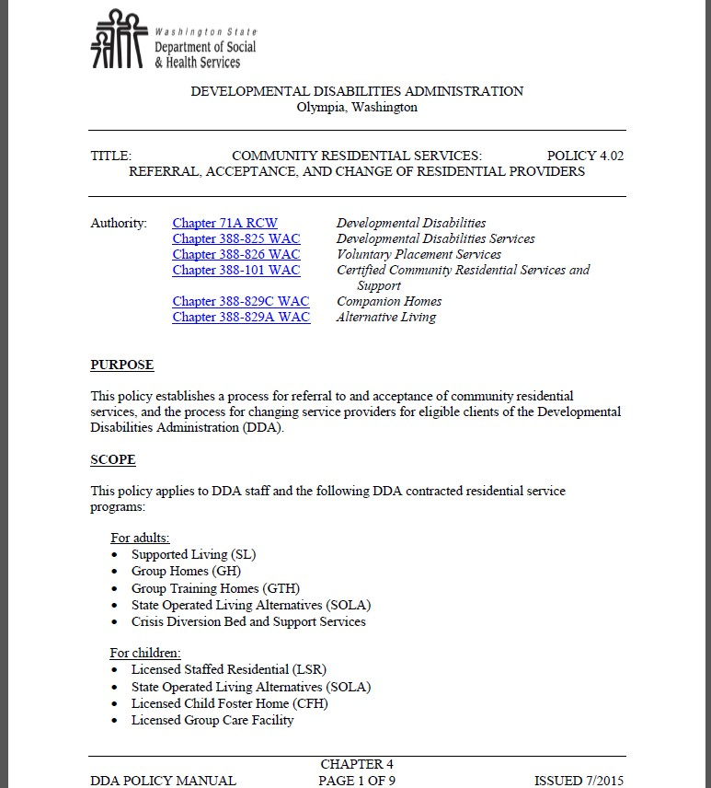

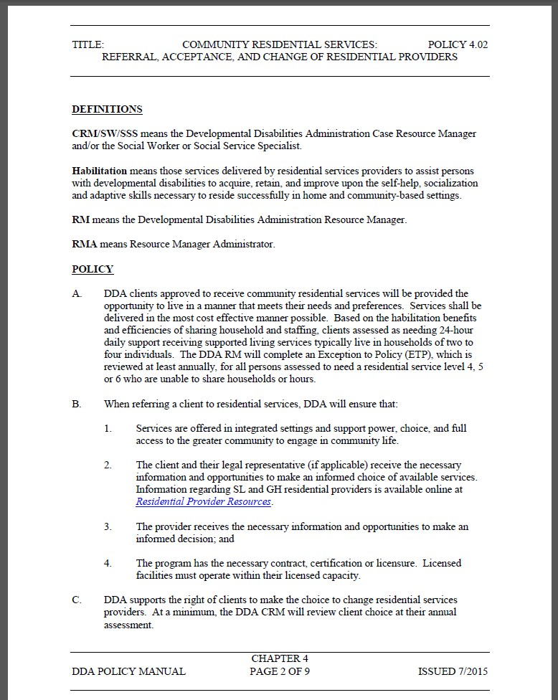Washington State

Revised Transition Plan for New HCBS Rules

To be Submitted to CMS in May 2017—Posted for Public Comment on March 15, 2017

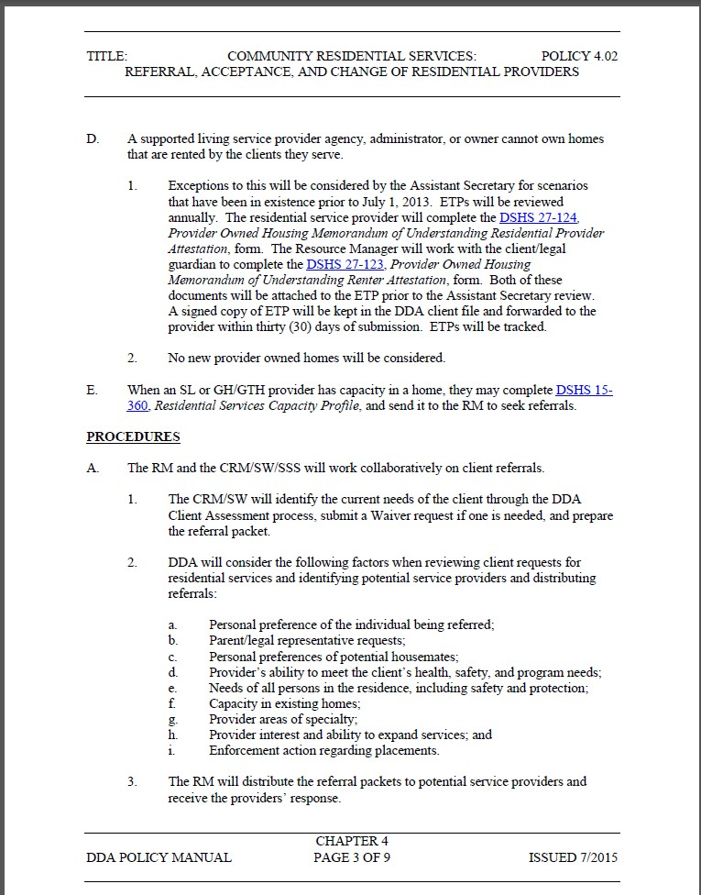Washington State

Revised Transition Plan for New HCBS Rules

To be Submitted to CMS in May 2017—Posted for Public Comment on March 15, 2017

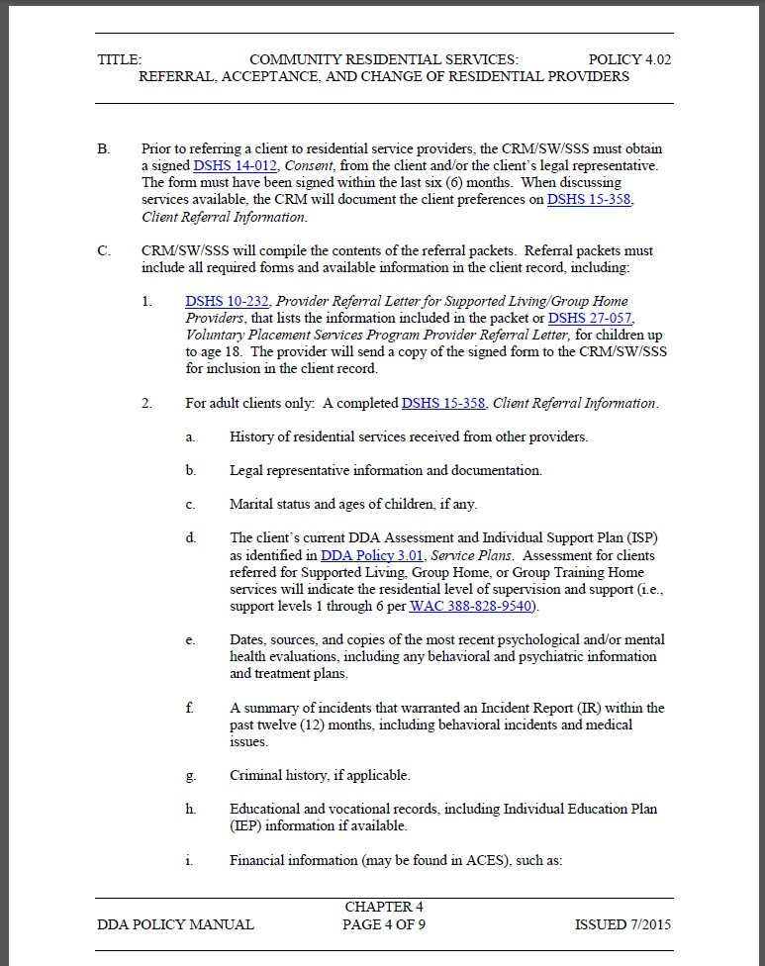Washington State

Revised Transition Plan for New HCBS Rules

To be Submitted to CMS in May 2017—Posted for Public Comment on March 15, 2017

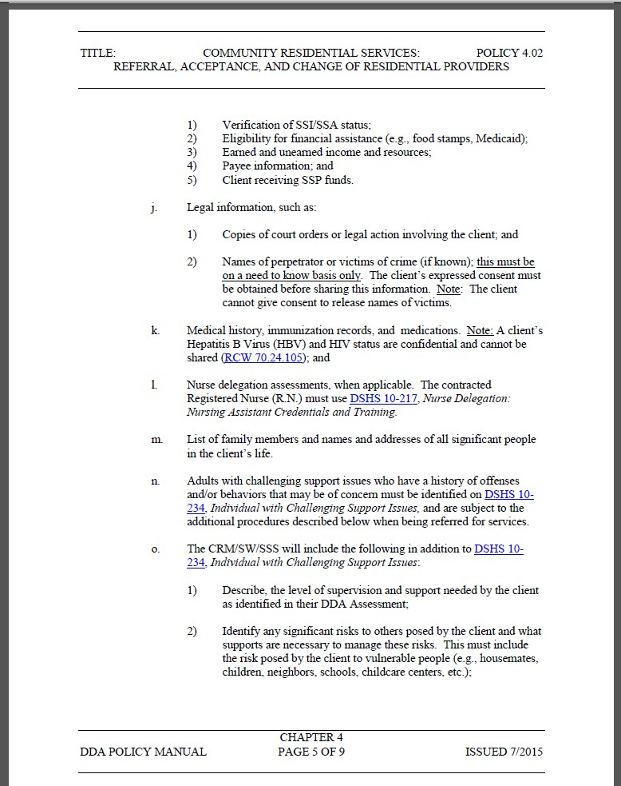Washington State

Revised Transition Plan for New HCBS Rules

To be Submitted to CMS in May 2017—Posted for Public Comment on March 15, 2017

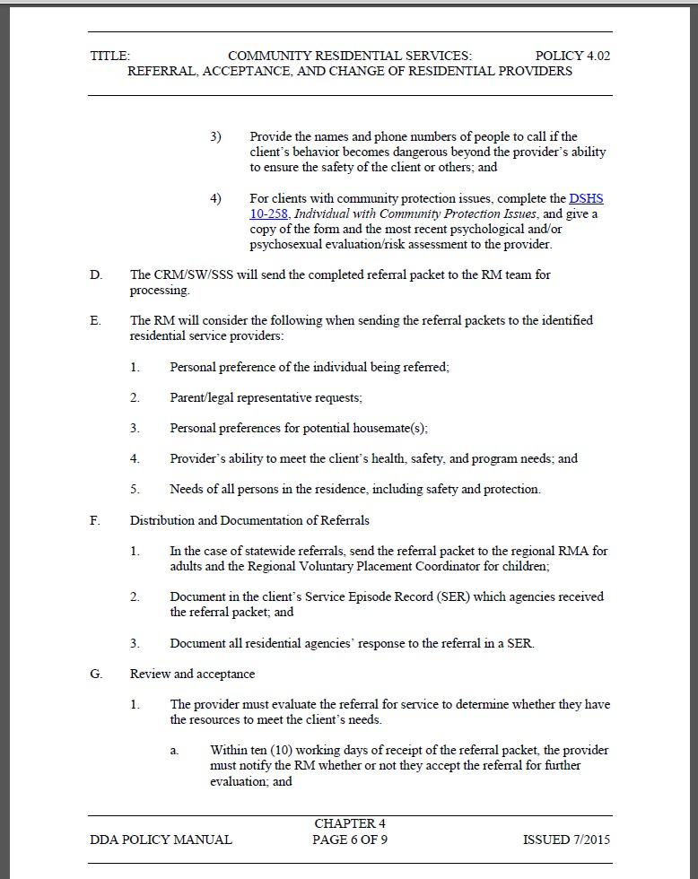Washington State

Revised Transition Plan for New HCBS Rules

To be Submitted to CMS in May 2017—Posted for Public Comment on March 15, 2017

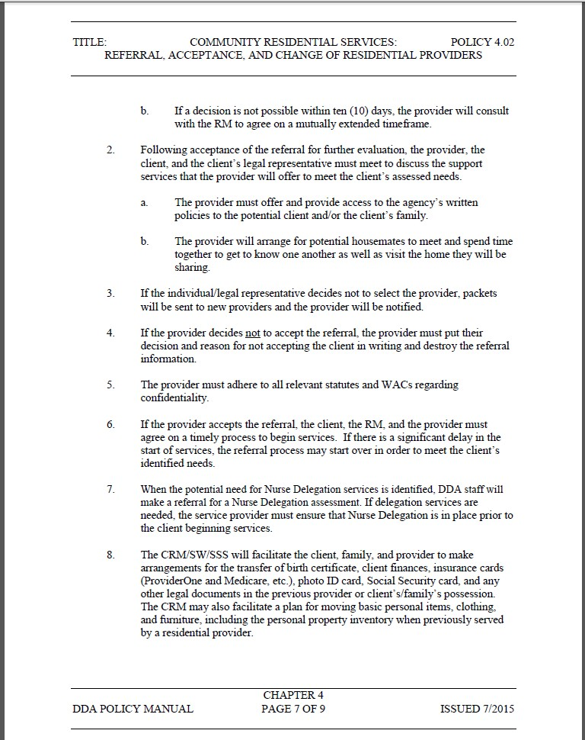Washington State

Revised Transition Plan for New HCBS Rules

To be Submitted to CMS in May 2017—Posted for Public Comment on March 15, 2017

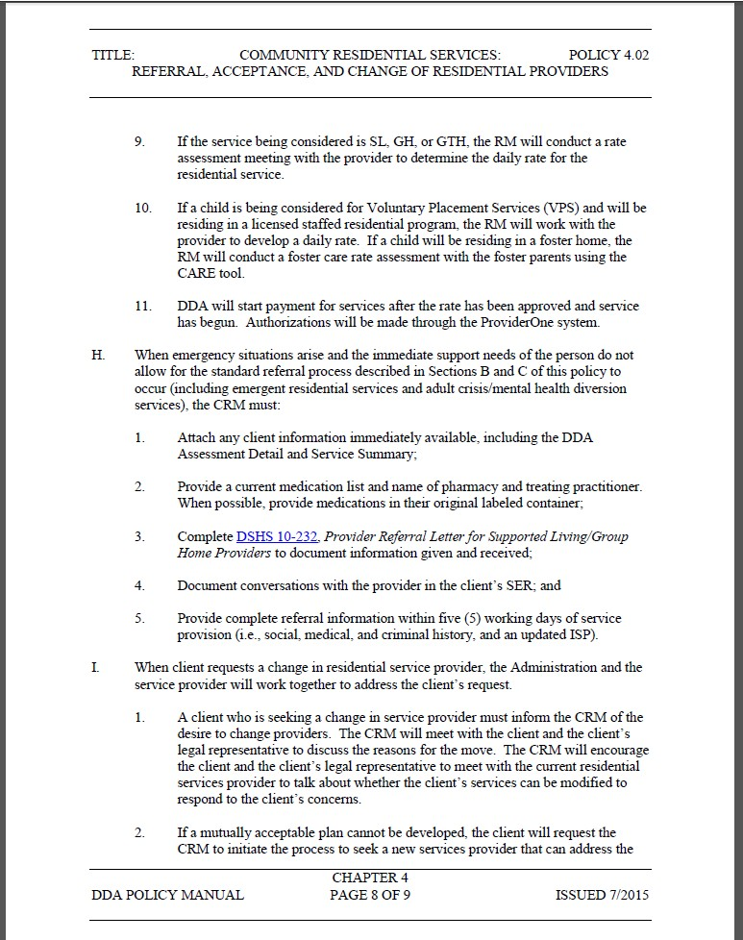Washington State

Revised Transition Plan for New HCBS Rules

To be Submitted to CMS in May 2017—Posted for Public Comment on March 15, 2017

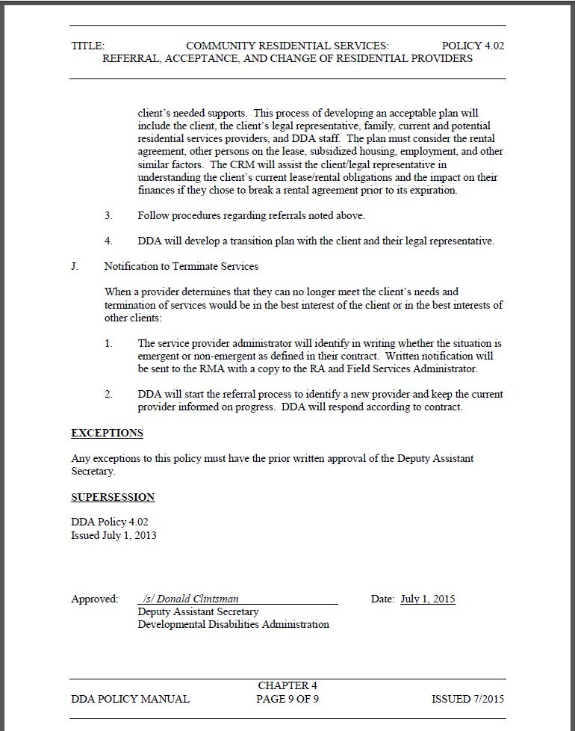Washington State

Revised Transition Plan for New HCBS Rules

To be Submitted to CMS in May 2017—Posted for Public Comment on March 15, 2017

Washington State

Revised Transition Plan for New HCBS Rules

To be Submitted to CMS in May 2017—Posted for Public Comment on March 15, 2017

Client Service Summary Excerpt

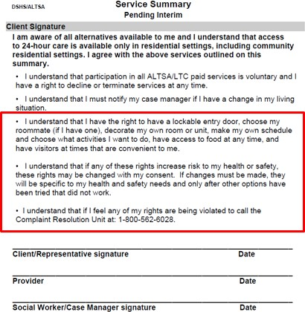

Washington State

Revised Transition Plan for New HCBS Rules

To be Submitted to CMS in May 2017—Posted for Public Comment on March 15, 2017

Excerpt from Client Service Contract for Companion Home 7-1-2015

Special Terms and Conditions

3. Expectations

a. Companion Home services are provided in an integrated setting and facilitate the client’s full access to the greater community. This may include opportunities to seek employment and work in competitive, integrated settings, engage in community life, control personal resources and receive services in the community in the same manner as individuals without disabilities. The Contractor will:

Protect essential personal rights of privacy, dignity, respect and freedom from coercion and restraint.

Support the Client’s initiative, autonomy and independence in making life choices. This may include but is not limited to choices in daily activities, physical environment and with whom to interact. Client’s choices are optimized and not regimented.

The client’s home is a specific physical place that can be owned, rented or occupied under another legally enforceable agreement by the client receiving services. The client has the same responsibilities and protections from eviction from their home under the landlord tenant law of the State of Washington, County, City or other designated entity as the general public.

Honor the Client’s right to privacy in their bedroom and right to decorate and furnish their bedroom.

Allow Clients to lock the door to their sleeping unit. The Contractor can retain a key to use in case of emergency.

Support Clients to have the freedom and support to control their own schedules.

Support the Client to have visitors of their choosing at any time.

Support the Client’s freedom to access to food at any time.

Provide a setting that is physically accessible to the Client.

Washington State

Revised Transition Plan for New HCBS Rules

To be Submitted to CMS in May 2017—Posted for Public Comment on March 15, 2017

Excerpt from DDA County Services Contract effective 7/1/2015
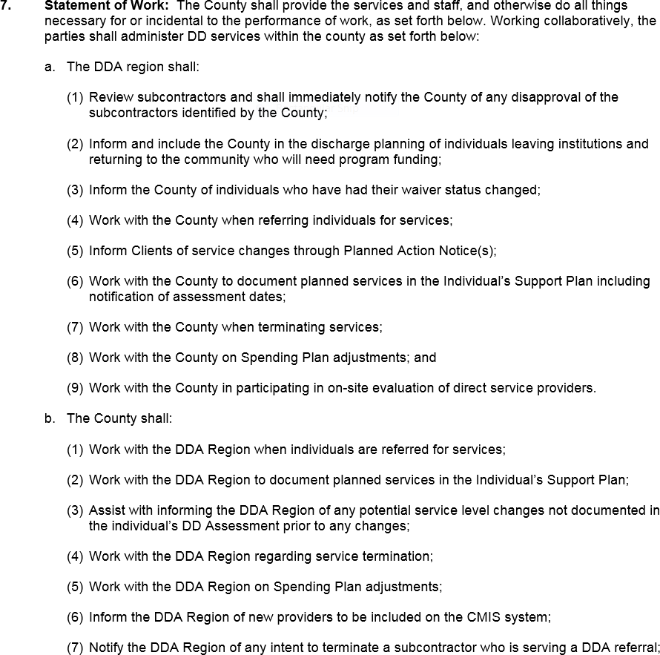

Washington State

Revised Transition Plan for New HCBS Rules

To be Submitted to CMS in May 2017—Posted for Public Comment on March 15, 2017

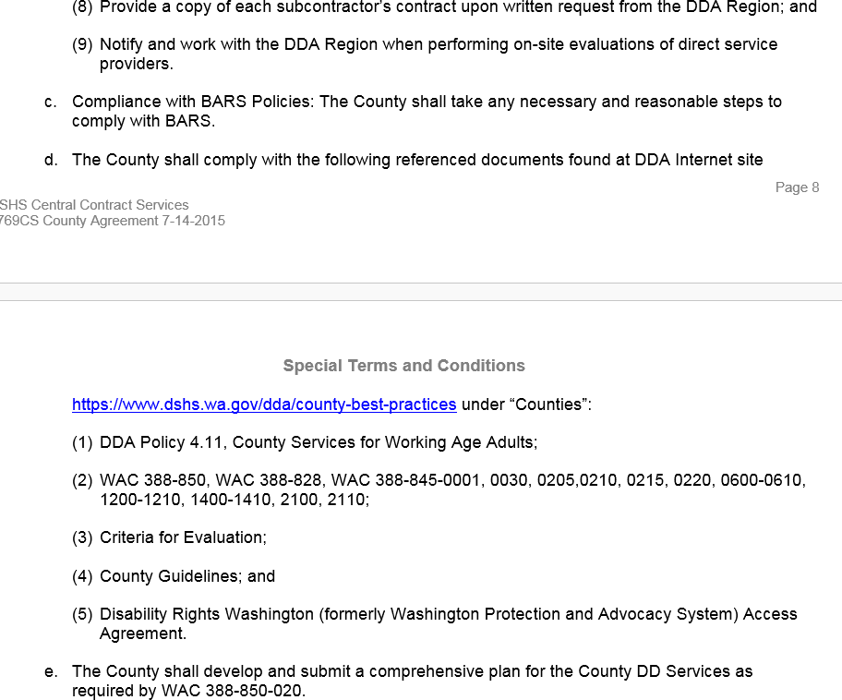

Washington State

Revised Transition Plan for New HCBS Rules

To be Submitted to CMS in May 2017—Posted for Public Comment on March 15, 2017

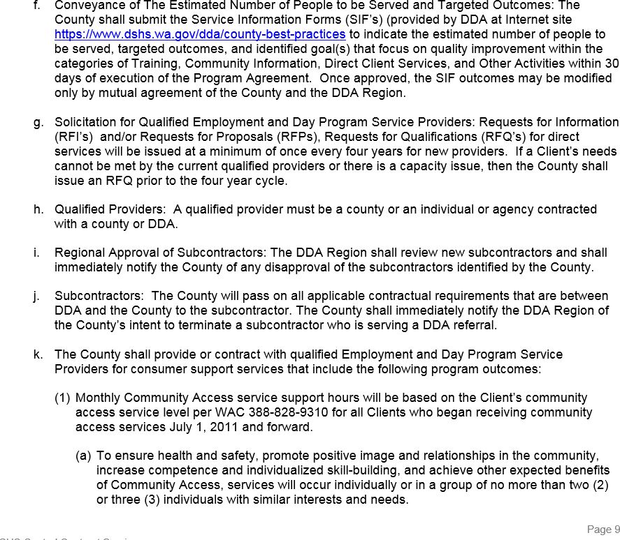

Washington State

Revised Transition Plan for New HCBS Rules

To be Submitted to CMS in May 2017—Posted for Public Comment on March 15, 2017
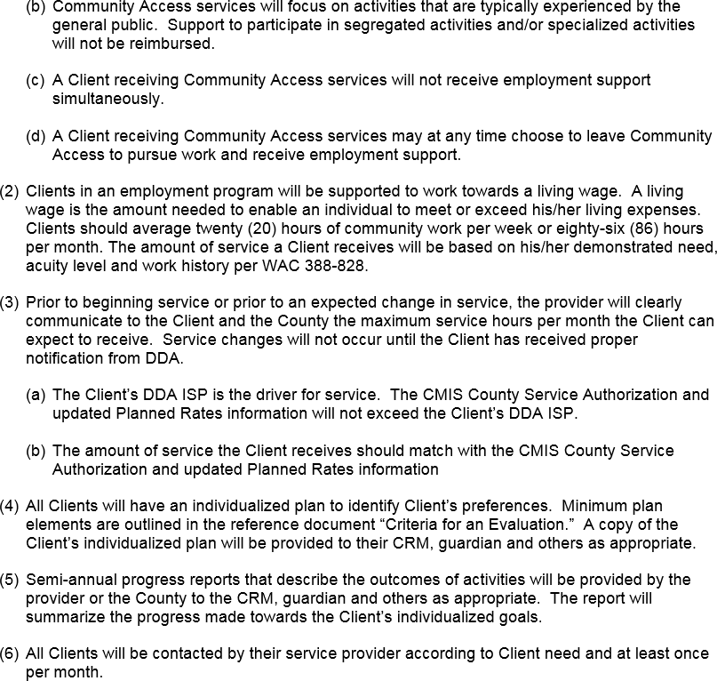

Washington State

Revised Transition Plan for New HCBS Rules

To be Submitted to CMS in May 2017—Posted for Public Comment on March 15, 2017

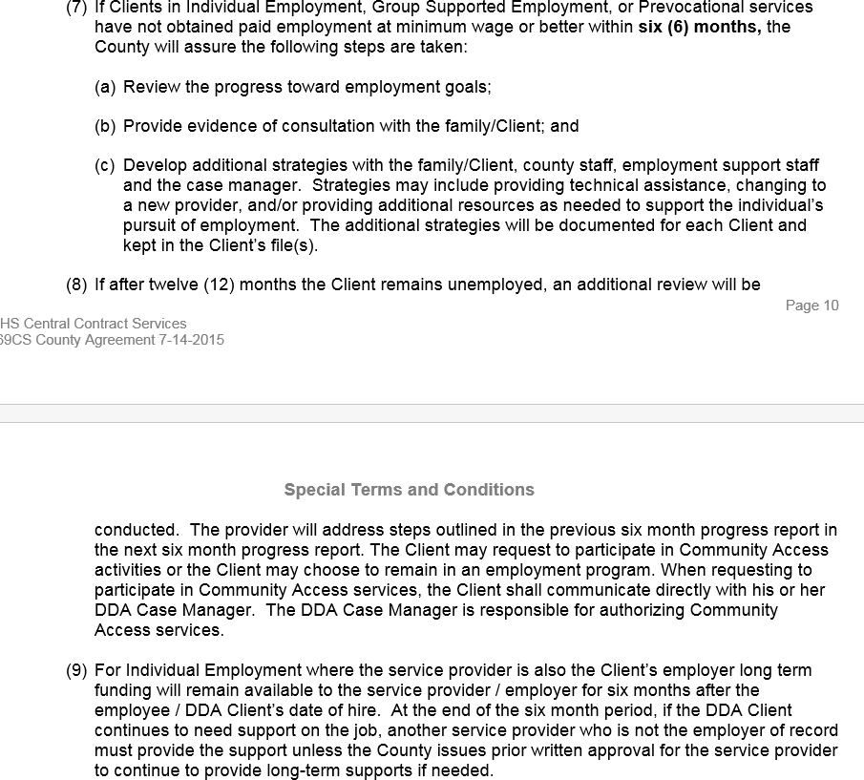

Washington State

Revised Transition Plan for New HCBS Rules

To be Submitted to CMS in May 2017—Posted for Public Comment on March 15, 2017
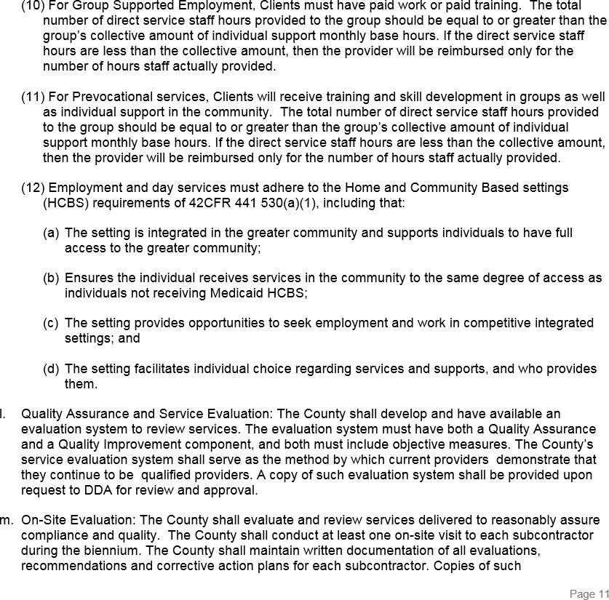

Washington State

Revised Transition Plan for New HCBS Rules

To be Submitted to CMS in May 2017—Posted for Public Comment on March 15, 2017
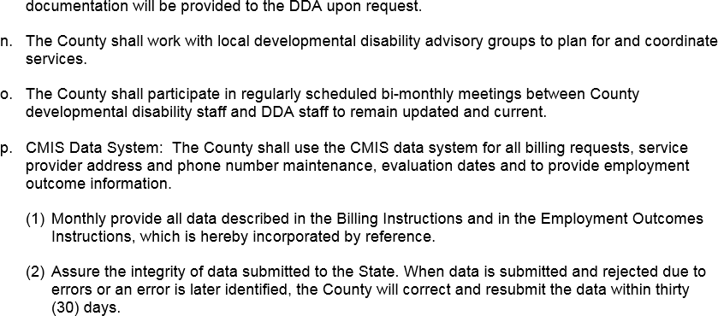

Washington State

Revised Transition Plan for New HCBS Rules

To be Submitted to CMS in May 2017—Posted for Public Comment on March 15, 2017

Excerpt from Engrossed Substitute Senate Bill 6052

Engrossed Substitute Senate Bill 6052, Chapter 4, Laws of 2015, Section 205 (Partial veto)

Legislative Charge

As part of the 2015 legislative Session, the Washington State Legislature passed ESSB 6052 requiring the Developmental Disabilities Administration to develop a report describing options for modifying the current system of Pre-vocational services for individuals with developmental disabilities. At minimum, the report must describe the following options:

Modification of the current system to ensure compliance with rules established by the centers for Medicare and Medicaid Services;

Continuation of the current system without federal matching funds; and

Transitioning of clients out of congregate settings and into integrated settings.

In addition, if a client transitions out of a congregate setting prior to December 1, 2016, then for each client, during the period before and after leaving the congregate setting, the report must describe the hours of service, hours worked, hourly wage, monthly earnings, authorized waiver services, and per capita expenditures.

Washington State

Revised Transition Plan for New HCBS Rules

To be Submitted to CMS in May 2017—Posted for Public Comment on March 15, 2017

Excerpt from Group Training Home Contract 7-1-2015

3. Statement of Work. The Contractor shall provide Supported Living, Group Home or Group Training Home Instruction and support services for Clients of DDA in accordance with Chapter 388-101 WAC and Exhibit A.

a. Group Homes or Group Training Homes

(3) For Group Homes and Group Training Homes:

Group Homes and Group Training Homes are specific physical places that can be owned, rented or occupies under another legally enforceable agreement by the individual receiving services. The contractor must have a lease, residency or other form of written agreement in place with the client that provides the same responsibilities and protections from eviction from their home under the landlord tenant law of the State of Washington, County, City or other designated entity as the general public.

Clients have the right to privacy in their bedroom.

i. Clients are allowed lockable doors to their bedroom (while still allowing for independent egress) with appropriate staff having keys to the door(s).

Washington State

Revised Transition Plan for New HCBS Rules

To be Submitted to CMS in May 2017—Posted for Public Comment on March 15, 2017

Excerpt from Washington Initiative for Supported Employment (WISE) Contract

Exhibit A3 Statement of Work: Pathway to Employment

The Contractor shall provide the services and staff, and otherwise do all things necessary for or incidental to the performance of work. The Contractor will provide the following statewide services and activities:

(5) Employment Agency Business Model:

The Contractor will provide the technical assistance necessary to promote employment agency viability and best available practice by conducting in-depth conversations, analysis, and assessment.

Said conversations, analysis, and assessment will culminate in an “Organizational Change Towards Effective Business Models for Employment Agencies” report identifying key components of an effective employment agency model within Washington.

(8) DDA will provide prior acceptance of the selected staff, third party consultant, to execute the quality assurance portion of the contract.

The consultant will collaborate with DDA to assess the quality and effectiveness of the Employment and Day Program.

The consultant will work with DDA to support counties and employment agencies looking to transform employment services from segregated to integrated models.

The consultant will communicate regularly with DDA.

Washington State

Revised Transition Plan for New HCBS Rules

To be Submitted to CMS in May 2017—Posted for Public Comment on March 15, 2017

R15-047 – INFORMATION

June 22, 2015

TO: | RCS Regional Administrators  RCS Field Managers RCS Management Team  RCS Compliance Specialists
FROM: | Kathy Morgan, Interim Director Residential Care Services
SUBJECT: | IMPLEMENTING FEDERAL HOME & COMMUNITY BASED SETTINGS (HCBS) RULES
PURPOSE: | To inform staff that a letter is being sent to all AFH providers and ALF administrators. The letter explains the expectations that the Centers for Medicaid and Medicare Services (CMS) has for providers when developing care plans that are in compliance with the new HCBS rules.
BACKGROUND: | - In 2014, CMS released federal regulations about home and community based settings. The regulations are intended to ensure that individuals receiving long-term care services have full access to the benefits of community living.  - These rules apply to adult family homes and assisted living facilities.  - How a resident accesses the community and is able to make choices about the care and services they receive is to be documented in their care plan.

WHAT’S NEW, CHANGED, OR

The attached letters will be sent to all AFHs & ALF, reviewing the key requirements of the federal HCBS regulations.

Washington State

Revised Transition Plan for New HCBS Rules

To be Submitted to CMS in May 2017—Posted for Public Comment on March 15, 2017

CLARIFIED:
ACTION: | Read the attached letters and be prepared to answer any questions that providers or administrators may have.
RELATED  REFERENCES: | None
ATTACHMENT(S): | - Dear AFH Provider - ALTSA: AFH #2015-013  - Dear ALF Administrator - ALTSA: ALF #2015-014
CONTACT(S): | If you have any questions about person-centered planning please contact your local Home and Community Services Office.

Washington State

Revised Transition Plan for New HCBS Rules

To be Submitted to CMS in May 2017—Posted for Public Comment on March 15, 2017

RCS MANAGEMENT BULLETIN

R15-056 - INFORMATION

July 27, 2015

TO: | RCS Regional Administrators  RCS Field Managers RCS Management Team
FROM: | Kathy Morgan, Interim Director Residential Care Services
SUBJECT: | TRAINING ANNOUNCEMENT FOR AFH AND ALF PROVIDERS/ADMINSTRATORS ON HOME & COMMUNITY BASED SERVICES (HCBS) SETTING REQUIREMENTS
PURPOSE: | To let field staff know that a provider/administrator letter is going out to AFHs & ALFs announcing that Home and Community Services (HCS) is going to provide two webinar trainings for providers/administrators.
BACKGROUND: | - In 2014, CMS released federal regulations about home and community based settings. The regulations are intended to ensure that individuals

Washington State

Revised Transition Plan for New HCBS Rules

To be Submitted to CMS in May 2017—Posted for Public Comment on March 15, 2017

receiving long-term care services have full access to the benefits of
community living.
WHAT’S NEW, CHANGED, OR  CLARIFIED: | - HCS will conduct a webinar for providers to explain the new expectations.  - The webinar will be done twice and the presentation slides will then be posted on the professional web pages.
ACTION: | - RCS staff are to read the provider/administrator letter and be aware of the training.  - Providers are to be directed to the number below if they have questions.
RELATED  REFERENCES: | R15-047
ATTACHMENT(S): | - Dear AFH Provider – ALTSA AFH #2015-017  - Dear ALF Administrator – ALTSA: ALF #2015-016
CONTACT(S): | Valentina Karnafel, HCS Residential Program Manager, 360-725-2370

Washington State

Revised Transition Plan for New HCBS Rules

To be Submitted to CMS in May 2017—Posted for Public Comment on March 15, 2017

Resident Interview Questions
Attachment G
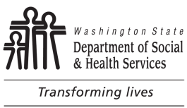
Assisted Living Facility Resident Interview
ASSISTED LIVING FACILITY NAME LICENSE NUMBER

INSPECTION DATE LICENSOR NAME

RESIDENT NAME |  | RESIDENT NUMBER | ROOM NUMBER | PAY STATUS  Private State
Brief Review of Negotiated Service Agreement:
The questions below are intended as a guide and should not prevent the interviewer from asking more questions or obtaining more data if concerns are identified. If you are concerned about the answers, please investigate further.
Introductory questions: The interviewer may want to consider one of the following questions as a lead to the interview.

SELECT ONE

Resident Interview Representative Interview
A. The following are REQUIRED questions and MUST be asked during the interview. Check “Y,” if the answer is yes; check “N,” if the answer is no and document the interviewee’s response; or check “D” if the interviewee declined to answer the question.
Y N D

Can you make choices about the care and services you
receive here at the home?

Washington State

Revised Transition Plan for New HCBS Rules

To be Submitted to CMS in May 2017—Posted for Public Comment on March 15, 2017

If you have a roommate, were you informed you would have a roommate? Could you change roommates if you wanted to?

Do you have an opportunity to participate in community activities?
Can you choose who visits you and when?
Do they pay attention to what you have to say?
Can you choose to lock your door?
Do you have access to food anytime?
Do you receive services in the community?
B. Care and Service Needs
What kind of help do you get from the staff?  How well does staff meet your needs? | Other:  No Concerns
C. Support of Personal Relationships (if the resident has family or significant others)
Does staff give you time and space to meet / visit with friends and family who come to visit? | Other:  No Concerns

Washington State

Revised Transition Plan for New HCBS Rules

To be Submitted to CMS in May 2017—Posted for Public Comment on March 15, 2017

Are you able to make personal phone calls without being overheard?
D. Reasonable House Rules
Tell me about the rules of the house.  What have you been told about how long you can stay up at night or how early or late you can watch TV? | Other:  No Concerns
E. Respect of Individuality, Independence, Personal Choice, Dignity
Does the staff here know about your preferences?  What kinds of things do you make choices about?  How does the staff treat you? Speak to you?  Do you have any concerns about how you are treated? | Other:  No Concerns
F. Homelike Environment
What is your room like? Are you comfortable there?  What personal items were you allowed to bring when you came here?  Is the temperature here comfortable to you? | Other:  No Concerns

Washington State

Revised Transition Plan for New HCBS Rules

To be Submitted to CMS in May 2017—Posted for Public Comment on March 15, 2017

G. Response to Concerns
Do you feel like you can tell someone if you don’t like it here?  Who would you talk to if you had concerns?  What do you think they would do about it? | Other:  No Concerns
H. Sense of Well-Being and Safety
Do you feel safe here?  Does anything make you feel uncomfortable here? | Other:  No Concerns
I. Meals / Snacks / Preferences
How is the food here?  If you can’t eat something or don’t like something, what kind of replacement does the home offer you?  How often do you get the foods you like to eat? | Other:  No Concerns
J. Activities
What activities are offered to you by the home?  What kinds of things did you do for fun and relaxation before you came here? | Other:  No Concerns

Washington State

Revised Transition Plan for New HCBS Rules

To be Submitted to CMS in May 2017—Posted for Public Comment on March 15, 2017

Are there activities you would like to do that you are not offered?

Is there anything you wanted to do and the home helped you do it?
K. Notice
Do you handle your own finances or does someone help you with that?  What were you told about paying for your care here and the home’s policy about admitting and keeping residents whose stay is paid for by the state (Medicaid)?  When and how were you told about this? | Other:  No Concerns
Leave a contact number for the resident to be able to contact you/RCS staff in the future.

Washington State

Revised Transition Plan for New HCBS Rules

To be Submitted to CMS in May 2017—Posted for Public Comment on March 15, 2017

Adult Family Home Resident Interview

ADULT FAMILY HOME’S (AFH) NAME | LICENSE NUMBER
PROVIDER / LICENSEE’S NAME | INSPECTION DATE
LICENSOR’S NAME

AGING AND LONG-TERM SUPPORT ADMINISTRATION (ALTSA)
Comprehensive Resident / Representative Interview (Resident: 1 2)

RESIDENT’S NUMBER | RESIDENT’S NAME
REPRESENTATIVE’S NAME |  |  | TELEPHONE NUMBER (AREA CODE)
Introductory Questions: First determine if the resident is interviewable. Indicate the question asked by checking the corresponding box.
What is the best part about living here? How long have you lived here?  Are you from around here?  If you could change one thing about living here, what would it be? |  | Other question (write it out):
SELECT ONE
Resident Interview Representative Interview
L. The following are REQUIRED questions and MUST be asked during the interview. Check “Y,” if the answer is yes; check “N,” if the answer is no and document the interviewee’s response; or check “D” if the interviewee declined to answer the question.
Y N D
Can you make choices about the care and services you receive here at the home?
If you have a roommate, were you informed you would have a roommate? Could you change roommates if you wanted to?

Washington State

Revised Transition Plan for New HCBS Rules

To be Submitted to CMS in May 2017—Posted for Public Comment on March 15, 2017
ADULT FAMILY HOME’S (AFH) NAME | LICENSE NUMBER
PROVIDER / LICENSEE’S NAME | INSPECTION DATE
LICENSOR’S NAME

AGING AND LONG-TERM SUPPORT ADMINISTRATION (ALTSA)
Comprehensive Resident / Representative Interview (Resident: 1 2)

Do you have an opportunity to participate in community activities?
Can you choose who visits you and when?
Do they pay attention to what you have to say? Can you choose to lock your door?
Do you have access to food anytime?
Do you receive services in the community?
INSTRUCTIONS: Your interview must address each category. Check the question asked or write your own question. If you are concerned about the answers, please investigate further. If resident is not interviewable, modify questions for Representative interview.
M. Care and Service Needs
What kind of help do you get from the staff? How well does staff meet your needs? | Other:  No Concerns
N. Support of Personal Relationships (if the resident has family or significant others)
Does staff give you time and space to meet / visit with friends and family who come to visit?  Are you able to make personal phone calls without being overheard? | Other:  No Concerns
O. Reasonable House Rules
Tell me about the rules of the house.  What have you been told about how long you can stay up at night or how early or late you can watch TV? | Other:  No Concerns
P. Respect of Individuality, Independence, Personal Choice, Dignity
Does the staff here know about your preferences? What kinds of things do you make choices about? | Other:

Washington State

Revised Transition Plan for New HCBS Rules

To be Submitted to CMS in May 2017—Posted for Public Comment on March 15, 2017
ADULT FAMILY HOME’S (AFH) NAME | LICENSE NUMBER
PROVIDER / LICENSEE’S NAME | INSPECTION DATE
LICENSOR’S NAME

AGING AND LONG-TERM SUPPORT ADMINISTRATION (ALTSA)
Comprehensive Resident / Representative Interview (Resident: 1 2)

How does the staff treat you? Speak to you? Do you have any concerns about how you are treated? | No Concerns
Q. Homelike Environment
What is your room like? Are you comfortable there?  What personal items were you allowed to bring when you came here?  Is the temperature here comfortable to you? | Other:  No Concerns
R. Response to Concerns
Do you feel like you can tell someone if you don’t like it here?  Who would you talk to if you had concerns? What do you think they would do about it? | Other:  No Concerns
S. Sense of Well-Being and Safety
Do you feel safe here?  Does anything make you feel uncomfortable here? | Other:  No Concerns
T. Meals / Snacks / Preferences
How is the food here?  If you can’t eat something or don’t like something, what kind of replacement does the home offer you? How often do you get the foods you like to eat? | Other:  No Concerns
U. Activities
What activities are offered to you by the home? | Other:

Washington State

Revised Transition Plan for New HCBS Rules

To be Submitted to CMS in May 2017—Posted for Public Comment on March 15, 2017
ADULT FAMILY HOME’S (AFH) NAME | LICENSE NUMBER
PROVIDER / LICENSEE’S NAME | INSPECTION DATE
LICENSOR’S NAME

AGING AND LONG-TERM SUPPORT ADMINISTRATION (ALTSA)
Comprehensive Resident / Representative Interview (Resident: 1 2)

What kinds of things did you do for fun and relaxation before you came here?  Are there activities you would like to do that you are not offered?  Is there anything you wanted to do and the home helped you do it? |  | No Concerns
V. Notice
Do you handle your own finances or does someone help you with that?  What were you told about paying for your care here and the home’s policy about admitting and keeping residents whose stay is paid for by the state (Medicaid)?  When and how were you told about this? |  | Other:  No Concerns

Washington State

Revised Transition Plan for New HCBS Rules

To be Submitted to CMS in May 2017—Posted for Public Comment on March 15, 2017
ADULT FAMILY HOME’S (AFH) NAME | LICENSE NUMBER
PROVIDER / LICENSEE’S NAME | INSPECTION DATE
LICENSOR’S NAME

AGING AND LONG-TERM SUPPORT ADMINISTRATION (ALTSA)
Comprehensive Resident / Representative Interview (Resident: 1 2)

W.
X.
Y.
Z.
AA.
BB.
CC.
DD.
EE.
FF.

Washington State

Revised Transition Plan for New HCBS Rules

To be Submitted to CMS in May 2017—Posted for Public Comment on March 15, 2017
ADULT FAMILY HOME’S (AFH) NAME | LICENSE NUMBER
PROVIDER / LICENSEE’S NAME | INSPECTION DATE
LICENSOR’S NAME

AGING AND LONG-TERM SUPPORT ADMINISTRATION (ALTSA)
Comprehensive Resident / Representative Interview (Resident: 1 2)

GG.
WA.0409

Washington State

Revised Transition Plan for New HCBS Rules

To be Submitted to CMS in May 2017—Posted for Public Comment on March 15, 2017
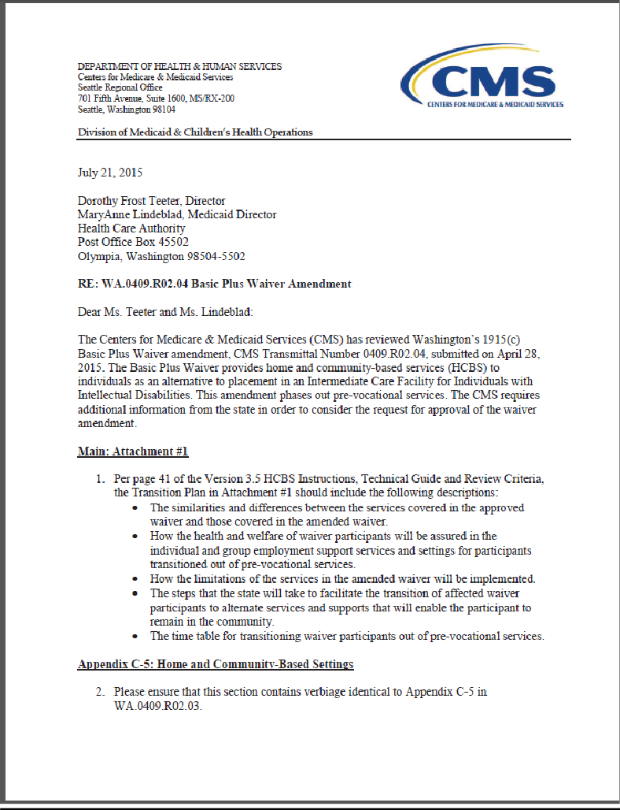

Washington State

Revised Transition Plan for New HCBS Rules

To be Submitted to CMS in May 2017—Posted for Public Comment on March 15, 2017
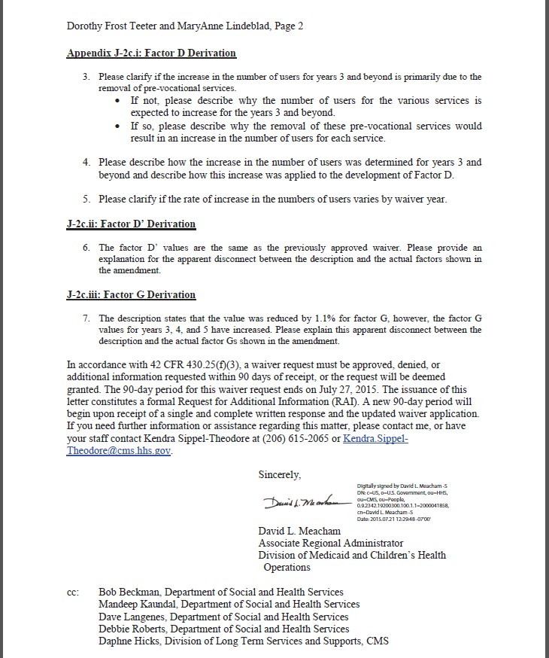

Washington State

Revised Transition Plan for New HCBS Rules

To be Submitted to CMS in May 2017—Posted for Public Comment on March 15, 2017

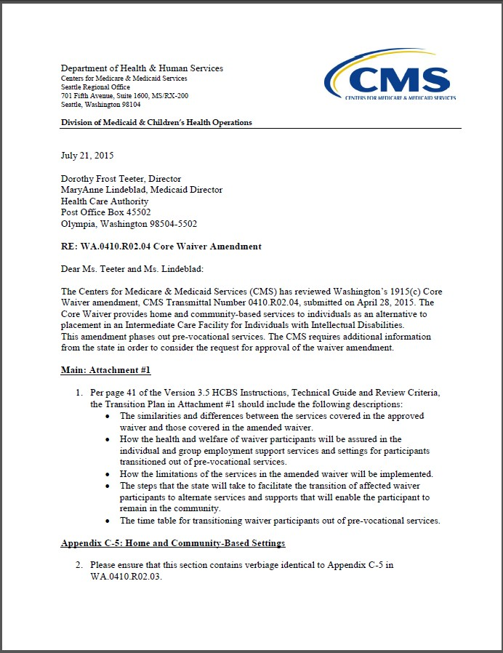
WA.0410

Washington State

Revised Transition Plan for New HCBS Rules

To be Submitted to CMS in May 2017—Posted for Public Comment on March 15, 2017
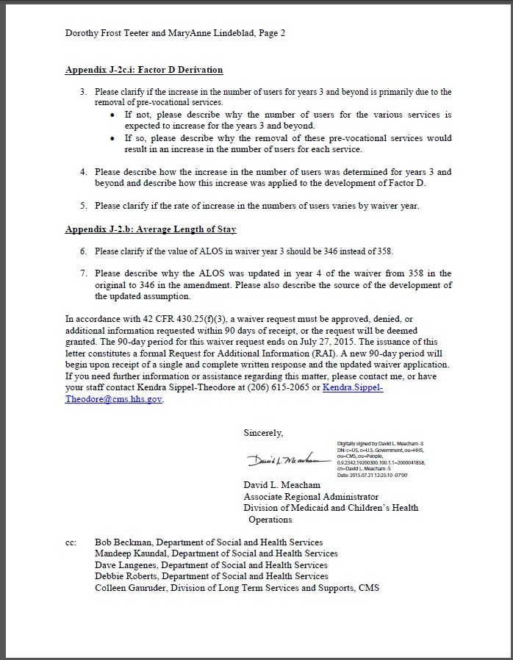

Washington State

Revised Transition Plan for New HCBS Rules

To be Submitted to CMS in May 2017—Posted for Public Comment on March 15, 2017

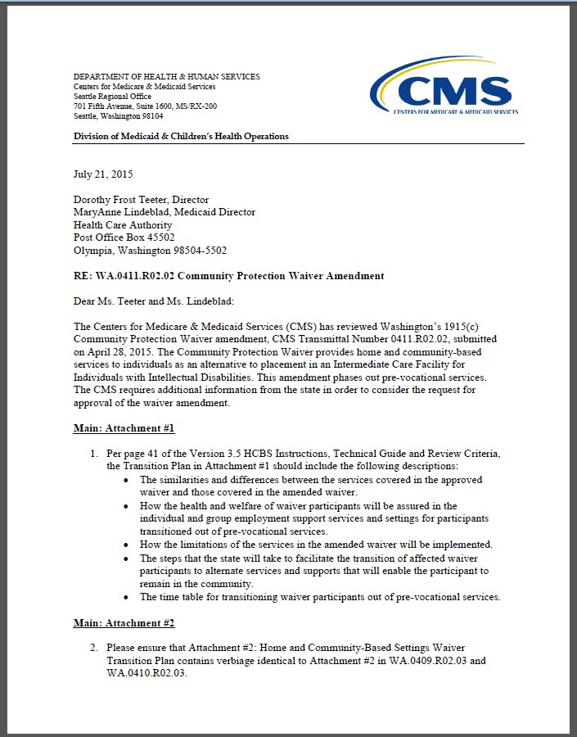
WA.0411

Washington State

Revised Transition Plan for New HCBS Rules

To be Submitted to CMS in May 2017—Posted for Public Comment on March 15, 2017
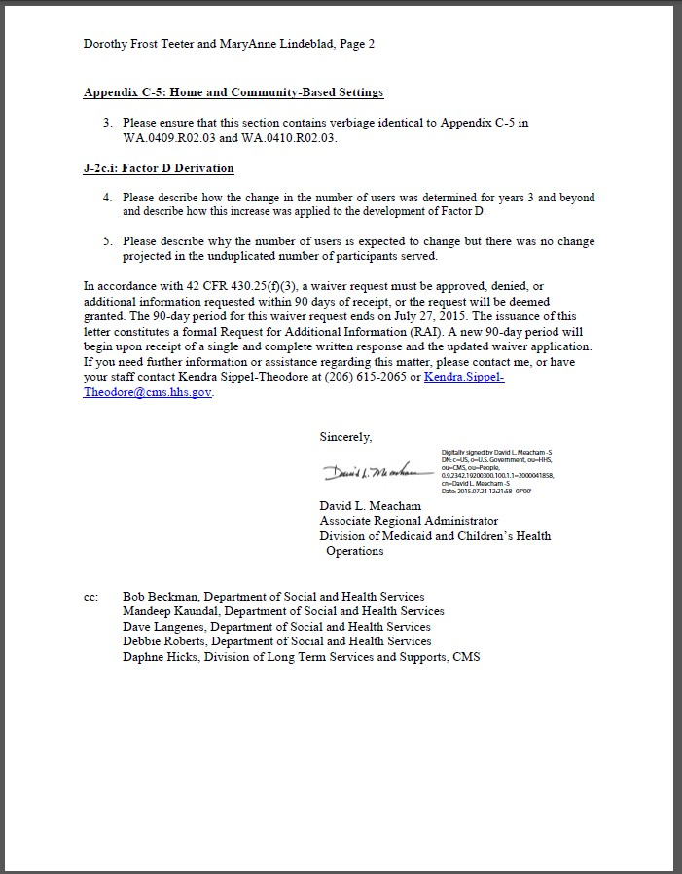

Washington State

Revised Transition Plan for New HCBS Rules

To be Submitted to CMS in May 2017—Posted for Public Comment on March 15, 2017

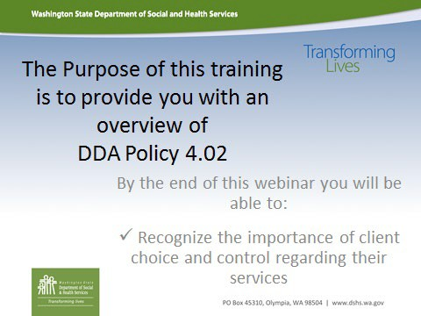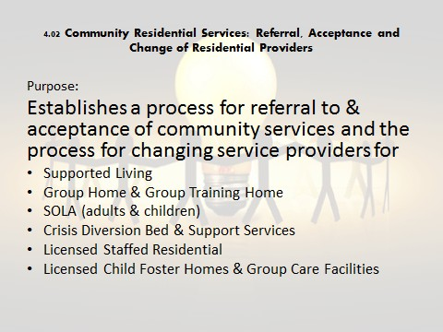DDA Residential Provider Training

Washington State

Revised Transition Plan for New HCBS Rules

To be Submitted to CMS in May 2017—Posted for Public Comment on March 15, 2017
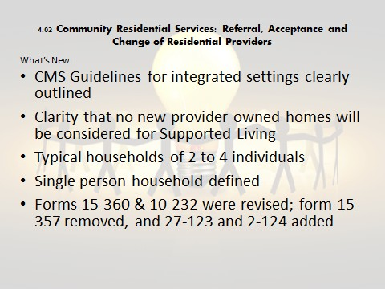

Washington State

Revised Transition Plan for New HCBS Rules

To be Submitted to CMS in May 2017—Posted for Public Comment on March 15, 2017
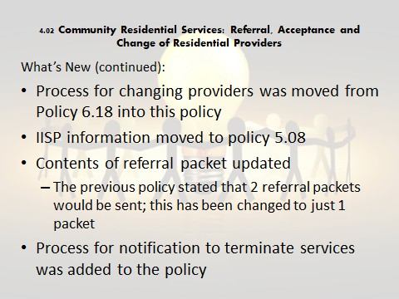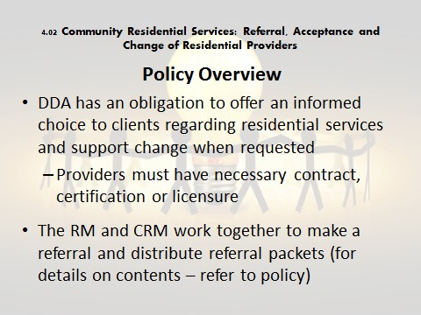

Washington State

Revised Transition Plan for New HCBS Rules

To be Submitted to CMS in May 2017—Posted for Public Comment on March 15, 2017
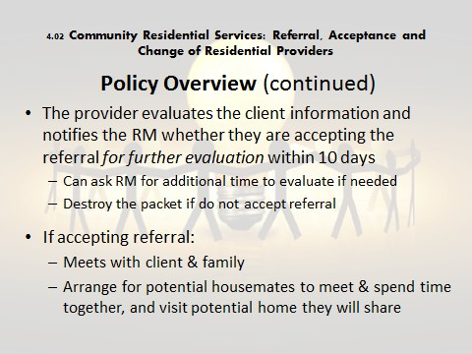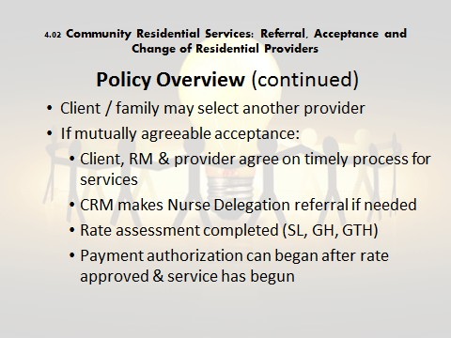

Washington State

Revised Transition Plan for New HCBS Rules

To be Submitted to CMS in May 2017—Posted for Public Comment on March 15, 2017
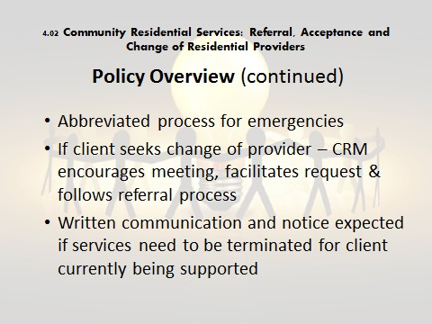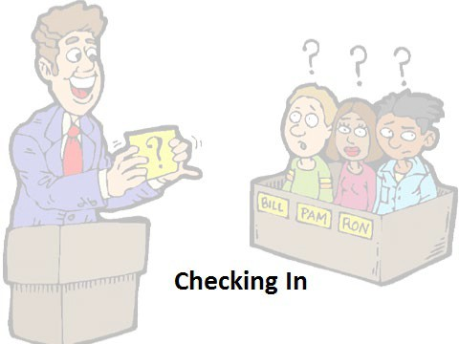

Washington State

Revised Transition Plan for New HCBS Rules

To be Submitted to CMS in May 2017—Posted for Public Comment on March 15, 2017
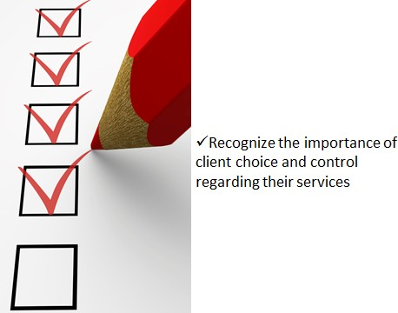

Washington State

Revised Transition Plan for New HCBS Rules

To be Submitted to CMS in May 2017—Posted for Public Comment on March 15, 2017
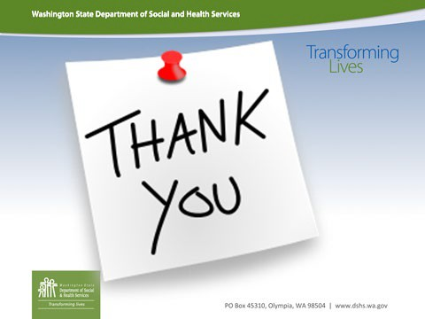

Washington State

Revised Transition Plan for New HCBS Rules

To be Submitted to CMS in May 2017—Posted for Public Comment on March 15, 2017

ALTSA and DDA HCBS Settings

 | DDA 1915c Waivers |  |  |  |  | ALTSA 1915c Waivers |  |  | State Plan  Programs | Statewide Transition Plan  Status
 | BASIC PLUS | CORE | CP | CIIBS | IFS | COPES | RESIDENTIAL SUPPORT WAIVER | NEW FREEDOM WAIVER | 1915k CFC HCS & DDA | INCLUDED | APPROVED  Through CFC and/or RSW and/or IFS
Private Homes | X | X | X | X | X | X |  | X | X |  | X
Adult Day Care |  |  |  |  |  | X |  |  |  | X
Adult Day Health |  |  |  |  |  | X | X |  |  |  | X
Adult Family Home |  |  |  |  |  |  | X |  | X |  | X
Enhanced Adult  Residential Care |  |  |  |  |  |  | X |  | X |  | X
Adult Residential Care |  |  |  |  |  |  |  |  | X |  | X
Assisted Living facility |  |  |  |  |  |  | X |  | X |  | X
Enhanced Service facility |  |  |  |  |  |  | X |  |  |  | X
Vehicle Modification  Providers |  |  |  | X | X |  |  | X |  | X
Community Healthcare  Providers |  |  |  |  |  |  |  | X |  | X
Dental Providers |  |  |  |  |  |  |  | X |  | X
DDA Group Training  Homes |  | X |  |  |  |  |  |  |  | X
DDA Companion Homes |  | X |  |  |  |  |  |  |  | X
DDA Group Homes |  | X |  |  |  |  |  |  |  | X
Licensed Staffed Residential, Child Foster Care and Group Care  Facilities |  | X |  |  |  |  |  |  |  | X
Veterinarians for Service  Animals |  |  |  |  |  |  |  | X |  | X

Washington State

Revised Transition Plan for New HCBS Rules

To be Submitted to CMS in May 2017—Posted for Public Comment on March 15, 2017

Transportation  Providers | X | X | X | X | X |  |  |  |  | X | X
DDA Individual Supported Employment  work sites | X | X | X |  |  |  |  |  |  | X
DDA Group Supported  Employment work sites | X | X | X |  |  |  |  |  |  | X
DDA Community  Inclusion | X | X |  |  |  |  |  |  |  | X
DDA Behavioral Health  Crisis Bed Diversion Services | X | X | X | X |  |  |  |  |  | X
DDA Specialized Psychiatric Services  Providers | X | X | X | X | X |  |  |  |  |  | X
DDA Positive Behavior Support and  Consultation Providers | X | X | X | X | X |  |  |  |  |  | X
DDA Community Crisis  Stabilization Services sites | X | X | X | X | X |  |  |  |  |  | X
DDA Pre-Vocational  Services sites | X | X | X |  |  |  |  |  |  | X
DDA Community  Engagement Providers |  |  |  |  | X |  |  |  |  |  | X
DDA Environmental Adaptations Providers | X | X | X | X | X |  |  |  |  |  | X
DDA Person-centered Plan Facilitation  Providers |  |  |  |  | X |  |  |  |  |  | X
DDA Peer Mentoring  Providers |  |  |  |  | X |  |  |  |  |  | X

Washington State

Revised Transition Plan for New HCBS Rules

To be Submitted to CMS in May 2017—Posted for Public Comment on March 15, 2017

DDA Supported  Parenting Providers |  |  |  |  | X |  |  |  |  |  | X
DDA Staff/Family Consultation & Training  Providers | X | X | X | X | X |  |  |  |  |  | X
DDA Therapeutic  Equipment & Supplies Providers |  |  |  | X | X |  |  |  |  |  | X
DDA Specialized  Clothing Providers |  |  |  | X | X |  |  |  |  |  | X
DDA Specialized  Nutrition Providers |  |  |  | X | X |  |  |  |  |  | X
Extended State Plan  Service Providers | X | X | X | X | X |  |  |  |  |  | X

Washington State

Revised Transition Plan for New HCBS Rules

To be Submitted to CMS in May 2017—Posted for Public Comment on March 15, 2017

DDA Policy 4.07
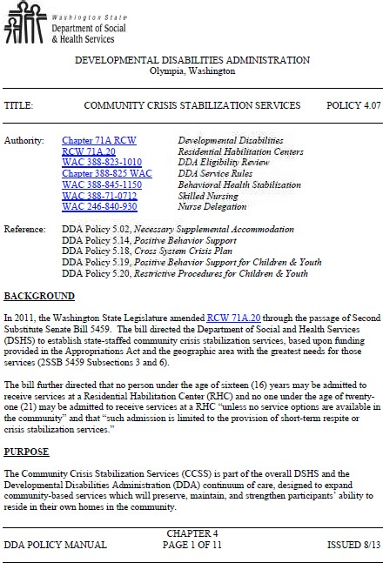

Washington State

Revised Transition Plan for New HCBS Rules

To be Submitted to CMS in May 2017—Posted for Public Comment on March 15, 2017
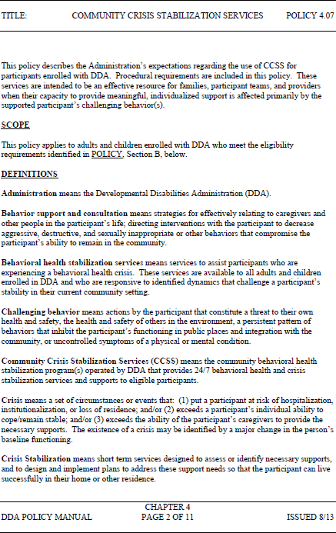

Washington State

Revised Transition Plan for New HCBS Rules

To be Submitted to CMS in May 2017—Posted for Public Comment on March 15, 2017
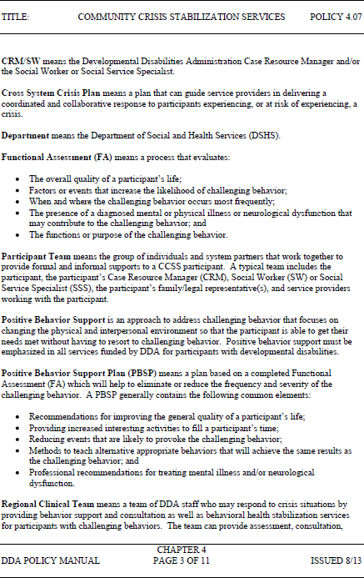

Washington State

Revised Transition Plan for New HCBS Rules

To be Submitted to CMS in May 2017—Posted for Public Comment on March 15, 2017
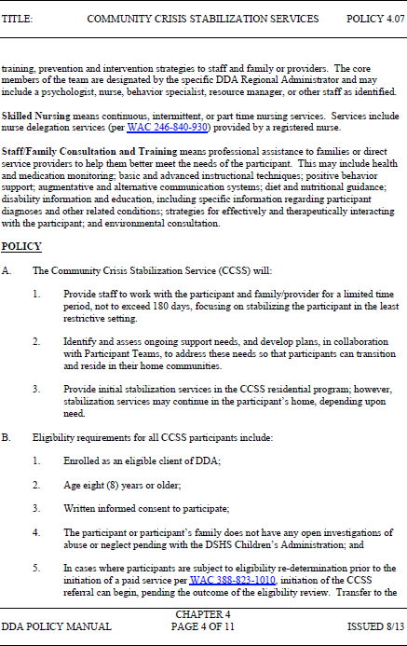

Washington State

Revised Transition Plan for New HCBS Rules

To be Submitted to CMS in May 2017—Posted for Public Comment on March 15, 2017
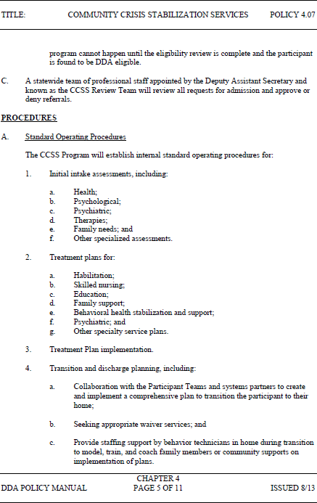

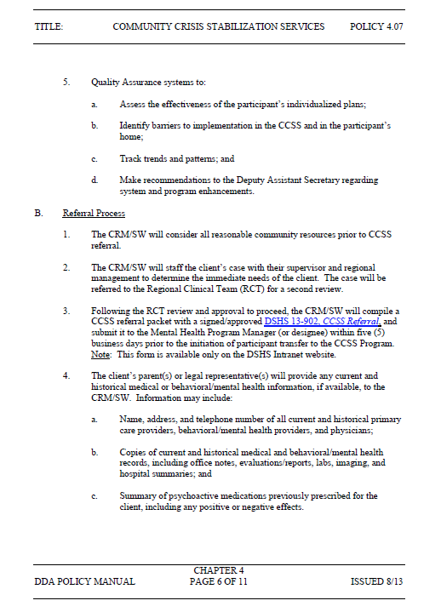Washington State

Revised Transition Plan for New HCBS Rules

To be Submitted to CMS in May 2017—Posted for Public Comment on March 15, 2017

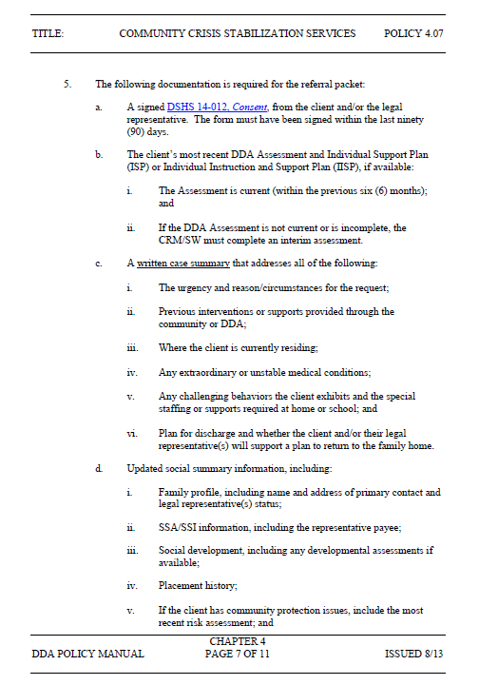Washington State

Revised Transition Plan for New HCBS Rules

To be Submitted to CMS in May 2017—Posted for Public Comment on March 15, 2017

Washington State

Revised Transition Plan for New HCBS Rules

To be Submitted to CMS in May 2017—Posted for Public Comment on March 15, 2017

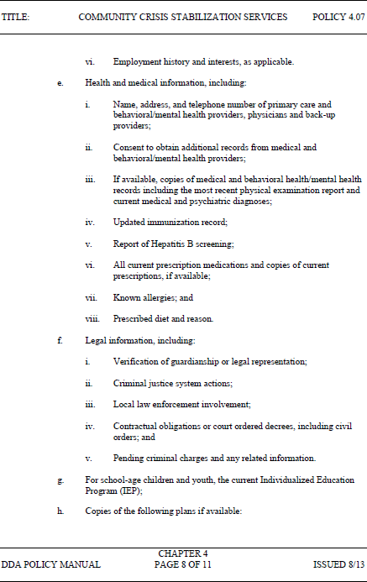

Washington State

Revised Transition Plan for New HCBS Rules

To be Submitted to CMS in May 2017—Posted for Public Comment on March 15, 2017

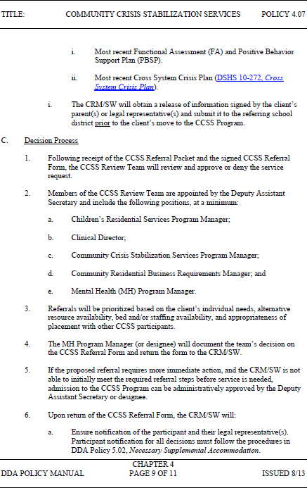

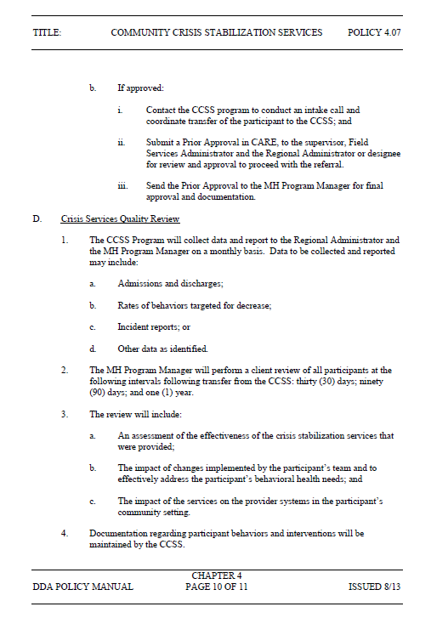Washington State

Revised Transition Plan for New HCBS Rules

To be Submitted to CMS in May 2017—Posted for Public Comment on March 15, 2017

Washington State

Revised Transition Plan for New HCBS Rules

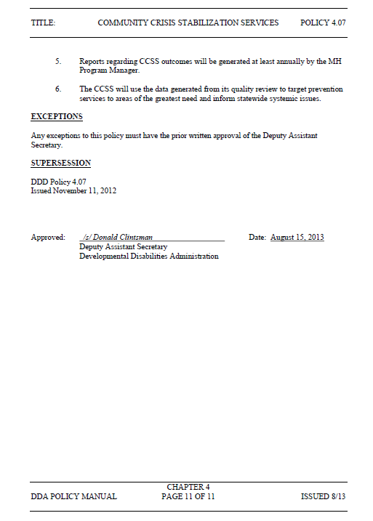To be Submitted to CMS in May 2017—Posted for Public Comment on March 15, 2017

Washington State

Revised Transition Plan for New HCBS Rules

To be Submitted to CMS in May 2017—Posted for Public Comment on March 15, 2017

WAC 388-823-1095

Client Rights WAC Revision Proposal updated 10-18-16

What are my rights as a DDA client?

As a DDA client, you have the following rights:

The right to be free from any kind of abuse or punishment (verbal, mental, physical, and/or sexual); or being sent to a place by yourself, if you do not choose to be alone;

The right to appeal any decision by DDA that denies, reduces, or terminates your eligibility, your services or your choice of provider;

The right to receive only those services you agree to;

The right to meet with and talk privately with your friends and family;

The right to personal privacy and confidentiality of your personal and other records;

The right to choose activities, schedules, and health care that meet your needs;

The right to be free from discrimination because of your race, color, creed, national origin, religion, sex, age, disability, marital status, gender identity, or sexual orientation;

The right to set your own rules in your home and to know what rules your providers have when you are living in their house or working in their facility;

The right to request information regarding services that may be available from DDA;

The right to know what your doctor wants you to do or take and to help plan how that will happen;

The right to be free from unnecessary medication;

The right to be free from coercion, restraints, and restrictions;

The right to vote and help people get elected to office;

The right to complain and not to have someone "get even";

The right to have your provider listen to your concerns including those about the behavior of other people where you live;

The right to receive help from an advocate;

The right to manage your money or choose other persons to assist you;

The right to be part of the community;

The right to make choices about your life;

The right to wear your clothes and hair the way you want;

The right to competitive, integrated employment; and

The right to decide whether or not to participate in research after the research has been explained to you, and after you or your guardian gives written consent for you to participate in the research.

Washington State

Revised Transition Plan for New HCBS Rules

To be Submitted to CMS in May 2017—Posted for Public Comment on March 15, 2017

As a DDA client, your home and community-based service settings have the following requirements:

The setting is integrated in and supports full access to the greater community;

The setting may be selected from setting options that include non-disability specific settings and an option for a private unit in a residential setting;

The setting ensures individual rights of privacy, dignity and respect;

The setting optimizes autonomy and independence in making life choices; and

The setting facilitates choice regarding services and service providers.

As a DDA client, your provider-owned or controlled home and community-based service residential settings are required to provide you:

A lease or other legally enforceable agreement providing similar protections from eviction that tenants have under the State landlord/tenant law;

Privacy in your unit including lockable doors, choice of roommates and freedom to decorate or furnish the unit;

Control of your own schedule including access to food at any time;

Freedom to have visitors at any time; and

A setting that is physically accessible to you.

As a DDA client, any change to these settings requirements must:

Be based on a specific assessed need;

Only take place after positive interventions, supports and less intrusive methods were tried, documented in your person- centered service plan but did not work;

Be written clearly in your person-centered service plan to show how the change meets your specific need;

Include a regular collection and review of data to measure the ongoing effectiveness of the modification;

Include established time limits for periodic reviews to determine if the modification is still necessary or can be ended;

Not cause you harm; and

Include your informed consent of the modification documented by your signature on your person-centered service plan.

Washington State

Revised Transition Plan for New HCBS Rules

To be Submitted to CMS in May 2017—Posted for Public Comment on March 15, 2017

Public Notification of Revised STP

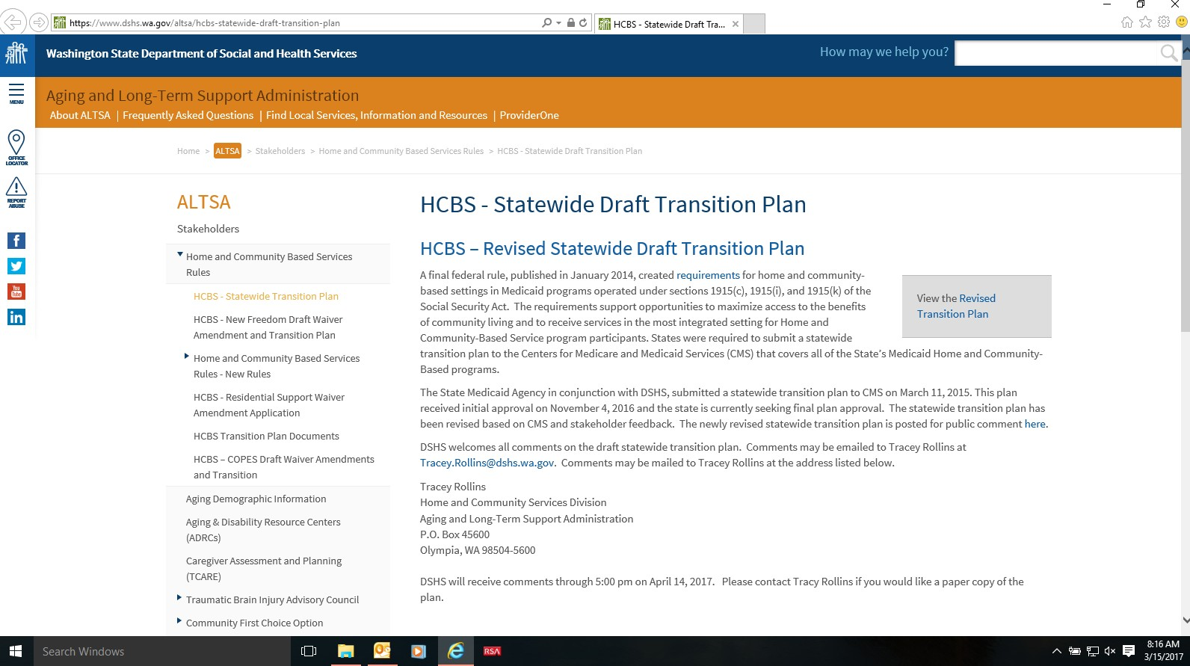

Washington State

Revised Transition Plan for New HCBS Rules

To be Submitted to CMS in May 2017—Posted for Public Comment on March 15, 2017

Public Notification of Revised STP
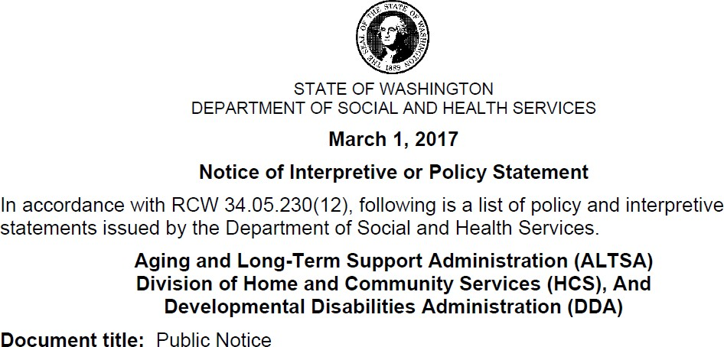
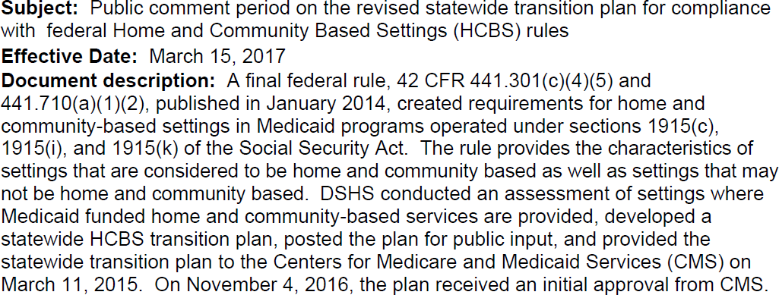

Washington State

Revised Transition Plan for New HCBS Rules

To be Submitted to CMS in May 2017—Posted for Public Comment on March 15, 2017
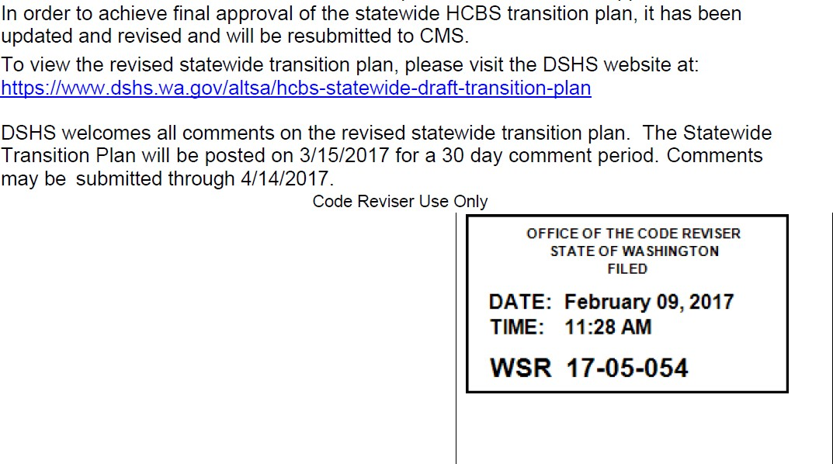

Washington State

Revised Transition Plan for New HCBS Rules

To be Submitted to CMS in May 2017—Posted for Public Comment on March 15, 2017

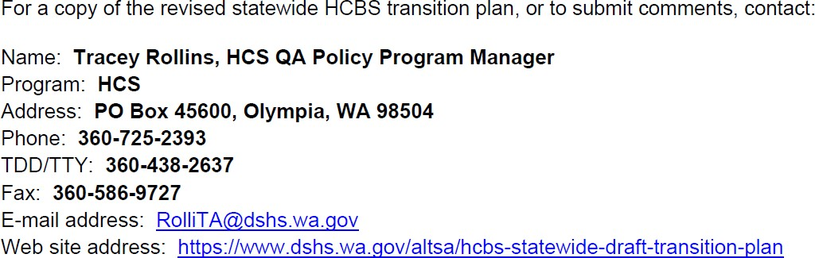

Washington State

Revised Transition Plan for New HCBS Rules

To be Submitted to CMS in May 2017—Posted for Public Comment on March 15, 2017

STP Tribal Notification Letter
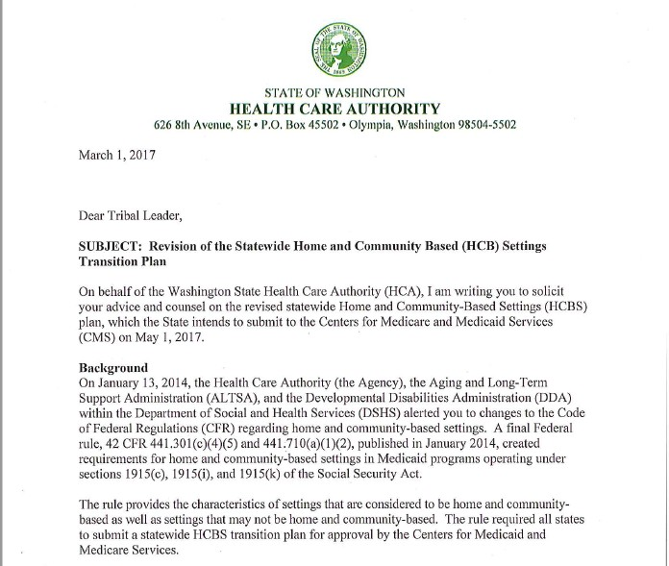

Washington State

Revised Transition Plan for New HCBS Rules

To be Submitted to CMS in May 2017—Posted for Public Comment on March 15, 2017

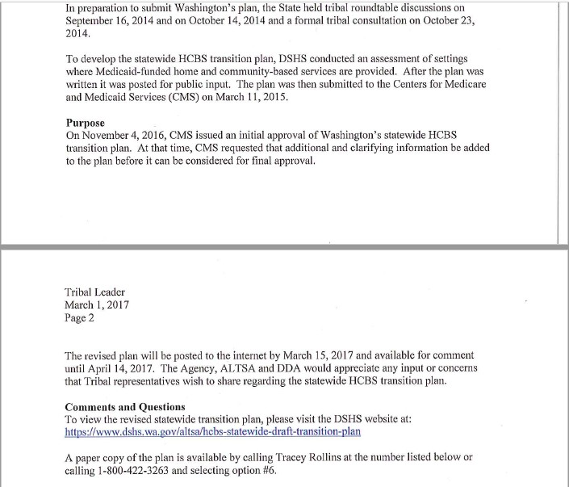

Washington State

Revised Transition Plan for New HCBS Rules

To be Submitted to CMS in May 2017—Posted for Public Comment on March 15, 2017

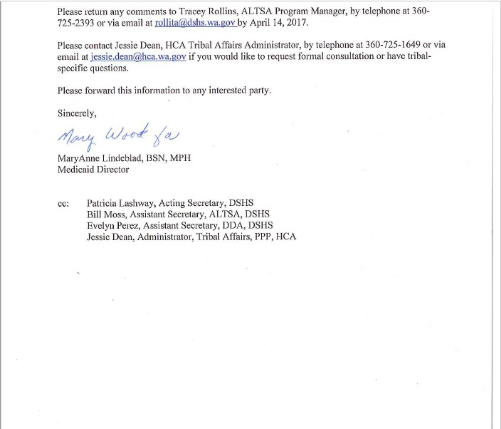

Washington State

Revised Transition Plan for New HCBS Rules

To be Submitted to CMS in May 2017—Posted for Public Comment on March 15, 2017

Notification to post HCBS Transition Plan Flyer
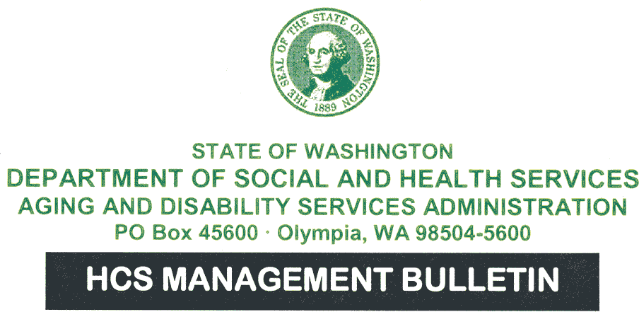

H17- 011 – Information March 01, 2017

TO: | Area Agency on Aging (AAA) Directors  Home and Community Services (HCS) Division Regional Administrators Developmental Disabilities Administration (DDA) Regional Administrators
FROM: | Bea Rector, Director, Home and Community Services Division, ALTSA Don Clintsman, Deputy Assistant Secretary, Developmental Disabilities Administration
SUBJECT: | Requirement to post flyer regarding public input to the revised statewide HCBS rules transition plan.
PURPOSE: | To inform HCS/DDA/ and AAA offices of the requirement to post the attached flyer in the client waiting area of each AAA, HCS, and DDA office. The flyer informs clients and the public about the public comment process for the statewide home and community based setting transition plan. The statewide transition plan was revised based on CMS feedback, and must be posted for public input.

Washington State

Revised Transition Plan for New HCBS Rules

To be Submitted to CMS in May 2017—Posted for Public Comment on March 15, 2017

BACKGROUND: | A final federal rule, published in January 2014, created requirements for home and  community based settings (HCBS) in Medicaid funded home and community based settings. The rule provides the characteristics of settings that are considered to be home and community based as well as settings that may not be home and community based. States were required to submit a statewide transition plan to CMS that covers all of the State’s Medicaid programs. DSHS submitted Washington’s statewide transition plan to CMS on March 11, 2015.
WHAT’S NEW, CHANGED, OR  CLARIFIED | DSHS received initial approval of the plan on November 4, 2016 and has revised the statewide transition plan based on CMS feedback.  DSHS is seeking public input on the revised plan. The public comment period for the statewide transition plan is March 15, 2017 through April 14, 2017. The attached notice provides information on how to provide comments and/or receive a paper copy of the plan from ALTSA headquarters.  The revised statewide transition plan is available on the DSHS website at: https://www.dshs.wa.gov/altsa/hcbs-statewide-draft-transition-plan.
ACTION: | In order to meet the federal requirements, each AAA, HCS, and DDA office is required to post this flyer in your public waiting area from 8:00 am on March 15, 2017 through 5:00 pm on April 14, 2017.  Please remove the flyer from the AAA, HCS, and DDA office at the close of business on April 14, 2017.
RELATED REFERENCES: | https://www.dshs.wa.gov/altsa/hcbs-statewide-draft-transition-plan  MB H14-064 regarding the new HCBS rules: http://adsaweb.dshs.wa.gov/docufind/MB/displayHCS.aspx?year=2014
ATTACHMENT(S): | HCBS Transition Plan Flyer:

Washington State

Revised Transition Plan for New HCBS Rules

To be Submitted to CMS in May 2017—Posted for Public Comment on March 15, 2017
Flyer.docx

CONTACT(S): | Tracey Rollins, HCS QA Policy Program Manager  (360) 725-2393  rollita@dshs.wa.gov  Bob Beckman, DDA Waiver Requirements Program Manager (360) 407-1555  Bob.beckman@dshs.wa.gov

Washington State

Revised Transition Plan for New HCBS Rules

To be Submitted to CMS in May 2017—Posted for Public Comment on March 15, 2017

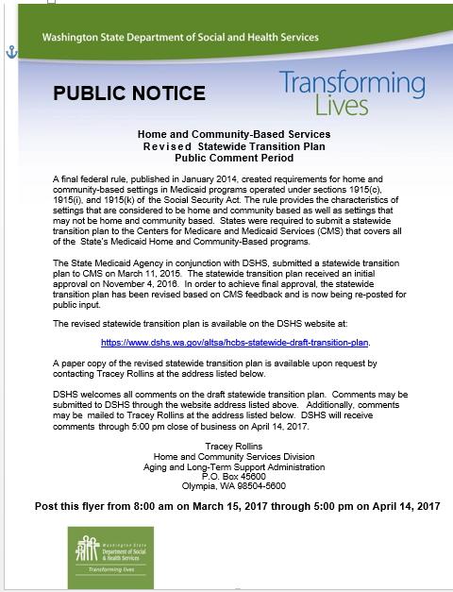
HCBS Transition Plan Flyer

