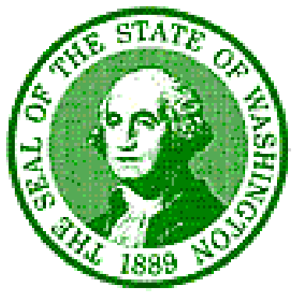

**STATE OF WASHINGTON**

**WASHINGTON STATE COUNCIL ON AGING**

#### PO Box 45600 🞗 Olympia, WA 98504-5600

January 29, 2015

The Honorable Barbara Bailey

State Senate

109B Irv Newhouse Building  
PO Box 40410  
Olympia, WA 98504

Dear Senator Bailey,

At the January 27, 2015 meeting of the Washington State Council on Aging (Council) the members asked me to send you this letter of thanks, honoring your services in 2013 and 2014 on the Joint Legislative Executive Committee on Aging and Disability (JLEC).

Over the past two years the Council monitored the work of the JLEC and was impressed by the studious manner in which you and your fellow members approached the complex and serious issues before you. We believe the thorough report of your findings has the potential of guiding key decision makers during the current Legislative session, and beyond.

We are very pleased that one of the key findings and recommendations in your final report is that the work of the JLEC should continue into the current biennium, and hopefully beyond. The Council is encouraged by the subsequent response to your recommendation, and stands ready to assist the JLEC if it is reformed.

While we don’t assume, prior to your involvement, that you were unknowing about the issues facing seniors in our state, we believe that you have gained considerable knowledge through your association with this group over the past two years. For that reason, and because of your willingness to approach the issues with an open mind and complete the work in a bi-partisan manner, we encourage you to continue the committee’s work into the future should you be offered the opportunity.

We wish to recognize and honor you for the time and energy you committed to these tasks, and are hopeful that your work has had, or will have, a positive impact on the lives of seniors in our State. Thank your for your efforts, and we wish you a productive session.

Sincerely,



Barry Lamont, Chair

State Council on Aging

CC: Jason McGill, Office of the Governor

Kevin Quigley, Secretary, Department of Social and Health Services

State Council on Aging Members