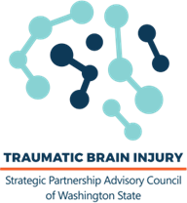

TBI Council Meeting Minutes

October 3, 2024

Promote – Advise - Engage

9:06 Welcome / Opening Facilitator

Mission / Meeting Norms Facilitator

Approval of Minutes – February 2024 Executive Committee
First – Hitchcock
Second – Kahlo
Approved – Unanimous
Abstain – 0
Decision – Minutes APPROVED

Council Member Recognition, Ended Terms Council Coordinator

Council Report Council Coordinator
Cornerstone Framework – focused efforts
Comprehensive Plan Review

Re-elections Council Coordinator
First – Nolte
Second – Mirkovich
Approved – Unanimous
Abstain – 0
Decision – Re-elections APPROVED

Center on Brain Injury Research and Training (CBIRT) Facilitator
WA TBI Survey Report Review

11:00 Meeting Adjourn Facilitator

Attendance
Council Members Present – Kahlo / Anderson / Brummett / Terlinchamp / Nolte / Kersey / Allard-Webb / Blanchard / Mirkovich / Hitchcock / Bahme / Goodwin
Absent – Terlinchamp / Johnston / Vattakattu / Roberts / Lenihan / Daniels
DSHS Staff / CDR Staff

