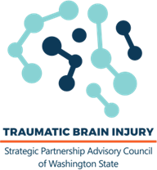
DRAFT TBI Council Meeting
May 2, 2024
Promote | Advise | Engage

Per the Policy of the Open Public Meeting Act, the Traumatic Brain Injury Council
was not able to conduct a formal Council Meeting.

The council used this time to review TBI topics and brainstormed about future work of the Council. No decisions were made, and business was not conducted.

