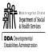

Washington State’s
RESIDENTIAL SERVICES CURRICULUM
4.1 EDITION

FACILITATOR GUIDE

Program Manager: Sarah Blanchette DDA Residential Training
Funding for the revisions made to the Residential Services Curriculum 4th Edition provided by Roads to Community Living. Public Access to this curriculum is permitted.

Training Objectives
As a result of participating in this segment of training, learners will be able to:
- Explain the correlation between clean environments and the decrease of communicable diseases
- Defend the state’s requirement for annual physical and dental exams
- Predict outcomes of maintaining healthy habits versus unhealthy habits
- Recognize signs and symptoms of illness or injury
- Differentiate between acute and chronic illnesses
- Identify and document changes in health conditions
- Determine suitable response for an individual’s symptoms as they relate to their health history
- Practice health care advocacy in designated scenarios
- Prepare and organize to make the most of the professional health care visit
- Identify steps to preventing high risk health problems
- Classify common age related health conditions for early detection and treatment
- Explain the DSPs legal and ethical response to a DNR or a POLST
- Give examples of 3 key practices to manage the chronic healthcare condition of seizures; (for example: complete seizure log, provide first aid support during seizure, assure medications are taken, provide appropriate supervision when swimming, bathing, or eating)
- Describe 3 key strategies to manage the chronic healthcare condition of diabetes (for example: following doctor’s orders for blood sugar levels, adapting menu plans, provide preventative professional healthcare measures, encourage exercise and activity)
- Explain 3 ways to manage the chronic healthcare condition of mental illness (for example: manage medications effectively, respond with empathy, seek professional services as appropriate)
- Name 3 key strategies to manage the chronic healthcare condition of substance abuse (for example: encourage financial responsibility, offer alternative activities, access community resources like AA or NA, educate about long-term consequences of substance abuse)
- Examine feeding skills for management of speed (how soon should another bite be offered), size (is the person able to take the bite size), consistency (as blended, pureed, or small bites may be necessary for successful eating), posture (is the person sitting at eye level with individual being fed), and ideas on how to teach someone to feed him or herself with potential adaptive equipment
- Identify Common blood-borne diseases
- Point out how blood borne pathogens are spread
- The need for and how to use standard precautions
- Define HIV
- Demonstrate the use of personal protective equipment
Estimated Time
4 hours depending on the number of participants

Supplies
Laptop or computer connected to a projector/monitor
External speakers for laptop or computer
Internet access
Paper and pens for participants
Residential Services Curriculum Toolkit (per participant)
Symptom cards copied and cut from the end of this facilitator guide
Auditory Hallucination Script (enough for groups of three)
Advocacy Scenarios and Medical Appointment form copied and cut from the end of this facilitator guide

Preparation before training |  | Review Facilitator Guide for this chapter and ensure each participant has their Curriculum Toolkit available. Symptom cards copied and cut from the end of this facilitator guide. Auditory Hallucination Script (enough for groups of three) copied from the end of this facilitator guide. Advocacy Scenarios copied and cut from the end of this facilitator guide.
Opening: Engaging Activity (2 minutes)
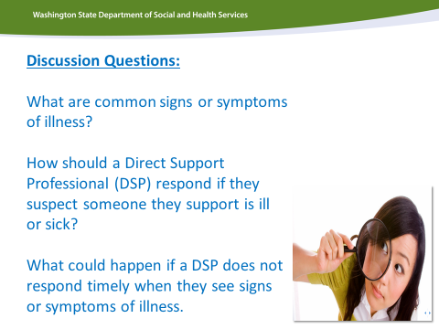  Say |  | We need your help to solve a healthcare mystery…  Start this chapter with a simple discussion about common signs and symptoms of illness and what your staff can do to support someone who is ill or sick.  This is your chance as a trainer to gage what you class already knows and what parts of this chapter you will need to highlight.
Say |  | You will need to be like a detective when looking for signs and symptoms of illness or injury; uncovering clues and making decisions about what to do next.
2

Immerse (15 minutes)
Say |  | There are areas of observation in which you can look for changes, some of which you saw addressed in the video.
Ask |  | What questions did Shirley ask? What were some of Jan’s signs and/or symptoms?  Answers may include: sitting all day when that’s not usual for her, red cheeks, grumpy.
Say |  | You will want to look for changes in: daily routine, behavior, ways of communicating, appearance, general manner or mood, and physical health.
Curriculum  Toolkit |  | Find the Observations List in CH 8 Curriculum Toolkit.
Activity |  | Choose a partner. Give each person a card with a symptom that they should keep secret (copied and cut from the end of this facilitator guide). One at a time, they will ask questions based on the Observations List, until they determine what health issue their partner is experiencing.  Switch. Allow 3-4 minutes for pairs to discover and discuss.
Ask |  | What did you discover? (Ask for a few volunteers to share what they learned and how).  Once you learned this type of information about someone you support, what would you do with it?
e |  | Note to Facilitator: The responses will vary, which is a good opportunity to point out that it can be difficult to determine changes in a person and what to do about those changes unless you know what is typical, or baseline, for that person. Guide the conversation to ensure answers include: report to supervisor, make a doctor appointment, document and monitor, make the person comfortable, and call 911 if necessary.
Say |  | You have observed changes, determined it is not a medical emergency, and contacted the supervisor. Now what?  Documentation!
Apply- Demonstrate Learning Application to Real Work (7-10 minutes)
Curriculum  Toolkit |  | Refer to your Curriculum Toolkit page for Guidelines and Examples for documenting health concerns.
Activity |  | Let’s practice documentation using the information you learned from your questioning earlier.  Using the space provided in your Curriculum Toolkit, take a few minutes to write about the changes you observed. This is a general format and each agency will have its own format for documentation.  Have volunteers share their examples, and use those examples as a catalyst for discussion. If there are some shared that need improvement, guide the conversation to a rewrite of those statements. Encourage class members to offer a suggestion if someone is struggling.
Ask |  | What is the benefit of writing down information?
Activity |  | Give 1 minute in pairs or small groups (depending on the size of the class) to brainstorm as many reasons they can think of for documenting any health related information. After the minute is up, ask for a volunteer to write on the white board or chart paper all the benefits of writing that are shared.
Note |  | Note to Facilitator: If not already listed, ask the board writer to add  “gives a history of issues of concern, so changes that are slowly occurring might be identified.”
Say |  | This might be particularly important if you are supporting a person with a chronic illness or condition.
Teach and Train (3-4 minutes)
4

Ask |  | What is the difference between a chronic and an acute condition?  Answers may include: long term vs. short term, immediate or intermittent.
Activity |  | Let’s review the symptoms from the cards you used earlier.  Have each of the partners take a minute to explain whether they believe their symptoms would be caused by an acute or chronic condition.
Note |  | Note to Facilitator: The conversation should reveal that it can be impossible to tell an acute from a chronic condition, without consulting a health care professional.
Apply- Demonstrate Learning Application to Real Work (15 minutes)
Curriculum  Toolkit  Say |  | Refer to the Curriculum Toolkit of the chapter titled, DSP Staff Roles, Self-Care, and Boundaries.  If you determine the appropriate next step is to make a medical appointment, you should prepare, so you don’t end up looking like this…
Say  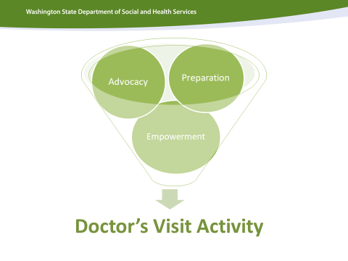  Curriculum  Toolkit |  | There is an activity in the Curriculum Toolkit for this chapter in Making the Most of Your Healthcare Professional Visit.  Refer to the Curriculum Toolkit of the chapter titled, DSP Staff Roles, Self-Care, and Boundaries.
Activity |  | Read each tip from the Making the Most of Your Healthcare  Professional Visit. Ask participants to indicate with a check mark in the margin any tips they saw demonstrated by the staff in the video.  • It is important the individual be accompanied by a staff they are familiar with if at all possible.  • Staff accompanying needs to be familiar with the individual and their overall health needs.  • Ensure transportation is arranged.  • Check with health care professional to be sure they are willing and able to provide any special accommodations needed in the office, including in the waiting room. If the person has trouble waiting, ask if there is anything they can do to expedite the visit. If helpful, bring items to occupy the individual.  • Bring good complete records with you to the appointment. Be sure to include:  - the person’s insurance card,  - list of current medication and medication history,  - forms for the doctor to complete,  - family/guardian information,  - name location and phone of pharmacy,  - directions to the appointment  • Talk with the individual and others involved in his or her  health care to identify any health concerns. Do this prior to the  visit.  • Bring a written list of any concerns and questions you and/or  the individual may have. Try to limit the list to the top three  concerns.  • Assist with the individual practice asking questions before the  visit.  • Make sure the questions get asked, either by you or the  individual.  • Play an active role in the visit maintaining a positive,  supportive environment.  • Make sure you understand what the health care professional  is saying, and don’t be afraid to ask for clarification.  • Ask any questions you have about diet, exercise, or smoking.  • Ask about treatment options.  • Bring a written list of all the medications the individual is  taking.  • When the health care professional writes a prescription, ask  questions about the medication, side effects and  contraindications.  • Ask about next steps in treatment, and be sure you understand  the expected results of the treatment and what the health care  professional wants done.  • Support the individual to participate as fully as possible in the  appointment.  • Always arrive early or on time for each appointment. If you  cannot get there, call well in advance and reschedule.  • Document the outcome of the appointment in the  individual’s record in accordance with your agency’s policies.  It is important all staff working with the individual know the  results of the appointment so their support is designed around  the information.
Say |  | Unfortunately, the staff doesn’t score very well by this list of suggestions! You will be more prepared now that you have seen what not to do!
 |  | Teach and Train (5-8 Min)
Say  Note |  | Since the last tip refers to documentation, let’s take a look at the documentation Marvin’s staff completed.  Since the HR department was made aware of the details of this appointment, the prior staff is no longer working with your agency. You are left with this documentation.  Note to Facilitator: Print and handout copies of the medical appointment form used by your agency.
Ask |  | What do you need to know to assist Marvin?  Example answers staff identify out loud should include: completion of  all areas of the form, legible writing, follow up dates, objective explanations or statements, signatures, etc.  Let’s look at a more complete version of this form.  What can you learn from this version that would help you better support Marvin?  Allow staff to identify what information they have available and any follow up needed.
 |  | Apply-Demonstrate Learning Application to Real Work (3-4 minutes)
Ask |  | If Marvin was your loved one, how would you feel about the prior staff’s interactions at the medical appointment? What does it mean to be a good advocate?

Curriculum  Toolkit |  | Write in your Curriculum Toolkit at least 3-4 statements regarding your expectations of someone supporting and advocating for your loved one at a medical appointment.
Teach and Train (10 minutes)
Ask |  | Have you heard the saying “an ounce of prevention is worth a pound of cure”? What does that mean?
Say |  | This expression means that it is better to try to avoid problems in the first place, rather than trying to fix them once they arise.
Show |  | Show A Pound of Prevention video (1:25)
Ask |  | What are ways to prevent health problems?
Curriculum  Toolkit |  | Let’s take a look at the list of habits in the Curriculum Toolkit section of this chapter.
Activity |  | Your task will be to circle the healthy habits and cross out the unhealthy ones.  Provide 2-3 minutes for participants to identify the healthy/unhealthy habits.

Ask |  | Regular visits for physical and dental appointments are a healthy habit. Why would the state require annual physical and dental exams for people we support?  Answers staff share aloud may include: to ensure health issues are addressed early, to find hidden health issues, to manage ongoing health conditions, etc. And, prevention!  Why is hand washing a good health habit? Answer: To prevent the spread of germs that cause illness and infection.
Curriculum  Toolkit |  | Take a few minutes to learn more about how germs are spread in the Fundamentals section of the Curriculum Toolkit. Be prepared to share one fact you learned or were reminded of from the section on germs with the person sitting next to you.
Activity |  | After several minutes of reading, ask the participants to share their facts with one another.  Besides keeping hands clean, what else needs to be clean to prevent the spread of germs?  Answers should include:  - areas of the home i.e., toilets, sinks, faucet handles, phones, door knobs, light switches, countertops, refrigerator handles  - people need to keep themselves and the people they support clean, including laundry and wheelchairs or other adaptive equipment
Say |  | Ultimately, healthy habits = good health!
Teach and Train (20 minutes)
Say |  | Sometimes people with developmental disabilities can be at greater risk for certain health conditions, and prevention is the key for reducing that risk.
9

Say  Curriculum  Toolkit |  | In the Fundamentals section of your Curriculum Toolkit for this chapter, you will find information about high-risk health problems.
Activity |  | Split the class into 5 groups, one group per topic. The topics are:  - skin breakdown  - constipation  - sun and heat-related illness  - sleep apnea  - choking  Each group will have 5 minutes to review their assigned topic and come up with the top 5 points they will share with the rest of the class. In the Curriculum Toolkit is a section labeled “My Top 5 Points about _______” and numbered lines. Instruct them to write in their assigned topic on the blank line, and capture their top 5 points in order of importance (like a countdown, 5 to 1, 1 being the most important). Ask them to consider at least one aspect of prevention as one of their top 5 points.  After the 5 minutes of preparation, ask a group to volunteer to present their Top 5 list first, and continue with the rest of the groups. Allow for time for questions after each group presents.
Say |  | Sometimes people require support to manage long term, or chronic, health conditions.  We are going to watch some videos about a select number of chronic health conditions. After each video we will have an opportunity for discussion and activities to share what was learned and how you can use that information to help those you support.
Teach and Train (15-20 minutes)
Ask |  | Have any of you experienced or witnessed a seizure? Are you willing to share some information about that?

Note |  |  | Note to Facilitator: Follow up questions could include: Did you know what to do? Was it something you expected? Were you afraid? Did the person get injured?  Give people an opportunity to share their personal experiences.
Show |  |  | Let’s take a look at an extreme seizure example.  Show Tonic-clonic Example video (1:52)
 | 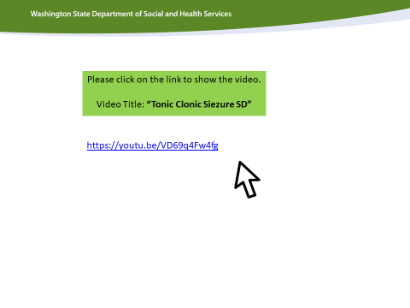
Curriculum  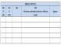  Toolkit |  |  | Use the sample medical activity log provided in the Curriculum Toolkit.
Activity |  |  | Following the video, ask everyone to document the first seizure they witnessed; the tonic-clonic. Some participants may protest that they can’t remember that seizure as well, since they saw another type immediately after the first. Ask them to do their best, and use this as an opportunity to emphasize the importance of timely documentation.  Once they have had a chance to write their description of the seizure, have a few staff share what they wrote.
Ask |  |  | Why would we need to document seizures? (Patterns, changes, history, etc.)  What details do you think are important? (Time, parts of body affected, injuries, potential triggers, how long until return to baseline, etc.)
Say |  |  | Documentation allows medical professionals to better address treatment of seizures. This may include medication adjustments or implants like the VNS (Vagal Nerve Stimulation). It also allows direct support staff to better support the person if we know when the seizures are more

 |  | likely to happen, and how long they typically last. This will guide the protocols involving supervision required during activities like bathing or showering, swimming, or eating.
Curriculum  Toolkit  Say |  | In the Curriculum Toolkit section of this chapter, find and complete the Please & Never activity.  Ensure the answers are as follows:  - Please roll onto side as soon as safely possible  - Please clear the area  - Never restrain  - Never put something in the mouth  - Never leave alone when eating or near water • Please stay with and reassure  Please refer to your agencies polies on seizures and the protocol depending on the individual’s plan.
Teach and Train (15-20 minutes)
Say |  | Another chronic health condition is diabetes.
Ask |  | How many of you know someone with diabetes?  If you are willing to share information, would you answer these follow up questions?  Do they manage their diabetes with medications, dietary changes, and exercise?  (People we support sometimes do all three.)  Do they have a protocol for monitoring their blood sugar?  (Doctors should establish blood sugar level ranges, and set protocols to follow.)  Why is it important for someone with diabetes to track their blood sugar?  (When a protocol is established, checking the numbers gives a course of action.)

Say |  | Now that you know how diabetes affects the body, you can see the importance of choosing more nutrient rich foods, in portion sizes (as you learned in the Nutrition chapter). Increasing the amount of activity can help the body utilize carbohydrates more effectively, thereby stabilizing blood sugar levels.
Ask |  | What are physical activities you like to do for fun?
Activity |  | In small groups have participants’ list activities they enjoy on a scratch piece of paper. After a few minutes ask a volunteer from each group to write their lists on the board. Duplicates could be indicated by a check mark if needed.
Say |  | Exercise doesn’t have to happen in a gym. To motivate people, find out what they like to do for fun!
Teach and Train (10-12 minutes)
Say |  | Having fun can be a benefit both for mental and physical health. Intense physical activity, as well as intense fits of laughter release dopamine, hormones that boost mood. In the next video we will see how laughter can be used to heal. There are some substance abuse counselors who have begun using laughter therapy in their practice.
Show |  | Show Laughter Yoga: Laughing Away the Stress video (3:02)

Say |  | Let’s give it a try!
Activity |  | Have everyone stand up. Let people know that participation is mandatory! Lead the group through a series of laughter “exercises”. Start with a simple laugh you are familiar with, like a Santa Claus laugh; HO HO HO in a deep voice while holding your belly. Do this for 30 seconds before switching to another laugh, like a snicker, then a snort, or a tee hee, pursed lip blowing, etc. Include suggestions from the group for other types of laughter. After several minutes allow people to sit down, and ask how they feel.  Option: An alternative is to have people lie on the floor with their head on someone’s stomach. The first person says, “HO!” The second says “HO! HO!” and so on down the line. By the time it reaches the end everyone is in laughter mode!
Say |  | While initially some of you may have had to force yourself to laugh, or fake it, most of you probably found the laughter contagious. The change in your mood occurs through the release of dopamine.  There are laughter clubs in some communities, but nearly every  community has support groups like AA (Alcoholics Anonymous) or NA (Narcotics Anonymous) that are great resources for those struggling with substance abuse. Research has shown that the incidence of alcohol abuse and dependence in adults with developmental disabilities is very similar to that of the general population. They are exposed to many of the known risk factors for developing substance abuse problems; however they are rarely provided preventive education. Finding AA or NA groups is a way to connect with others who will understand, and can build a new network for healthy fun.  In order to support someone with a substance abuse problem, it is important to understand what substance abuse is. Let’s take a look at the difference between drug abuse and substance abuse.

Show  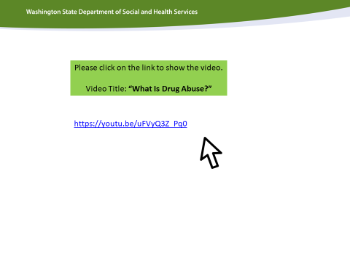  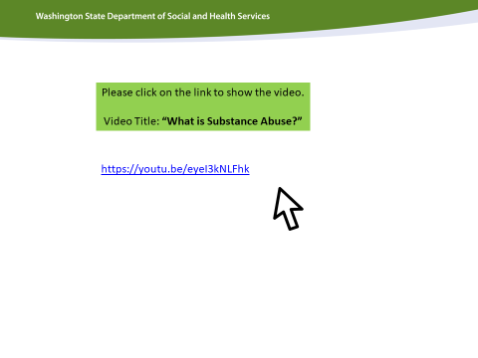 |  | Show Drug Abuse video (1:00) and Substance Abuse video (1:16)
Say  Curriculum  Toolkit |  | If someone you are supporting has a history of drug/substance abuse, assist them to seek appropriate professional support, and work with the team to provide a safe, positive environment.  In the Curriculum Toolkit section of this chapter, resources for Substance Abuse are provided.
Teach and Train (15-20 minutes)
Say |  | A safe, positive environment is equally important for supporting those with mental illness.  Mental illness can be an invisible disability, and as a society we tend not to acknowledge it as we do other diagnoses.
Activity |  | Split the group in half, and call one group “Supervisors”, one group  “Staff”.  Ask the supervisors to leave the room so you can give the staff the following instructions.  You are calling in sick because you broke your arm.  Invite the supervisors back into the room and tell them that their “staff” will be calling them on the phone.
Note |  | Note to Facilitator: Allow staff and supervisors a chance to role play for at least 30 sec. Then, have the participants reverse roles and send the new supervisors out of the room. Instruct the current staff to call in with a panic attack. Allow 30 seconds for the role-play.

Ask |  |  | Supervisors, what was your response when your staff called in sick?  Staff, how did you feel about your supervisor’s response?  Does there tend to be more empathy when someone has a physical injury or illness than when someone has a mental illness?
Say  Curriculum  Toolkit |  |  | Take a few minutes to read Major Kinds of Mental Illnesses at a Glance in your Curriculum Toolkit.  Provide a few minutes for staff to review the information in the Curriculum Toolkit section of this chapter.
Ask |  |  | Regardless of the diagnosis, what is a common measure of support found in each of the notes to support staff?  Staff should identify that the statement, “Follow prescribed medication and/ or treatment plans” is repeated in each section.  What are some barriers to people following their prescribed treatment plans?  Possible answers may include: impaired judgment, impaired memory, a lack of understanding consequences of avoiding the treatment, direct support professionals not following individuals’ prescribed treatment.  What is our responsibility as DSPs if we recognize people are not following their prescribed treatment?  Answers should include: document, alert medical professionals, encourage healthy choices, explain consequences of following vs. not following their plan, enlisting advocates such as family and friends for encouragement.

Immerse (15 minutes)
Note |  | Note to Facilitator: For the next activity each group of three will need one copy of the Auditory Hallucination Script. They will also need a blank piece of paper to roll into a funnel.
Activity |  | Have staff gather in groups of three. Two people will be having a conversation about their favorite vacation, one will share the other will listen. The third person will roll a piece of paper to create a funnel and stand slightly behind the person listening to whisper the statements into the ear of the listener. Ask them to repeat the Auditory Hallucination Script exactly as written and continue to repeat the statements while the other two staff shares about their vacation. After one minute ask staff to change roles.
Ask |  | How did this affect your ability to listen and focus?  Did you physically respond?  How would it change your life if this was your experience all of the time?
Say |  | If you had a diagnosis of schizophrenia this could be a reality for you. When we are supporting people who may have a mental illness it is important that we are empathetic, understanding, and validating. As advocates it is our responsibility to support the individual in seeking treatment as we would for any illness.
Show  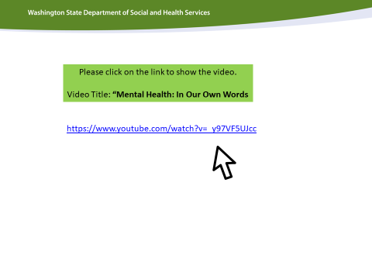 |  | Show Mental Health: In Our Own Words video (00:30)
Say  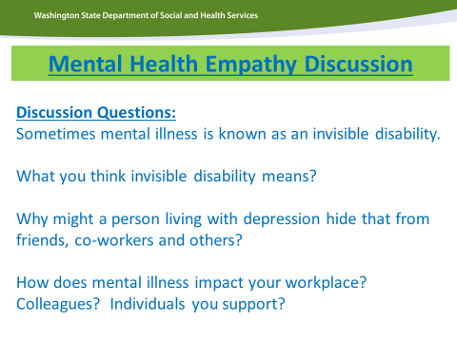 |  | As advocates we can help change the stigma surrounding mental illness.
Apply- Demonstrate Learning Application to Real Work (15-20 minutes)
Say |  | Now that you have learned about a variety of health conditions, here is your opportunity to practice healthcare advocacy.
Activity |  | Practice advocacy with the following four scenarios. Break the staff up into four groups and assign each group a scenario card. Allow each group 2-3 minutes to read the scenario and discuss how the staff can advocate for the person. Suggest that they consider how they would interact with the person described, who else they might involve & what kinds of conversations they might have with those individuals. Each group will then present to the whole group their solution ideas. After each group presents, encourage others in the class to ask questions, or contribute other possible solutions.

Teach and Train (15-20 minutes)
Show  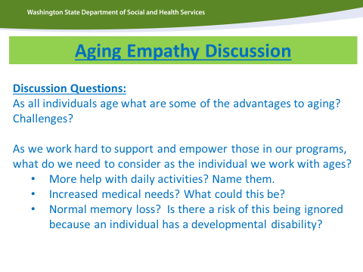 |  | Individuals with Developmental Disabilities age just like the rest of us and they also go through many of the normal processes of aging. However, often, the normal symptoms of aging can be blamed on their disability and they do not get the interventions and care they need as an Aging adult in a timely manner that would otherwise prolong independence and functioning.  Lets take a moment to discuss what aging with a Developmental Disability means.
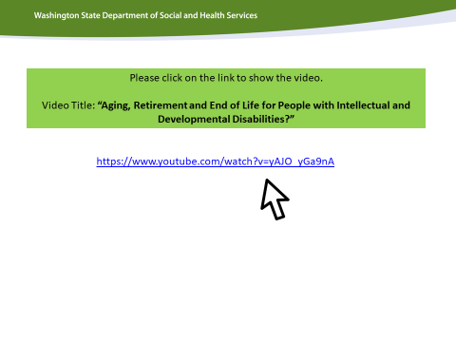 |  | Show Aging, Retirement and End of Life for people with Intellectual and Developmental Disabilities video
Say  Curriculum  Toolkit |  | As we age, there are changes we all can expect. Many individuals with developmental disabilities experience age-related changes earlier than the general population. This is particularly true for individuals with cerebral palsy, Down Syndrome and metabolic diseases and some individuals who have a mental illness in addition to a developmental disability.  Let’s turn back to the beginning of this chapter in your Curriculum Toolkit, to the Observations List that you used to determine changes.
Ask |  | What health concerns or possible changes did you see in the video?  Participants should identify physical changes in hearing loss, mobility, eating and swallowing, and confusion.
Ask |  | What is your role as a DSP when someone you are supporting has a Do  Not Resuscitate (DNR) order or a Physician’s Order for Life Sustaining Treatment (POLST)?

Say |  |  | Your responsibility is to support the individual you support and that means knowing, following and keeping track of the Physician’s Order for Life Sustaining Treatment (POLST). If you are unsure if an individual has a POLST; call 911 and start CPR. The policy of Developmental Disabilities Administration is to follow all directives on a POLST form and abide by decisions made between an individual and their doctor.  It is your responsibility to identify changes that may indicate the early onset of an age-related health condition and to report these changes to the individual’s health care professional. Early detection permits early treatment that often adds to the individual’s length and quality of life. Sometimes these changes are slow and subtle, so documentation becomes essential in order to track changes over time.
Say |  |  | Difficulties in eating and swallowing can be part of the onset of aging issues, but can also be a result of a diagnosis like Cerebral Palsy or Traumatic Brain Injury. Regardless of the cause of the difficulties, it is important for staff to know how to assist someone to eat safely. Ultimately we would want to provide opportunities for someone to be able to feed themselves (unless they have come to a point in their lives when this is no longer feasible).  Sometimes adjusting our approach can be the adaptation that makes eating more successful.  Let’s take a look at some people who might need your assistance to eat.
Activity |  |  | In groups of 3, ask participants to take turns assuming the posture of one of the people in the images. The others in the group should problem solve and position themselves to make eating assistance successful.  Remind people to engage in this activity as though it were an actual circumstance, with dignity and respect.  Allow groups enough time, 4-5 minutes, to problem solve and practice each of the different postures.

Ask |  | Besides adjusting for posture, what are other ways we can help people eat if they are unable to feed themselves?
Activity |  | Provide 8-10 minutes for the same small groups to draw pictures on letter size scratch paper indicating other ways to assist people to eat safely. The pictures must represent the following labels:  - Speed  - Size  - Consistency  - Adaptive equipment
Say |  | Use your Fundamentals for this chapter to find ideas.
Note |  | Note to Facilitators: Once the pictures are complete, or the assigned time has elapsed, instruct everyone to leave their papers on the table. Have everyone stand, and move around to view each group’s artistic expressions.
Immerse |  | Blood borne pathogens
Say |  | Think about a time when you had to clean up something disgusting. Are you wrinkling up your nose at the thought? Most of us have had to clean up something we found disgusting at some point in our lives. For some of you it’s just scraping the dishes after a meal and hoping that the same food you just ate, that you are scraping from someone else’s plate, doesn’t get on you! UGH! Disgusting! What do you do to protect yourself from that situation? (allow for brief discussion – someone else does the dishes, wears gloves,)  In our line of work you may have to assist with things you have never had to do before. It’s ok when you know how to protect yourself and what you are protecting yourself from. We want you and the people you support to be safe.
Say |  | In addition to all of the other health information you have received today, we cannot forget to discuss blood borne pathogens. Blood borne pathogens are disease causing germs that spread through contact with blood. You may come in contact with a client’s blood or body fluid in the normal course of your work. This presents a small risk of exposure

to blood borne pathogens.

As a support staff you may need to know common types of blood borne diseases, how blood borne pathogens can and cannot be spread, how to use standard precautions to protect yourself and the people you support, and what to do if exposed to blood or body fluids.
Say  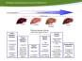 |  | Diseases that can be spread by contact with blood or body fluids includes: Hepatitis B. This is a viral infection that infects the liver.  - More contagious than HIV  - 90% will recover  - May have no symptoms  - You can get a vaccine to protect you  Include information about how to get this vaccine at your agency.
Hepatitis C is also a viral infection of the liver but it causes chronic inflammation with possible scarring (also known as cirrhosis of the liver) and causes permanent liver damage.
- Not as easy to contract as Hep B but more infectious than HIV
- Once infected – remain infected
- No vaccine currently available

Both Hep B and C can be spread through contact with dried blood
Human Immunodeficiency Virus or HIV is a virus that damages the immune system of an infected person.
- There is no vaccine
- Transmitted when infected blood, semen, vaginal fluids or breast milk enter the body through the mucous membranes of the anus, vagina, penis, urethra, or mouth; or abrasions on the skin

Spread by:
- Having unprotected (no condom) sex or oral sex
- Using or being stuck by a needle or syringe that has been used by an infected person, including tattoo needles or ink and body piercing needles.
- Sharing drug paraphernalia (syringe-needle, cotton, “cooker” and or rinse water. Sharing these items may spread the disease) Sharing may also transmit Hep C.
- Giving birth and breast feeding (Moms can pass it on to their infant)
- Receiving blood – this is less common then it used to be due to screening protocols.
- Anyone with HIV can transmit the virus
- The virus is in your body for the rest of your life and you can infect others for the rest of your life.
- Virus attaches to the T-cells in your blood. Overtime the HIV virus destroys the t cells since the immune system cannot fight it. This leave people at risk of other unusual infections, cancer and life threatening diseases.
- Having HIV is not the same as having Aids.

Standard Precautions are used any time you may come in contact with a person’s blood, body fluids, broken skin or mucous membranes. You must use standard precautions if you:
- Assist with toileting or bathing
- Clean up spills from bodily fluids like urine or semen
- Provide first aid to open cuts or have exposure to blood
Standard precautions include:
- Using a protective barrier between you and the blood or body fluid. These barriers can be gloves, a face mask, goggles and/or a gown.
- Cleaning and disinfecting any surfaces contaminated with blood or body fluids –disinfect immediately. Wear gloves and use any other barriers required, use paper towels for clean up and dispose of properly.
- Following special laundry procedures by
  - Wear gloves
  - Put contaminated items in leak proof plastic bag or covered hamper
  - Handle as little as possible and do not shake items out
  - Avoid holding soiled linens close to your body or against your clothing
  - Wash items with detergent and/or bleach according to manufacturer label
  - Keep soiled linen separate
  - Wash your hands when the task is completed
  - Properly disposing of contaminated waste – contaminated items in heavy duty plastic bag, tied shut and placed in a second bag before putting in the trash can. Label as “contaminated”.
  - Normal trash can removal is acceptable
  - Handling needles or other sharps objects correctly. – Dispose of syringes, needles, razors and other sharp items in a sharps container or puncture proof container.
Discuss how your agency deals with this and where the disposal units are kept, how they are disposed of or recycled.

It is also your responsibility to report exposure to blood borne diseases. If you are exposed to another person’s blood or other potentially infectious materials (OPIM) - discuss your agency policies on this reporting procedure.

Take a look at these things that you can do if you are exposed.

Hand out the one page addition to the Curriculum Toolkit fundamentals.

Next print, this will be included in the fundamentals.

Review the slides: how it spread in the workplace, and the two Exposed? Slides.
 | 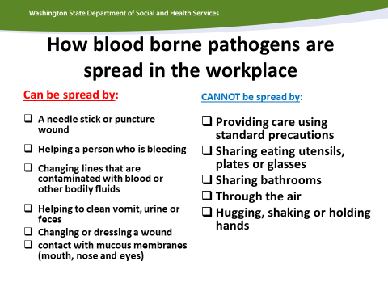
 | 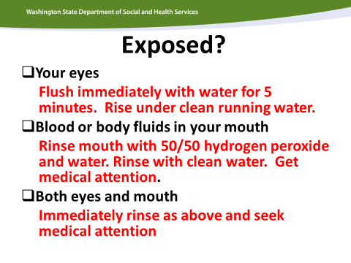
 | 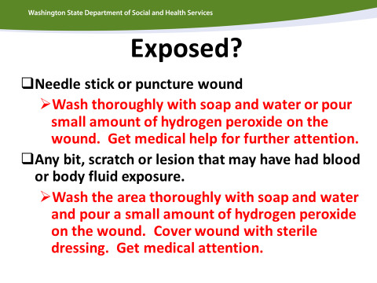
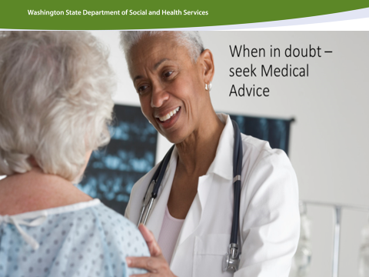 |  |  | You are also encouraged to seek additional supports if you are exposed. You can request HIV testing of the source individual. If the source individual does not want to be tested, assistance from the local health officer can be requested, provided:  - Request is made within 7 days of the exposure  - Health officer determines that a “substantial exposure” has occurred. They may determine the testing is unnecessary.  - Exposure occurred on the job.
PPE Activity |  |  | At your tables determine the best PPE to use for each scenario. Discuss each group’s answers. (# 3 is a trick question. The answer for that is to call 911 and keep the person comfortable until help arrives.) They may choose too many PPEs. Discuss respect and dignity with PPE use. Snap on a pair of gloves in front of someone. Put on all of the gear (or have a volunteer do it) and make a point that wearing all of the PPEs is frightening and ridiculous.  If you choose not to hand this out:  Alternative 1: do a relay race. Purchase tap lights (the ones that light up when you touch them – available at most hardware stores)  - Divide participants into 2 groups or at least groups of 5.  - Place PPEs on the table and ask that the first person on each team to put on the PPEs required for this case.  Put the first question on a slide and show the slide. (Or write on easel paper or a dry erase board. Only show one situation at a time) Teams race to put on the PPEs and tap the light to indicate they are finished. Each question is a slide with a new person putting on the PPEs. Allow time in between slides to take the PPEs off for reuse. This becomes a way to correct how people put on and take off gloves or how they wear the gown  Alternative 2: Post this chart on the wall using chart paper or draw it on a dry erase board. Make cardboard X’s (ala the price is right tic tac toe) with magnets on the back or Velcro or however you wish to stick them to the correct column. Divide into teams and race to the board as each person on the team adds X’s to the correct column(s)

Reflection & Celebration (5 minutes)
Say  Curriculum  Toolkit |  | Ask staff to consider what they have learned about healthcare management and how it could be applied to their own lives or the life of a loved one.  Ask them to take at least 30 seconds to think and process before they begin writing in the Curriculum Toolkit 3 tips they could apply to their own lives, or 3 ways they could advocate for someone they love. If they would like to combine ideas for themselves and loved ones, that is acceptable.  They do not have to share what they write.
Activity  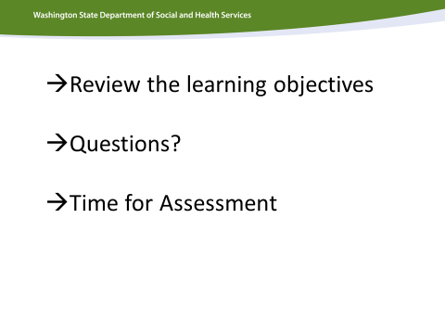 |  | Please administer the assessment at the end of this chapter.
Note |  | Note to Facilitator: Please review the objectives in the Curriculum Toolkit on the first page with participants. Ask participants to circle the objectives for this chapter in which they believe they need more clarity. Allow for question and answer dialogue to ensure that all of the objectives have been met.  Hand out the assessment for this chapter to each participant. End of chapter assessments should take approximately 10 minutes.  As a learning tool, it will be important for each participant to leave the training with the correct answers. Please review the answers and ensure that each participant has marked the correct answer. When you review the assessment with participants, note where people are having difficulty and review that section again with the whole group or determine where you will address this in the next chapter. Ensure that you reteach/retrain topics where learning gaps were identified.  Due to the confidential nature of the assessments in this course, please collect and shred all completed assessments.

Symptom Cards

Sore eyes | Constipation
Ear ache | Swollen ankle
Toothache | Open sore on elbow
Heart is racing | Abdominal pain
Nausea | Stiff back

Auditory Hallucination Script

Why are you talking to him (her)?

Don’t trust him.

Is he looking at you?

Why would he (she) want to talk to you?

Do you think you can trust him (her)?

You can’t trust him (her). You can’t trust anyone.

This page left intentionally blank.

Advocacy Scenarios

Scenario #1
Lisa takes medications for seizures. She recently started a new medication and seems to be excessively sleepy and her appetite has decreased. The doctor assures you this is an expected effect that should not continue. It has been several weeks with no improvement.

Scenario #2
Bill seems to be increasingly agitated and is requesting his prescribed psychoactive medication as a result. You are concerned that he may be imitating signs of agitation specifically to get more of the medication (drug seeking behavior).

Scenario #3
Garth has been newly diagnosed with type 2 diabetes. His doctor would like him to check his blood sugar before breakfast and dinner. Garth is not happy about this new practice and has been refusing to check his blood sugar. Sometimes he will agree to check it, but only once a day.

Scenario #4
Molly has anxiety disorder. You have been a part of her support team for nearly one year. You notice over the last few weeks she has become more anxious and has begun barricading herself in her room for extended periods of time. There are several new staff working in her home, who feel Molly just needs additional psychoactive medication to manage her increased anxiety.

Chapter 9 – Healthcare/Health Management Curriculum Toolkit Fundamentals – please print as handout
Blood Borne Pathogens annual refresher. (This will be added to the Curriculum Toolkit for the 40 hours. Until it has been added, please print this page as a handout. )
 | How blood borne pathogens are spread in the workplace
 | Can be spread by: | CAN NOT be spread by
•  •  •  •  •  •  • | A needle stick or other puncture wound  Helping a person who is bleeding Changing lines that are contaminated by blood or other body fluids Helping to clean up blood, vomit, urine or feces  Changing a dressing or bandage with blood that has oozed from the wound Contact with broken skin (chapped, weeping, or dermatitis)  Contact with mucous membranes  (mouth, nose and eyes) | - Providing care for a person with a blood borne pathogens disease when standard precautions are used  - Sharing eating utensils, plates or glasses  - Sharing bathrooms  - Through the air  - Hugging shaking or holding hands

Exposure to blood borne diseases
Kind of exposure | What to do
Your eyes are splattered with blood or body fluids | Flush immediately with water for at least 5 minutes. Rise under clean running water.
Blood or any body fluids get into your mouth. | Rinse your mouth with a 50/50 mix of hydrogen peroxide and water. Then rinse with plain water.  Get medical attention for further action.
Bothe eyes and mouth are exposed. | Immediately rinse both as recommended above and get medical attention for further action.
A needle stick or puncture wound. | Wash thoroughly with soap and water or pour a small amount of hydrogen peroxide on the wound. Get medical attention for further action.
Any bite, scratch or lesion that may have had blood or body fluid exposure. | Wash the area thoroughly with soap and water or pour a small amount of hydrogen peroxide on the wound.  Cover the wound with a sterile dressing. Get medical attention for further action.

Activity:

Choose the PPEs (Personal Protective Equipment) necessary for each situation.
Be careful! Be safe! | goggles | gloves | gown | mask | Wash hands
1. You are in the bathroom ready to assist with toileting.
2. Everyone in the house has a stomach flu. Vomit everywhere. You are on the cleanup crew.
3. On an outing, someone falls on a stick and it goes through the leg.
4. You have a small scrape on your hand.
The person you are assisting has Hep C.
They need assistance with bathing.
5. It’s a horror show! The person you are assisting has blood spurting from their neck after a fight with a housemate.

