RESIDENTIAL SERVICES CURRICULUM

C O N F I D E N T I A L

TESTING INSTRUCTIONS & MATERIALS

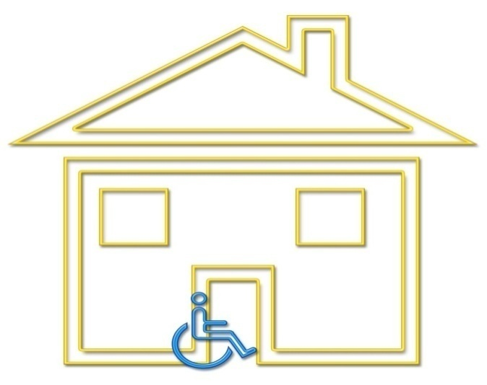

January 2017

TEST INSTRUCTIONS

NOTE: THE CONTENT OF THIS DOCUMENT IS CONFIDENTIAL AND FOR USE OF
TRAINING INSTRUCTORS ONLY

This document contains the following:

- Instructions for administering the DDA Residential Services Curriculum Competency Test
- Master score sheet for tracking each student’s individual chapter scores (using either # of answers scored correctly)
- DDA Residential Services Curriculum Competency Tests
- DDA Residential Curriculum Competency Test Scoring Guide with an abbreviated answer key
- Skills acquisition attestation signature page for staff records. To be signed by student and staff administering the skills portion of this course.

- The instructor will determine when to administer the test. The purpose of the test is to determine that each individual taking the course has achieved a minimal level of competency with the material. The instructor may choose among several options in administering the competency test:

- The test may be separated into the individual chapters and the test for each chapter given at the end of the training related to that chapter.
- The test sections may be grouped at the beginning or ending of the day.
- The entire test may be given at the end of the entire course.

- All tests must be administered in class. There are no “take home” examinations. The students may refer to their Curriculum during the test.

- Students may not keep the test. All tests will be collected by the instructor after the student finishes the test. This step will help to ensure that the test questions remain confidential.

It is recommended that tests are graded by the instructor, rather than the student or other students. The instructor may want to use a master score sheet to tally the chapter scores or some other method of keeping track of whether or not the student scored enough correct answers to pass 30 of 45 questions.

- Instructors are encouraged to use the test(s) as a learning tool. Reviewing the test and answers after the test administration is recommended. This is most easily accommodated when giving the test one chapter at a time.

- The test must be given exactly as written with no alterations or substitutions. Reasonable accommodations for giving the test must be cleared with the Residential Training Program Manager.

Instructors will give certificates of completion when all the chapter tests have been successfully completed. This may happen at the end of the course or later if a re-test is required. A student must score a minimum of 73 of 89 possible points correctly to pass the course. Please see the passing score for each chapter on the scoring sheet. Passing score is indicated in ( ).

- Re-Testing: The competency test may be taken twice. If the test is failed a second time, the student must re-take the entire training course before any additional tests are administered.

If tests are given in individual chapters or groups of chapters and a student is absent when the test for that chapter or set of chapters is given, it is up to the instructor to decide if the student will be allowed to make up the missed test by taking it before the end of the course.

CHAPTER 12: PERSONAL CARE SKILLS AND SUPPORT with checklist for skills
Agency: __________________________ Staff Name: _________________________
1st attempt Date: ___________________ 2nd attempt Date: ____________________
- When I provide personal care I will: (circle all that apply) (5 pt)
a. respect the individual by giving them choices
b. be confidential
c. take responsibility when things go wrong and I know what happened
d. encourage self-determination for each individual
e. respect the person when they refuse to complete a task
f. choose the types of products used for bathing
- Infection and germ protection is my responsibility. To ensure that I have provided this I should: (1 pt)
  - Wash my hands
  - Wear gloves
  - Report skin injuries to my supervisor or delegating nurse
  - All of the above
- It’s ok and sometimes preferred to go to a “professional” for hair and nail care. T F
When you don’t | This can happen…  To person you support | This can happen…  To your agency
ash your hands/wear gloves
Provide privacy
Pat dry instead of rub dry
Provide opportunity for movement
Follow instructions for eating protocols
Support choices
Observe physical and emotional change
Document properly
Teach the person the skill to do it themselves
___________ correct out of 16
The assessment for the skills is a demonstration of the skills in the chapter. It should only be signed when the skill has been demonstrated correctly.
Student initial Instructor initial
- Common Care practices (Chapter 12) _________ _________
- SWIPES (Chapter 12) _________ _________
- Proper hand washing (Safety) _________ _________
- Proper gloving, removal and disposal (Safety) _________ _________
- Help a person to take medications (Chapter 10) _________ _________
- Proper mouth care and denture care (Chapter 12) _________ _________
- Proper fingernail and foot care (Chapter 12) _________ _________
- Help a person to walk (Chapter 12) _________ _________
- Help a person with a weak arm to dress (Chapter 12) _________ _________
- Apply passive range of motion to : knee, shoulder, ankle (Chapter 12)_________ _________
- Apply elastic hose up to the knee (Chapter 12) _________ _________
- Assist person with peri-care (Chapter 12) _________ _________
- Assist person with catheter care (Chapter 12) _________ _________
- Assist person with eating (Chapter 12) _________ _________
- Turn and reposition a person in bed from prone to side (Chapter 12)_________ _________
- Transfer a person from a bed to a wheelchair (Chapter 12) _________ _________

I attest that the student named above demonstrated all of the skills and has been informed that use of these skills is mandatory when performing these tasks.

Printed name of instructor:

Signature of instructor:
Instructor I-Code:

(Original to student. Copy to personnel file.)

STUDENT COMPETENCY TEST SCORE SHEET

Student Name: ______________________________________________

Enter the number of points scored correctly on the corresponding chapter test. Passing score for each chapter is indicated ( ).

SCORE CHAPTER

______ Chapter 1: DSP Staff Roles and Boundaries (4)
______ Chapter 2: Overview of Developmental Disabilities (2)
______ Chapter 3: Residential Service Guidelines (4)
______ Chapter 4: Positive Behavior Supports (5)
______ Chapter 5: Effective Communication (7)
______ Chapter 6: Habilitation Skills (7)
______ Chapter 7: IISP (1)
______ Chapter 8: Nutrition and Dietary Guidelines (8)
______ Chapter 9: Healthcare/ Health Management (5)
______ Chapter 10: Medication Management (5)
______ Chapter 11: Emergency Procedures (5)
______ Chapter 12: Personal Care (passing score of 13)
______ Chapter 13: Confidentiality (5)
______ Chapter 14: Mandatory Reporting (2)

______ TOTAL SCORE (89 possible points)
A minimum of 73 of 89 possible points is required for a passing score.

____________________________________________ _________
Student Signature Date

(Original to personnel file, copy to student)
CURRICULUM TEST
Short & ANSWERS

Chapter 12: Personal Care (16 pts)
- All but F
- D
- True
When you don’t | This can happen…  To person you support | This can happen…  To your agency
Wash your hands/wear gloves | Infection, spread disease
Provide privacy | Lack of dignity and respect, lose trust with person you support
Pat dry instead of rub dry | Skin injury, lose trust
Provide opportunity for movement | Loss of ability to move  Less independence
Follow instructions for eating protocols | Choke, hospitalization, death | Loss of trust with DDA, possible loss of contract, death
Support choices | Loss of independence
Observe physical and emotional change | Increase health care concerns, not preventing
Document properly | Loss of communication and important information, and a whole lot of other things!
Teach the person the skill to do it themselves | Loss of independence

To score this table, please provide one point for the middle column if they entered anything that is reasonable.
The last column is to see that they know there are consequences for the agency. Same answer would be correct for each one. There could be other acceptable responses.

