RESIDENTIAL SERVICES CURRICULUM

C O N F I D E N T I A L

TESTING INSTRUCTIONS & MATERIALS

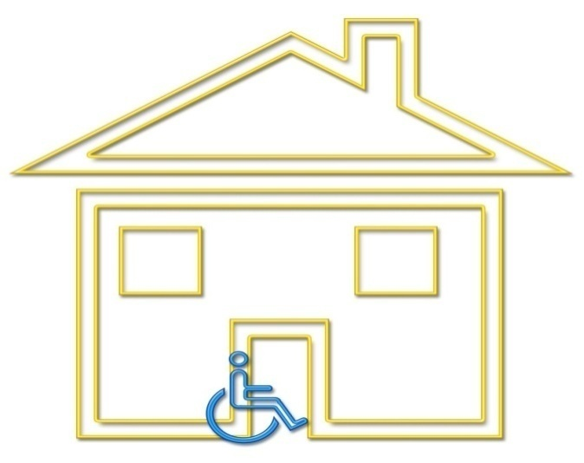

January 2017

TEST INSTRUCTIONS

NOTE: THE CONTENT OF THIS DOCUMENT IS CONFIDENTIAL AND FOR USE OF
TRAINING INSTRUCTORS ONLY

This document contains the following:

- Instructions for administering the DDA Residential Services Curriculum Competency Test
- Master score sheet for tracking each student’s individual chapter scores (using either # of answers scored correctly)
- DDA Residential Services Curriculum Competency Tests
- DDA Residential Curriculum Competency Test Scoring Guide with an abbreviated answer key
- Skills acquisition attestation signature page for staff records. To be signed by student and staff administering the skills portion of this course.

- The instructor will determine when to administer the test. The purpose of the test is to determine that each individual taking the course has achieved a minimal level of competency with the material. The instructor may choose among several options in administering the competency test:

- The test may be separated into the individual chapters and the test for each chapter given at the end of the training related to that chapter.
- The test sections may be grouped at the beginning or ending of the day.
- The entire test may be given at the end of the entire course.

- All tests must be administered in class. There are no “take home” examinations. The students may refer to their Curriculum during the test.

- Students may not keep the test. All tests will be collected by the instructor after the student finishes the test. This step will help to ensure that the test questions remain confidential.

It is recommended that tests are graded by the instructor, rather than the student or other students. The instructor may want to use a master score sheet to tally the chapter scores or some other method of keeping track of whether or not the student scored enough correct answers to pass 30 of 45 questions.

- Instructors are encouraged to use the test(s) as a learning tool. Reviewing the test and answers after the test administration is recommended. This is most easily accommodated when giving the test one chapter at a time.

- The test must be given exactly as written with no alterations or substitutions. Reasonable accommodations for giving the test must be cleared with the Residential Training Program Manager.

Instructors will give certificates of completion when all the chapter tests have been successfully completed. This may happen at the end of the course or later if a re-test is required. A student must score a minimum of 73 of 89 possible points correctly to pass the course. Please see the passing score for each chapter on the scoring sheet. Passing score is indicated in ( ).

- Re-Testing: The competency test may be taken twice. If the test is failed a second time, the student must re-take the entire training course before any additional tests are administered.

If tests are given in individual chapters or groups of chapters and a student is absent when the test for that chapter or set of chapters is given, it is up to the instructor to decide if the student will be allowed to make up the missed test by taking it before the end of the course.

CHAPTER 14: MANDATORY REPORTING
Agency: __________________________ Staff Name: _________________________
1st attempt Date: ___________________ 2nd attempt Date: ____________________

- Abuse includes: (circle all that apply)
a. hitting someone
b. name calling
c. taking away personal items
d. “borrowing” money from the person you support
e. making someone feel less than they are
f. leaving someone with a supervision level of 1:1
sitting alone in the car while you go in the store
g. all of the above

- I am a mandatory reporter to report abandonment, abuse, neglect, exploitation, and financial exploitation of a child or vulnerable adult. (circle answer)
True False

- Abuse, neglect and exploitation are so serious that I must have SOME proof before I make a report to CPS, APS or RCS (CRU). (circle answer)
True False

_________ correct out of 3

STUDENT COMPETENCY TEST SCORE SHEET

Student Name: ______________________________________________

Enter the number of points scored correctly on the corresponding chapter test. Passing score for each chapter is indicated ( ).

SCORE CHAPTER

______ Chapter 1: DSP Staff Roles and Boundaries (4)
______ Chapter 2: Overview of Developmental Disabilities (2)
______ Chapter 3: Residential Service Guidelines (4)
______ Chapter 4: Positive Behavior Supports (5)
______ Chapter 5: Effective Communication (7)
______ Chapter 6: Habilitation Skills (7)
______ Chapter 7: IISP (1)
______ Chapter 8: Nutrition and Dietary Guidelines (8)
______ Chapter 9: Healthcare/ Health Management (5)
______ Chapter 10: Medication Management (5)
______ Chapter 11: Emergency Procedures (5)
______ Chapter 12: Personal Care (passing score of 13)
______ Chapter 13: Confidentiality (5)
______ Chapter 14: Mandatory Reporting (2)

______ TOTAL SCORE (89 possible points)
A minimum of 73 of 89 possible points is required for a passing score.

____________________________________________ _________
Student Signature Date

(Original to personnel file, copy to student)
CURRICULUM TEST
Short & ANSWERS

Chapter 14:
Mandatory Reporting
3 pts
- g
- True
- False

