*Photograph of Dr. Fischer
*

**R3 Online TRaining**

**Developmental disabilities administration**

**Continuing education Training**

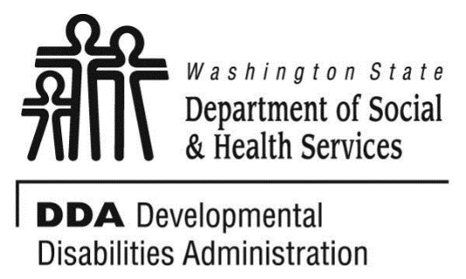

Figure 1 Developmental Disabilities Administration Logo

Figure 2 Developmental Disabilitiies Administration Logo

June 27, 2024 9AM to 12 PM 3 CEUs

**Fetal Alcohol Spectrum Disorder**

Supporting individuals with Neurodevelopmental disorder and/or mental health issues does require understanding of the origins of these disorders. This course will provide an introduction to Fetal Alcohol Spectrum Disorder (FASD), its causes, and how to support these individuals.

* Different disorders under Fetal Alcohol Spectrum.
* Causes for FASD.
* Neurological effects on the developing brain.
* Behavioral impacts.
* Supports for people identified with FASD.

Participants will be introduced to the spectrum, which is not a diagnosis.

Presented by Edward Fischer, PsyD

Dr. Fischer has worked 21 years with individuals with developmental disabilities and Autism. He works for the Developmental Disabilities Administration in Region 3 with the Regional Clinical Team. He is also associate faculty at two universities where he teaches clinical and forensic psychology and serves as dissertation chair and committee member.

*This training will be presented virtually and highly interactive. Participants should have the ability to access MS Teams platform.

4

**R3 Online TRaining**

**Developmental disabilities administration**

June 27, 2024 9AM to 12 PM 3 CEUs

***Click the link to register for Fetal Alcohol Spectrum Disorder:***

## **Thursday, June 27, 2024**

## 9:00 AM – 12:00 PM

**LINK:** [**https://www.eventbrite.com/e/fetal-alcohol-spectrum-disorder-dr-edward-fischer-62724-9am-12pm-tickets-774024868217?aff=oddtdtcreator**](https://www.eventbrite.com/e/fetal-alcohol-spectrum-disorder-dr-edward-fischer-62724-9am-12pm-tickets-774024868217?aff=oddtdtcreator)

**Class Size: Limited to 50 Participants**

**Additional classes are listed online at** [DDA Provider Training Opportunities](https://www.dshs.wa.gov/dda/dda-provider-training)

***Please Note:***

* **Class starts promptly at the stated times. If you are late, you may not receive credit.**
* **Please print any handouts, if provided, as they may be used in the class.**
* **Use of video is preferable.**
* **Please do not use a cellphone, a computer with screen is recommended to attend this course.**