Trainer’s Manual for Instructor lead courses
This course was developed by DSHS/DDA. You may add to this course but no other changes are authorized.

Course Title: Train the Trainer / Beyond Mandated Reporting 3.0
Course Code:
# of CE hours: 6
Intended Audience: Residential Provider Trainers (You may not hold your own TTT for this course.)

Before the event:

- Reserve the room, invite people to attend, determine if you will provide light refreshments or not and ensure that you have marked it off on your calendar so you can prepare. Set aside time to practice. No matter how well you know the material, you should go through it before you stand to deliver.
- Prepare Certificates. Print with person’s name, instructor number (if needed) and the trainer information. Print one certificate for each participant. The certificate for this course is available in the masters section of this Guide.
- Prepare handouts, packets, information you will share during your training.
  - These may be found at the end of this chapter or
  - You may have a participant toolkit to print.
- Prepare activities to use and PRACTICE them. Ensure that you have written instructions for all activities including time.
- Gather all materials that you will need for the training. Be prepared and organized.
- Arrange the room in a friendly lay out.
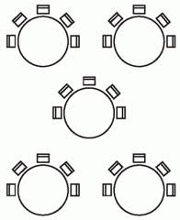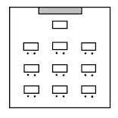

Please note that each arrangements allows for several things, safe evacuation, small group discussions without having to move and easy access to the front of the room so they can focus on the presenter and the screen with visuals.

You will want a large table at the front of the room for your training materials, laptop, projector and whatever you need to have handy during your presentation. Speakers, water bottle, mouse – all take up space so make sure you have enough room.

- Provide stress reliever objects for kinesthetic learners like stress balls, tangle toys, or pipe cleaners, markers, post its, 3x5 cards, pens at each table
- Start on time!
- Greet participants as they enter.
- Play some entry music. Select ahead of time or add to your power point
- Provide instructions on the dry erase board or easel paper regarding name tags, table tents or what to do to fill their time. (Table challenges or puzzles are a great way to fill time for early guests.)
- Create a sign in sheet with the name of the course, date and location. Participants may print their name and sign in or you may pre-print participants’ names and have them initial or sign for each day they are present. Participants must complete your course prior to receiving a certificate. Keep this sign in sheet or an electronic form for 6 years from date of training.

Materials for this course:
Computer
Internet cord or Wi-Fi connection
Long extension cord
Monitor or projector and additional speakers
Screen or blank white wall
Blank paper
Markers
Easel sheet and easel

Easel sheets to prepare before class:
Welcome
Instructions for completing sign in sheet, name tags, table tents, where to sit

Objectives:
- Recognize that your responsibility is for the safety of the person you support in ANY setting
- Identify what supports and partners you have to maintain a safe environment
- Identify plans in place and how to locate information to support you as the staff
- List two questions to ask hospital and medical personnel before discharge
- Represent confidently the needs of the individual you support
- Demonstrate how to obtain additional supports
- Instruct agency staff looking for ways to prevent bad things from happening
- Utilize best practices for teaching adult learners
https://www.google.com/search?site=imghp&tbm=isch&source=hp&biw=1536&bih=733&q=remember&oq=remember&gs_l=img.1.0.0l10.2503.3401.0.4877.8.6.0.2.2.0.91.468.6.6.0....0...1ac.1.64.img..0.8.488.BZ4hsEGqykA#imgrc=JFj9We5gHJ4q_M%3A
Here are some trainer tips to review before every presentation!
Your tone of voice needs to vary throughout your training. A Visual learner likes it to be fast and funny, an auditory learner likes it medium speed and a kinesthetic learner likes it slow and calm. Avoid a monotone voice.
Be intentional in your movement. Plant yourself in one location and then if you have to move, move to a spot that is intentional! Some facilitators are also successful with slowly moving around the room.
Use normal hand gestures and arm movements.
Connect with people. Look at their faces for no longer than 5 seconds or for a full thought. Looking people in the eye for longer than this makes them uncomfortable! Looking over their heads breaks your connection with them. Make brief eye contact with everyone at some point in your training.
Breathe quietly and deeply.
Focus on the group. What do they need? Are they getting tired? Give them a break, or do some movement. Are they hungry? Are they bored? Don’t let your need to cover content make you forget that people cannot learn if they are anxious, bored, tired, hungry, or stressed.
Best practices for in person training including:
- Read the room
- Start activities with small groups or pairs and move into individual or larger group activities. Creating a safe starting point will help you build trust.
- Meet people where they are – content should not be too basic or too advanced
- Tell people why they are there
- Remind people you are just there to help them
- Ask yourself, what did you learn?
- Leave time for self-reflection on what they learned and what they will apply when they return to work
- Use post it notes first. Some people may not want to share their ideas out loud. By asking each person to write on post its first, allows their voice to be heard for the rest of the activity.
- Answer questions of fact.
- Questions of opinion should be answered by the group.
- Share your expertise when the content in a discussion didn’t get covered.
- Listen effectively. Paraphrase, use active listening skills
- Tell your own story.
- Connect similar ideas throughout the day.
FranklinCovey Facilitator Enhancement Day Series, 2016
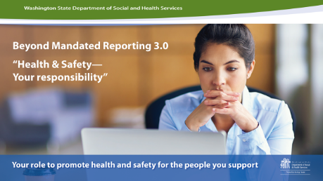 |  | Prepare easel sheets:  - Welcome people as they arrive  - Pass Sign-in sheet
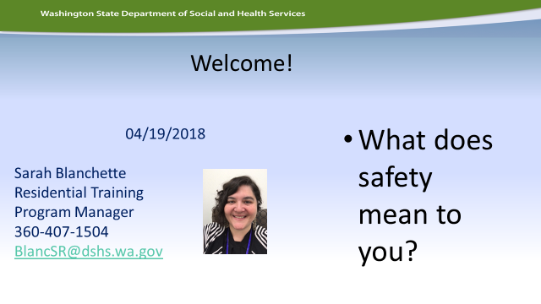 |  | - Put your name and contact info here (picture is optional)  - Have people introduce themselves  --Name/Agency/Role within Agency (trainer, admin?)  --Ask each person to talk about what safety means to them or where do they feel safest?
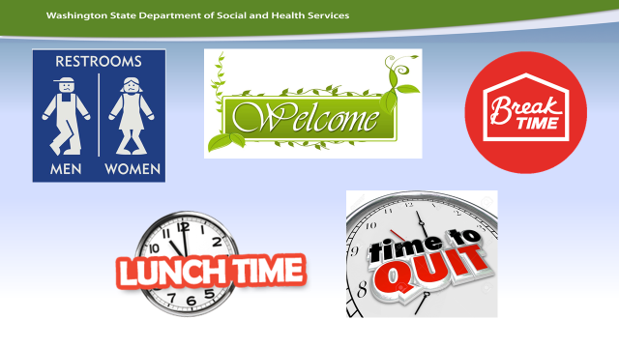 |  | Housekeeping, before adults can learn anything, they must know these essentials.  --Where are the restrooms?  --When is lunch and breaks?  --What time does this training end?  This is also a good time to go over cell phone policy
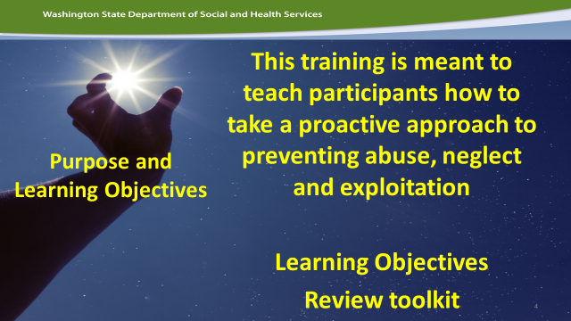 |  | Review Pg. 2 of toolkit  --What is the agenda  ---Learning Objectives  --Goals of the workshop?
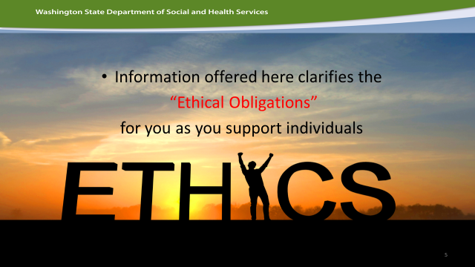 |  | Ethics  --Introduce this topic by having a mini-discussion: “What is the difference between a job and a profession?” (let them answer). The answer you are looking for is that a big difference between a job and a profession is that professional adhere to a specific Ethical code. Doctors have the Hippocratic oath, Psychologists, Nurses, Lawyers and even Social Workers have an ethical code they have to follow. There is a national movement right now to lobby for Direct Support Professionals to be viewed as a profession and not just a job.  Have them read the Ethical Statement for DSPs on Page 3.  DON’T HAVE A BIG DISCUSSION AFTER THEY READ THIS  Pages 4-7 break this ethical code into smaller pieces.
SMALL GROUPS—break the class up into small groups and assign each group 1 or 2 (pg 4-7). Have each group talk about what the Ethical Code means and what could potentially happen if a DSP does not respect or follow that ethical code.
Debrief—Have the small groups share what they discussed.
Tell this story. A Case Resource Manager was conducting a CARE assessment in the home of an individual receiving Supported Living services. It is documented that this individual has a history of PICA and ingesting inedible items. There were clear instructions to lock up all cleaning supplies, chemicals, soap and toothpaste. A PBSP with clear instructions was in place. The direct service staff minimized the need to lock up all items and stated they had not seen any of those issues since he had been with them. Mandated reporting occurred. The individual did ingest laundry detergent, was hospitalized, and later died.

The intent is not to assign blame here. Rather, it is to look at what in the future might we do beyond mandatory reporting in these situations that may bring a different outcome? These circumstances will always occur in some setting, in some way, but we need to work to reduce the chances of risk. This training is designed to help you minimize the possibility of incidents occurring in the first place. Observe your environment with new eyes each day.
This is the only slide where there is a mini-review of what Mandated Reporting is. Hand out 6.12 policy a reminder. Ask a few simple questions for review:
--What is mandate reporting?
--Are you a mandated reporter?
--Where do you report Abuse, Neglect and Exploitation?

Ask: What is Reasonable Cause?
--Read through Reasonable cause on pg. 8 in the toolkit

Ask: What puts us all at risk of committing abuse, neglect and exploitation? Point out that the story about leaving the laundry detergent out on accident could happen to any of us. Talk about their plans to manage stress, exhaustion, distraction, and other factors in their workplace.
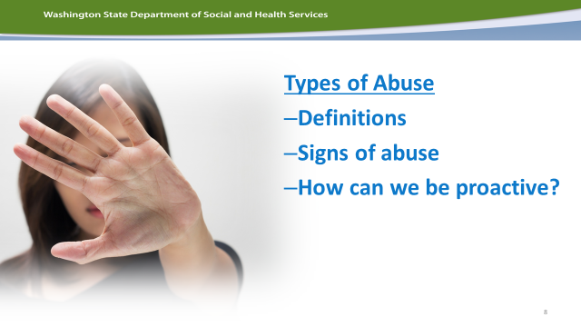 |  | Review Pgs. 9-12  Small Groups—break your class into small groups, give each group a large piece of easel paper and assign each of them an abuse definition and ask them to do list signs of this type of abuse (if you program only works with adults—assign only types of abuses for adults) and how to intervene. Then have each group present this to the rest of the class.  Then during the presentations, ask the whole class this question:  How can this type of abuse be prevented?  Have the small group list all the ideas that larger group has about preventing this type of abuse.
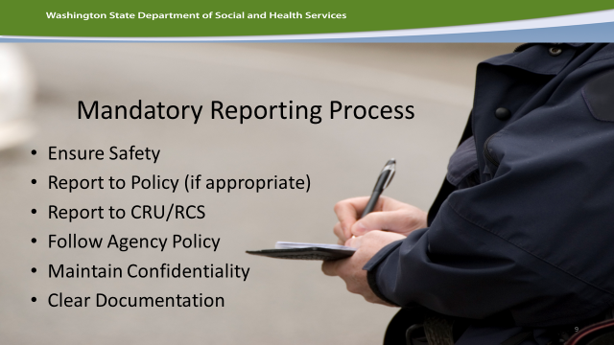 |  | Review pg. 13  Have class read steps and discuss the order of operations and why they need to follow this plan and in this order.  Please highlight your agency’s process
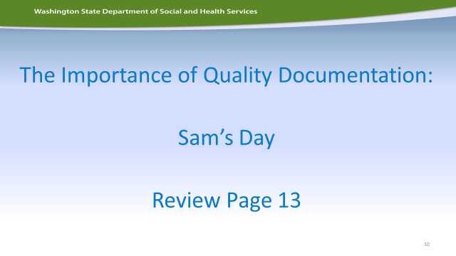 |  | Independent Practice  Please USE your agency documentation here. Write a Service Entry Record with many common mistakes. You can use the documentation activity on pg. 13 as a guide when you write your own.  Have each person read the documentation activity and then have a discussion of all the mistakes in this written documentations.  Challenge each person to rewrite this Service Entry Record in their own words, correcting the mistake. Debrief as a large group and ask someone to share their rewritten example.
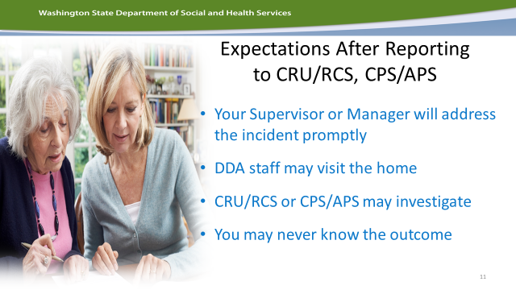 |  | Review pg. 14  Talk about what happens after a report is filed.  Review the discussion questions (review documentation tips)
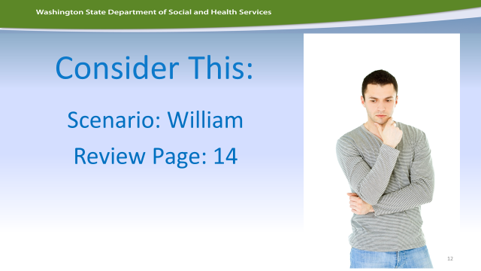  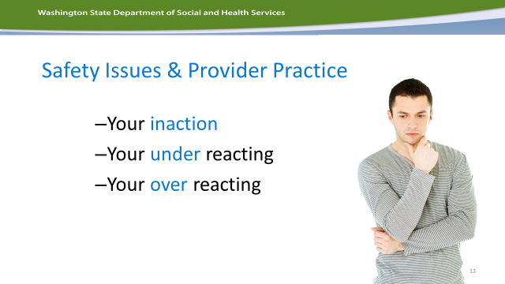 |  | Review pg. 14  Before you review anything else, have the class read the scenario-1 about William  Have a large class discussion. Push the class to give an example of what would be an example of-Inaction, Under-Reacting and Over-reacting as well as what they SHOULD do in this situation.  Remember that those who have a history of false allegations are at an increased risk of actually being abused. We must report and intervene every time.  Note to TRAINER: don’t fight the conflict on this but let the class grapple with what could happen if we fail to report and William really is being assaulted. Push them to consider the consequences of not reporting.
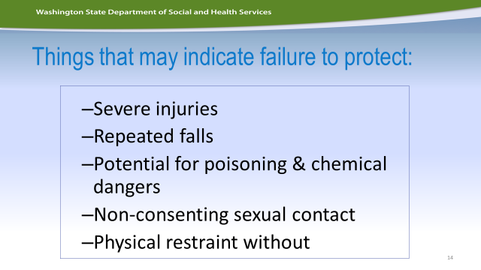  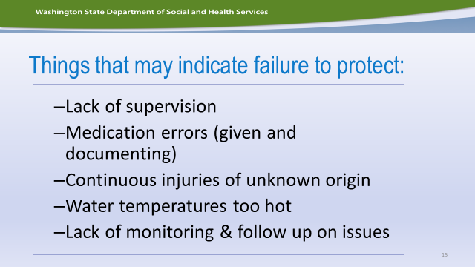 |  | Review pg. 15 and the two PPT slides.  Have a discussion about each topic on the PPT slides. Ask for examples. How would a situation where a staff failed to protect an individual lead to:  - Severe Injuries  - Repeated falls  - Potential Poisoning  - Etc.
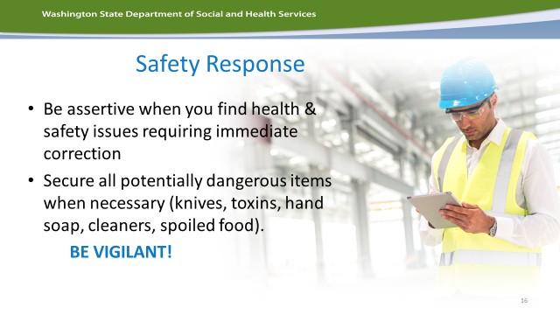  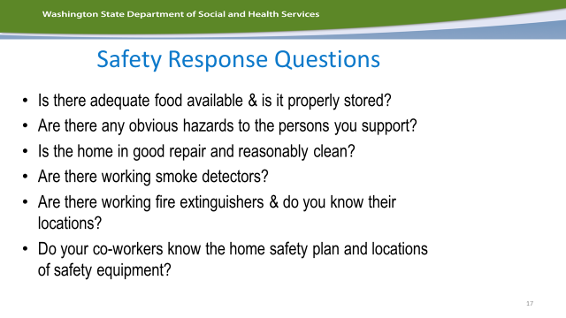 |  | Discussion Slides pg. 15  Ask the safety questions to help the class prepare of how to be assertive and build strong safety responses.
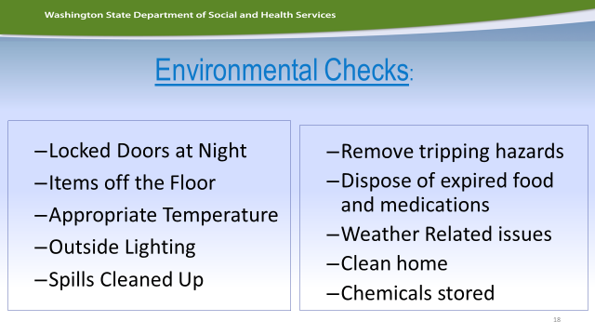 |  | How do you do environmental checks at your jobsite?  BRING THAT INTO THIS TRAINING. If you use a checklist, train to that vs. this slide or pg. 15  If there are no environmental checks then use pg. 15 and this slide and ask your class to create a personal plan about how they will build environmental checks onto their daily activities.
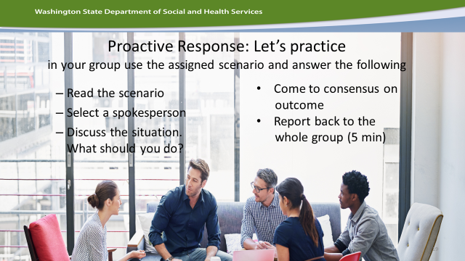 |  | Small Groups—break your class into small groups. It’s time for them to put this knowledge to use. Assign 1-2 different scenarios to each group (pg. 16-19).  Push your small groups by asking them to give an example of inaction—over-reaction and under-reaction to these scenarios as well as the ideal response to these scenarios.  Ask each small group to present to the larger group the scenario and responses.  Large Group Discussion—after each scenario is discussion ask each group if and how each situation could have been prevented or how can we intervene early in these situation to protect individuals of abuse, neglect and/or exploitation?
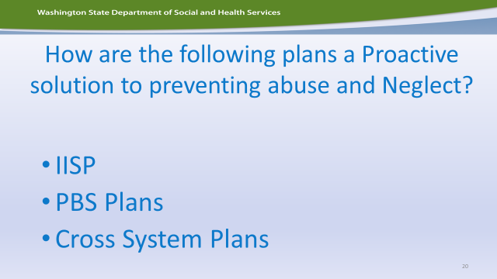 |  | Large Group Discussion  How is reading and following support plans prevent abuse, neglect and/or exploitation?  Review each plan listed on pg. 19-20
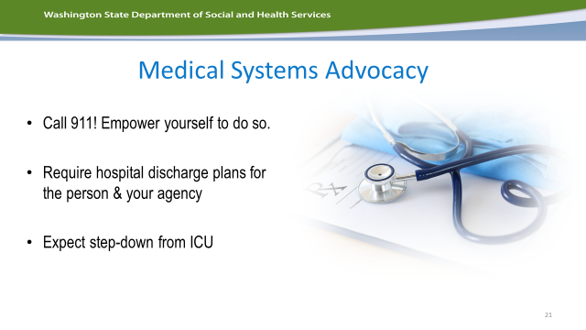 |  | This part of the BMR training is brief introduction to a larger topic.  Highlight:  - Everyone should be empowered to call 911 when there is an emergency. Empathize they do not need permission to call 911  - Hospitals MUST create a “SAFE DISCHARGE” plans. Help your staff understand they can request a safe discharge plan when interacting with the hospital.
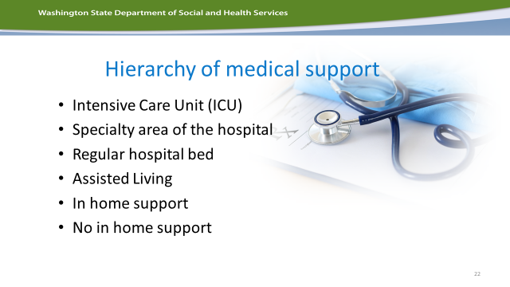 |  | Review Pg. 21—  Let your staff know that no one discharges from the ICU but hospitals have different levels of care. We often think of hospitals as one place with one level of care.
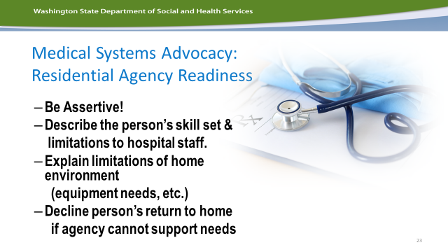  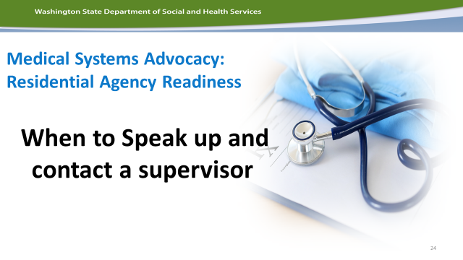 |  | Review Pg. 21  Ask how they would advocate?  Have they ever worked with someone discharging from the hospital?  Empathize they should not make these decisions alone and should talk to their supervisor before they say yes to any discharge. Review your agency’s policy/practice.
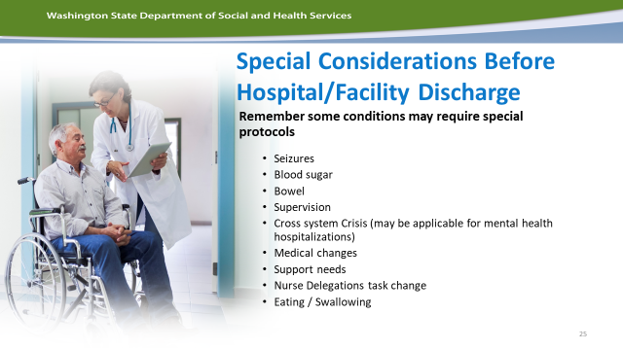 |  | Review pg. 22  When individuals discharge from the hospital there are many special situations.  Ask discussion questions like:  If someone has a seizure disorder and they were hospitalized due to a seizure what questions might we ask when they are discharging from the hospital?  What about someone who has diabetes? Mobility limitations?  Push your class to consider how they would think critically about discharges and how to proactively assess potential concerns when they discharge too quickly from the hospital.
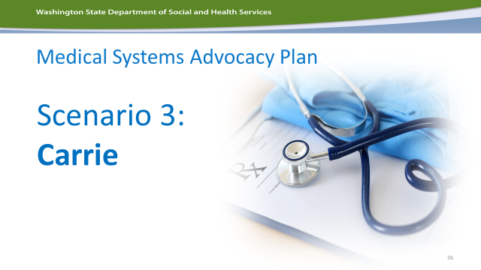 |  | Small Group  Have each group read Scenerio 3—Carrie (pg. 22).  Give each group an easel paper  Have them list the concerns about Carrie’s discharge.  For each concern have them write a question they would ask the discharge planner from the hospital.  When would it be safe for Carrie to return home?  How would we advocate for Carrie in this situation? What would we say?
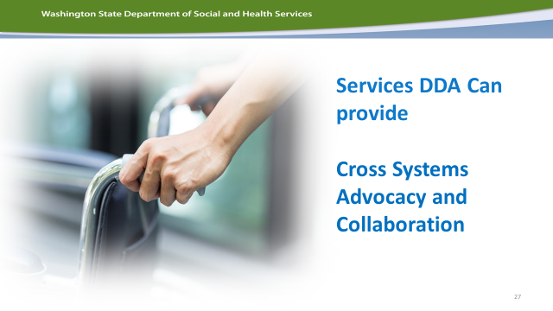 |  | Spend a small amount of time discussion the power of cross system planning, advocacy and collaboration. Please share your experience with this.  Here is an example you can use:  Lucy was very afraid of ambulances and also experience complex medical needs where she would sometimes need to be hospitalized. Every time EMTs would approach her with a gurney to transfer to the ambulance, out of fear, Lucy would hit, scream and kick the emergency personnel. This became so hard it nearly threatened her ability to live safely in the community. A Direct Support Professional who knew Lucy well, knew that she loved Taylor Swift, specially the song “Shake It Off’, the DSP communicated this with her counselor, DDA Case Manager and they reached out to the local fire Department and EMT team. Before long they had a mini meeting set up where they shared this information and a new protocol was developed. Now, when EMT is called to Lucy’s home to transport to the hospital, an EMT will pull up “Shake It Off” on his cell phone and they will dance into Lucy’s room. She now goes willingly and sometimes with a smile into the ambulance with her favorite song playing.  This is just one example of creative cross-system planning. (pg. 23)
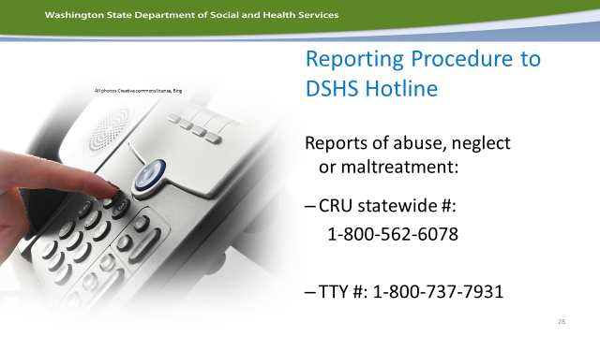 |  | This is the beginning of your wrap-up, remind people about where to go to report abuse, neglect and exploitation (pg. 24)  Ask participants to take out their phones and input this phone number right away.
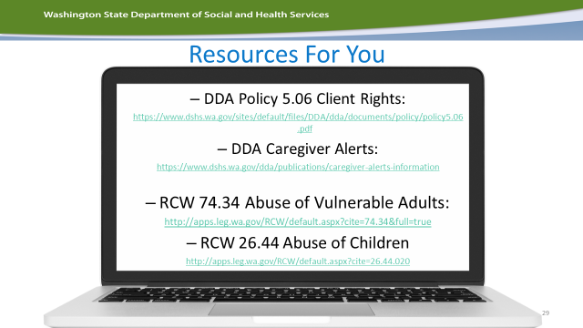 |  | This slide gives resources for individuals who are interested finding more information (pg. 25)  A good resource is “Questions to Ask During Incidents”, it is a great problem-solving guide.
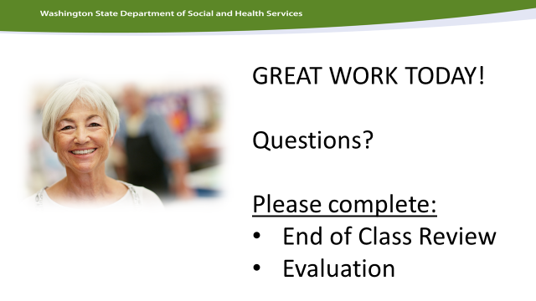 |  | This is a the final wrap-up slide.  Pg. 25 a great end of class review, you can do this as a large group or individually and discuss. This review is meant to be a way for you to check for learning and review key points.  Evaluation is at the back of the toolkit and a great way for people to give you feedback about how they felt about the training.

Bibliography:
Visuals used in this Facilitator’s Guide. All visuals are used with permission under a Creative Commons License or were free and are labeled here or in the Power point to attribute the creator.
<a href="http://cliparts.co">Clipart.co</a> | Activity
https://www.google.com/search?biw=1536&bih=733&site=imghp&tbm=isch&sa=1&btnG=Search&q=toolkit+icon&oq=toolkit&gs_l=img.12..0l10.360790.361782.0.370872.7.5.0.2.2.0.96.378.5.5.0....0...1c.1.64.img..0.7.400.HFcvS96-AKo#imgdii=z2HL0bQUte0ESM%3A%3Bz2HL0bQUte0ESM%3A%3BCoqcJzi9rzwALM%3A&imgrc=z2HL0bQUte0ESM%3A | Participant toolkit/ handouts
<a href="http://cliparts.co/clipart/42602">Clip arts</a> | Trainer idea or note
https://commons.wikimedia.org/wiki/File:White_square_with_question_mark.png | Discussion / Questions to ask
http://www.clipartbest.com/clipart-di79jjei9 | What to say, answers to questions
http://www.clipartbest.com/clipart-7caKbeKoi | Video clips
http://cliparts.co/clipart/607993 | Use easel sheets

This course was originally designed by Linda Gil, DDA for Case Managers.
Certificates: use approved DSHS CE Template. For more information contact Sarah Blanchette at BlancSR@dshs.wa.gov

