New Hire Reporting —Secure Access Washington [SAW] For Employers

Introduction: Secure Access Washington [SAW] is an online portal where employers can report new hires and remit child support for their employees by using DCSOnline. Now that you have created your SAW account, you may start reporting new hires.
Step 1: Log in to SAW by entering your SAW ID and Password.

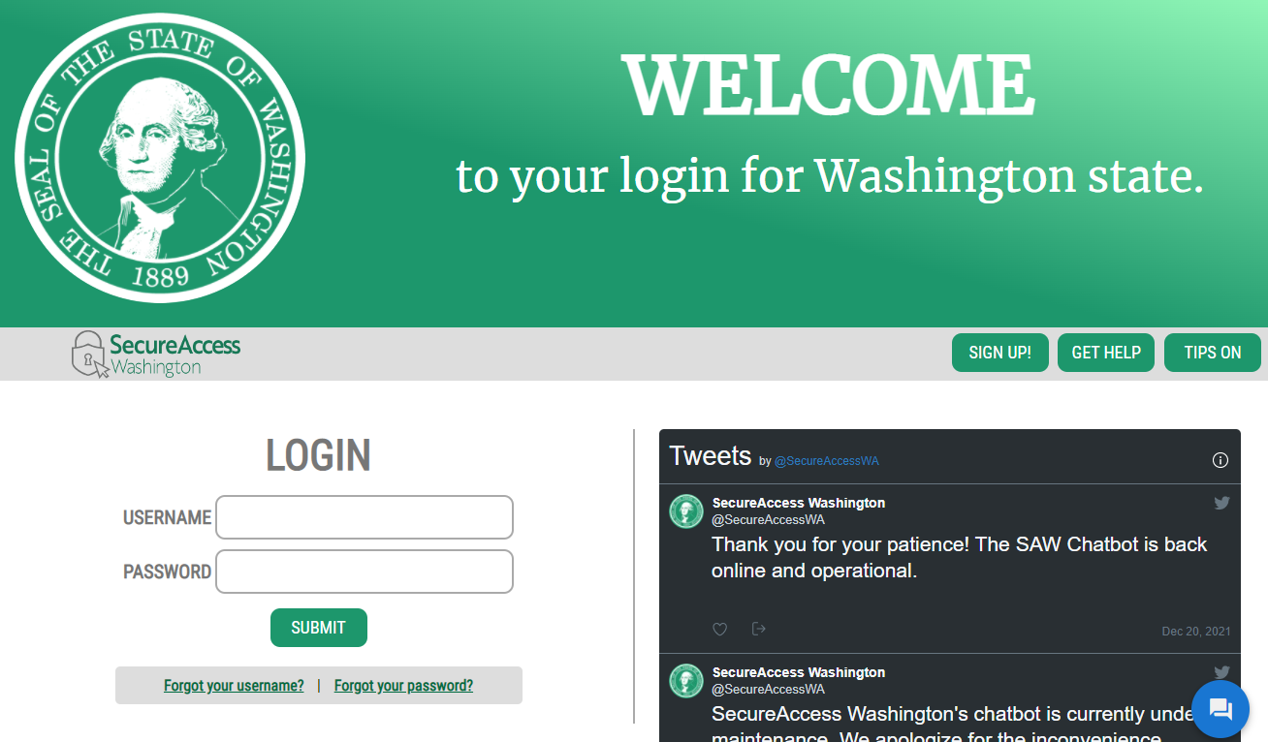
Enter your SAW USERNAME and password

Step 2: Find Division of Child Support Online Service and click on Access Now
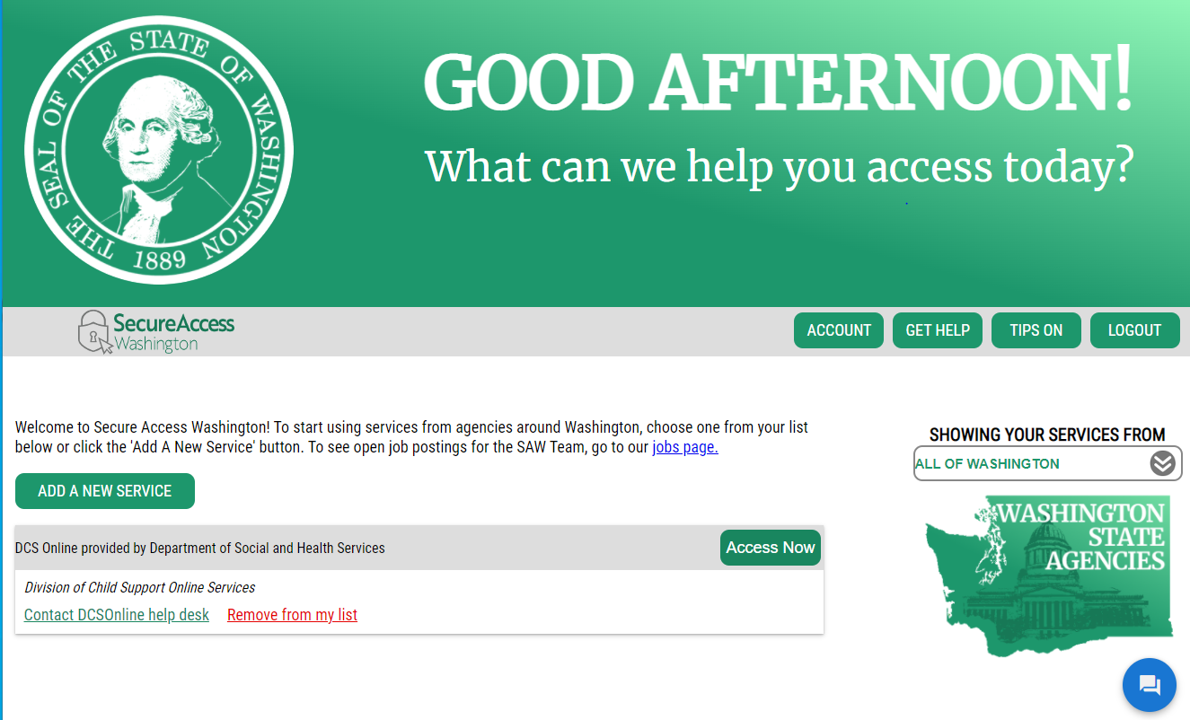
…. then Click Access Now
Find DCS Online and…
Step 3: Find Report a New hire and click on Report a Newly Hired or Rehired employee.
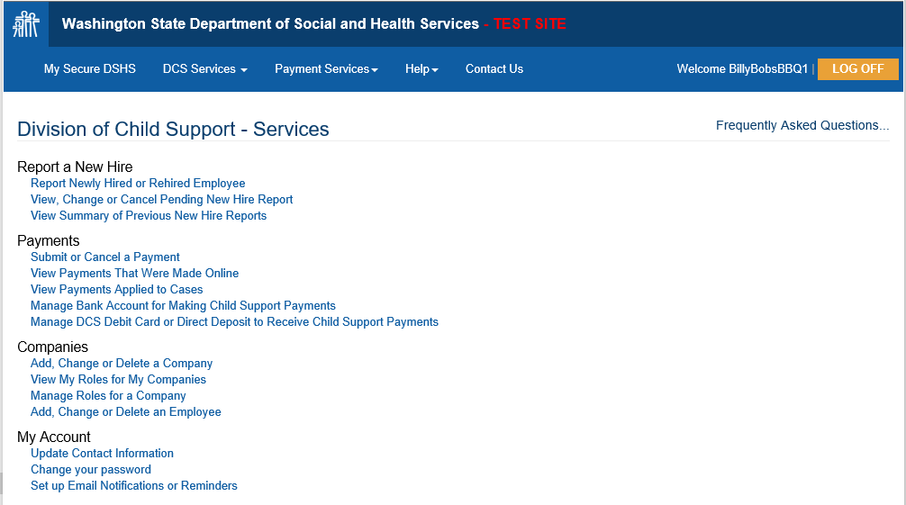
First, Add, Change or Delete your company. The information will be saved in in your DCS Online account for your use.
Click here to report a newly hired or rehired employee for a company you have added.

Step 4: There are three different ways you can report new hires in SAW.
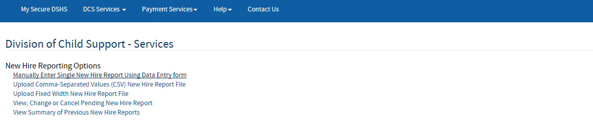
Option 2- Click here to upload a Comma-Separate Values new/rehire file
Option 1 - Click here to enter each new/rehire manually
Option 3 - Click here to upload a Fixed width new/rehire file

Option 1: Manually Enter Single New Hire:
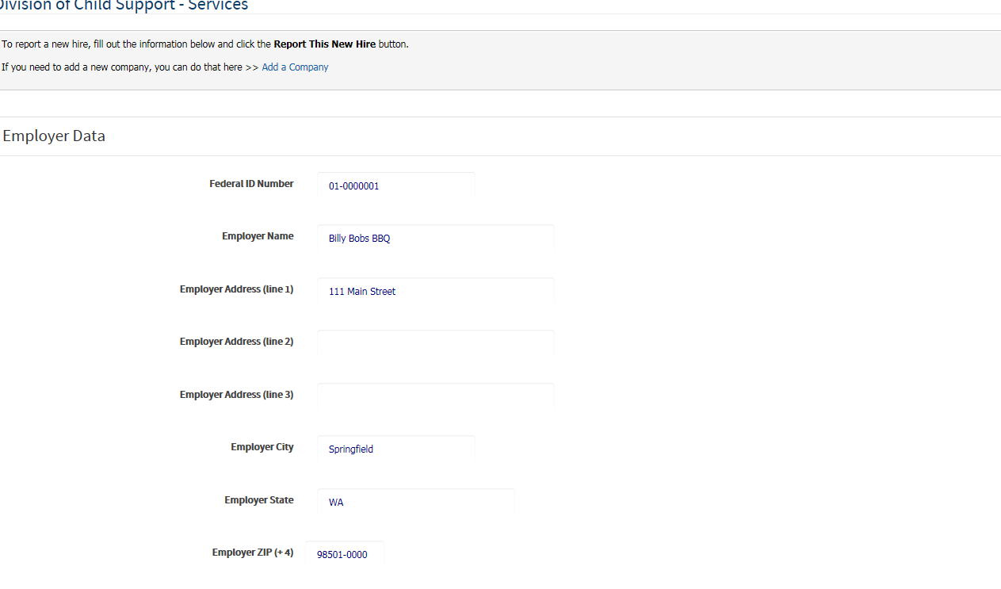
Verify your employer information
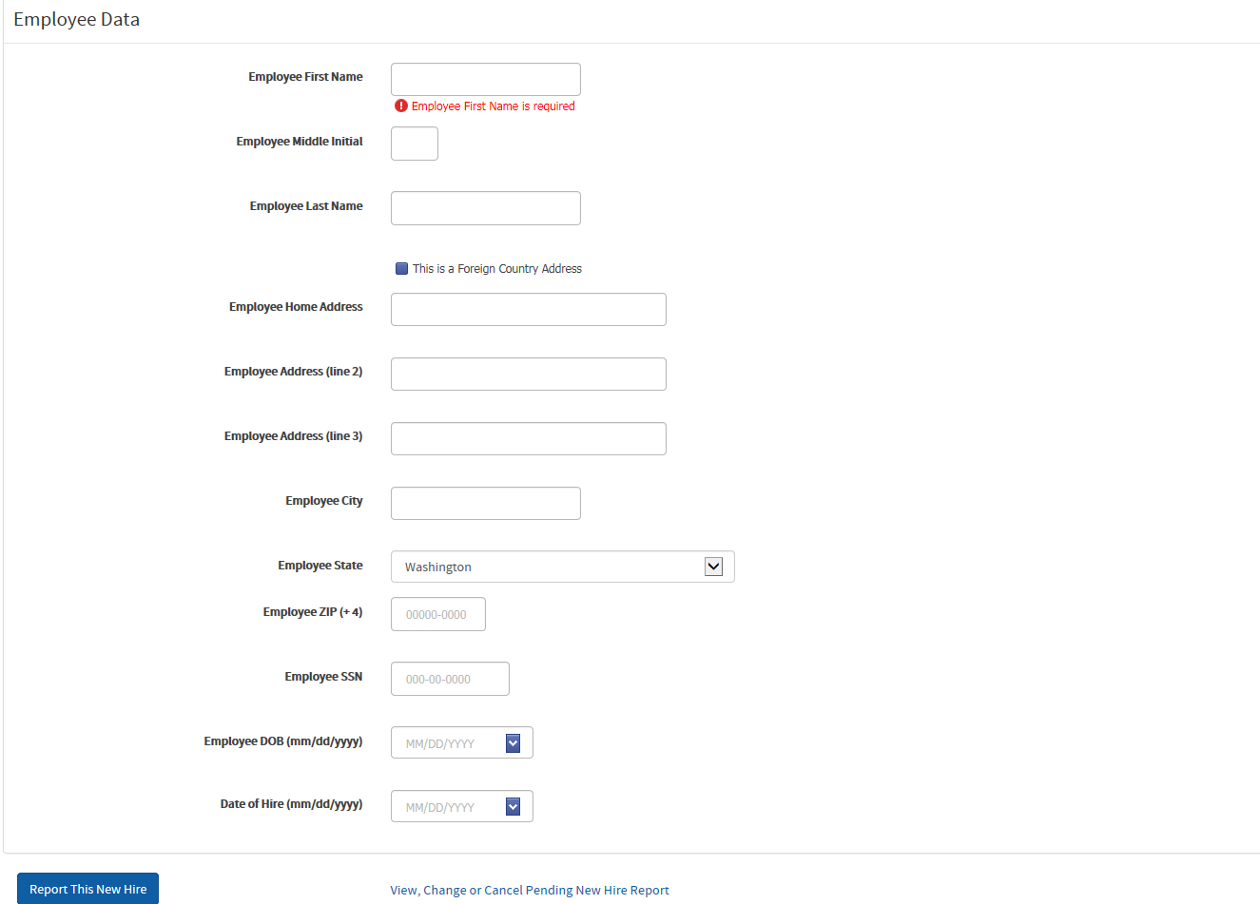
Enter your employee’s information
Click here to submit a new hire report for this employee
Once you click the Report a New Hire, you will be returned to the top of the screen where it should look like this. You may continue to submit new hires one at a time.
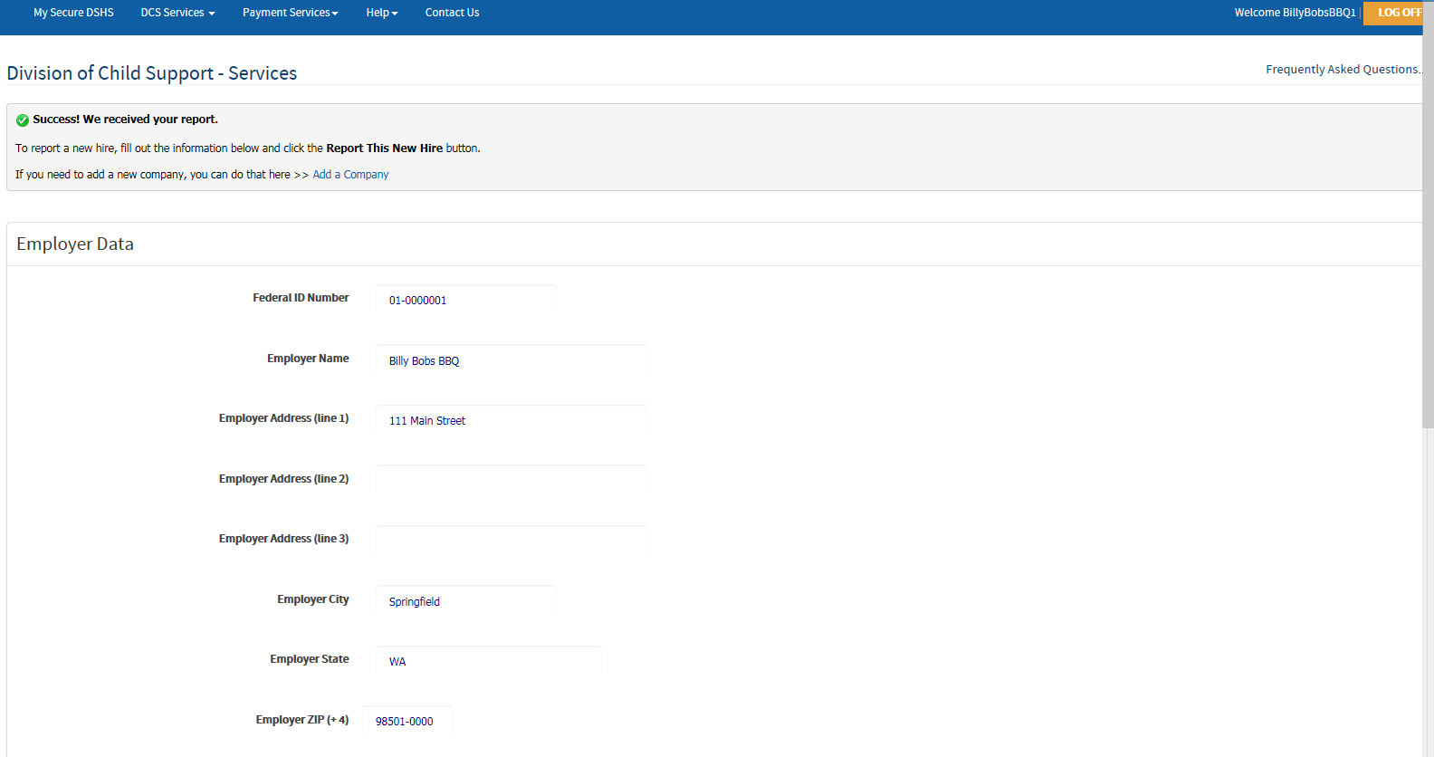
If you have other things to do with Child Support, click here
Success!
If you are done, click here to log off
You may continue adding additional employee information
If you want to see who you have already reported, make any changes, or cancel your current report, click here.

If you click on the View, Change or Cancel Pending New Hire Report, you should see the following.
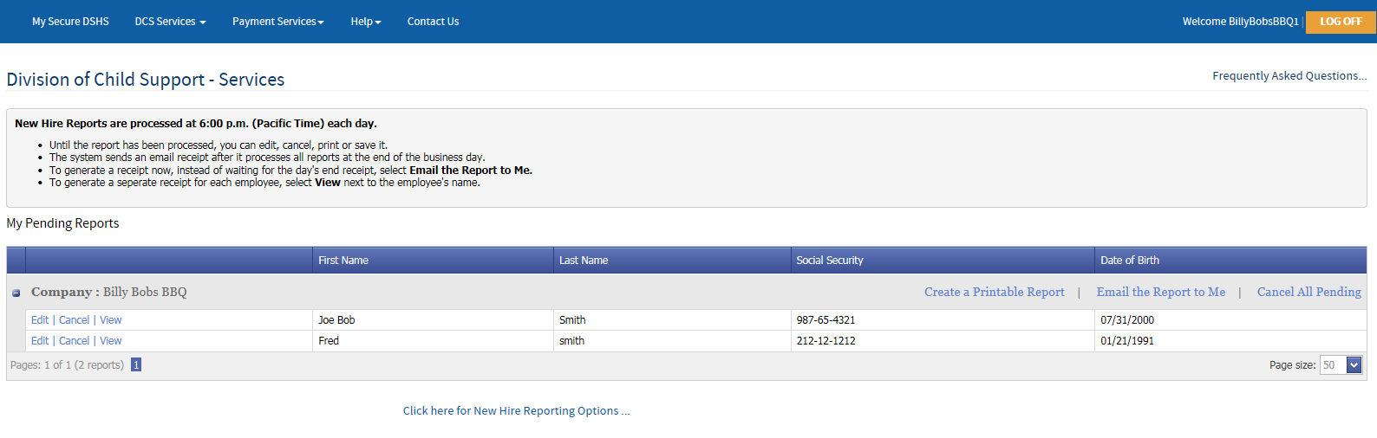

You may edit, cancel and view the information by clicking here

Option 2: Upload Comma-Separated Values (CSV)
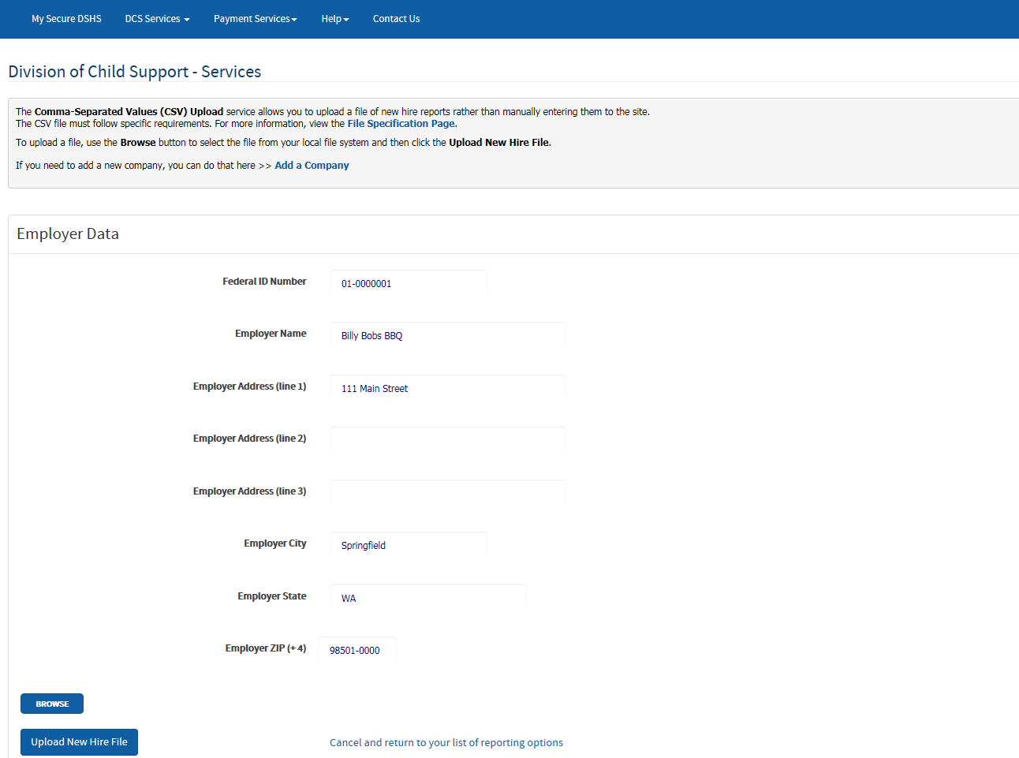
If you have questions about formatting the CSV file, click here. See the next page for additional help.
Step 3 – Click here to upload the document you selected
Step 2- Browse and select the document you want to upload
Cancel and return to the prior screen by clicking here
Step 1 - Verify your employer information

Creating a CSV File
This is the file specification page for information on formatting the file
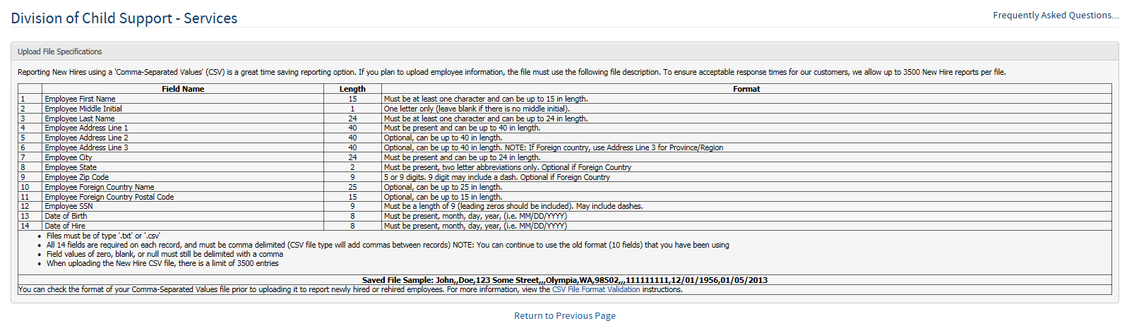
Open an Excel Spreadsheet and enter the employee information based on the above example. Multiple employees may be entered into one document, but must be entered on separate lines
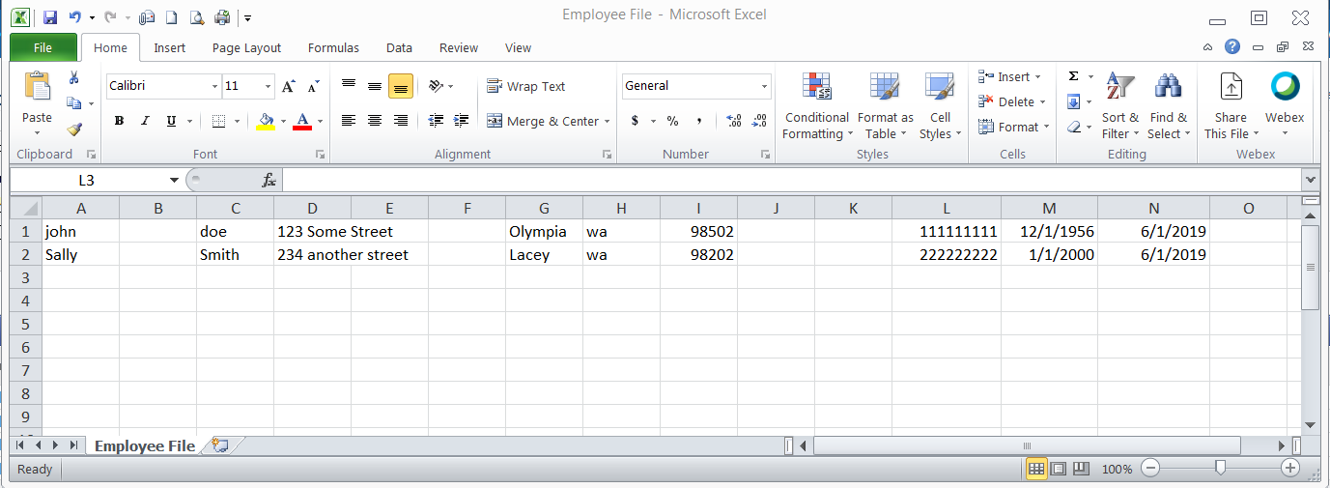
Save the spreadsheet as a CSV (Comma Delimited) file
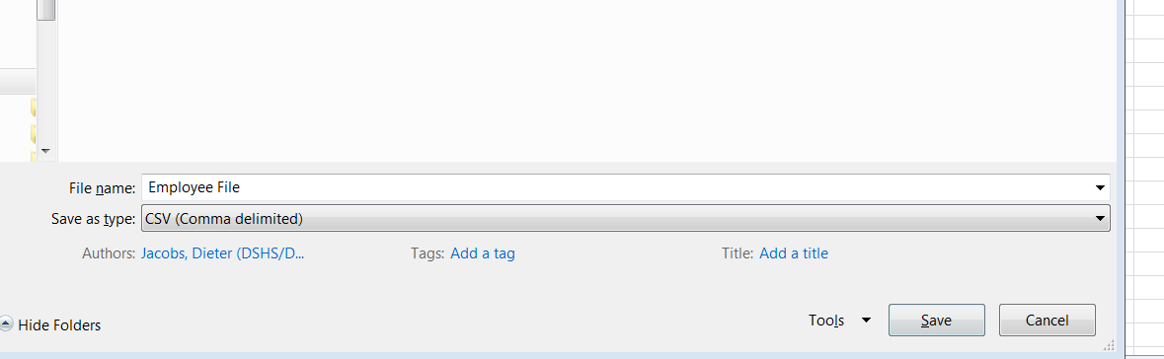

Once you download the file successfully, you should see this screen:
Success!
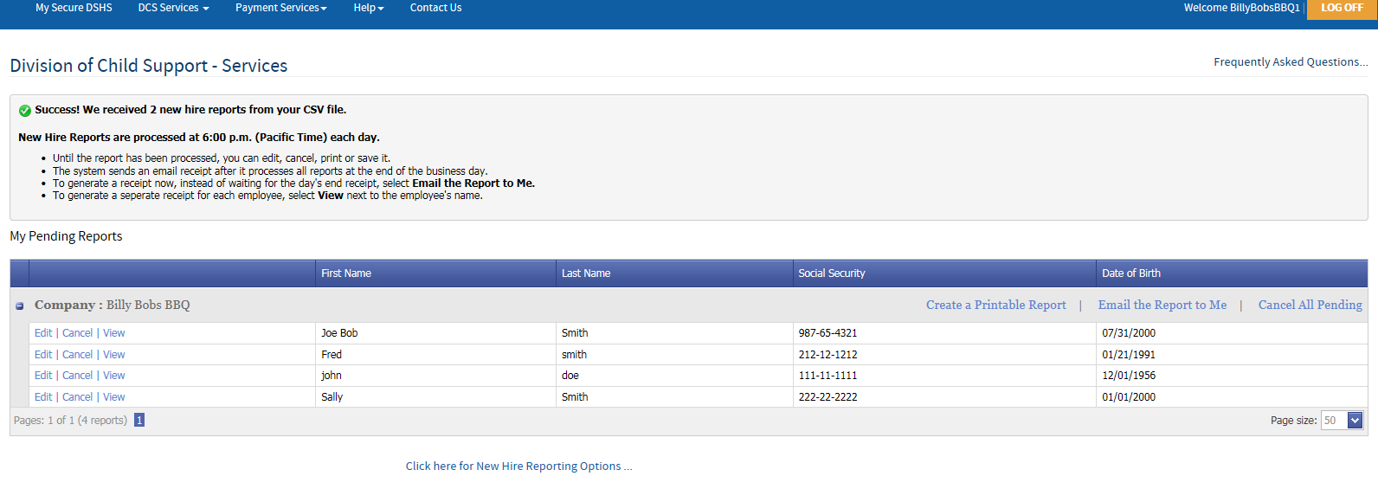
You may edit, cancel and view the information by clicking here

Option 3: Upload Fixed Width New Hire Report File – you should now see this:
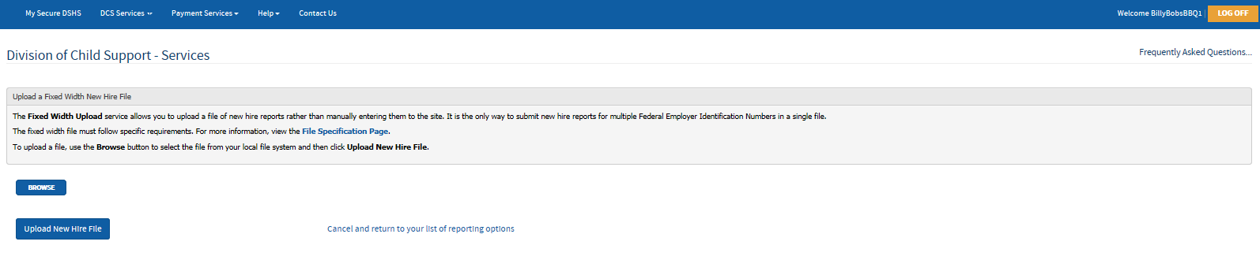
If you have questions about formatting the Fixed Width File, click here. See the next page for additional help
Browse and Upload the file by clicking on these buttons

Creating a Fixed Width File
This is the File Specification Page for information on formatting the file
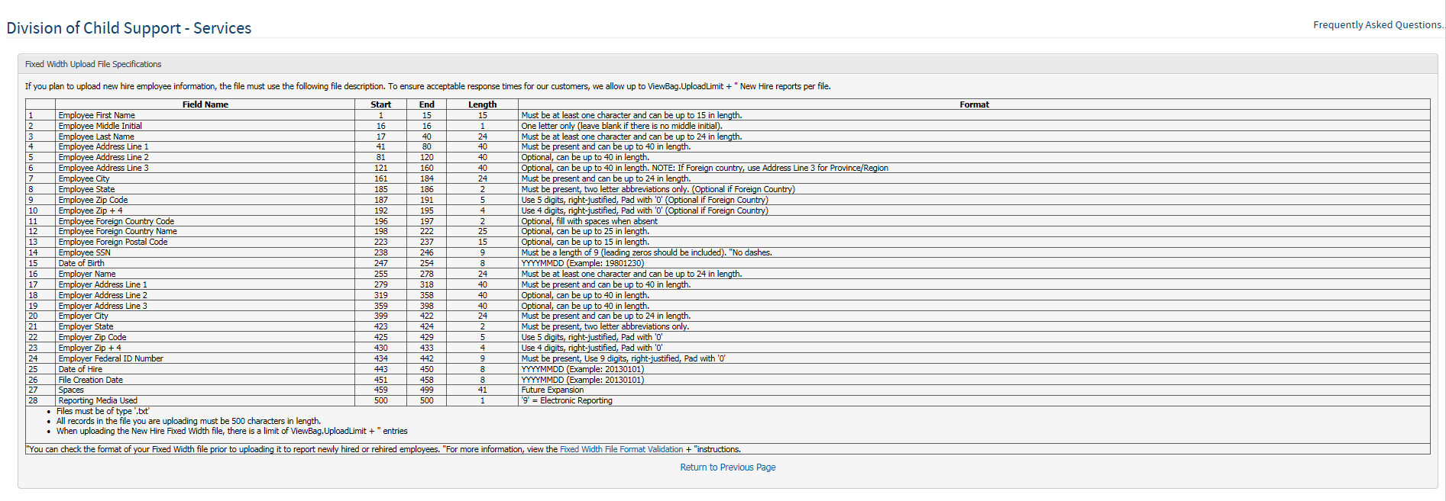
Cancel and return to the prior screen by clicking here
If you would like to test your file to see if it is formatted correctly click here.

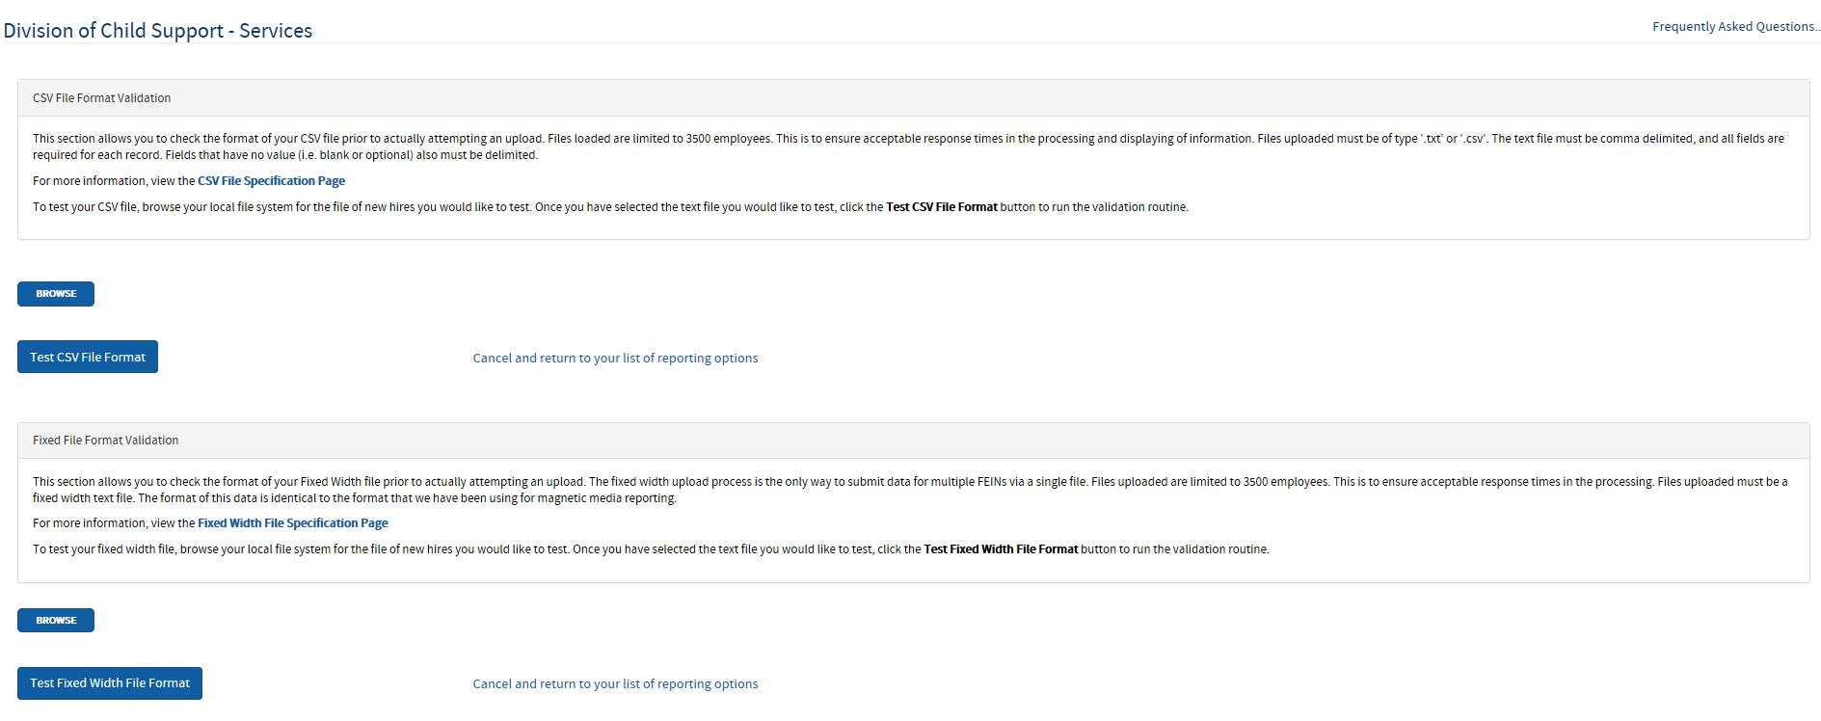
Click here to test your Fixed Width File Formatting
Cancel and return to the list of reporting options

If you need additional assistance with DCS Online or have questions regarding Child Support or New Hire Reporting as an employer, please contact the DCS Employer Relations Team at 800-562-0479 or email dcs-ert@dshs.wa.gov. We’re happy to help!

