SecureAccess Washington
Introduction: Secure Access Washington [SAW] is a central login that lets you access the online services of multiple state agencies. Employers can report new hires and remit child support for their employees by using DCSOnline within SAW. You may use an existing SAW account or create a new SAW account. Once you have logged in to SAW, you will need to add DCS Online as a service. Follow the steps below.

Step 1: Log in using an existing account or create a new account and log in
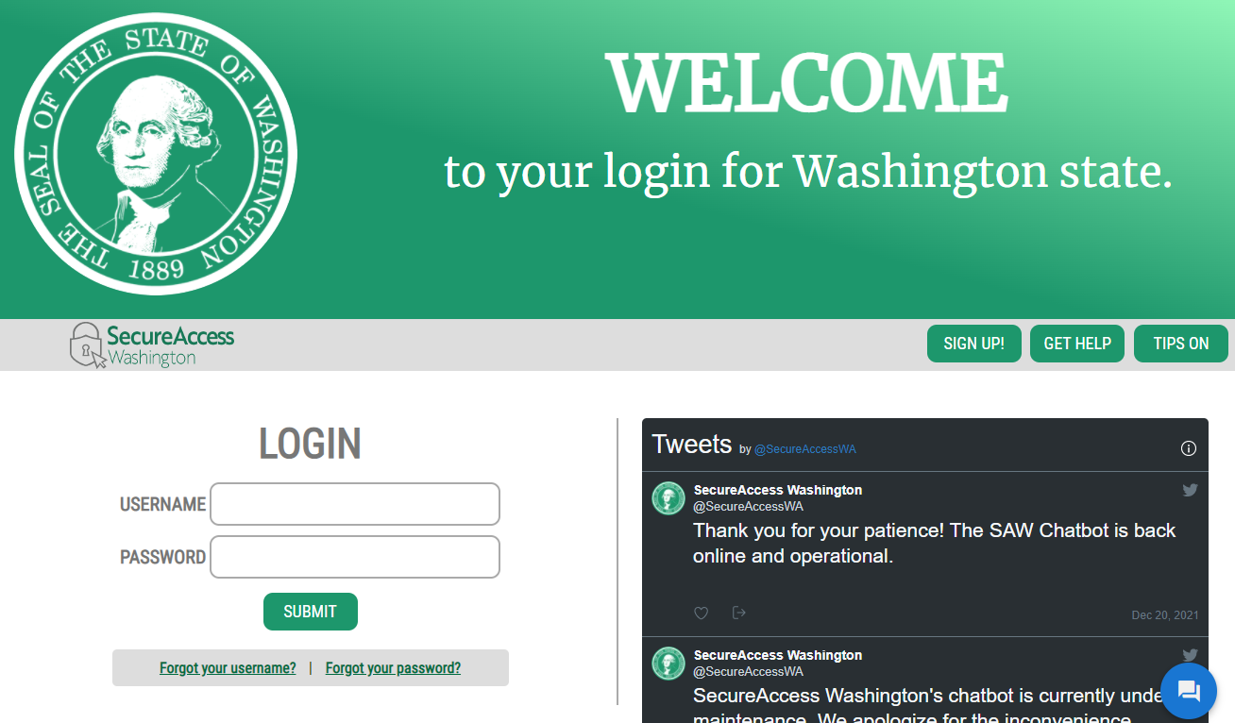
Option 1: You may enter the same USERNAME and PASSWORD you used with the other agencies or for DCS Online
Option 2: Sign up for a new SAW Account

Step 2: Add a New Service – DCS Online
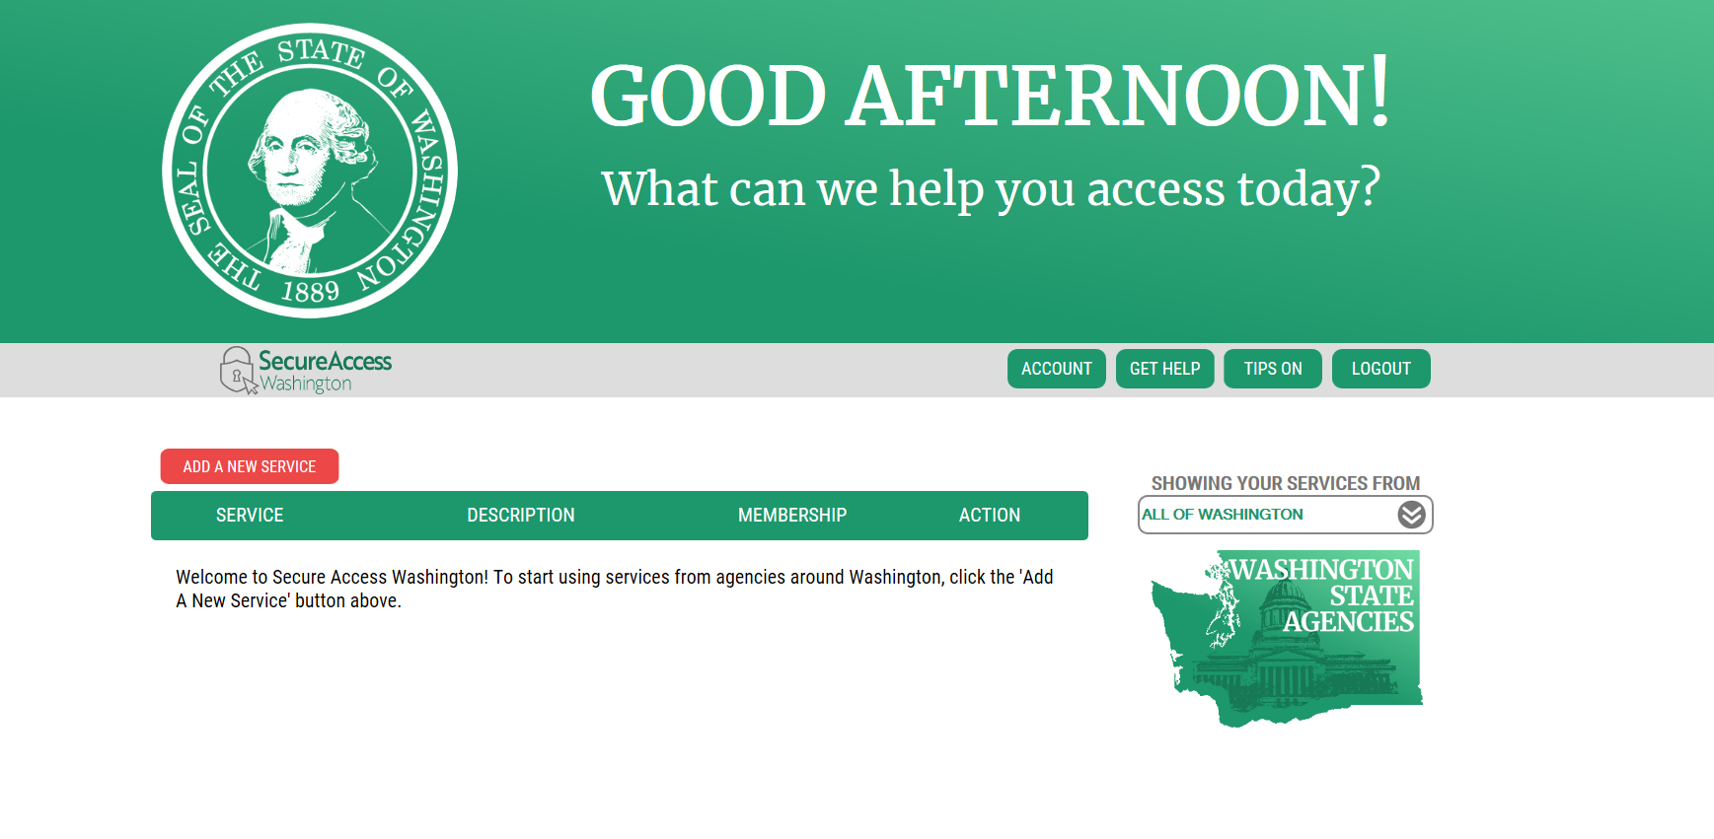
Click here to ADD A NEW SERVICE
Step 3: Browse to find DCS Online so you can add it as a service
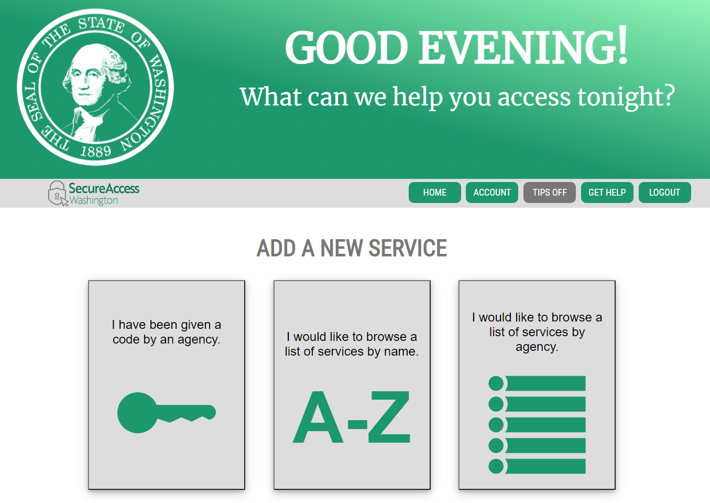
Click here for a list of services

Step 4: Scroll down to DCS Online and click Apply to add DCS Online as a service
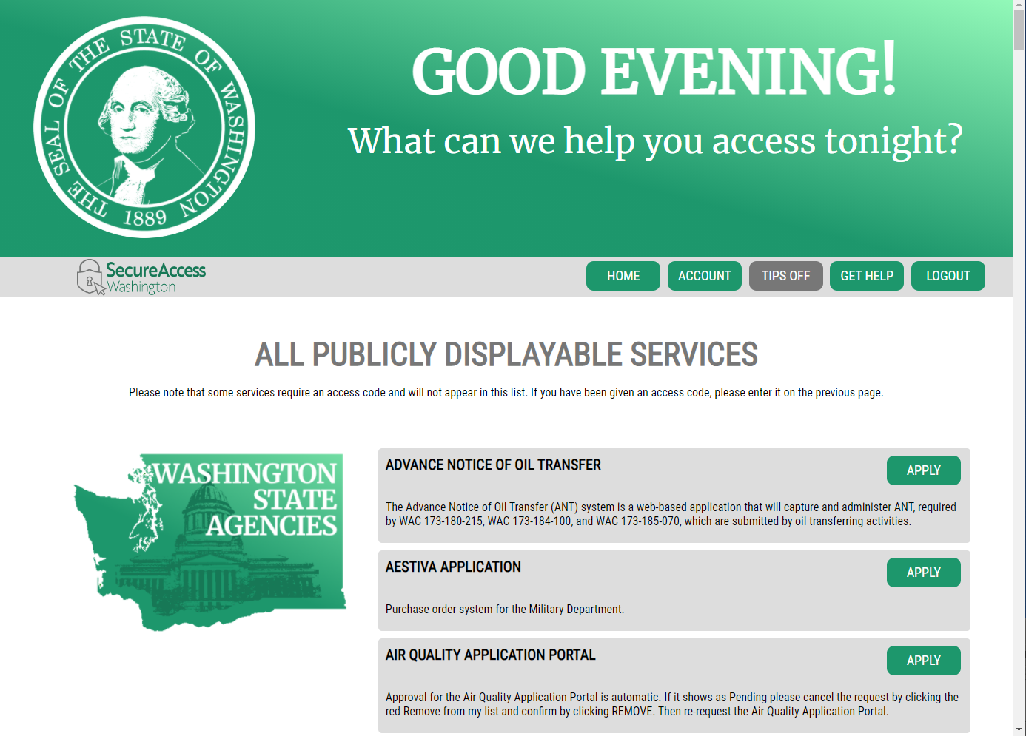
Scroll down using the side bar to DCS ONLINE

Find DCS ONLINE and …
… Then Click APPLY

Step 5: If you have previously added DCS Online to your services, you will see it listed in your services when you log into SAW. Just find Division of Child Support Online Services and Click on Access Now
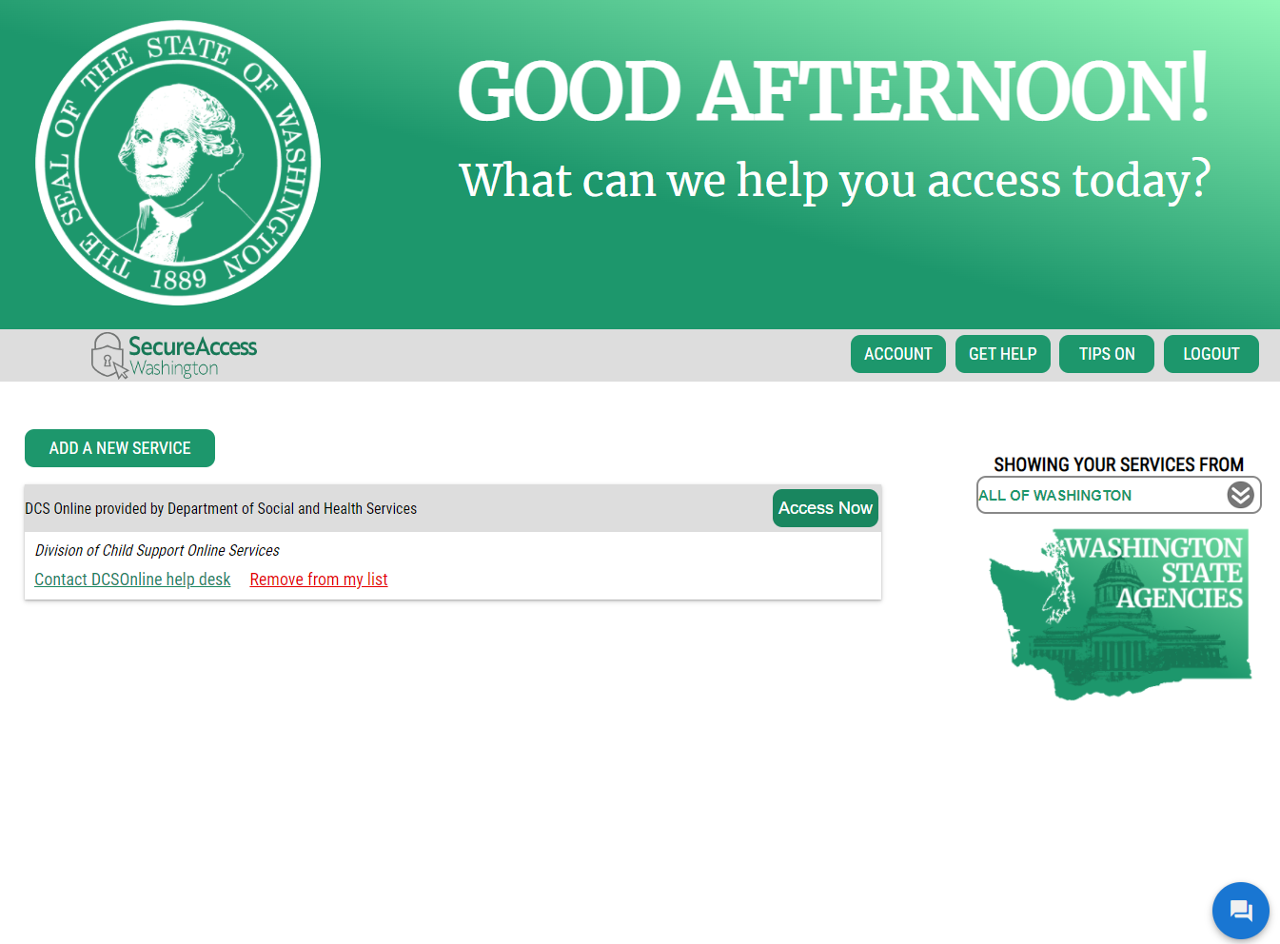Step 6: Click Continue
…. then Click Access Now
Find DCS Online and…
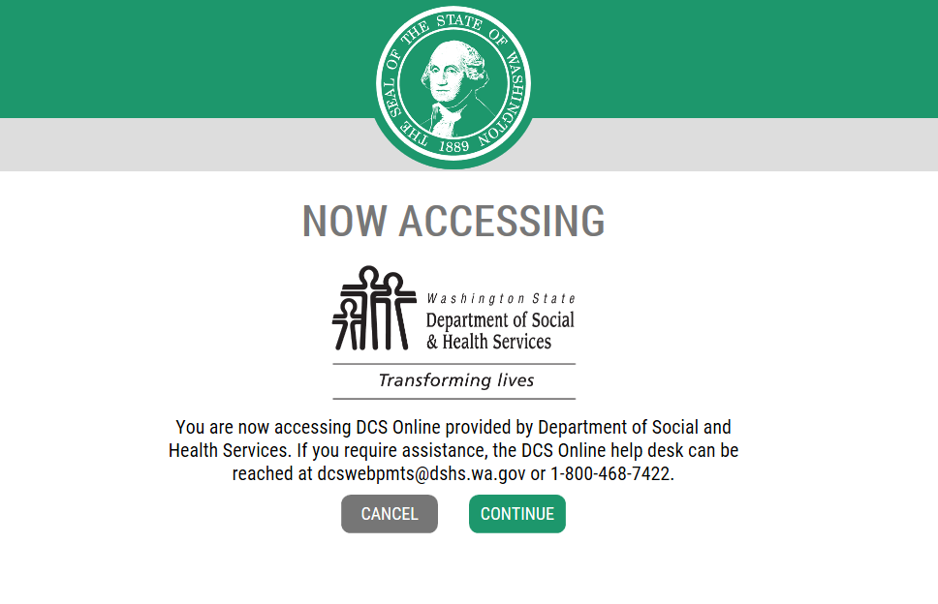
Click Continue
Step 7: If you are adding DCS Online to your SAW account the first time, you will need to enter your contact information. We use this information to contact you if we have any questions about your account or send you notifications. When finished, you will be taken to the main menu page.
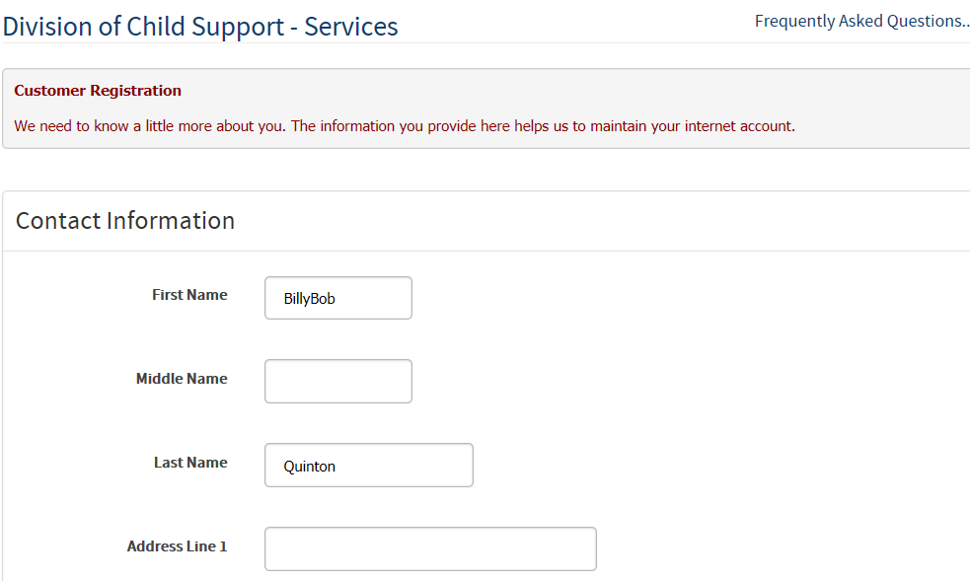
Enter your information
Step 8: Add your Company from the main menu page.
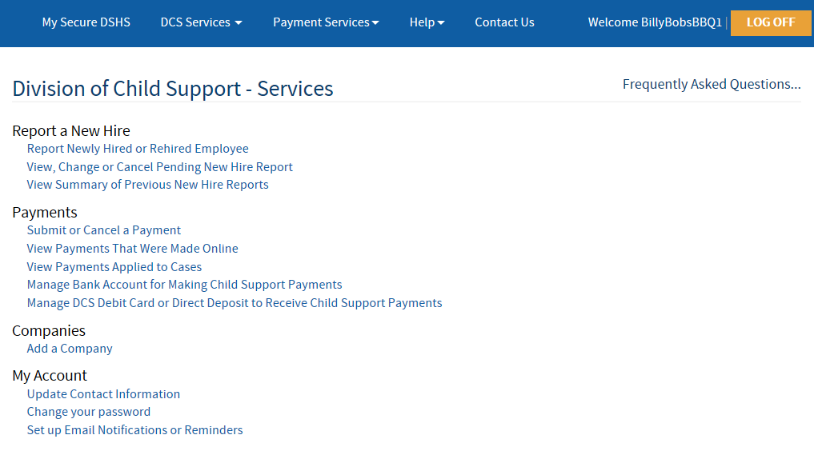
Click Here to Add Your Company
Step 9: See if your company is already in the system
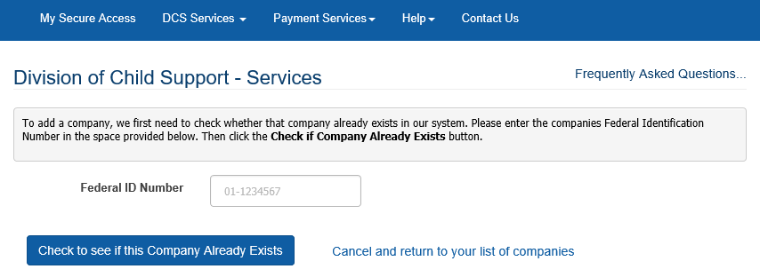
Add your Federal ID number here and press enter and then…
… Click here to see if your company is already in our system. If it does you can request access to it. If not you will enter information about your company.

Step 10: If your company is not in the system, you will need to add your company information.
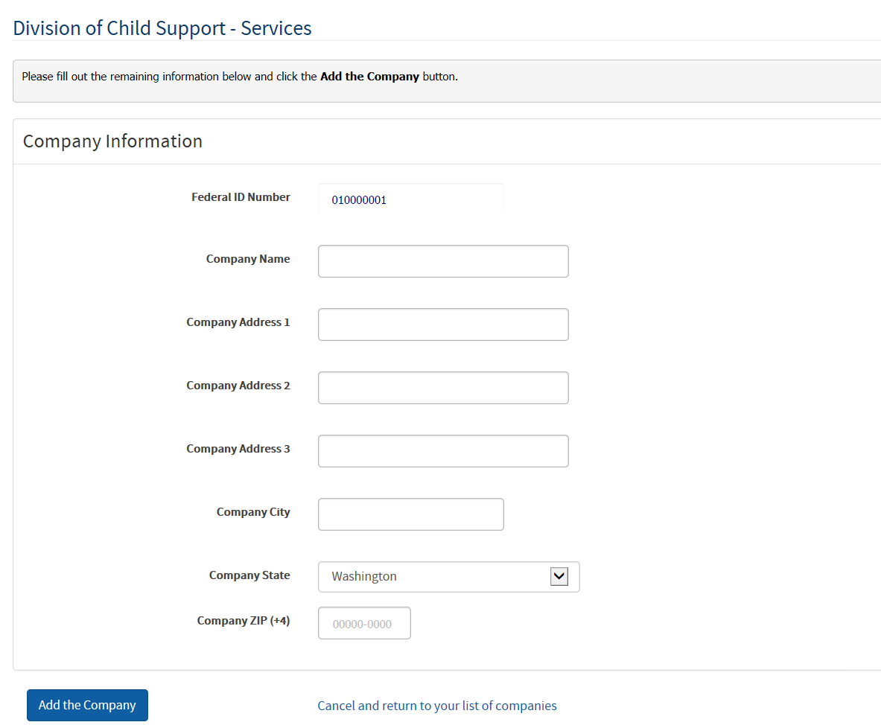
Click here to add your company
Enter your Company’s information on this page

Congratulations. Your SAW Account is set up in DCSOnline. You may now set up a bank account, make payments, view past payments, and report newly hired employees. There are additional How To documents on our website covering New Hire Reporting and Making Payments.
Select what you want from the DCS Services drop down menu or from the list down the left side of the page. DO NOT select Payment Services as these are for other DSHS services. You may also access the Frequently Asked Questions from this page.

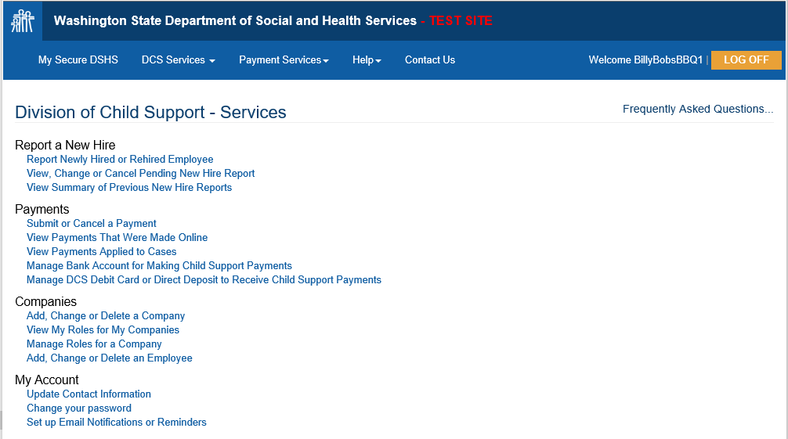
DCSOnline Frequently Asked Questions
This Main Menu page shows DCSOnline Options
DCSOnline Dropdown Menu

If you need additional assistance with DCS Online or have questions regarding Child Support or New Hire Reporting as an employer, please contact the DCS Employer Relations Team at 800-562-0479 or email dcs-ert@dshs.wa.gov. We’re happy to help!

