- Open WF Orientation video, in lower righthand corner look for “Settings icon
- Select “Settings” icon

- Select “Subtitles/CC”

- Select “English (auto-generated)”

- Once that is set, select “Subtitles/CC” again

- Select “Auto-translate”
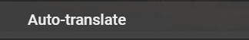

- Select preferred language from the auto-translate list
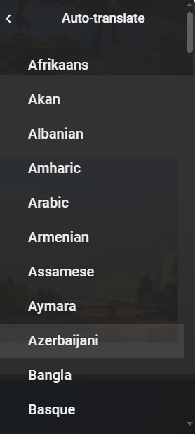

- Then play video from beginning and ensure preferred language is showing up as closed captions for client viewing.

