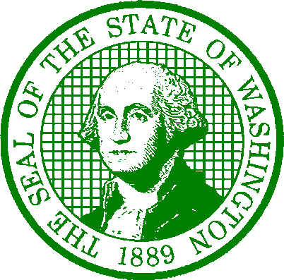

STATE OF WASHINGTON DEPARTMENT OF SOCIAL AND HEALTH SERVICES

PO Box 45811, Olympia WA 98504-5811

DATE: August 24, 2023

TO: RFQQ #2334-829 – Executive Recruiting Services

FROM: James O'Brien, Solicitation Coordinator DSHS Central Contracts and Legal Services

SUBJECT: Amendment No. 1 – Pre-Bid Conference – Time and Link

DSHS amends RFQQ #2334-829 solicitation to confirm and list the time and link for the Pre-Bid Conference for this solicitation.

The Pre-Bid Conference will be held on Tuesday August 29, 2023 from 1:00 to 2:00 pm PDT.

The Teams link for the meeting is here:

Microsoft Teams meeting
Join on your computer, mobile app or room device
Click here to join the meeting
Meeting ID: 211 614 692 510
Passcode: Zem7UE
Download Teams | Join on the web
Or call in (audio only)
+1 564-999-2000,,801462281# United States, Olympia
Phone Conference ID: 801 462 281#
Find a local number | Reset PIN
Learn More | Meeting options

All other terms and conditions in this Solicitation remain the same.

