  CENTRAL PURCHASING UNIT (CPU)  Sole Source Filing Justification |  | PURCHASING COORDINATOR:  Tim Scott
 |  | PR NUMBER  PR2524465 |  | TODAY’S DATE
SELECT SERVICE/PRODUCT DESCRIPTION / SUB-OBJECT CODE
EJ
Vendor Information
VENDOR’S LEGAL NAME  UpToDate, Inc. (UpToDate) |  |  | TAX IDENTIFICATION (TIN) OR UNIFORM BUSINESS IDENTIFICATION (UBI) NUMBER  043310941
ADDRESS
230 Third Avenue, Suite 1000 Waltham, MA 02451
Purpose of Purchase
To extend annual subscription term for UpToDate, an evidence-based on-line clinical decision support resource library that offers comprehensive, peer-reviewed content already approved by DSHS Department of Technology (DIT) as an enterprise solution and is currently in use at BHHA facilities.
Funding Source(s)
FEDERAL FUNDING  $0 | STATE FUNDING  $142,390 |  | CONTRACT TOTAL  $142,390
Proposed Purchase Dates * Start Date must be more than 20 business days from date of request to CPU.
*START DATE  12/1/2025 |  | END DATE  11/30/2027
AMENDMENT OPTIONS
Agreement may be extended for an additional one (1) two-year period.
Sole Source Definition and Guidelines
What is a sole source filing?
“Sole source” means a vendor providing goods or services of such a unique nature or sole availability at the location required that the contractor is clearly and justifiably the only practicable source to provide the goods or services.
(RCW 39.26.0101)
Unique qualifications or services are those which are highly specialized or one-of-a-kind.
Other factors which may be considered include past performance, cost-effectiveness (learning curve), and/or follow-up nature of the required goods and/or services. Past performance alone does not provide adequate justification for a sole source filing. Time constraints may be considered as a contributing factor in a sole source justification however will not be on its own sufficient justification.
Why is a sole source justification required?
The State of Washington, by law and policy, believes competition is the best strategy to obtain the best value for the goods and services it purchases, and to ensure that all interested vendors have a fair and transparent opportunity to sell goods and services to the state.
A sole source filing does not benefit from competition. Thus, the state, through RCW 39.26.010, has determined it is important to evaluate whether the conditions, costs and risks related to the proposal of a sole source filing truly outweigh the benefits of a competitive procurement.

Sole Source Justification
To expedite CPU and DES review of this sole source filing, please provide clear and compelling answers to the following justification questions.
- What is the business need or problem that requires this procurement?
DSHS BHHA facility clinical staff must have uninterrupted access to point of care data that is unique to our behavioral health patient population, especially side-effects and issues related to the use of antipsychotic drugs. UpToDate provides information related to the BHHA patient population, which is mostly psychiatric in-patient care. For optimal treatment, physicians, pharmacists, psychologists, and psychiatrists need access to on-the-spot drug interaction libraries that integrate with primary care treatment. BHHA needs to have access to the most current and unbiased information to reduce medical errors, reduce complications, and improve overall quality of care and patient outcomes. The current subscription for UpToDate expires November 30, 2025, and for BHHA to continue use, a new subscription with UpToDate must be reissued to ensure services continue without interruption.
- Describe the unique features, qualifications, abilities or expertise of the vendor proposed for this sole source filing.

UpToDate is an evidence-based clinical decision support resource that offers comprehensive, peer-reviewed content in 25 medical specialties. With this subscription, clinicians can access more than 11,800 topics (including text, graphics, and links to more than 425,000 references), graded recommendations, and select drug databases. UpToDate uses more than 7,100 medically trained authors, editors, and reviewers to write on UpToDate topics. The content incorporates findings from more than 420 journals, providing synopsis for clinicians in the form of concentrated reviews and summations with detailed recommendations and approaches for use in completing their diagnosis. This proprietary database is unique from any other online medical database or search engines as it is designed to answer specific questions at point of care.

UpToDate is the leading provider in the field of clinical care and is regarded as the “gold standard” for evidenced based information. UpToDate is the only system that provides more than 12,000 evidence-based clinical topics across 25 robust clinical specialties as stated in the attached sole source letter received from UpToDate.

UpToDate is used in more than 180 countries and has been shown in numerous independent studies to be associated with improved medical knowledge, improved quality of care, reduced complications, and reduced medical errors. UpToDate also had a proven track record of linking directly into electric medical records and other library systems for rapid searching of medical problems. There is no other resource that offers UpToDate’s extensive amount of content.

Physicians can obtain Continuing Medical Education (CME) credits for using the database. Practitioners are required to obtain continuing medical education (CME) each year, to renew their state licensure. The UpToDate product offers CME classes as well as tracks website usage by individual practitioners, giving them credit based on their searches and website usage.

A detailed list of additional UpToDate unique features are as follows:
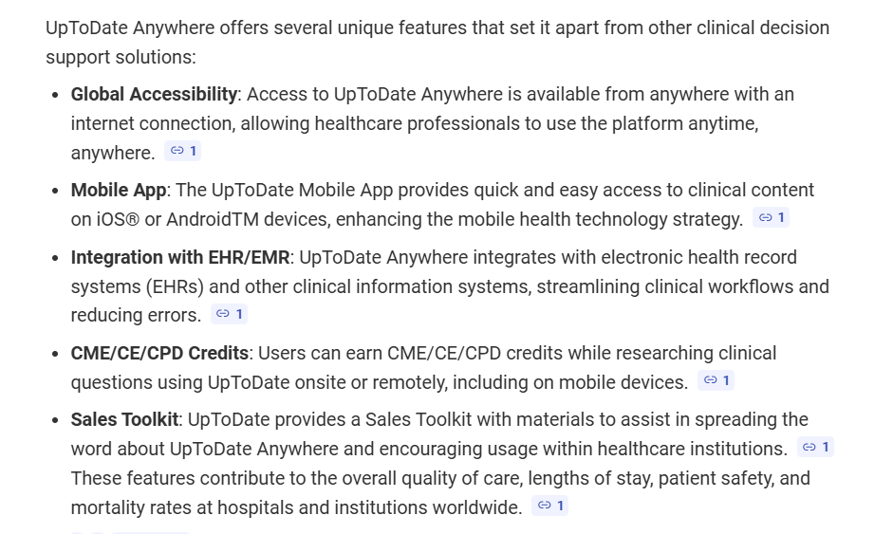
- What kind of market research did the agency conduct to conclude that alternative sources were inappropriate or unavailable? Provide a narrative description of the agency’s due diligence in determining the basis for the sole source filing, including methods used by the agency to conduct a review of available sources such as researching trade publications, industry newsletters and the internet; contacting similar service providers; and reviewing statewide pricing trends and/or agreements. Include a list of businesses contacted (if you state that no other businesses were contacted, explain why not), date of contact, method of contact (telephone, mail, e-mail, other), and documentation demonstrating an explanation of why those businesses could not or would not, under any circumstances, fulfill the procurement; or an explanation of why the agency has determined that no businesses other than the prospective vendor can provide or perform the goods and/or services needed.

UpToDate is the only system that provides more than 12,000 evidence-based clinical topics across 25 robust clinical specialties as stated in the attached sole source letter received from UpToDate. In addition, industry market research for alternatives (via internet publications and forums) found that no other database provides the volume of content that UpToDate offers. Vendors analyzed for comprehensive clinical decision support systems included Epocrates, Andor, Dynamic Health, and Verana Health, which do not offer in-depth editorials, are geared more toward outpatient care, and/or do not have the expansive library of topics. A snip-it of additional market research of clinical decision support data evaluated is provided below:

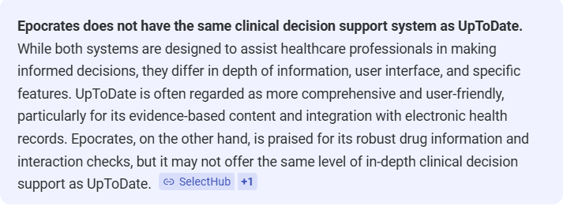

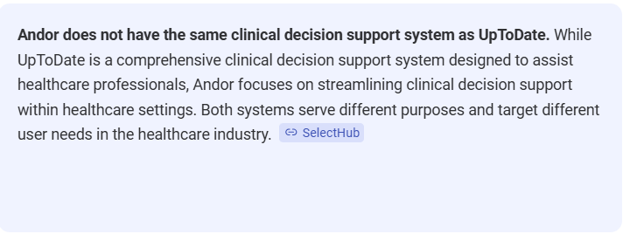

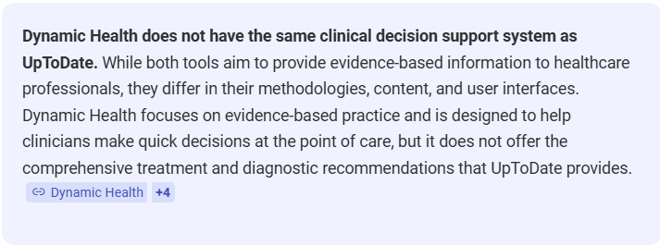

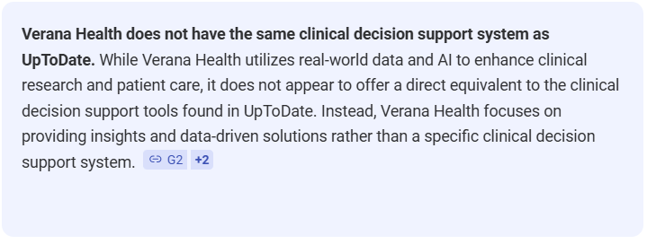

In addition, UpToDate integrates seamlessly with LexiDrug, a separate system that the BHHA Facilities also use. These two systems interface with each other, ensuring clinical consistency of care. Another vendor would not under any circumstances be able to provide this seamless interaction as these products are proprietary and are unable to interact with another vendor. See attached Sole Source Letter.

- What considerations were given to unbundling the goods and/or services in this procurement, which would provide opportunities for Washington small, diverse, and/or veteran-owned businesses. Provide a summary of your agency’s unbundling analysis for this procurement.

BHHA was unable to locate any vendors listed as small, diverse, and/or veteran-owned when searching on WEBS and OMWBE. Being unable to find small and/or diversified suppliers inhibited the possibility of unbundling.
- As part of the market research requirements, include a list of statewide contracts reviewed and/or businesses contacted, date of contact, method of contact (telephone, mail, e-mail, other), and documentation demonstrating an explanation of why those businesses could not or would not, under any circumstances, fulfill the procurement; or an explanation of why the agency has determined that no businesses other than the prospective vendor can perform or provide the goods and/or services needed.
There are no DES statewide contracts available for this product.
- Per the Supplier Diversity Policy, DES-090-06 and A.P. 13.27: Was this procurement included in the agency’s forecasted needs report?
This item is tied to a PO, and was inadvertently not included on the 2026 contract forecast list.
- Describe what targeted industry outreach was completed to locate small and/or veteran-owned business to meet the agency’s need?
Product searches for medical knowledge resources and clinical decision databases did not result in any local small and/or veteran-owned businesses. The online research pointed to websites that highlight small or diverse businesses but there were no alternatives to UpToDate listed.

Vendor searches were also conducted for small businesses on WEBS and OMWBE. WEBS search was conducted for “Evidenced Based Clinical Decisions”, which resulted in 0 relevant commodity codes. Search on WEBS for “Clinical Subscription Library” resulted in relevant commodity code 956-38, of which search for WA Small Business and WA Veteran-owned business resulted in one vendor (Griffin Hayes LLC). Unfortunately, this vendor does not offer clinical based subscription and their business model focus is on financial and accounting. Vendor search on OMWBE website also resulted in 0 matches.
- Provide a detailed and compelling description that includes qualification of the costs and risks mitigated by purchasing with this vendor (i.e., learning curve, follow-up natures).
UpToDate has been in use by BHHA facilities since 2015 and is an established enterprise solution. BHHA’s medical professionals are familiar with or have been educated using UpToDate and know the system inside and out. UpToDate is easy to use and access, integrates seamlessly with other products, and there is no learning curve. Introducing or switching to a new system is not cost effective and would result in additional staff training and retraining. In addition, there are no other systems available that have the required comprehensive clinical decision support and switching systems may open opportunities for delayed patient care or lead to safety issues or concerns. To minimize cost, the vendor is providing an institutional subscription that allows staff to have unlimited access without any additional fees. After comprehensive market research, BHHA has determined that by continuing subscription with UpToDate will mitigate costs.
- Is the agency proposing this sole source filing because of special circumstances such as confidential investigations, copyright restrictions, etc.? If so, please describe.
☒Not applicable.

- Is the agency proposing this sole source filing because of unavoidable, critical time delays or issues that prevented the agency from completing this acquisition using a competitive process? If so, please describe. For example, if time constraints are applicable, identify when the agency was on notice of the need for the goods and/or service, the entity that imposed the constraints, explain the authority of that entity to impose them, and provide the timelines which work must be accomplished.
☒Not applicable.

- What are the consequences of not having this sole source filing approved? Describe in detail the impact to the agency and to services it provides if this sole source filing is not approved.

The BHHA patient population is a unique group requiring proven resources to help treat these patients’ unique needs. Many BHHA patients are prescribed anti-psychotic medications with their own set of side-effects and issues. Weight gain, diabetes, hyponatremia, and other illnesses are common among BHHA patients. The Medical Staff of all BHHA facilities require access to a proven tool to give the BHHA patients the best care available. Use of UpToDate’s subscription helps to mitigate general and fatal errors from occurring. Without a proven and reliable source of accurate and timely medical information, delays could lead to slower treatment times, less accurate care and possible reliance and outdated practices which would not be in the best interest of our patients and residents. Ultimately, denial of this service has the potential to open DSHS and its clinicians to possible incorrect drug dosages, and general errors that could have been prevented with the use of the UpToDate product, UpToDate, as a double check to clinician's knowledge base.

The integration between UpToDate and other systems currently in use provides front-line treatment of the BHHA patient population. If this service is denied, the integration between care and poly-pharmacy would be lost, potentially placing BHHA patients in harms way.
- Since competition was not used as the means for procurement, how did the agency conclude that the costs, fees, or rates negotiated are fair and reasonable? Please make a comparison with comparable procurements, use the results or a market survey, or employ other appropriate means calculated to make such a determination.

Comparing the price with other services is not an accurate comparison as other services do not provide an all-inclusive subscription. BHHA is confident this subscription is in the best interest of DSHS, and the State of Washington. BHHA is receiving substantial cost savings under the institutional subscription option offered by UpToDate. As stated above within Question 8, UpToDate is providing an institutional subscription that allows staff to have unlimited access without any additional fees. BHHA has determined that the costs associated with this system are fair and reasonable.
If filing is considered late, obtain your Division Director and Fiscal Approvals. (Remove or incorporate into the paragraph below. i.e… Mention the forms must be approved by at least a Division Director or above for all late filings.)
If the filing is “late” (where the purchase start date is less than 20 business days from date sent to CPU for review, approval, and submission to DES), you must also complete and attach the Late Filing Justification form.
This purchase is exempt from Sole Source filing.
The following exemption applies: _____________
This purchase does not need to be filed as a sole source.
Completed by: __________________
Date: _______________

