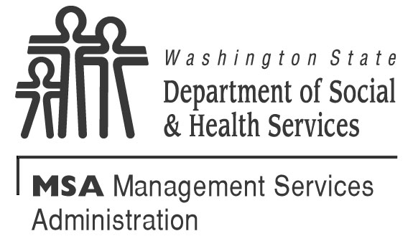  REQUEST FOR HEARING  per Chapter 388-02 for DSHS hearing rules. | FOR AGENCY USE ONLY  Oral request taken by:  NAME TELEPHONE NUMBER  INVOLVED DIVISION/ORGANIZATION DATE
MAIL TO: OFFICE OF ADMINISTRATIVE HEARING (OAH) MAIL STOP: 42489
PO BOX 42489
OLYMPIA WA 98504-2489 FAX: 360-586-6563

If you are requesting a hearing for the denial of medical benefits or services from your DSHS managed care health plan, you must complete your plan’s appeal process before you can file a hearing. (WAC 388-538-112)

I request a hearing because I disagree with the following decision by the Department of Social and Health Services (DSHS) or my DSHS managed care health plan:
Explain briefly what DSHS or your DSHS managed care health plan did or did not do (add pages if you need more room); and
Attach a copy of the notice you are appealing, if possible.

YOUR NAME (PLEASE PRINT) |  |  | DATE OF BIRTH
MAILING ADDRESS OF PERSON REQUESTING HEARING  CITY STATE ZIP CODE |  |  | CLIENT ID NUMBER  TELEPHONE NUMBER (INCLUDE AREA CODE)  MESSAGE PHONE
I was notified of the decision on: by:
DATE CSO OR DSHS MANAGED CARE HEALTH PLAN NAME AND LOCATION
I want continued assistance, if I am eligible: Yes No Program:
I am represented by (if you are going to represent yourself, do not fill in the next two lines):
YOUR REPRESENTATIVE’S NAME | ORGANIZATION |  |  |  | TELEPHONE NUMBER
ADDRESS STREET |  | CITY |  | STATE |  | ZIP CODE
I authorize release of information about my hearing to the representative listed above.
YOUR SIGNATURE |  |  |  |  |  | DATE
Do you need an interpreter or other assistance or accommodation for the hearing? Yes No
If yes, what language or what assistance?
Administrative Law Judges (ALJ’s) may hold some hearings by telephone. If you want to change to an in-person hearing. Follow the instructions in the Notice of Hearing that will be mailed to you by OAH.

