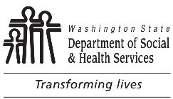 | Aging and Long-Term Support Administration (ALTSA)  Residential Care Services (RCS)  Assisted Living Facility Monitoring Visit
Name of Assisted Living Facility |  |  | License Number
Name of Licensor |  |  | Date
A brief observational tour of the facility was done to observe the residents and environment for health and safety issues. The licensor spoke with residents, collateral contacts (only if needed), and staff. Residents were observed for obvious problems such as hygiene, hydration, and nutrition issues, pain, and bruising.
Names of Residents |  | Names of Staff
General condition of facility (e.g., clean, well maintained, no hazards)

General condition of the residents (e.g., clean, no obvious bruising, relaxed, comfortable)

General resident interview information

General staff interview information

Outcomes
No significant signs of resident health and welfare issues were identified during a brief observational monitoring visit to the facility.
Significant signs of resident health and welfare issues were identified during a brief observational monitoring visit to the facility. Document issues and actions on
Assisted Living Facility Notes / Worksheet (Attachment L).

