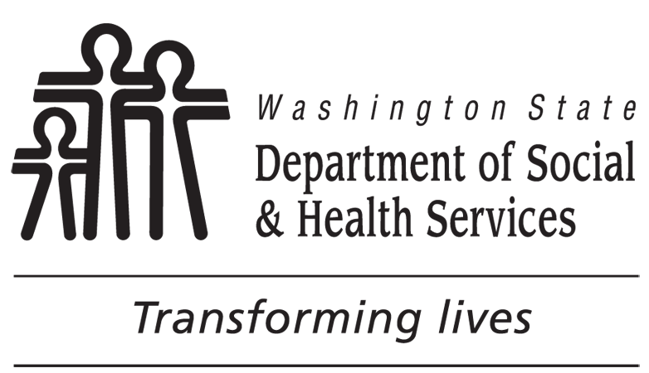 | OFFICE OF DEAF AND HARD OF HEARING (ODHH)  ASSISTIVE COMMUNICATION TECHNOLOGY (ACT) PROGRAM  ODHH (360) 725-3460 V/TTY OR 360-339-7382 VP  Assistive Communication  Technology Request |  |  |  | Official Use Only
 |  |  |  |  | ORGANIZATION REPRESENTATIVE TRAINED
 |  |  |  |  | AUTHORIZED TRAINIER
Reservation
1. NAME OF ORGANIZATION |  |  |  |  | 2. DATE OF REQUEST (MM/DD/YYYY) | 3. PICK UP DATE (MM/DD/YYYY)
4. EVENT TYPE |  |  |  |  | 5. EVENT DATE  (MM/DD/YYYY) | 6. RETURN DATE  (MM/DD/YYYY)
7. ORGANIZATION REPRESENTATIVE’S NAME

8. ORGANIZATION ADDRESS

9. PHONE NUMBER (INCLUDE AREA CODE) |  |  | 10. E-MAIL ADDRESS
Below is for ODHH / RSC Authorized Staff Use Only
11. EQUIPMENT CHECK-OUT / RETURN
EQUIPMENT |  | TAG NUMBER | TRAINING NEEDED | RETURNED | COMMENT
12. PICKUP CONDITION  Equipment turns on  Equipment transmits amplified sound  Batteries tested  All parts included  Equipment sent in satisfactory condition |  |  | NOTES

Assistive Communication Technology Equipment Loan Agreement
I. Ownership
The Assistive Communication Technology (ACT) equipment belongs to the Washington State Department of Social and Health Services (DSHS), Office of the Deaf and Hard of Hearing (ODHH), Assistive Communication Technology (ACT) program. ODHH also contracts with Regional Service Centers (RSCs) to provide the loan of ACT equipment in regions outside the ALTSA Headquarters area. The ACT Program Manager manages the ODHH ACT assignment / loan program.
II. Eligibility for ACT Equipment Use
Eligibility to borrow ACT equipment, Organization borrowing must be a DSHS/ALTSA agency, non-profit organizations or business to provide communication access for individuals with a hearing loss. ODHH and RSCs reserve the right to deny requests for ACT equipment loan based on previous loan to the organization. Organization representative must pick up and return ACT equipment at ODHH or the applicable RSC.
III. State Agency ACT Equipment Assignments
DSHS and ALTSA agencies may use the assigned ACT equipment for long-term needs per request submitted to the ODHH ACT Program Manager.
IV. Borrowing ACT Equipment
Organizations seeking to borrow ACT equipment in the must contact the ODHH ACT Program Manager at odhh@dshs.wa.gov for ACT equipment availability. Organizations in other parts of Washington are encouraged to contact the nearest RSC (https://www.dshs.wa.gov/altsa/odhh/centers) to their event and arrange to borrow ACT equipment. All Organizations must fill out and submit an ACT Equipment Request, form DSHS 11-066, to reserve the ACT equipment.
The organization representative must receive training on how to setup ACT equipment prior to loaning equipment for a scheduled public meeting or stakeholder event.
Training with ODHH or RSC staff takes approximately 30 minutes and will cover aspects on the proper use and care of the equipment. Organization Representative is expected to read the ACT Equipment Loan Agreement and accept responsibility for equipment care. The authorized ODHH and the RSC staff prefer that the Organization Representative who receives the training to be the individual who will be setting up the ACT equipment at a scheduled public meeting or stakeholder event. ODHH and RSCs reserve the right to deny the loan if the individual responsible for setting up is not present for training.
IV. Damages
Organizations borrowing ACT equipment are responsible for the care of equipment while in their possession. If an organization representative, returns equipment that is broken, or has missing parts worth $200 or more, the ODHH or RSCs can bill the organization for the cost of damages. In addition, the ODHH or RSCs may refuse the organization further use of ACT equipment. ODHH will not hold the organization responsible for normal wear-and-tear or any previous damages of the equipment. The ODHH or RSC has ten (10) business days to report to the organization whether there has been damage to ACT equipment by the organization.
V. Non-Compliance
If an organization repeatedly returns ACT equipment that is not packed properly, or not cared for properly, or does not pay the cost of damage or loss from a previous ACT equipment loan, ODHH and RSCs may reserve the right to decline further loaning of the ACT equipment to the organization involved.
VI. Returning ACT Equipment
Organizations are expected to return ACT equipment on time and in the same condition in which it was checked out. If the organization experienced any problems with ACT equipment, they must report the problems to ODHH or RSC staff upon returning ACT equipment. After the returned ACT equipment is checked by an authorized staff, both the Organization Representative and the authorized staff will sign the box below.
13. ORGANIZATION REPRESENTATIVE’S SIGNATURE DATE | 14. AUTHORIZED SIGNATURE DATE

This section is to be filled out by the Organization representative.
- Organization. What is the name of the organization that wishes to borrow the ACT equipment? Insert the name of the organization borrowing the ACT equipment.
- Date of Request. Insert the date that you are filling out this form to borrow the ACT equipment.
3. Planned Pick Up Date. Give the date that you plan to pick up or receive the ACT equipment. This may be two or three days before the actual meeting / event.
4. Event Type and Event Date. Insert the description and location of the meeting/event where the ACT equipment will be used. Include the actual date your meeting/event is scheduled to take place.
5. Return Deadline. Fill in the return date. This is the date you must bring back the ACT equipment after your meeting/event. Another organization may have a reservation following yours.
6. Organization Representative’s Name. Provide the name of the Organization Representative who will be picking up the equipment and receiving training on how to setup and use the ACT equipment.
7. Organization Representative’s address. Provide Organization address or the address to the Organizations Representative.
8. Phone Number. Provide a direct contact phone number for the Organization Representative who is involved in planning your meeting/event.
9. E-Mail Address. Provide a contact E-mail for the Organization Representative who is involved in planning your meeting / event.

When completed filling out blocks 1 - 10, email this form to ACT Program Manager at steven.peck@dshs.wa.gov or fax to (360) 725-3456.
Organization Representatives do not write below this line. The remaining blocks are to be filled out by authorized ODHH / RSC staff.
9. Name of Organization Representative Trained. Insert the name of the Organization Representative who is picking up the ACT equipment and being trained in proper care, setup and usage.
10. Authorized Trainer. Insert the name of the Authorized Trainer who is providing training.
11. Equipment Checkout / Return. Authorized Trainer will need to write down on block 11 the type of equipment and the Tag number for each piece of ACT Equipment being loaned. If several pieces of ACT equipment are loaned, and there is not enough space in block 11, please attach a separate inventory sheet. This will assist the organization later to confirm that all ACT equipment is accounted. Once ACT equipment is returned, authorized ODHH / RSC staff will check to ensure that all ACT equipment has been returned to the ODHH or RSC location.
12. Pickup Condition. Enter the condition of the ACT equipment being loaned. Was it in good condition when it was loaned? Include any previous damage in the "NOTES" section so that this organization will not be blamed for any damage to the ACT equipment.
13. Organization representative Signature. The Organization Representative is required to read the information on the ”Equipment Loan Agreement,” page 2 of this form and attend training. The Organization Representative’s signature at the bottom of the Equipment Loan Agreement indicates that he/she understands his/her responsibility to care for the ACT equipment.
14. Authorized Trainer’s Signature. Authorized trainer who provided training to the Organization Representative signs at the bottom of the Equipment Loan Agreement.

