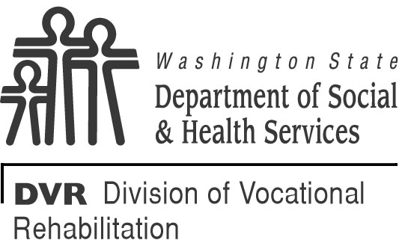 |  | STATE OF WASHINGTON  DEPARTMENT OF SOCIAL AND HEALTH SERVICES  DIVISION OF V OCATIONAL REHABILITATION  Customer Internship Program  Internship Agreement
This form outlines the job duties, wages/salary, expected schedule, contact information and the terms of DVR reimbursement for the host employer.
CUSTOMER’S NAME

ADDRESS CITY STATE ZIP CODE

TELEPHONE HOME CELL |  |  |  | EMAIL ADDRESS
EMERGENCY CONTACT NAME TELEPHONE NUMBER

Internship Program
JOB TITLE

JOB DUTIES

BEGIN DATE | END DATE |  | WAGE  $ /hour | EXPECTED WORK SCHEDULE (DAYS AND HOURS/WEEK)
DVR services provided to support the internship:

Employer Information
EMPLOYER |  |  |  | INTERN SUPERVISOR
ADDRESS CITY STATE ZIP CODE

TELEPHONE CELL |  |  |  | EMAIL ADDRESS
EMERGENCY CONTACT NAME TELEPHONE NUMBER

is responsible for paying wages directly to
.
DVR will pay for internship expenses as follows:
DATE AMOUNT
Total amount for up front costs (if any)
Total amount for first month
Total amount for second month
Final payment for third month
Termination of Customer Internship
If the internship is terminated, the employer may receive payment for the month in which the internship was terminated. If the individual works significantly fewer hours than originally agreed-upon, the fee is renegotiated.

DVR Counselor Information
DVR COUNSELOR’S NAME

ADDRESS CITY STATE ZIP CODE

TELEPHONE CELL | EMAIL ADDRESS
EMERGENCY CONTACT NAME TELEPHONE NUMBER

DVR Intern Responsibilities
- Work the agreed upon Internship schedule and maintain regular attendance;
- Notify the employer in advance of any absence;
- Maintain at least monthly contact with the DVR counselor; request additional DVR services or support, if needed;
- Follow supervision of the employer and perform assigned job duties;
- If this is a paid internship, work with DVR counselor to understand how income will impact benefits;
- Other:
DVR Counselor/Representative Responsibilities
- In advance of a paid internship, help the customer understand how a paid internship will impact benefits;
- Provide identified VR services to support the internship;
- Maintain at least monthly contact with the customer;
- Pay the employer according to the agreed-upon schedule;
- Be available, upon request, to visit the internship site;
- Identify any reasonable accommodations that will be needed by the intern to perform the essential job functions of the internship, and reimburse all employer costs to implement these accommodations;
- Contact the employer at least monthly to check in and monitor progress:
- Fax a copy of the completed agreement form to the State Office Internship Coordinator at fax number (360) 438-8007;
- Other:
Employer Information
- Provide DVR with itemized cost estimate for sponsoring internship;
- Complete necessary paperwork to get set-up as a DVR vendor;
- Employ and supervise the intern as outlined in the agreement;
- Pay wages, payroll taxes, and worker’s compensation;
- Implement the agreed upon reasonable accommodations necessary for intern to perform the essential job functions of the internship (associated costs will be reimbursed by DVR);
- Notify the DVR counselor/representative of any problems or concerns that arise;
- Complete the Intern Evaluation Form at the end of the internship.
DVR CUSTOMER’S SIGNATURE |  | DATE
DVR COUNSELOR’S SIGNATURE |  | DATE
EMPLOYER’S SIGNATURE |  | DATE

