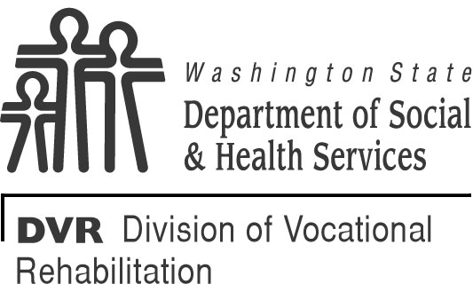 |  | STATE OF WASHINGTON  DEPARTMENT OF SOCIAL AND HEALTH SERVICES  DIVISION OF V OCATIONAL REHABILITATION  Customer Internship Program  Attendance Log and Billing Invoice
This form may be used by the host employer to track the hours worked, and wages/salary paid, to the intern. If the host employer chooses, they can use their own invoice. This form or the host employer’s invoice is submitted on a monthly basis to the DVR counselor at the time of billing.
INTERN’S NAME |  |  |  | MONTH
HOST EMPLOYER’S NAME |  |  |  | AFP NUMBER
HOST EMPLOYER’S ADDRESS

Total amount billed to DVR for this month: $
DATE | HOURS WORKED |  |  | DATE | HOURS WORKED
 | START TIME |  | END TIME |  | START TIME | END TIME
TOTAL WAGES  $ |  |  | PAYROLL TAXES  $ |  | WORKER’S COMPENSATION  $
SUBMITTED BY: NAME SIGNATURE DATE

