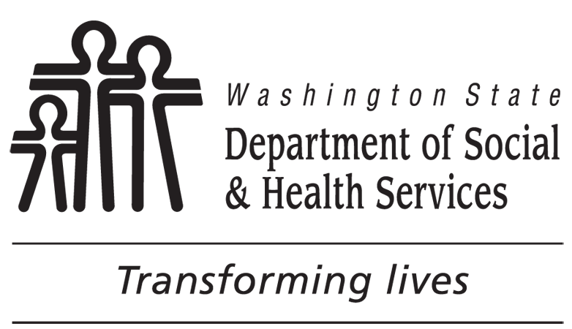 |  | Waiver of Administrative Disqualification Hearing  For Washington Food Assistance Programs
DATE | CLIENT’S NAME |  | CLIENT’S SSN |  | CLIENT’S BIRTH DATE | CLIENT ID NUMBER
You are being referred for an Administrative Hearing based on our belief that you have committed an Intentional Program Violation (IPV). You have the right to appear at the hearing and contest the charges against you. You also have the right to waive (give up) your right to a hearing. If you decide to waive your hearing, you need to know the following information:
- If you sign this agreement, you will be disqualified for benefits and there will be a reduction in benefits for the entire period of the disqualification even if you do not admit to the facts alleged by the State Agency.
- You do not have to admit to any of the charges. You have the right to remain silent concerning the charges, as anything said or signed by you could be used in a court of law.
- If you sign this waiver, you must also choose one of the following statements to indicate whether or not you admit to the facts as alleged:
I admit the facts as presented and understand that a disqualification penalty will be imposed if I sign this waiver.
I do not admit that the facts as presented are correct. However, I have chosen to sign this waiver and understand that a disqualification penalty will results.
- The remaining adult household members, if any, will be held responsible for payment of the resulting claim.
- The penalty remains the same whether you choose to have a hearing and are determined guilty, or whether you waive the hearing.
This waiver must be returned within days of the above date. If no waiver is returned to the department, an Administrative Hearing will be scheduled.
If the accused individual is not the head of the household, the head of the household must also sign this waiver as stated in 7 CFR 273.16(3).
For additional information, you may contact Department Representative at Phone Number (with area code).
Explanation of Your Hearing Rights
If you do not admit that the facts as present are correct and would like to exercise your right to an Administrative Hearing, you do not need to do anything further.
You will be notified of the hearing date and time by the Office of Administrative Hearings. The notice will include those hearing rights listed in 7 CFR 273.16(e)(3).
Food Assistance Program Penalty Warning
Under WAC 388-446-0020, a person will not receive food assistance benefits for:
One year for knowingly violating a food assistance or Supplemental Nutrition Assistance Program(SNAP) rule;
Two years for a second such violation; or a first conviction for buying, selling, or trading food assistance or SNAP benefits for a controlled substance;
Ten years for knowingly giving false identity or residence information to get duplicate benefits;
Lifetime for:
- Knowingly breaking a food assistance or SNAP rule a third time;
- A second conviction for buying, selling, or trading food benefits for a controlled substance;
- Conviction for buying, selling, or trading food benefits for firearms, ammunition, or explosives; or
- Conviction for buying, selling, or trading food benefits worth $500 or more.
Persons who knowingly and intentionally violate a food assistance rule can be prosecuted and fined up to $250,000 or imprisoned up to twenty years or both. They are also subject to prosecution under other applicable federal laws.
DISQUALIFIED PERSON’S SIGNATURE DATE |  |  |  | HEAD OF HOUSEHOLD’S (HH) SIGNATURE DATE  (IF THE ACCUSED IS NOT THE HEAD OF HOUSEHOLD)

