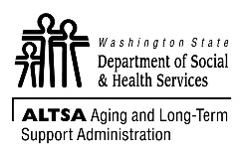 | AGING AND LONG-TERM SUPPORT ADMINISTRATION (ALTSA)  Adult Family Home Incident Log  WAC 388-76-10220)
WAC 388-76-10220 states: “The Adult Family Home must keep a log of:
(1) Alleged or suspected instances of abandonment, neglect, abuse or financial exploitation;
(2) Accidents or incidents affecting a resident’s welfare; and
(3) Any injury to a resident…”
INSTRUCTIONS: Provider, Resident Manager, or caregiver completes a log entry whenever there is an injury or accident involving a resident. Keep this log in the Adult Family Home in a readily accessible area.

PROVIDER’S NAME |  |  | STREET ADDRESS |  | CITY
DATE |  | NAME OF RESIDENT | NATURE OF INJURY OR ACCIDENT | REPORTED TO WHOM AND WHEN | OUTCOME

