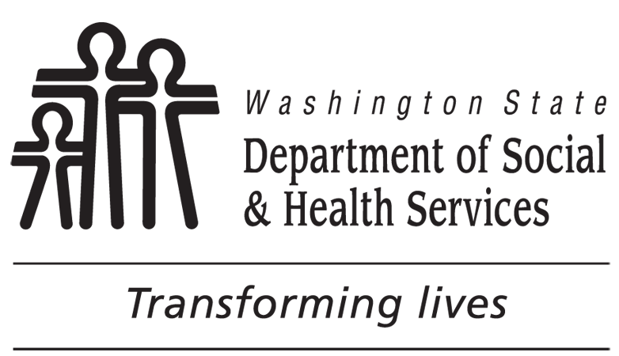 | AGING AND LONG-TERM SUPPORT ADMINISTRATION  HOME AND COMMUNITY-BASED SERVICES
Acknowledgement of Services
APPLICANT’S NAME

ACES CLIENT ID NUMBER

Home and Community Based Service programs offer the opportunity for eligible individuals to receive Medicaid services in the community instead of institutional services.
The Home and Community Based Service programs are:
- Community First Choice (CFC)
- COPES Waiver
- Residential Support Waiver (RSW)
- New Freedom Waiver
- Medicaid Alternative Care (MAC)
I choose to receive services under a Home and Community Based program instead of nursing home care.
CLIENT’S SIGNATURE |  | DATE
REPRESENTATIVE’S SIGNATURE |  | DATE
Guardian
Representative
SOCIAL WORKER / CASE MANAGER’S SIGNATURE |  | DATE
AGENCY

TELEPHONE NUMBER (INCLUDE AREA CODE)

Below are your rights to an Administrative Hearing:

If you are denied Home and Community Based services, you have the right to request an Administrative Hearing. You have 90 days from the date services are denied to request a hearing. You may request an Administrative Hearing by writing to your local Home and Community Services Division office, local Area Agency on Aging, or by writing to:

OFFICE OF ADMINISTRATIVE HEARINGS, MAIL STOP: 42489,
DEPARTMENT OF SOCIAL AND HEALTH SERVICES,
PO BOX 42489,
OLYMPIA WA 98504-2489.

