 | Removing communication barriers for people who are  Deaf • Hard of Hearing • Late-Deafened  • Deaf-Blind • Speech Disabled
Application for Telecommunication Equipment
The Office of the Deaf and Hard of Hearing (ODHH) operates a Telecommunication Equipment Distribution (TED) program. The TED Program supplies specialized telecommunication equipment to people who have a hearing loss or speech disability so that they can have access to distance communication.  Washington State residents ages 4 and up who are deaf, hard of hearing, late-deafened, deaf-blind or speech disabled are eligible to apply to receive telecommunication equipment.  This application has the information you will need to complete the process. If you have any questions or need help filling out the application, you may contact the TED Program. |  |  |  | CONTENTS
Cover Page 1
Program
Information 2
Equipment
Catalog 4 - 5
Application 6 – 8*
* You MUST return all three pages of this form.
Office of the Deaf and Hard of Hearing
Telecommunication Equipment Distribution Program
TED Program  PO Box 45301  Olympia, WA 98504-5301 |  | (800) 422-7930 V/TTY  (360) 725-3450 V/TTY  (360) 725-3456 FAX
Videophone: 360-339-7382
E-mail: odhh@dshs.wa.gov
Web : http://odhh.dshs.wa.gov
To receive equipment, you must:  Complete the Application for Telecommunication Equipment (pages 6 - 8).  An incomplete application may cause a delay in service.  We will send you a letter if your application is incomplete or denied.  Mail your application to the TED Program at the address above or send electronically to odhh@dshs.wa.gov. |  |  | When your application is accepted and processed, we will:  - Send you a letter showing the cost of equipment, if any.  - Add your name to the next equipment distribution list.  - Issue the equipment to you.  For more information about the application process, see Frequently Asked Questions in Program Information (page 3).
Applications are available in Large Print, Braille, and other languages.
You may contact ODHH to request an application in an alternative format.

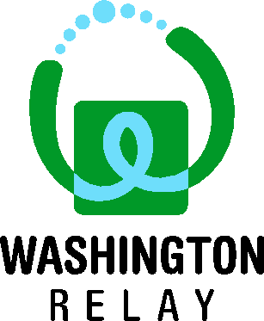 | Washington Telecommunication Relay Service (WATRS)  www.washingtonrelay.com  Some specialized telecommunication equipment may be used with Relay. Relay is a free service that connects people who use specialized telephone devices to people who use a standard telephone, and vice versa.  - To use Relay, simply dial 7-1-1.  - You will be connected to a Relay Operator (RO) or Communication Assistant (CA).  - The RO will dial the phone number being called and relay the conversation between both people.
Frequently Asked Questions (FAQ)
Does my income disqualify me from getting equipment through the TED Program?
No. Anyone who meets the qualifications (page 1) may apply for equipment, regardless of income.
Do I have to pay for equipment?
Many clients receive free equipment, but that is determined by family size and income. We use a sliding scale to determine your cost of equipment. We will send you a letter that shows if the equipment is free, or it will tell you the amount you owe.
We must receive payment before we can issue equipment. If you are unable to pay the amount owed, you may request a waiver. For more information about the waiver process, contact the TED Program.

Frequently Asked Questions (FAQ) (Continued)
What income must be reported?
You must report any and all sources of income including but not limited to wages, disability benefits, retirement income, social security, and interest.
What equipment may I choose from?
The TED Equipment Catalog (pages 4 - 5) shows equipment types available. You may select one (1) telecommunication device with accessories for that device, if available; and one (1) signaling device. You must select the equipment type you want on the application (page 7, section 3).
What kind of home phone service is required?
Clients applying to receive a Teletypewriter (TTY) or amplified phone landline-based phone service. Internet or cable-based phone services such as those provided through Comcast or Wave Cable are not compatible with the TTY phones; however, will work for most amplified phones.
  - A person who is licensed or certified by the Department of Health to provide health care in the state of Washington;
  - An audiologist or hearing aid fitter / dispenser in the State of Washington;
  - A deaf specialist or coordinator at one of the community service centers for the deaf and hard of hearing in the state;
  - Any in‐state nonprofit organization serving the hearing or speech impaired.
  - Staff from a qualified Washington state agency;
  - A vocational rehabilitation counselor within the State of Washington;
Frequently Asked Questions (FAQ) (Continued)
  - A deaf‐blind specialist or coordinator at an organization that serves deaf‐blind people within the State of Washington;
  - A licensed occupational therapist within the State of Washington;
  - A certified speech pathologist practicing in the State of Washington; or
  - Other: write-in your profession and include contact information for program verification.
I received equipment in the past. May I reapply for new equipment?
You are eligible to reapply for new equipment after three (3) years only if your current equipment from the TED Program is not working or no longer meets your needs. If you received the equipment at no cost, you may be required to return that equipment before we can give you new equipment. You may contact the TED Program for more information.
When will I receive equipment?
The process to receive equipment can take four (4) to eight (8) weeks depending on inventory availability. Most equipment is shipped directly to you. Some specialty equipment must be delivered by a contracted TED trainer.
If equipment is delivered to you by a trainer, they will contact you to schedule a date and time to meet with you and others who may be interested. Most iPads and iPhones will be shipped directly to the client by a contracted vendor via UPS and will require a signature to receive that shipment.
The TED Program provides these delivery and training services for free.

Telecommunications Equipment Catalog
This section is to help applicants and professionals select the most appropriate equipment to meet the applicant’s needs.
The equipment type must be selected on the application.
Applicants are eligible to receive the following:
One (1) telecommunication device  With accessories for that device, if available. |  |  |  | And one (1) signaling device.
- Equipment shown with an asterisk (*) must be delivered by a qualified trainer. It will not be shipped. Applicants who select that equipment are automatically referred to the trainer.
- All models are subject to change.
Specialized Telecommunication Equipment
Amplified Telephone
For individuals with mild to moderate hearing loss.
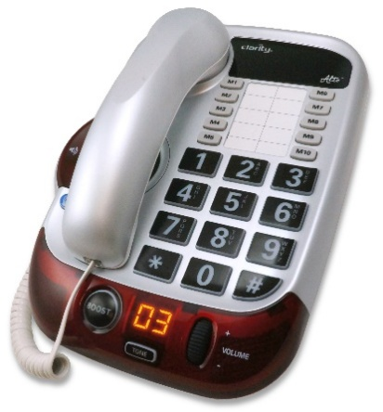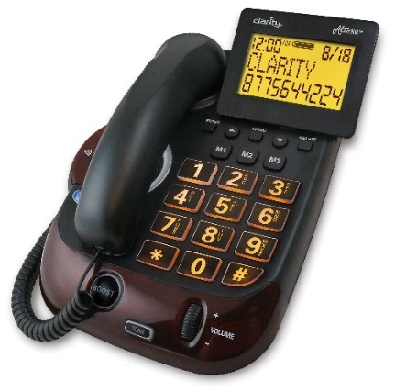 |  | - Operates like a standard telephone.  - Use amplification to hear spoken conversation.  - Adjust volume and tone to meet specific needs.  Corded models available:  - Clarity Alto  - Clarity Alto Plus with caller ID  Cordless model available:  - Panasonic KX-TGM403B with caller ID  Accessories:  - Neck Loop (NKL)
iPad or iPhone – Available with cellular or WiFi Only options*
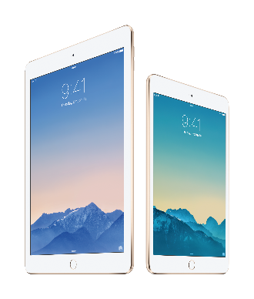  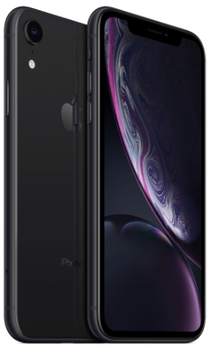 | For access to cellular and WiFi based telecommunication.  iPad and iPhone devices are provided with a protective case (required to maintain warranty). Clients have the choice of the iPad, iPad Mini, or iPhone. The devices are specifically distributed to provide telecommunication access over a cellular or WiFi network and will be shipped to you by a Contracted Vendor.
Teletypewriter (TTY)
For individuals with profound to total hearing loss and/or speech disabilities.
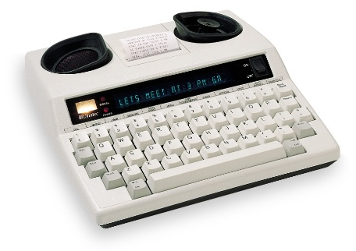 | - Communicate by typing.  - Messages appear on the display screen and can also be printed out.  - Conversations are a turn-taking process. |  |  |  |  | - May require use of the Washington Relay Service.  - Requires basic analog landline phone service.
TruTone Emote Electrolarynx
For individuals who are laryngectomee patients.
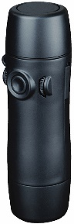 | - Use Electronic Speech Aid to communicate.  - Artificial larynx allows natural intonation when speaking. |  |  |  | - Shipped directly to clients.
- May be used with Washington Relay Speech-to-Speech Service.
Other specialized telecommunication equipment may be available for individuals with special needs.
Contact the TED Program for more information (see contact information on page 1).
Ring Signalers
Audible Ring Signaler  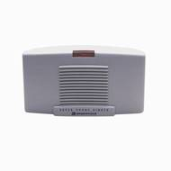  - Signaler rings when landline telephone rings.  - Adjust ringer volume to meet  specific needs. |  |  | Lighted Ring Signaler  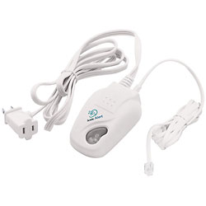  - Connects to a lamp.  Lamp flashes when the telephone rings.
Disclaimer: Equipment makes / models are subject to change.

 | Application for Telecommunication Equipment |  |  |  |  |  | OFFICE USE ONLY
 |  |  |  |  |  |  | Date Received
Incomplete applications may be returned and result in a delay of service.
Please make sure all “required” fields are completed. Print or type clearly.
When you have completed the application, detach pages 6 through 8, and mail to: TED Program
PO Box 45301
Olympia, WA 98504-5301
How did you hear about the TED program?
Friend or family member Magazine or newsletter
Medical professional Presentation or information booth
TV advertisement Other:
Have you received equipment from the TED Program in the past?
Yes No Don’t know
Section 1. Applicant Information
1. Last name, first name, middle initial |  |  |  |  |  |  | 2. Gender  Male Female
3. Home address (include apartment number), City, State, and
Zip Code
4. Mailing address (if different) City State Zip Code
5. Community / Facility name (i.e., nursing home, apartment complex) |  |  |  |  |  |  | 6. County
Telephone number (include area code)  Voice  VP  TTY |  |  |  | 8. Cell number (include area code)  Voice  VP  TTY
9. E-mail address |  |  |  |  |  |  | 10. Best times to contact
11. Social Security Number (optional) |  |  |  |  |  |  | 12. Date of Birth (required for eligibility)
13. Alternate contact person / message  Name |  |  |  |  |  |  | Relationship
Telephone number (include area code)  Voice VP TTY |  |  |  | E-mail address
Section 2. Profile
1. Financial information (required):
Family size:
Monthly income: $ Annual income: $
2. Disability (required for eligibility)  Deaf  Deaf-Blind  Hard of Hearing  Speech Disabled  Late-Deafened |  |  | 3. In addition to hearing loss or speech disability:  a. Do you have low vision?  Yes No  b. Are you blind? Yes No  c. Do you have limited mobility?  Yes No
4 Communication preferences
- Sign  language:  ASL  PSE  SEE  Tactile |  | - Spoken:  Speaking  Lip reading |  |  |  | c. Writing
 |  |  |  |  |  | d. Other:
e. What language do you speak?
English Other:
f. Do you need an interpreter? Yes No
5. Are you of Hispanic origin? Yes No
The Spanish / Hispanic / Latino question is about ethnicity, not race. Please continue to answer the following question by marking one or more boxes to indicate what you consider your race to be (check all that apply):
White
American Indian or Alaskan Native
Native Hawaiian or Pacific Islander
Black or African American
Asian
Other race
Section 3. Equipment Selection
Select one telecommunication device and one signaler.
Amplified Home Phone (landline service required):
Corded Phone with Caller ID Cordless Amplified Phone
Corded Phone – No Caller ID
Text Based Home Phone (analog landline service required): Teletypewriter (TTY)
Wireless Devices (* Cell devices are unlocked and can be set up with any cellular service provider. Cost of the cell service is the responsibility of the client and not covered by the TED Program.):
iPad iPad Mini iPhone
** iPad devices are WiFi Only. If the client needs a cellular based iPad, check here: Cellular capable,* and provide a reason for the special request:
Name of cell phone company:
Signaling Devices – landline phones only. Not compatible with wireless devices.
Loud Ringer Flashing Ringer
Specialty Devices may be available for clients with Speech disabilities.
TruTone Emote ElectroLarnyx Other:
Equipment is shipped directly to the client.
By signing Section 4. below, you authorize the Office of the Deaf and Hard of Hearing to provide your name, mailing address, contact information and self-reported disability provided on this application to the contracted vendor for the purpose of shipping equipment and providing warranty and technical support services.
Section 4. Client Signature
I understand that equipment I receive at no cost is on loan to me and remains the property of Washington State.
I understand that I must protect the equipment from damage. I must protect it from damage that may be caused by rain, heat, and physical abuse.
I understand that if I misuse the equipment, I may not be eligible to receive replacement equipment.
If the equipment is lost or stolen, I will report it to the TED Program and, I will report it to the police. I understand that I must provide a copy of the police report to the TED Program.
If I move, I will notify the TED Program of my new address and phone number.
If I move out of the State of Washington, I understand that I may have to return the TED equipment before I leave the State of Washington.
I understand that I cannot sell, pawn, or loan the equipment to anyone for any reason.
If the equipment is broken, I will not try to fix it myself. I will contact the TED Program for instructions.
I understand that if I have problems with the iPad, all services are to be done by a TED Program Representative or “Teltex” through the instructions provided in/on the iPad box.
I understand I cannot take the iPad to the Apple Store and I cannot contact Apple Care for assistance on the TED Program iPad.
I understand that the iPad must be kept in the protective case it comes in.
I understand that the iPad is being provided for distance communication purposes.
I certify (or declare) under penalty of perjury under the laws of the State of Washington that information on this form is true and correct.
1. Signature Date

2. Person completing application (if other than applicant)  Name |  |  |  |  | Relationship
Telephone number (include area code)  Voice VP  TTY |  |  |  |  | E-mail address
Section 5. Professional Certification
Professional must sign the application to certify hearing loss or speech disability.
Instructions to “Professional”: You must be authorized to work in the State of Washington to verify the applicant’s hearing loss or speech disability. By signing below, you attest that you are aware of the extent of the applicant’s hearing loss or speech disability and believe the applicant can benefit from the requested equipment in Section 3 above.
Contact the TED Program if the applicant requires specialized telecommunication devices.
1. Professional information:
Doctor Hearing Aid Fitter / Dispenser
Audiologist State Agency Employee
Deaf Specialist Voc Rehab Counselor
Non-Profit Rep Deaf-Blind Specialist
Occupational Therapist
Speech Pathologist
Other:
Professional’s contact information required (phone number and/or email address) for Program evaluation.
2. Professional certification
Signature Date

Printed name and title

Telephone number

Email address

License / certificate number (if applicable)

