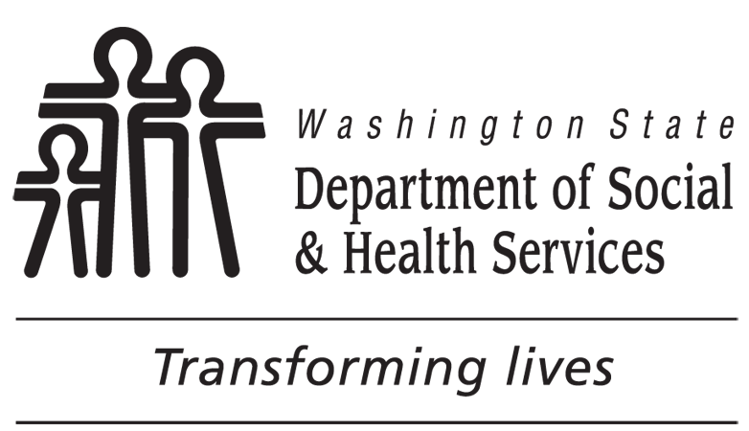 | Cash Assistance Direct Deposit Enrollment
CHECK ONE
New Request Change Account Cancel Direct Deposit

Personal Information: Please print.
NAME (YOUR LAST NAME, FIRST NAME, AND MIDDLE INITIAL) |  |  |  | YOUR TELEPHONE NUMBER (AND AREA CODE)
YOUR MAILING ADDRESS

YOUR CLIENT IDENTIFICATION NUMBER OR SOCIAL SECURITY NUMBER

Financial Institution Information
NAME OF FINANCIAL INSTITUTION |  | BRANCH LOCATION (CITY, STATE)
ROUTING NUMBER |  | ACCOUNT NUMBER
ACCOUNT TYPE (CHECK ONE)  Checking or Savings |  | ACCOUNT HOLDER’S NAME
NOTE: Be sure to include a pre-printed deposit slip, a voided check, or a financial institution printout showing your name on the account, the account number, and routing number.
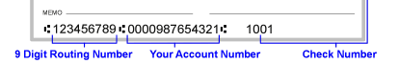

Please read both pages and sign below.
I authorize the Department of Social and Health Services (DSHS) to deposit my cash assistance benefits directly into the account listed above. I will immediately notify DSHS if my banking information changes. I must submit a new authorization form to change my direct deposit. I can stop my direct deposit by notifying DSHS. Once enrollment is complete, deposit of cash benefits will be made on the first banking day of the month.
I have read and understand the above.
SIGNATURE |  | DATE
Office Use Only
DATE RECEIVED |  |  | ENTERED BY

Cash Assistance Direct Deposit Enrollment
DSHS can deposit cash benefits into your bank account.
To receive direct deposit do the following:
- Fill out and sign the form on the other side of this page.
- Provide a pre-printed voided check or deposit slip from your bank or credit union, or a financial institution printout showing your name on the account, account number and routing number.
- Submit your Direct Deposit Enrollment request using one of the following options:
- Mail to:
DSHS Customer Service Center
PO BOX 11699
TACOMA, WA 98411-6699
- Fax to 1-888-338-7410
- Drop off at a local office, see www.dshs.wa.gov for locations.
It can take up to two months to start direct deposit after we receive your enrollment form. You will receive a letter before direct deposit begins.
You will still need your Washington QUEST EBT Card when you have direct deposit to:
- Spend your food benefits.
- Receive your cash benefits before direct deposit starts.
- Receive your cash benefits after direct deposit ends.
Cash benefits are deposited on the first banking day of every month. For example, if the first day of the month is Saturday, your benefits will not be available until Monday, the third day of the month.
To STOP direct deposit:
a) Call the Direct Deposit Unit 1-888-235 -2954 or
b) Mail cancellation request to:
DSHS Customer Service Center
PO BOX 11699
TACOMA, WA 98411-6699
c) Fax cancel request to 1-888-338-7410
d) Drop cancel request off at a local office, see www.dshs.wa.gov for locations.
It can take up to two months to stop direct deposit after we receive your request. If you have questions about direct deposit contact DSHS Direct Deposit Unit at 1-888-235-2954.

