Non-Profit Organization*
Application for Reconditioned Telecommunication Equipment

* Must be a 501(c)(3) organization.
Please attach a copy of the organization’s by-laws and Non-Profit Status letter from the IRS.
 Mail your completed application to: 1115 Washington St. SE
PO Box 45301
Olympia, WA 98504-5301
Please print or type.

1. Organization name |  |  |  |  |  |  | 2. Contact person
3. Street address |  |  |  |  |  |  | City | State  WA |  | Zip Code
4. Mailing address (if different than above) |  |  |  |  |  |  | City | State  WA |  | Zip Code
5. Main telephone number  ( ) |  |  |  | Voice TTY |  | VP | 6. Contact telephone number  ( ) |  |  | Voice TTY | VP
7. E-mail address |  |  |  |  |  | 8. Hours of operation |  | 9. County of physical location
10. Equipment Selection (see Equipment Options on page 2)
Equipment offered is reconditioned and is provided based on availability.
AMP | VCO | CAP | TTY
11. Please briefly explain the reason for applying for reconditioned telecommunication equipment.
12. Average number of deaf, hard of hearing, late-deafened, deaf-blind, or speech disabled people that the organization provide services for on an annual basis:
13. Yes, I would like to schedule an appointment for equipment training and/or outreach. If yes, an ODHH/TED representative will contact the organization.
I certify (or declare) under penalty of perjury under the laws of the State of Washington that the information on this form is true and correct.
14. Name of person completing application |  |  |  |  |  |  |  |  | Date
15. Name of manager/owner |  |  |  |  | Signature |  |  |  | Date

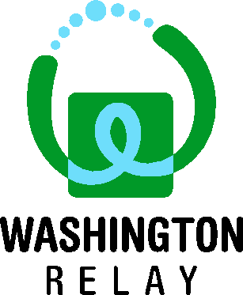 | Washington Telecommunication Relay Service (WATRS)  www.washingtonrelay.com  Some specialized telecommunication equipment must be used with Relay. Relay is a free service that connects people who use specialized telephone devices to people who use a standard telephone, and vice versa.  - To use Relay, simply dial 7-1-1.  - You will be connected to a Relay Operator (RO).  - The RO will dial the phone number being called and relay the conversation between both people.
Equipment Options
Amplified Telephone (AMP)
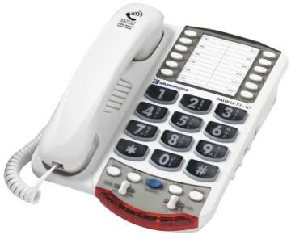 |  | For individuals with mild to moderate hearing loss.  - Operates like a standard telephone.  - Use amplification to hear spokane conversation.  - Adjust volume and tone to meet specific needs.
Voice-Carry-Over Telephone (VCO)
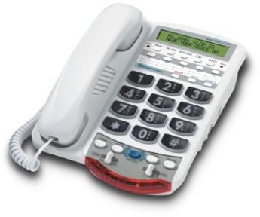 |  | For individuals with moderate to severe hearing loss.  - Communicate using voice and read incoming conversation in text on the display screen.  - Conversations are a turn-taking process.  - Requires use of the Washington Relay Service.
Captioned (CapTel) Telephone (CAP)
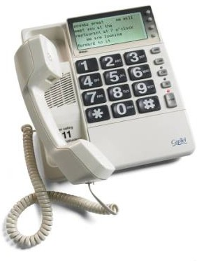 |  | For individuals with severe to profound hearing loss.  - Communicate using voice and read incoming conversation in text on the display screen.  - User may be able to use residual hearing to hear spoken conversation through the amplified handset.  - Conversations flow naturally (not a turn-taking process).  - Analog phone line or Digital Subscriber Line (DSL) with digital-to-analog filter required.  - Requires use of the Washington Relay Service.
Text Telephone (TTY)
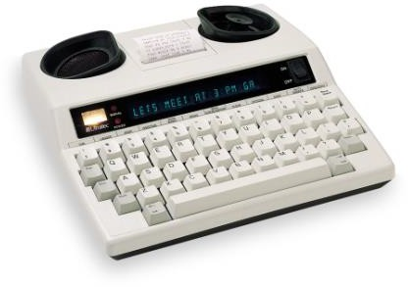 |  | For individuals with profound to total hearing loss and/or speech disabilities.  - Communicate by typing.  - Messages appear on the display screen and can also be printed out.  - Conversations are a turn-taking process.  - May require use of the Washington Relay Service.

