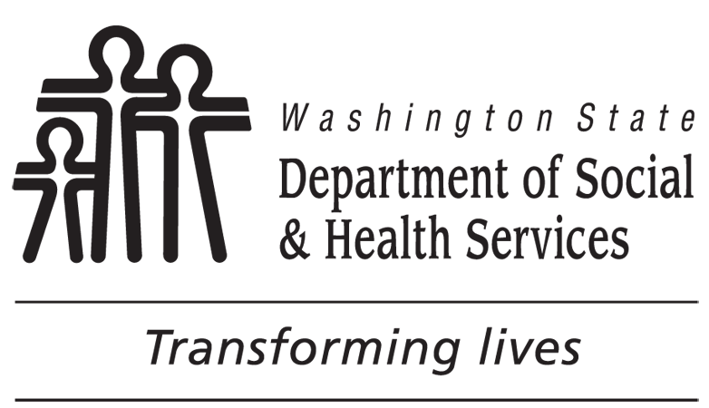 | Assessment Meeting Wrap-up
Client Information
CLIENT NAME

Wrap-Up
Please review the items below with your Case Manager. The plan will not be finalized until you have checked each item and signed below. If “No” is selected, your Case Manager will ask if they can talk about it with you.
Yes No N/A
I was able to lead (or chose someone to lead) my Person Centered Service Plan meeting.
My case manager answered questions I had about DDA services.
We talked about available services that would meet my needs and goals, including paid and unpaid supports.
My concerns or issues about my Person Centered Service Plan have been or are being addressed.
My case manager explained that I can choose or change my service provider(s).
My case manager explained what to do if I do not receive the services in my plan.
My case manager explained that I can make changes to my Person Centered Service Plan at any time.
My case manager explained the Planned Action Notice (PAN) document and how to appeal if I disagree with DDA decisions about my services.
My case manager explained how I can make a complaint that is not about an appeal of DDA services.
My case manager explained the importance of letting DDA know when things change (address, phone number, etc.).
My case manager explained that I can call 1-866-363-4276 (1-866-End Harm) at any time to report abuse or neglect.
We talked about the importance of emergency planning.
Complete only if you have declined an annual physical or dental visit this year.
We talked about the importance of a yearly physical and I declined.
We talked about the importance of a yearly dental visit and I declined.
CLIENT’S SIGNATURE |  | DATE
LEGAL REPRESENTATIVE’S SIGNATURE (IF PRESENT AT ASSESSMENT) |  | DATE
If your legal representative was not present for your person centered service plan meeting, we will send a copy of this form to your legal representative for review.

