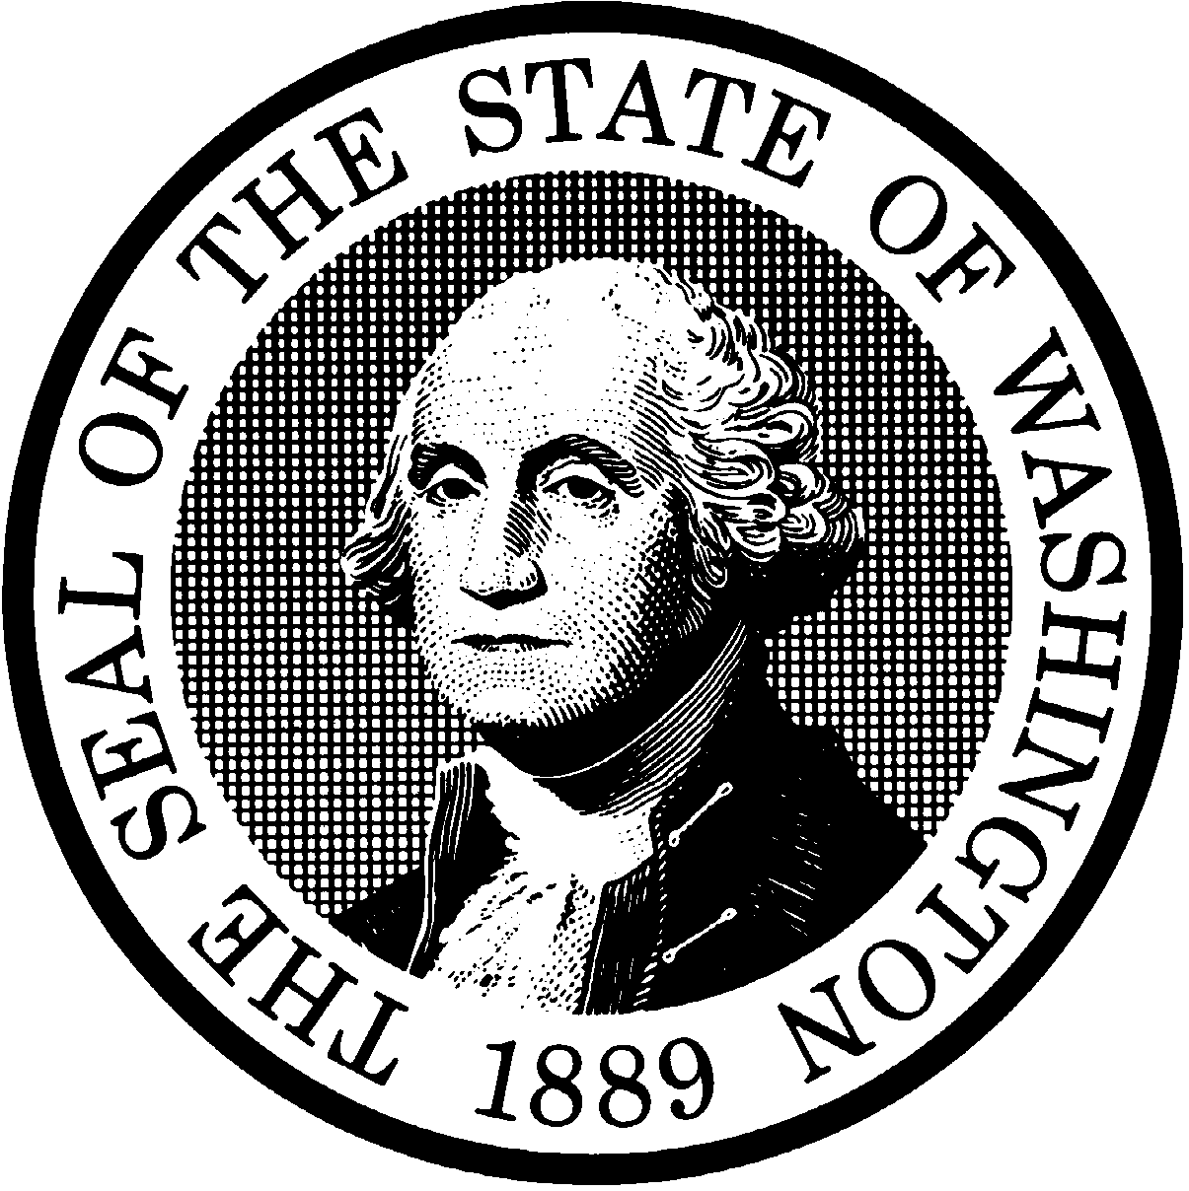
STATE OF WASHINGTON
DEPARTMENT OF SOCIAL AND HEALTH SERVICES

Date:

Client Number:
Language:
Program:
You must provide proof you have completed a chemical dependency assessment by .
DATE
Your chemical dependency assessment recommends that you complete substance use disorder treatment. You must
provide proof you are participating in treatment by .
DATE
If you don’t complete an assessment or treatment as required, your Aged, Blind, or Disabled (ABD) or Pregnant Women Assistance (PWA) cash assistance may end per WAC 388-449-0220.

Chemical Dependency assessment and treatment providers in your area include:

Please call me if you have any questions or if you need help finding a certified chemical dependency assessment or treatment provider.

Telephone:
SOCIAL SERVICE SPECIALIST TIME
CSO:

