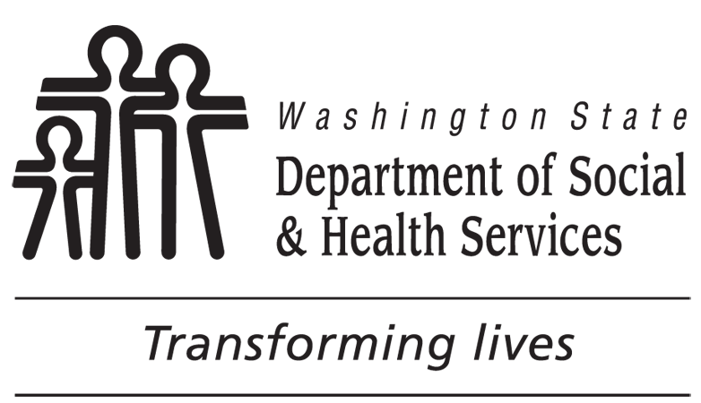 | DEVELOPMENTAL DISABILITIES ADMINISTRATION (DDA)  No Paid Services Group
RE: No Paid Services Assignment

This letter is to let you know that because you are not currently receiving a DDA paid service you have been assigned to a No Paid Services group with the Developmental Disabilities Administration (DDA). If you are approved to receive a DDA paid service in the future your case will be assigned to a case manager. For information about community resources please refer to the enclosed information or call 211.

Please call DDA at if you’d like to request a paid service. You may also request services
online by going to https://www.dshs.wa.gov/dda/service-and-information-request.

Thank you.

Cc: Client File
Client Representative
Provider(s)

INSTRUCTIONS

This form letter is designed to be sent when assigning a new client to the NPS queue established for their assigned reporting unit in the regions. It is also used when a client is being moved from a paid services caseload to an NPS queue.

1. Enter the client name and address.

2. Enter the client representative name and address.

3. Enter the designated toll free number for the client region.

