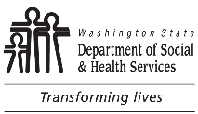 | Division of Vocational Rehabilitation  Exhibit E: School-to-Work Success Story
Name of Student (optional) |  | Month and Year | Reporting County
Describe the student’s journey and success* in school to work:

* Success may be, for example: Job Placements, movement towards community employment, personal challenges the student was able to overcome, or getting connected to valuable community resources.
250 words minimum or summary with a link to a video.
Exhibit E must be submitted one (1) time per county served to the DVR School-to-Work Transition Program Manager by June 30th.
This form is not valid without the following signed documents:
- DVR’s Personal Information Release form:
DSHS 16-178, Personal Information Release (wa.gov); and
- DSHS’s Photo Release form: DSHS 16-235, Photo Release (wa.gov).

