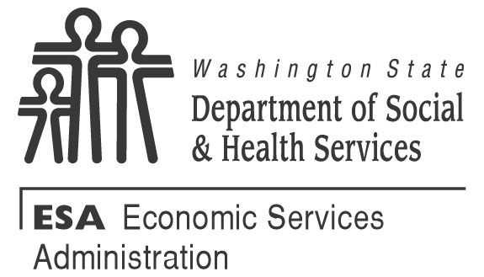 | Interim Assistance Reimbursement Authorization
CLIENT NAME | SOCIAL SECURITY NUMBER | CLIENT ID NUMBER | TELEPHONE NUMBER
STREET ADDRESS CITY STATE ZIP CODE

MAILING ADDRESS CITY STATE ZIP CODE

The term State means the Washington State Department of Social and Health Services. The terms I, me, and my means the client named above. The term SSA means the Social Security Administration. The term SSI means Social Security Supplemental Security Income, which is a federal income supplement program. The term Interim Assistance means the cash payments totally financed by state funds and provided by the State to or on behalf of the client to meet the client’s basic needs that is later duplicated by an initial or reinstated SSI payment.
What am I authorizing by signing this form?
If I am found eligible to receive SSI payments, I understand I am authorizing the SSA Commissioner to issue to the State from my retroactive SSI payments, an amount equal to the amount of State public assistance I received.
Does the State have the authority to require me to sign this authorization?
Yes. Signing the authorization is an eligibility requirement for state funded cash assistance per WAC 388-400-0060 and RCW 74.62.030. . If I refuse to sign this authorization, I can’t receive State public assistance.
What do I do if SSA sends the full retroactive payment to me?
I understand that I can’t receive State public assistance and SSI benefits for the same period of time. When approved for SSI, I understand that the State public assistance becomes a debt I owe and must repay. If I receive SSI retroactive payments that are not reduced to repay the State, I will call the Office of Financial Recovery at 1-800-562-6114 and follow their instructions about how to repay the debt.
How long is this authorization effective?
The authorization must be signed by me and a State representative to be valid. It is binding on the State and me for one calendar year from the date the State receives it and I agree to file for SSI during that time.
When an SSI application is filed, this authorization continues to be valid until:
- I get my first SSI payment; or
- I don't file a request for review or administrative appeal and the maximum time allowed to file has expired; or
- The State and I agree to terminate this authorization.
This authorization is not binding on me if the State does not notify SSA within 30 days of the date that I signed this authorization.
Does this authorization serve as a protective filing for SSI benefits?
Yes, if I have not already filed a SSI application, SSA must accept this form and use the date I signed this authorization as the date I applied for SSI if I file an SSI application within 60 days of the date I signed the authorization. If I do not file an application for SSI benefits within 60 days, this authorization no longer protects my filing date for SSI.
I have the right to an Administrative Hearing if I disagree with an action taken by the State regarding this authorization.
CLIENT SIGNATURE |  |  | DATE
DSHS REPRESENTATIVE SIGNATURE |  |  | DATE RECEIVED BY DSHS

