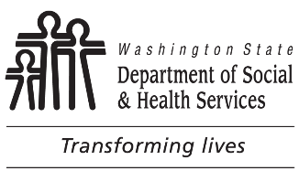 | STATE OF WASHINGTON  DEPARTMENT OF SOCIAL AND HEALTH SERVICES  DIVISION OF CHILD SUPPORT (DCS)  Direct Deposit Authorization
TO: |  |  |  | CASE NUMBER:  INDIVIDUAL NUMBER:
I want a DCS debit card I want direct deposit to my bank account listed below.
FIRST NAME MIDDLE INITIAL LAST NAME

SOCIAL SECURITY NUMBER |  |  | DATE OF BIRTH (MONTH/DAY/YEAR)
MAILING ADDRESS APT. #

CITY STATE ZIP CODE

HOME TELEPHONE NUMBER  ( ) |  | DAYTIME TELEPHONE NUMBER  ( ) |  | EMAIL ADDRESS (OPTIONAL)
Update my address in the child support system to the address listed above.
SIGNATURE (REQUIRED) |  |  |  | DATE
Enter information below if you selected direct deposit to your bank account. Attach a voided check.
BANK NAME |  |  | BANK BRANCH TELEPHONE NUMBER  ( )
BANK ROUTING NUMBER |  |  | BANK ACCOUNT NUMBER |  | Checking  Savings
If you have questions about direct deposit or the DCS debit card, call 800-468-7422.
Mail To:  DIVISION OF CHILD SUPPORT  EFT DISBURSEMENTS  PO BOX 9010  OLYMPIA WA 98507-9010  Or Fax to: 360-664-5109 |  |  | 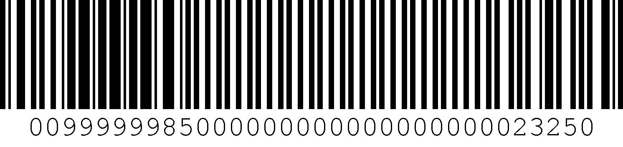
No person because of race, color, national origin, creed, religion, sex, age, or disability, shall be discriminated against in employment, services, or any aspect of the program's activities. This form is available in alternative formats upon request.

U.S. Bank ReliaCard® Pre-Acquisition Disclosure
Program Name: Washington Division of Child Support
Reference Date: June 2017

You have options as to how you receive your payments,
including direct deposit to your bank account or this prepaid card.
Ask your agency for available options and select your option.
Monthly fee Per purchase ATM withdrawal Cash reload
$0 $0 $0 in-network N/A
$0.99* out-of-network

ATM Balance Inquiry (in-network or out-of-network) $0

Customer Service (automated or live agent) $0 per call

Inactivity $0

We charge 3 other types of fees. One of them is:

Card Replacement (standard or expedited delivery) $0 or $15.00

* This fee can be lower depending on how and where this card is used.
See the accompanying Fee Schedule for free ways to access your funds and balance information.
No overdraft/credit feature.
Your funds are eligible for FDIC insurance.
For general information about prepaid accounts, visit cfpb.gov/prepaid.
Find details and conditions for all fees and services inside the card package or call
1-866-363-4136 or visit usbankreliacard.com.
U.S. Bank ReliaCard® Fee Schedule
Program Name: Washington Division of Child Support
Effective Date: May 2018
All fees |  | Amount | Details
Get cash
ATM Withdrawal  (in network) |  | $0 | This is our fee per withdrawal. “In-network” refers to the U.S. Bank or MoneyPass® ATM networks. Locations can be found at usbank.com/locations or moneypass.com/atm-locator.
ATM Withdrawal  (out-of-network) |  | $0.99 | This is our fee per withdrawal. This fee is waived for your first 2 ATM withdrawals per ACH, which includes both ATM Withdrawals (out-of-network) and International ATM Withdrawals. “Out-of-network” refers to all the ATMs outside of the U.S. Bank or MoneyPass ATM networks. You may also be charged a fee by the ATM operator even if you do not complete a transaction.
Teller Cash Withdrawal |  | $0 | This is our fee for when you withdraw cash off your card from a teller at a bank or credit union that accepts Visa®.
Information
ATM Balance Inquiry  (in network) |  | $0 | This is our fee per inquiry. “In-network” refers to the U.S. Bank or MoneyPass ATM networks. Locations can be found at usbank.com/locations or moneypass.com/atm-locator.
ATM Balance Inquiry  (out-of-network) |  | $0 | This is our fee per inquiry. “Out-of-network” refers to all the ATMs outside of the U.S. Bank or MoneyPass ATM networks. You may also be charged a fee by the ATM operator.
Using your card outside the U.S.
International Transaction |  | 2% | This is our fee which applies when you use your card for purchases at foreign merchants and for cash withdrawals from foreign ATMs and is a percentage of the transaction dollar amount, after any currency conversion. Some merchant and ATM transactions, even if you and/or the merchant or ATM are located in the United States, are considered foreign transactions under the applicable network rules, and we do not control how these merchants, ATMs and transactions are classified for this purpose.
International ATM Withdrawal |  | $2.50 | This is our fee per withdrawal. This fee is waived for your first 2 ATM withdrawals per ACH, which includes both ATM Withdrawals (out-of-network) and International ATM Withdrawals. You may also be charged a fee by the ATM operator even if you do not complete a transaction.
Other
Card Replacement |  | $0 | This is our fee per card replacement mailed to you with standard delivery (up to 10 business days).
Card Replacement Expedited Delivery |  | $15.00 | This is our fee for expedited delivery (up to 3 business days) charged in addition to any Card Replacement fee.
Your funds are eligible for FDIC insurance. Your funds will be held at U.S. Bank National Association, an FDIC-insured institution, and are insured up to $250,000 by the FDIC in the event U.S. Bank fails. See fdic.gov/deposit/deposits/prepaid.html for details.
No overdraft/credit feature.
Contact Cardholder Services by calling 1-866-363-4136, by mail at P.O. Box 551617, Jacksonville, FL 32255 or visit usbankreliacard.com.
For general information about prepaid accounts, visit cfpb.gov/prepaid. If you have a complaint about a prepaid account, call the Consumer Financial Protection Bureau at 1-855-411-2372 or visit cfpb.gov/complaint.

The ReliaCard is issued by U.S. Bank National Association pursuant to a license from Visa U.S.A. Inc. ©2018 U.S. Bank. Member FDIC.

